Plant physiology laboratory

Introduction
Plant physiology focuses on the functioning of plant organs and tissues. It aims to understand the nature of the mechanisms through which organs perform their functions and how the plant develops within its environment.

Objective
The objective is to become familiar with a plant physiology laboratory its equipment and how it operates.

Materials and equipment

Glassware and small instruments
- Slides: small glass plates used to place and hold a prepared sample for microscopic observation.
- Cover slips: thin, small glass plates used to cover a sample placed on a slide for microscopic observation.
- Petri dishes (plastic and glass): circular containers used as supports for seed culture.
- Magnifying glass: useful for many types of examinations.
- Forceps: metallic or wooden instruments used to hold slides during staining procedures.
- Test tubes: used for preparing dilutions and for containing reagents.
- Various types of glassware: including beakers, volumetric flasks, Erlenmeyer flasks, graduated pipettes, etc.

Optical microscope: It consists of two main parts:

A) Mechanical part
Comprising the following components:
a) Base: serves as the foot of the microscope.
b) Arm: supports both the eyepiece holder and the objective holder.
c) Revolving nosepiece (objective holder): equipped with 3 or 4 objectives, allowing for objective changes.
d) Stage: fixed support used to hold the specimen to be examined.
e) Stage clips: system used to fix the slide in place.
f) Eyepiece holder: equipped with a sliding system to adjust the eyepieces according to the user’s vision.
g) Condenser holder: adjustment system containing the diaphragm, which regulates light intensity.
h) Coarse and fine adjustment knobs: used to focus the image.

B) Optical Part: Comprising:
a) A lamp and a condenser, made up of several lenses to enhance illumination.
b) Objectives: two types are commonly used:
- Dry objective: the lens does not touch the specimen; it is separated from the preparation by air.
- Oil immersion objective: the lens touches the specimen through an oil with a refractive index close to that of the glass cover slip. This oil ensures total reflection of light rays exiting the slide. The most commonly used oil is cedar oil.
c) Eyepieces: the lower eyepiece illuminates the real image produced by the objective, and the upper eyepiece magnifies this real image tenfold (×10) to produce a virtual image.

The Binocular (or Stereomicroscope)
The binocular microscope, also known as a stereomicroscope, is an optical instrument designed for observing objects at low magnification, typically between 10× and 40×.
Unlike the conventional optical microscope, it provides a three-dimensional (stereoscopic) view of the specimen, allowing observation of its external structures and surface details.

Structure of the Binocular: It consists of two main parts:

1. Mechanical Part:
- Base: supports the instrument and often houses the lower light source.
- Arm: connects the base to the binocular head and allows adjustment of the height of the specimen.
- Stage: the platform where the object or specimen is placed.
- Coarse focus knob: used to focus by adjusting the distance between the objectives and the specimen.

2. Optical Part:
- Two eyepieces: provide a binocular (relief) view.
- Two objectives: arranged to produce a stereoscopic image.
- Lighting system: usually consists of two light sources:
  - Incident (upper) light for observing opaque objects,
  - and Transmitted (lower) light for transparent or semi-transparent specimens.

Uses of the Binocular
It is used to:
- Observe external plant structures (leaves, seeds, stems, roots).
- Examine floral organs or non-transparent tissues.
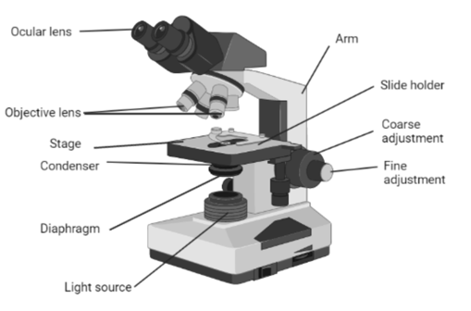
- Study small organisms or plant fragments without microscopic preparation.
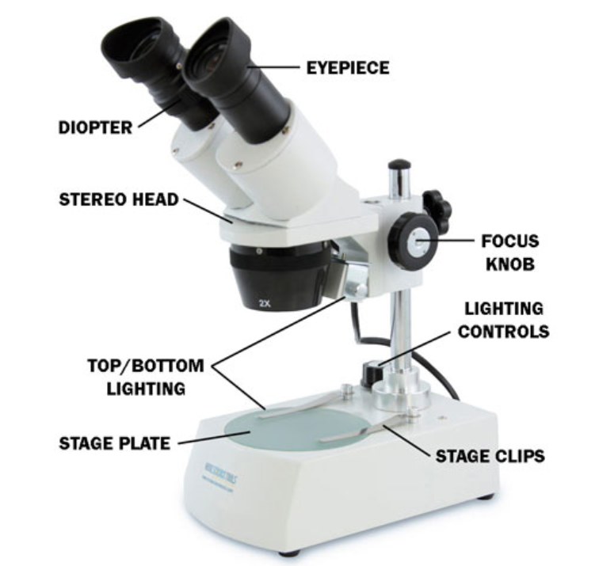
Fig. The Optical microscope
Fig. The Binocular (Stereomicroscope)

Practical work report

1 – Drawing guidelines
- All drawings must be done entirely in pencil.
- The cover page must include: full name, group number, date, and the title of the practical session.
- Never draw on both sides of the paper, use only one side for better presentation.
- The drawing must faithfully reproduce the image observed under the microscope (enlarge it while keeping the same proportions and arrangement) and indicate the magnification used.

Important recommendations
- Arrive on time to avoid disturbing the session.
- Wear a long-sleeved, closed laboratory coat.
- Prepare for the practical session by carefully reading the instructions beforehand.
- Bring your drawing materials: A4 white drawing sheets, graphite pencil, eraser, etc.
- Eating, drinking, and smoking are strictly prohibited in the laboratory.
- Wash your hands before leaving the laboratory.
- Work while seated.
- Shake all suspensions before use.
- Do not touch your mouth or face during manipulations.

Before leaving the laboratory:
- Clean the benches, sinks, and microscope lenses.
- Return all clean materials to their proper place and put the chairs back in order.
- Check that all gas and water taps are closed before leaving.

