Subscribe to DeepL Pro to edit this document.
Visit www.DeepL.com/pro for more information.
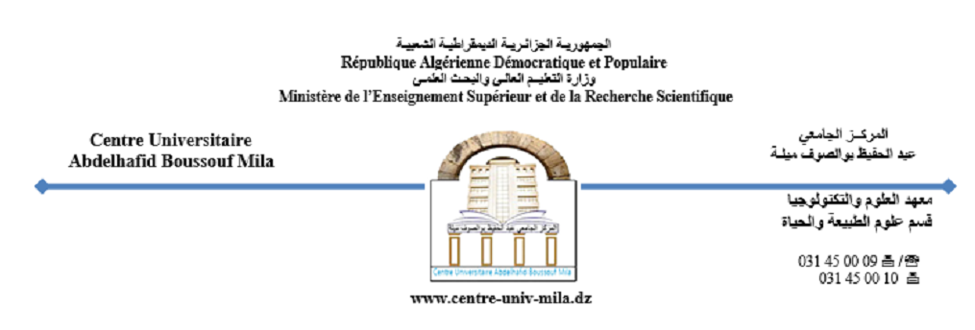

Institute of Natural and Life Sciences
Department of Ecology and Environment

Course: Analysis and Laboratory

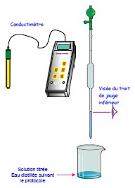

Intended for third-year bachelor's degree students
Specialization: Agroecology
Taught by: Dr. Bouaroudj Sara
Email: sara.bouaroudj@centre-univ-mila.dz
Academic Year 2024/2025

I- INTRODUCTION
The reliability of monitoring the nutritional and sanitary quality of food depends in particular on the methods used to perform the analyses. Different types of analytical methods can be distinguished, depending on the analytical objective pursued (detection/quantification, characterization, etc.) or the status of the method (standardized reference method, commercially available alternative method, internal method).
This course covers analytical techniques used in agroecological practices. It presents regulated instrumental analysis with an emphasis on general methods for testing and analyzing soil and water.
The choice of analytical method must take into account the nature of the results sought.
This is why it is important to know the "internal" performance characteristics of an analytical method during the period under consideration when using it on substances to be analyzed. Any analytical method used on substances to be analyzed must be applied consistently.
The course is divided into a series of chapters that enable students to acquire knowledge and skills in the analytical techniques used in agroecological practices.
The course will provide theoretical knowledge on the description and operating principles of analytical equipment, as well as practical experience of analytical methods through laboratory work involving the analysis of certain elements.
This course also enables students to acquire the know-how and interpersonal skills essential for agroecological monitoring, while respecting good laboratory practices and mastering certain basic principles such as: methods for preparing solutions and reagents and how to interpret results.

CHAPTER 1
Review of basic concepts

2. General information on solutions

2.1. Definitions (solute, solvent, concentrations)
2.1.1. The phenomenon of dissolution
When a substance is dissolved in a liquid, the result is a solution, which is a homogeneous mixture.
The dissolved substance is called the solute, and the liquid in which the substance is dissolved is called the solvent.
Note: If the solvent is water, the solution is called an aqueous solution.
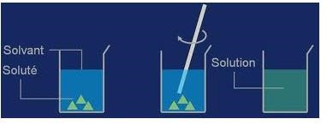
Figure 2. Preparation of a solution

2.1.2. Ionic aqueous solution and non-ionic aqueous solution
An aqueous solution that conducts electricity contains ions (cations and anions). It is called an ionic aqueous solution. The solute is an ionic crystal. Example: The mixture of salt and water is an ionic aqueous solution containing Na⁺ and Cl⁻ ions.
An aqueous solution that does not conduct electricity is a non-ionic aqueous solution. Example: A sucrose (sugar) solution is a non-ionic solution.
2.1.3. Stages of dissolution
The dissolution of an electrolyte in a solvent occurs in three distinct stages: dissociation, solvation, and dispersion.
a. Dissociation
Since the solvent is polar, its molecules behave like small electrostatic dipoles. The cations of the ionic crystal are therefore attracted to the positive sides of the solvent molecules, and the anions to the negative sides. These attractions outside the crystal unbalance the internal interactions and weaken its cohesion: the ions on the surface of the crystal are gradually pulled away by the solvent molecules. This is referred to as dissociation of the ionic crystal. This is the phenomenon of dissociation.
NB. In the case of a molecular electrolyte rather than a non-ionic one, the same thing happens since each molecule of the electrolyte is polar and therefore has a positive side and a negative side.
- Solvation
Once removed from the crystal, each ion is surrounded by solvent molecules. These form a shield and prevent any interaction between the ions in solution. This is the phenomenon of solvation. When the solvent is water, the solvation stage is also known as hydration.
- Dispersion
Once solvated, the ions move freely in the solution with their entourage of solvent molecules, and the solution gradually becomes homogeneous. This step is considerably accelerated if the solution is stirred.
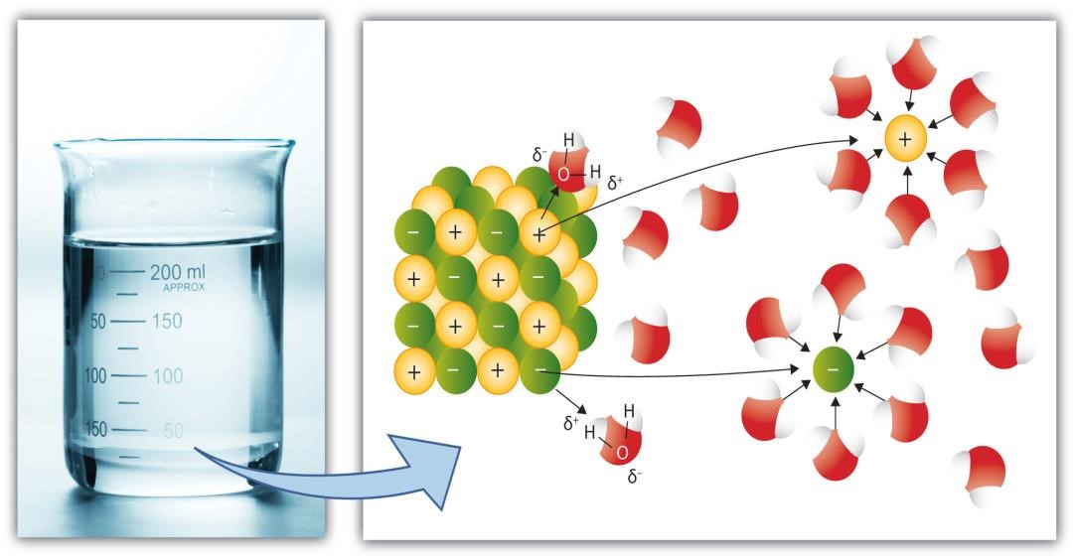
Figure 3. Principle of electrolyte dissolution.

2.1.4. Thermal effects of dissolution
The dissolution of certain solutes is accompanied by:
  - An increase in temperature: the dissociation is said to be exothermic (NaOH in water).
  - Or a decrease in temperature: the dissociation is said to be endothermic (NH4NO3).

2.2. Units of concentration
2.2.1. Mass concentration of an aqueous solution
The mass concentration of a solution is the mass of solute contained in one liter of that solution. It is denoted by Cm and its unit is g/L.

Cm: the mass concentration of the solution (g.L(⁻¹⁾ ⁾;
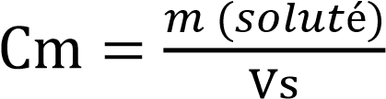 where Vs: the volume of the solution (L);
M: the mass of the solute (g)
2.2.2. Molar concentration of a solution.
The molar concentration of a solution is the amount of solute contained in one liter of solution. It is denoted by C and its unit is mol/L.

n (solute): the number of moles of solute (mole).
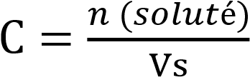 where: Vs: the volume of the solution (L);
C: the molar concentration of the solution.

2.3. Solubility-Saturation
2.3.1. Saturation of a solution.
As dissolution progresses, the number of solvent molecules available for dissociation decreases, so dissolution becomes increasingly slow. Since the number of water molecules available is limited, the amount of solute that a solution can dissolve is itself limited. When this limit is reached, the solution is said to be saturated.
2.3.2. Solubility
The solubility of a substance in water is the maximum amount of that substance that can be dissolved in a given volume of water. It is a quantity that depends on temperature.
2.4. Normality
Normality is the number of equivalent gram of a solute (i) present in one liter of solution. A normal solution (or one normal) contains one equivalent gram per liter.
Normality (N) and molar concentration (CM) are related by the following equation:
N = nCM; n = The gram equivalent is the amount of substance comprising one mole of the particles in question (H+, e–) number of protons exchanged during the
acid-base reactions or electrons in the case of redox reactions.
- Mass/volume percentage % (m/v): This is the number of grams of a solute in 100 ml (or 100 ^{cm³}) of solution.
Example: A 50% (m/v) solution of _{H₂SO₄}means that such a solution contains
50 g of H_{₂SO₄ in} 100 ml of water.
Note: Since the volume of liquids varies with temperature, the titles defined above therefore depend on temperature.
- Expressions based on a mass/mass (m/m) ratio:
Titles defined in this way do not depend on temperature.
a) Parts per million (ppm): The concentration in ppm represents the number of parts of solute dissolved in 1 million parts of solution: 1 ppm = 1/10⁶
This concentration is often used to quantify trace amounts (i.e., very small quantities) of solutes contained in any solution.
One part per million also corresponds to one milligram per kilogram (1 mg/kg) or one milligram per liter of solution (1 mg/L).
Application: Calculate, in ppm, the concentration of an aqueous NaCl solution with a concentration equal to 26 x 10⁻⁴mol/L.
Answer:
Reminder: 1 ppm = 1 part per million = 1 mg per million mg = 1 mg/kg.
NaCl has a molar mass of: M_{Na}+ M_{Cl}= 23 + 35.5 = 58.5 g/mol
A 26 x 10⁻⁴mol/L solution therefore contains 26 x 10⁻⁴x 58.5 = 0.152 g/L.
If we assume that a 1 L column of NaCl solution weighs 1 kg, then this implies that the NaCl solution contains 0.152 g/kg, i.e.: 152 mg/kg = 152 ppm.
b) Molality (molal concentration): This is the number of moles of solute per kilogram of solvent (water). It is given by the following equation:
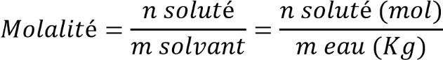
Application:
We have an aqueous solution of acetic acid with 856 g of acid per liter and a density of 1.07 kg/L. What is the molality of this solution?
Answer:
Mass of solute CH₃ COOH= 856g
Molar mass of solute = 60 g/mol
Number of moles of acid contained in one liter of solution:
N solute = m solute/M solute = 856/60 = 14.26 moles 1 liter of solution weighs 1070g:
Mass of water = mass of solution – m solute = 1070 – 856 = 214g = 0.214 kg Molality = n solute/m water = 14.26 / 0.214 = 66.63 mol/kg.
- Percentage mass/mass (% m/m) (% mass percentage): This is the number of grams of any solute contained in 100 grams of solution.
Example: A 15% m/m solution of KOH means that such a solution contains 15 g of KOH in 100 g of water.
- Molar fraction (X)
The molar fraction of the solute is the ratio of the number of moles of solute to the number of moles of the solution (solvent + solute).
3. Methods for preparing solutions

3.1. Weighing method
Determining the mass of solute to be weighed
Suppose we want to prepare a volume V of a solution containing species X, with molar mass M(X), at concentration [X]. In general, we need to determine the mass of species X to be weighed.
Let m(X) be this mass.
[X] = n (x)/v or n (x) = m (x) / M(x)
Therefore [X] = m (x) / M (x) * v
And m(x) = [X] * M(x) * v

Operations to be performed
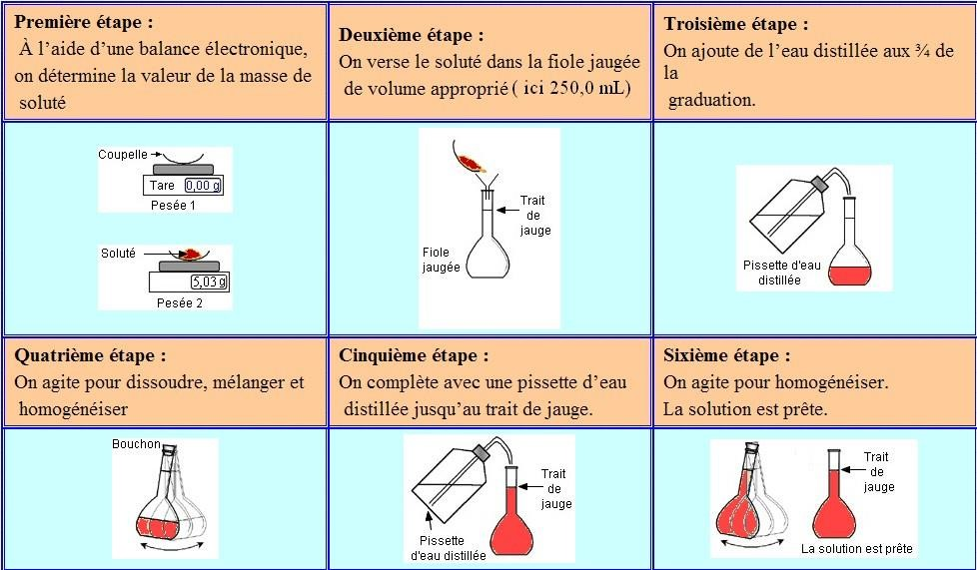
Figure 4. Method for preparing solutions using the weighing method

3.2. Dilution method
Diluting a solution means reducing its concentration. To do this, solvent must be added. However, the volume of solvent added must be known in order to determine the concentration of the new solution obtained. The most concentrated solution is often referred to as the "stock solution," while the diluted solution is called the "daughter solution."

Principle
A volume V₀ of the stock solution with concentration C₀ is taken and diluted with distilled water to obtain a diluted solution with volume V₁ and desired concentration C₁ .
Determining the volume V₀ to be taken
During dilution, the amount of solute remains constant. We write: n₁= n₂
Therefore: C₀ . V₀ = C₁ . V₁

Operations to be performed
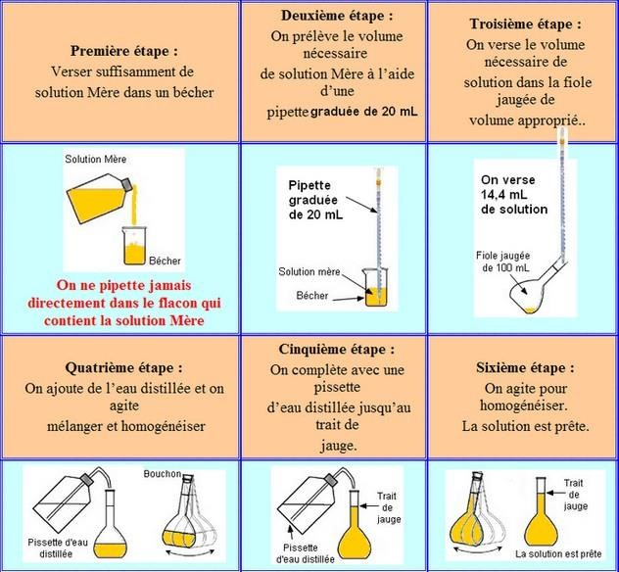
Figure 5. Method for preparing solutions by dilution

