**Comparison and Contrast**

Comparison and contrast is a technique that we use every day. For example, we compare and contrast courses and teachers when we decide which classes to take. We compare and contrast products and prices when we shop. An employer compares and contrasts applicants for jobs, and a job applicant compares and contrasts job offers. In college classes, you will often have to compare and contrast. For example, in a history class, you might be asked to compare and contrast two historical figures or two events. In a literature class, you might have to compare two poems or two characters in a play. Knowing how to write comparison/contrast paragraphs is a very useful skill.

When we compare two (or more) things, we tell what is similar about them. When we contrast things, we tell what is different about them. Usually, the emphasis is on the differences, but sometimes a paragraph describes both similarities and differences. As you read the model paragraphs, decide which one emphasizes differences and which one describes both similarities and differences.

There are two ways to organize a comparison/contrast paragraph. One way is called block organization, and the other way is called point-by-point organization. In block organization, you group all the similarities together in one block and all the differences together in one block.

In point-by-point organization, you write about similarities and differences by subtopic. For example, if you are comparing and contrasting several wireless telephone plans, you might compare and contrast them on these subtopics.

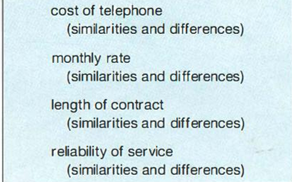

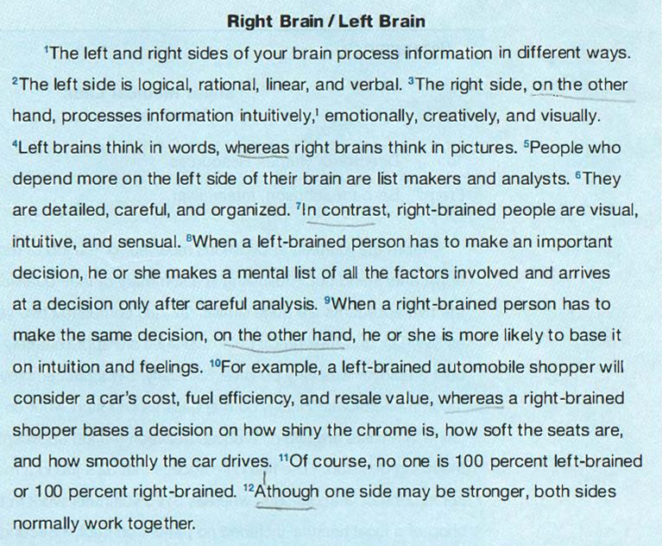

Here is a contrast paragraph:

