**Writing Process**

**1. Creating**

It is also called pre- writing because you do it before you start writing.

* 1. **Choosing and Narrowing the topic**

You are in an exam, you have two or three topics, how can you choose the one that suits you? There are two choices: (1) Choose a topic that interests you. (2) Choose a topic that fits the assignment.

* 1. **Generating Ideas**

This step is also called brainstorming. After you have chosen a topic and narrowed it, the next prewriting step is to collect information and develop ideas. For some writing tasks, you will need to go to outside sources, such as newspapers, magazines, library books, or the Internet.

**2. Planning**

In this stage the writer organize ideas into an outline.

**2.1. Making Subtitles**

When writing a paragraph about culture shock, in the example below, the writer develops three ideas: communication problems, classroom environment, American family life. Choosing communication problem , the writer should further sub-lists to this idea to write an outline. A suggested sub-lists are as follows:

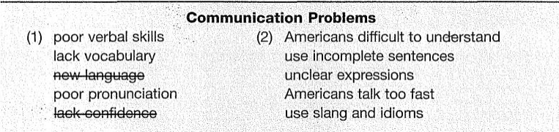

**2.2. Topic Sentence**

Having a clear direction now enables the writer to write a topic sentence. A possible topic sentence can be

One problem that many international students face in the United States is communication with Americans.

OR International students in the United States face communication problems with Americans.

**2.3. Outline**

A formal outline is a clear plan for what the writer is going to talk about in the paragraph. It is optional you can write it or not. Fortunately having an outline ensures a clear path to be followed. Here is an example of an outline

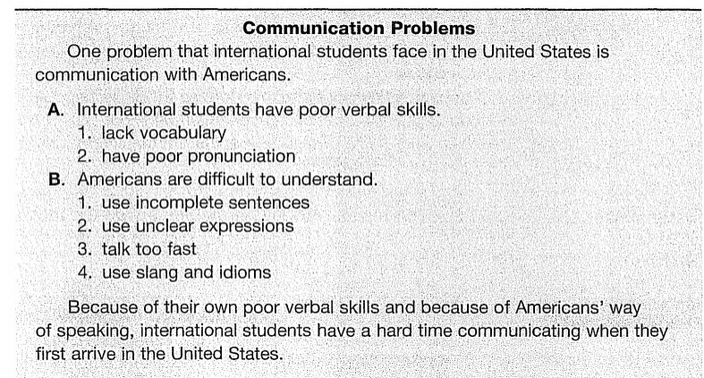

**3. Writing**

Writing process is writing the rough draft. Follow your outline and don't worry about grammar, punctuation, or spelling. A rough draft is not supposed to be perfect. As you are writing, you will think of new ideas that may not be in your brainstorming list or outline. You can add or delete ideas at any time in the writing process. Just be sure that any new ideas are relevant can be added. An example of a rough draft is:

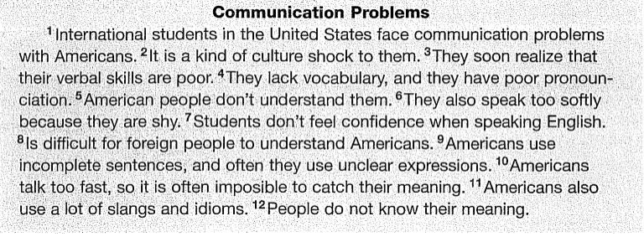

**4. Polishing**

The fourth and final step in the writing process is polishing what you have written. This step is also called revising and editing. Polishing is most successful if you do it in two stages. First, attack the big issues of content and organization (revising). Then work on the smaller issues of grammar and punctuation (editing).