1. **Introduction:**

The present technical regulations set the rules for the conception and the earthquake resistant design of constructions in seismic areas. They are applicable to all current constructions but not directly applicable to constructions such as: nuclear or power plants, stocking flammables, explosive, toxic or polluting products, marine works, bridges and tunnels....

1. **Definitions and notations**
   * 1. **Classification of the constructions according to their importance**

The minimum seismic protection level accepted for a building depends on its destination and importance (See table IV - 1) in regard to the protection objectives set by the community.

Table IV - 1: Usage groups of buildings

|  |  |  |
| --- | --- | --- |
| Group | Description | examples |
| Group 1A | Construction of vital importance | Decision making centers, civil defense centers, police or military barracks, hospitals and centers equipped with emergency. |
| Group 1B | Construction of high importance | Public buildings occupied by more than 300 people, mosques, commercial and industrial buildings, schools, universities sport, hotels and collective buildings with height exceeding 48 m. |
| Group 2 | Constructions of moderate importance | Buildings for collective housing or office services with height not exceeding 48 m and other buildings occupied by less than 300 persons and public parking lots. |
| Group 3 | Constructions of low importance | Industrial or agricultural buildings sheltering low value goods and buildings with limited risk for people and temporary constructions |

* + 1. **Classification of sites**

The sites are classified into four (04) categories according to the mechanical properties of the constituting soils.

* Category S1 (rocky site): Rock or other geological formation characterized by an average shear wave velocity Vs ≥ 800 m/s
* Category S2 (firm site): Very dense gravel or sand and/or over consolidated clay deposits with a thickness of 10 to 20 meters and Vs ≥ 400 m/s from a depth of 10 meters.
* Category S3 (soft site): Thick deposits of moderately dense gravel and sand or moderately stiff clay with Vs ≥200 m/s from a depth of 10 meters.
* Category S4 (very soft site): Loose sands deposits with or without soft clay with Vs < 200 m/s within the 20 first meters and Soft to moderately stiff clay with Vs < 200 m/s within the 20 first meters.
  + 1. **Classification of the seismic zones**

The national territory is subdivided into five (05) zones of increasing seismicity, defined on the seismic zoning map (Figure IV - 1) which details this repartition at the wilaya and commune levels, that is:

* Zone 0: neglected seismicity
* Zone I: low seismicity
* Zones IIa and IIb: moderate seismicity
* Zone III: high seismicity

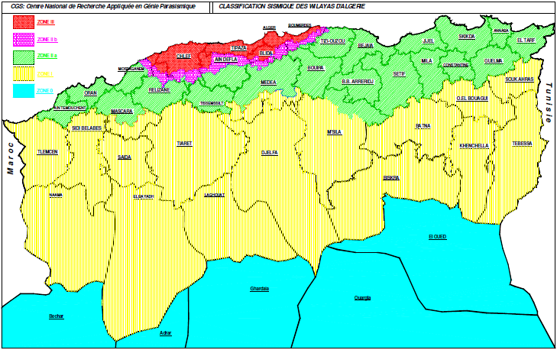

Figure IV - 1: Seismic Macrozoning Map of Algeria

* + 1. **Classification of the constructions according to their configuration**

Each building (and its structure) should be classified according to its configuration in plan and in elevation as a regular building or not, in regard to the criteria hereafter mentioned:

1. **Regularity in plan**

The building should present a quite symmetrical configuration in regard to two orthogonal directions. At each level and for each design direction, the distance between the center of gravity of the masses and that of the rigidities should not be more than 15% of the building dimension perpendicular to the considered direction of the seismic action.

The shape of the building should be compact with a length to width ratio of the floor less than or equal to four (4). The sum of the dimensions of the re-entrant parts and setbacks in a given direction should not exceed 25% of the global dimension of the building in that direction (Figure IV - 2). Finely, the floors should have sufficient in plane rigidity in regard to that of the vertical bracing elements to be considered as rigid in their plane. In this case, the total area of the floor openings should be less than 15% of that of the floor.



Figure IV - 2: Limits of the plan setbacks

1. **Regularity in elevation**

The bracing system should not present vertical discontinuous bearing element the load of which is not transmitted directly to the foundation. Both the lateral stiffness and the mass of the individual stories remain constant or reduce gradually, without abrupt changes, from the base to the top of the building. In the case of setbacks in elevation, the variation of the horizontal dimensions of the building between two successive levels should not be more than 20% in the two design directions, decreasing along the height. The largest horizontal dimension of the building should not exceed 1,5 times its smallest dimension (Figure IV -3).



Figure IV - 3 : Limits of elevation setbacks

1. **General rules for conception**
2. **Selection of the site**

For the selection of the site, a special attention should be paid on some unfavorable or penalizing conditions as: presence of known active faults, suspected zones, presence of different geological formations, unstable soils (unstable slopes, edge of cliffs, saturated poorly drained soils, underground cavities and non-compacted fills…)

1. **Soil investigations and studies**

The soil investigations are mandatory for the constructions classified as of middle importance and more, sited in zones having a seismicity ranging from moderate to high. Except for the constructions having a basement with 3 stories at most or having an average height of 11m (as for individual housing or assimilated buildings) with a total floor area less than 400m2.

1. **Infrastructure and foundations**

The infrastructure composed of the structural elements of the basements and the foundation system should form a resistant and rigid unit that rests, if possible, at a minimum depth on compact and homogeneous soil, preferably away from water. This unit should be capable of transmitting both horizontal and vertical seismic forces. The foundation system should be homogeneous (isolated footings, mats, piles) with only one mode of foundation per construction block limited by joints. Their assignment on fills or restored soils is not accepted unless special justifications are provided.

1. **Superstructure**

To offer a better resistance to earthquakes, the constructions should preferably have simple forms on one hand, and a distribution of the masses and rigidities as regular as possible in plan and in elevation on the other hand. Seismic joints might be adopted to limit the lengths of buildings and separate the blocks of coupled buildings having unequal geometry and / or rigidities and masses.

In general, the constructions should have lateral load resisting systems at least in two horizontal directions. These systems should be arranged in order to:

* take up a sufficient vertical load enough to ensure their stability.
* ensure a direct transmission of the forces to the foundations.
* minimize the torsion action effects

The lateral load resisting systems should have a regular configuration and form a continuous and coherent structural system as monolithic as possible. A particular attention should be given to the design and execution of all the connections, keeping in mind the effects of any failure at this level on the behavior of the structure.

1. **Modeling and analysis**

The choice of the analysis method and the structural modeling should aim at reproducing to the best the actual behavior of the structure.

In the case of the constructions concerned by the present regulations, it is accepted that the structures, subject to a seismic ground motion can undergo deformations in the post-elastic domain. It is then necessary to use equivalent linear analysis methods, using an elastic model of the structure where the seismic action is represented by a response spectrum. A unique behavior coefficient associated to the structure permits then to:

* determine the structural design loads
* assess the inelastic deformations of the structure for the verification of the damage criteria.

Otherwise, more sophisticated analysis methods can eventually be used, provided appropriate scientific justification is given.

1. **Analysis methods**

In general, the seismic loads calculation can be performed according to three methods:

* the equivalent static method
* the modal response spectrum analysis method
* the time history dynamic analysis method

The static equivalent method is the simplest one, it can be used in the following conditions:

**a)** The building or the studied block comply satisfy the conditions of regularity in plan and in elevation with a height to most equal to 65m in zones I and IIa and to 30m in zone IIb and III.

**b)** The building or studied block presents an irregular configuration but satisfying, in addition to the conditions of height expressed in (a), the following complementary conditions:

**Zone I :** all groups

**Zone II :**

using group 3

using group 2, if the height is lower or equal to 7 stories or 23m.

using group 1B, if the height is lower or equal to 5 stories or 17m.

using group 1A, if the height is lower or equal to 3 stories or 10m.

**Zone III :**

using groups 3 and 2, if the height is lower or equal to 5 stories or 17m.

using group 1B, if the height is lower or equal to 3 stories or 10m.

using group 1A, if the height is lower or equal to 2 stories or 08m.

The modal response spectrum analysis method can be used in all cases, and in particular, in the case where the equivalent static method is not permitted.

The time history dynamic analysis method can be used in specific cases by a qualified personnel which must justify the choice of the seismic inputs (accelerograms) to be used, the behavior relationships of materials, the method of results interpretation and safety criteria to comply with.

1. **Analysis with static equivalent method**
2. **Principals**

The dynamic real loads developed in the construction are replaced by a system of nominal static loads the effects of which are considered equivalent to those of the seismic action.

The soil motion can be in any direction in the horizontal plan. The equivalent horizontal seismic loads will be considered successively applied in two successive orthogonal directions chosen by the designer. In general, these two directions are the principal axes of the horizontal plan of the structure.

However, the loads and deformations for a given element obtained from the static analysis methods for recommended design loads are lower than those that would be observed on the structure under effects of a major earthquake for which the loads have been specified. This excess of loads is balanced by the ductile behavior that is provided by detailing of the element.

The building model to be used in each of the two directions for analysis is plane, with masses concentrated at the gravity center of the floor and only one degree of freedom by floor in horizontal translation is considered. The lateral stiffness of supporting elements of the bracing system is calculated from non-cracked and only the fundamental vibration mode of the structure is considered.

1. **Total seismic load**

The total seismic load **V**, applied to the basement of the structure according to the following formula:

$$V=\frac{A×D×Q}{R}×W$$

In wish:

**A :** zone acceleration coefficient, given by table (IV - 2), according to the seismic zone and the using group of the building.

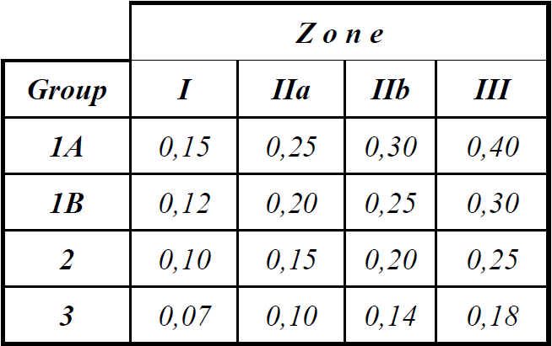

Table IV - 2: coefficient of zone acceleration

**D :** average dynamic amplification factor, depending on the site category, on the damping correction factor ( η ) and on the fundamental period of the structure (T). The factor (D) is given in chart forms in figure (VI - 4) for a damping coefficient ξ = 5%.

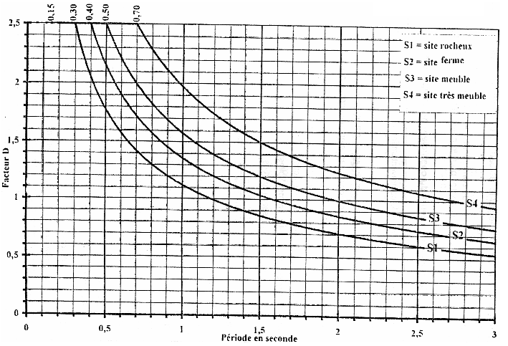

Figure IV - 4: Average dynamic amplification factor

**R:** global behavior coefficient of the structure, given in table (IV - 3) according to the lateral force resisting system. In case of different lateral force resisting systems in the two considered directions, the smallest value of R must be used.

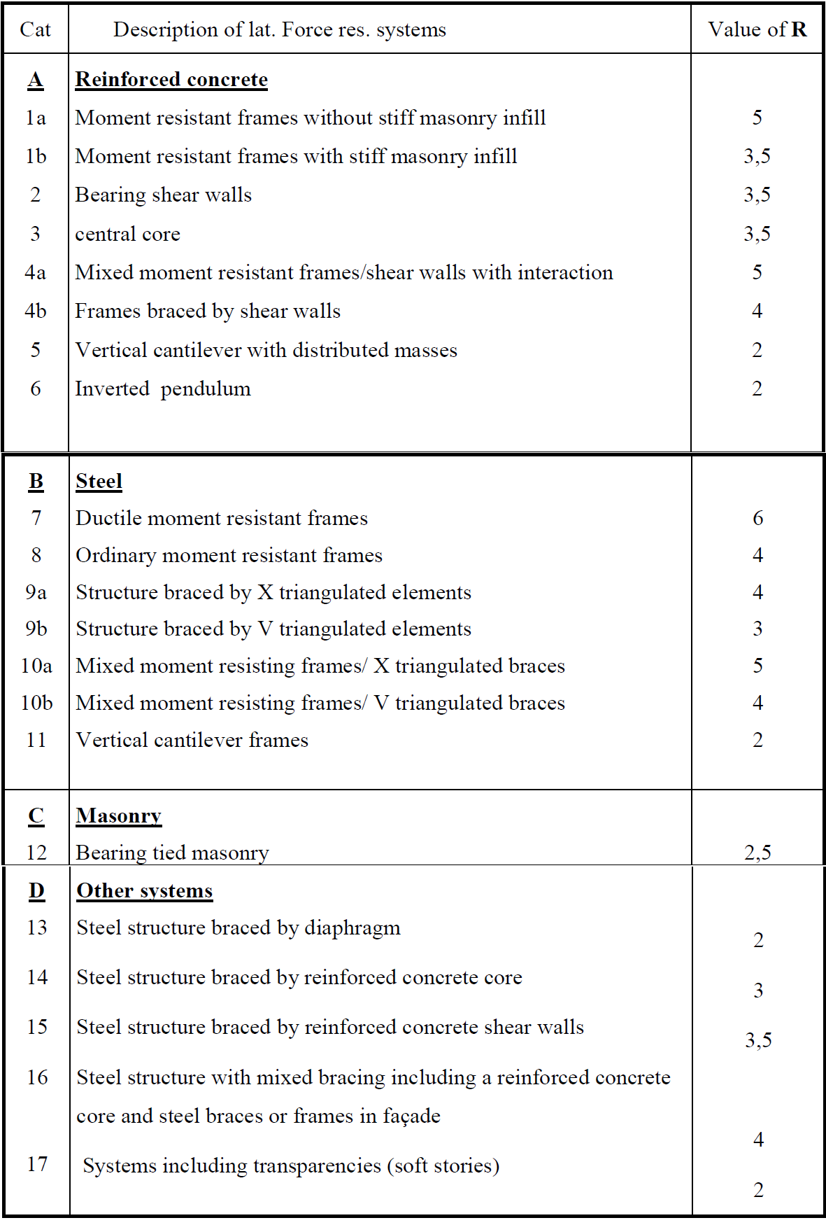

Table IV - 3 : Behavior factor values R

**Q**: Quality factor of the structure it depends on:

* the redundancy and the geometry of the constituent elements.
* the regularity in plan and in elevation.
* the quality of the control of construction.

The value of Q is determined by the formula:

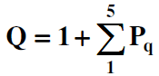

Pq is the penalty to be applied depending on whether the criteria of quality q “is satisfied or not”. Its value is given in table (IV – 4).

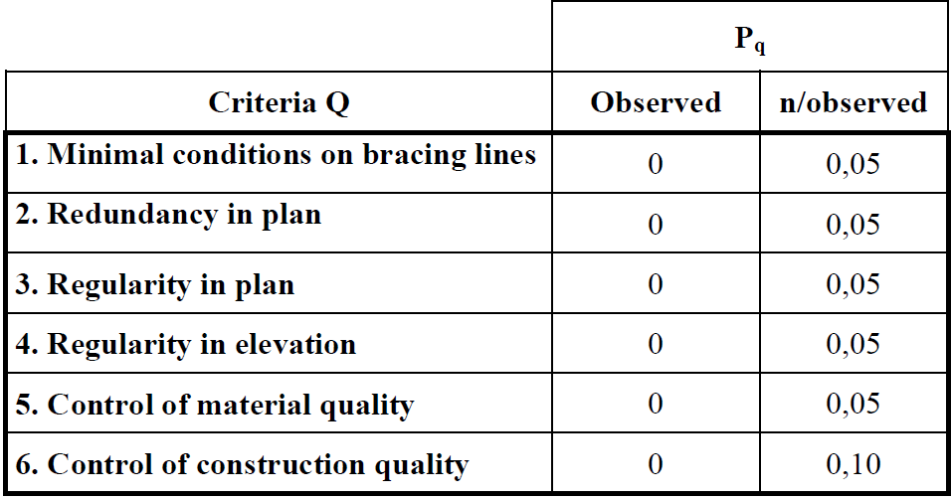

Table IV - 4 : Values of the penalties Pq

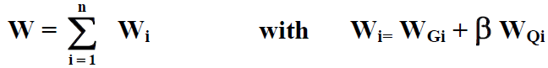**W**: total weight of the structure wish is equal to the sum of the weights Wi, calculated at every floor (i):

* WGi: weight due to the dead loads and loads of the eventual fixed equipment attached to the structure.
* WQi: live loads
* β : weighting coefficient, depending on the nature and the duration of the live load, given in table (IV – 5).

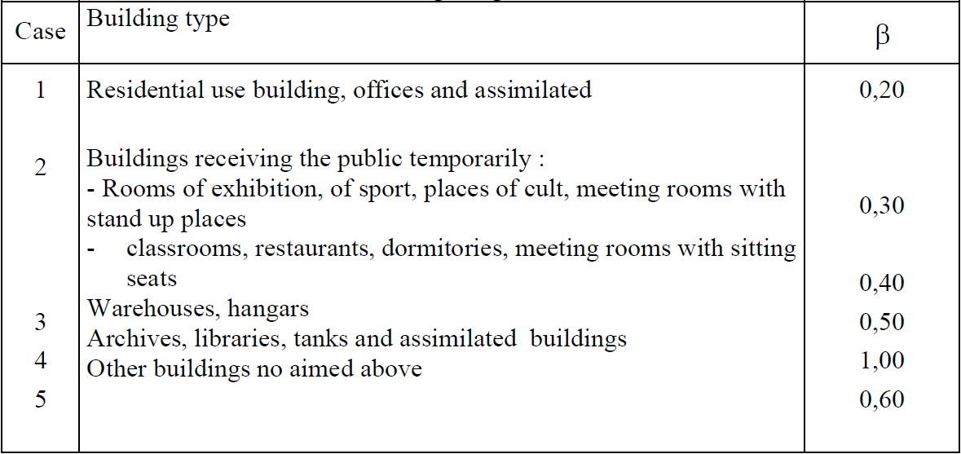

Table IV - 5 : Weighting coefficient

1. **Distribution of the global seismic force in the building height**

The global seismic force **V** at the base of the building should be distributed following the height of the structure like shown in figure (IV - 5) and according to the following formulae:



The concentrated force (**Ft**) at the top of the structure allows to take into account the influence of the high vibration modes of the structure. It is determined by the formula: **Ft = 0.07 TV.**

Where (**T**) is the fundamental period of the structure (in second). The value of (**Ft**) should not exceed (**0,25 V**) and should be taken equal to 0 when (**T**) is smaller or equal to 0.7 seconds.

The differential part of **V**: (**V - Ft**) should be distributed following the height of the structure following the formula:

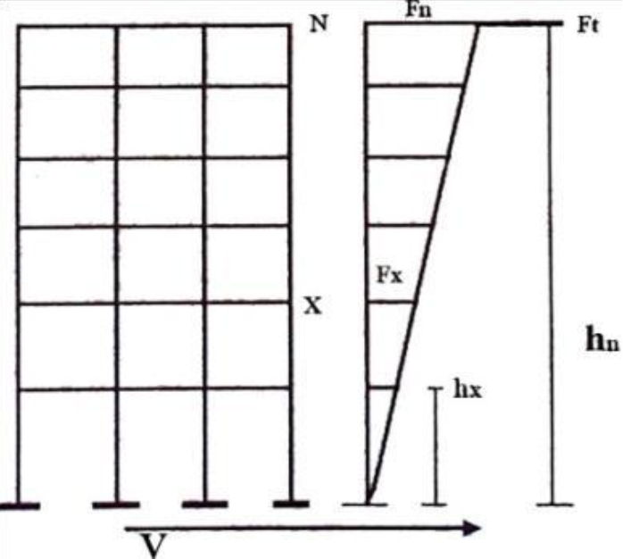

Figure IV - 5 : Seismic force distribution

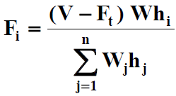

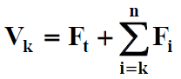

The shear force at the level k:

1. **Estimation of the fundamental period of the structure**

The value of the fundamental period (**T**) of the structure can be estimated from empirical formulae or can be calculated by numerical or analytic methods. The empirical formula recommended the only one presented in this course is described in the following:

hN: height measured in meters from the basis of the structure to the top of the last level (n).

CT: coefficient, function of the lateral force resisting system and of the type of infill. It is given by the table (IV – 5).

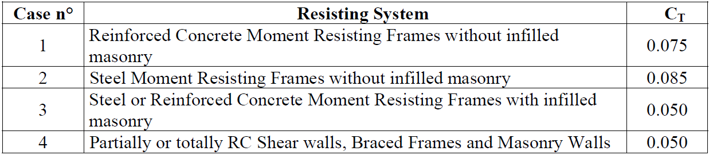

Table IV - 6: values of the coefficient CT