**Chapter 05: Semiconductor**

**5.1. Definition:**

**Semiconductor**is therefore a crystalline body whose electrical conductivity properties are intermediate between those of metals and those of insulators. The semiconductor will be an insulating material at 0K but which can lead to temperatures close to room temperature.

**5.2. BAND STRUCTURE**

A semiconductor is a crystalline solid whose electrical conduction properties are determined by two particular energy bands: on the one hand, the valence band, which corresponds to the electrons involved in covalent bonds; on the other hand, the conduction band, comprising the electrons in an excited state, which can move in the crystal. These two bands are separated by a gap, a forbidden band that the electrons can only cross thanks to an external excitation (for example, the absorption of a photon). The forbidden band corresponds to an energy barrier, the order of magnitude of which is the electron Volt.

**5.2.1 GAP:**

The gap is by definition the width of the forbidden band, that is to say the difference in energy between the absolute minimum of the conduction band and the absolute maximum of the valence band.

**5.2.2 The Fermi level EF:**

This is the particular level called the Fermi level. EF corresponds to the average statistical level occupied at thermodynamic equilibrium by all the carriers. It is located approximately in the middle of the forbidden band of the material

**6. INTRINSIC SEMICONDUCTOR:**

Pure semiconductor, without impurities (undoped). Charge carriers are obtained exclusively following the transitions of electrons from the valence band (BV) to the conduction band (BC) (fig. 1a) thanks to the thermal agitation energy. Each electron that makes a transition from BV to BC leaves a vacant (unoccupied) level in BV. To this vacant level we attribute a fictitious particle of positive charge q0, called a hole. Therefore the electrons of BC and the holes of BV are the charge carriers in an intrinsic semiconductor.

**7. EXTRINSIC SEMICONDUCTOR:**

It is obtained by doping, that is to say the addition of a very small number of doping atoms in an intrinsic semiconductor.

**8. DOPING:**

Doping involves introducing impurities into a material (e.g. silicon). The impurities introduced into silicon are of two types:

**8.1. Pentavalent n-type extrinsic semiconductor:**

Doping atoms have a number of valence electrons greater than the base (> 4 for Si and Ge which have 4 valence electrons). Phosphorus P, arsenic As or antimony Sb atoms, having five valence electrons, are commonly used as dopants in N-type semiconductors. These atoms are called donors because they provide electrons to the conduction band. These electrons represent the majority charge carriers.

The binding energy of the 5th electron is given by the following relation: 𝐸𝑙𝐷=𝐸𝐶−𝐸𝐷

𝐸𝐷:is the energy of the impurity donor level.

**8.2. Extrinsic p-type semiconductor -trivalent-:**

Doping atoms have a lower number of valence electrons than the base (< 4 for Si and Ge). Boron B, aluminum Al, indium In or gallium Ga atoms, having three valence electrons, are commonly used as dopants in P-type semiconductors. These doping atoms are called acceptors here, because they accept electrons from the valence band, creating vacant levels (holes) in the latter. Holes represent the majority charge carriers.

The hole binding energy is given by the following relation:=𝐸𝐴−𝐸𝑉

𝐸𝐴:is the energy of the impurity acceptor level.

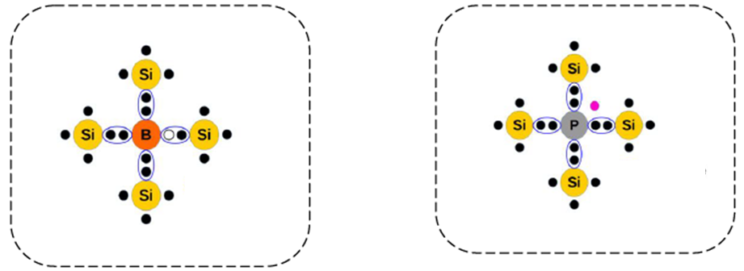

***Semiconductor P-type Semiconductor N-type***

**8.3 Position of the Fermi level in a semiconductor material**

✓ The intrinsic Fermi level (corresponding to the intrinsic material), is located approximately in the middle of the material's band gap, theoretically in the middle at T = 0K.

✓ The Fermi level therefore gradually shifts from the middle of the band gap towards the conduction band when the n-type doping increases as shown in figure.

✓ In the case of a p-type doped semiconductor, the Fermi level will be found closer to the top of the valence band, the more doped the material is.

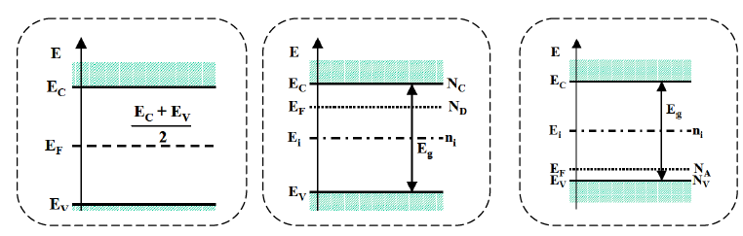

*Figure: Position of the Fermi level and corresponding value of the dopant concentration in a semiconductor, at room temperature*

**8.4 Neutrality equation**

Consider a semiconductor containing a donor density ND and an acceptor density NA, then:

: is the number of ionized donors

: is the numberof acceptorsionized

The total charge of the material is zero (principle of conservation of charges).

n and p are the electron and hole densities, respectively. At room temperature, the thermal energy kBT is of the same order of magnitude as the binding energies of the donor electron and the acceptor holes. This means that all donors and acceptors are ionized.

The previous neutrality equation is therefore written as: 𝒏 + 𝑵𝑨= 𝒑 + 𝑵𝑫

NHASand NDare the densities of acceptors and donors.

**8.4.1 n-type semiconductors:**

In an n-type semiconductor, the donor density (ND) is greater than the acceptor density (NA). According to the neutrality equation, the electron density (n) is greater than the hole density (p).

𝑵𝑫>𝑵𝑨**and n > p**

The electrons in this case are called the majority carriers and the holes are minority carriers. n+NA=𝒑+𝑵𝑫

With: 𝒏.𝒑=𝒏𝒊𝟐

𝑵𝑫−𝑵𝑨𝒏=𝒏𝟐−𝒑𝒏

From where 𝑵𝑫−𝑵𝑨𝒏−𝒏𝒊𝟐=𝟎 The solutions to this equation are:

𝒏=𝑵𝑫−𝑵𝑨+( 𝑵𝑫−𝑵𝑨 𝟐+𝟒𝒏𝒊𝟐)𝒑=− 𝑵𝑫−𝑵𝑨−( 𝑵𝑫−𝑵𝑨 𝟐+𝟒𝒏𝒊𝟐)

The absolute value gives the hole density.

In practice ND, NA and (ND-NA) are very high densities, they are higher than ni.

**8.4.2 p-type semiconductors:**

In this type of semiconductor the acceptor density (NA) is higher than the donor density (ND). In this case, the majority carriers are holes. The carrier densities are:𝑁𝐴>𝑁𝐷 And 𝑝>𝑛

𝒑≈ 𝑵𝑨−𝑵𝑫 and 𝒏≈𝒏𝒊𝟐(𝑵𝑨−𝑵𝑫)

**9. TRANSPORT PHENOMENA IN SEMICONDUCTORS**

**9.1 Mobility – Conductivity**

Generally speaking, when an electric field is applied, there is a tendency to move the charge carriers, electrons and holes. In reality, the physical mechanism of driving by an electric field occurs on carriers that move randomly, in all directions of space, in the material, due to thermal agitation (at normal operating temperatures) and that perform a mean free path without shock.

The electron current density is expressed most simply by:𝑗 𝑛= −𝑞 𝑛<𝑣 𝑛>

𝑗𝑛: Current density generally expressed in Amperes per cm2,

𝑛: Concentration of electrons,

𝑣 𝑛: average speed of electrons, <𝑣 𝑛>=−𝜇𝑛𝐸

𝜇𝑛: Electron mobility (cm2/Vs)

So,𝑗𝑛= −𝑞 𝑛−𝜇𝑛𝐸 𝑗𝑛=𝑞𝑛𝜇𝑛𝐸The expression for the hole current density is then as follows, remembering that the holes move in the same direction as the electric field:𝑗𝑝=𝑞𝑝𝜇𝑝𝐸

These two current densities are actually drift currents in the electric field. In some works, these current densities are called conduction current. We will see in this chapter that other phenomena allow conduction.

It may be noted that we find Ohm's law,𝑗=𝜍.𝐸for each of the two types of carrier. σ is the conductivity.

We can therefore define a conductivity for electrons (𝜍𝑛), and a conductivity for holes, (𝜍𝑝) as follows:𝜍𝑛=𝑞𝑛𝜇𝑛And𝜍𝑝=𝑞𝑝𝜇𝑝 𝑗 𝑇𝑜𝑡=𝑗 𝑛+𝑗 𝑝=𝑞𝑛𝜇𝑛+𝑞𝑝𝜇𝑝 𝐸=𝜍.𝐸

Since (𝜌=1𝜍), the resistivity of the material is expressed by:𝜌=1𝑞𝑛𝜇𝑛+𝑞𝑝𝜇𝑝

**10. HETEROSTRUCTURES**

**10.1 The PN junction**

The PN junction is a basic structure in electronic components. Since the components are made of differently doped semiconductors, PN or NP junctions are present at the interfaces. It is therefore essential to understand the physical phenomena that occur there. The PN junction is also a component in itself. The function of this component is to allow current to flow in one direction only.

**10.2 Homojunction and energy band diagram alignment**

It results from the juxtaposition in the same semiconductor material of two zones: one of type P and the other of type N. The energy band diagrams of the P–N junction were well understood through work by Shockley and others during the early days

of solid state electronics. The P–N junction can be represented by a conduction band bottom and a valence band top as shown in Figure 1. The Fermi level is close to the threshold of the conduction band and the valence band in the N-doped and P-doped region respectively.



***Figure 1:****Energy diagram of a homojunction.*

*𝑉𝐷: the height of the barrier. EC: the bottom of the conduction band. EV: the top of the valence band. Ef: Fermi level*

**10.3 Heterojunction and energy band diagram alignment**

It is due to the interface between two different semiconductor materials and is more complicated analogue of the P–N junction between two differently doped regions in the same material (homojunction). Heterojunctions result from the growth of one semiconductor on another. To construct an energy band diagram of a heterojunction, it must be taken into consideration that the band gap changes from one material (𝐸𝑔1) to another material (𝐸𝑔2). Thus, the discontinuities (Offset) Δ𝐸𝑉 𝑒𝑡Δ𝐸𝐶come from the heterojunction and their magnitudes must be found for each particular combination of materials, see Fig.2.

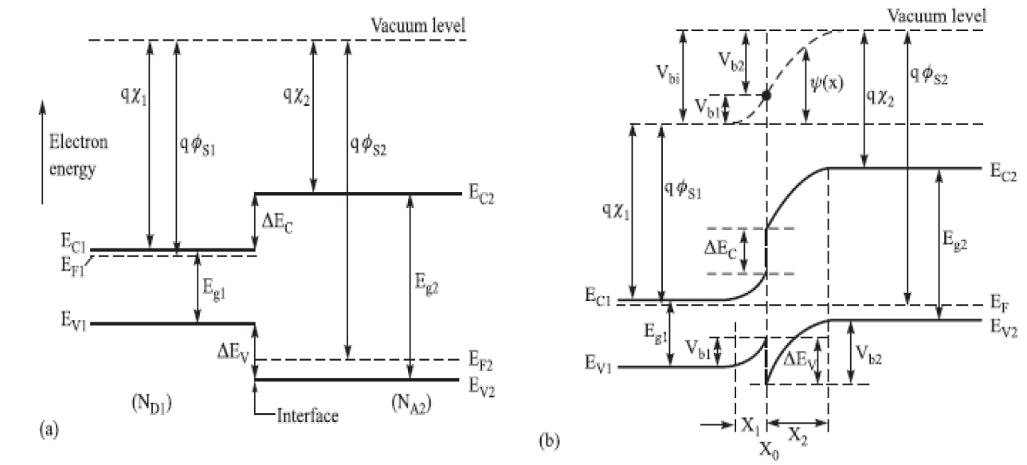

***Figure 2****: a- Band diagrams of semiconductors S1 and S2 before contact, S1 is an S/C with gap Eg1 and donor type so its Fermi level Ef1 is close to Ec1 while S2 is an S/C with gap Eg2 and acceptor type so its level Ef2 is close to Ev2, b- band diagrams of semiconductors S1 and S2 after contact.*

**11. POWER SEMICONDUCTORS**

Three types of power semiconductors are used:

* uncontrolled semiconductors:

*→***Power diodes**;

* Controlled semiconductors without blocking command:

*→***Thyristors**;

*→***Triacs**;

* controlled semiconductors with blocking control:

*→***Power bipolar transistors**;

*→***Power MOSFET transistors**;

*→***GTO (Gate Turn Off) thyristors**;

*→***IGBT (Insulated Gate Bipolar Transistor)**.