**Chapter 03: Dielectric materials**

**3.1. Introduction:**

According to the energy band model, when the conduction and valence bands are separated by an energy greater than5𝑒𝑣 in the atoms of a material, it becomes a poor conductor of electricity, thus the material is dielectric or insulator.

A medium is dielectric (a word composed of the prefix dia (through) and electric) if it does not contain any electrical charges capable of moving macroscopically. The medium cannot therefore conduct electric current, and by definition is an electrical insulator. Some examples of dielectric media: vacuum, glass, dry wood, many plastics, etc.

**3.2. Physics and characteristics of dielectrics**

Despite the impossibility of dielectric media to conduct current, they have many electrical characteristics. Indeed, and under the effect of an external electric field, a very small displacement of negative and positive charges occurs. The electrons present in a dielectric medium cannot, by definition, move over large distances. On the other hand, they can present movements of very small amplitude on a macroscopic scale which can attribute to the dielectric different characteristics such as: The phenomenon of polarization, Electrical susceptibility, Dielectric permittivity, Dielectric rigidity, etc.

**2.2.1. Electrostatic dipole**

An electrostatic dipole results from a distribution of distinct electric charges, such that the barycenter of the positive charges does not coincide with that of the negative charges. The simplest dipole consists of a pair of opposite charges +q and −q distant from

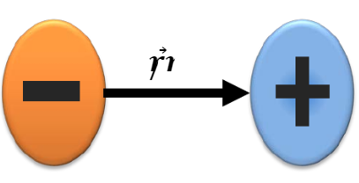

To quantify this phenomenon, a physical quantity called dipole moment is introduced. The dipole moment vector is given by:

The SI unit used is coulomb-meter (Cm). Sometimes, the debye (D) is used: 1D=3.336 10-30 Cm. In materials, we can distinguish three types of dipoles.

**2.2.1.1. Permanent dipole**

In chemistry, a permanent dipole results from an asymmetry in the distribution of electronic charges within a molecule. In the case of a linear molecule, the permanent dipole results from the difference in electronegativity between the atoms, which leads to the appearance of a negative pole on the most electronegative atom and a positive pole, equal in absolute value, on the least electronegative atom. Examples include: HCl, H2O, NH3, CO, etc.

**2.2.1.2. Induced Dipole**

This dipole results from the deformation of an electron cloud (originally neutral) of an atom under the action of an external electric field. Indeed, the positive charges will move in the direct direction of the field, while the negative charges will move in the opposite direction of the field.

**2.2.1.3. Instantaneous dipole**

Resulting from an asymmetrical distribution of the valence electrons of an atom for a short instant.

**2.2.1.4. Electric field of a dipole**

In an electrostatic dipole, the field lines start from the positive charges and go either to a negative charge or to infinity. Near a point charge, the field lines are radial, almost identical to those of a single charge. An electrostatic field line is never closed on itself.

**3.2.2. Polarization in dielectric media**

**3.2.2.1. Atomic polarization**

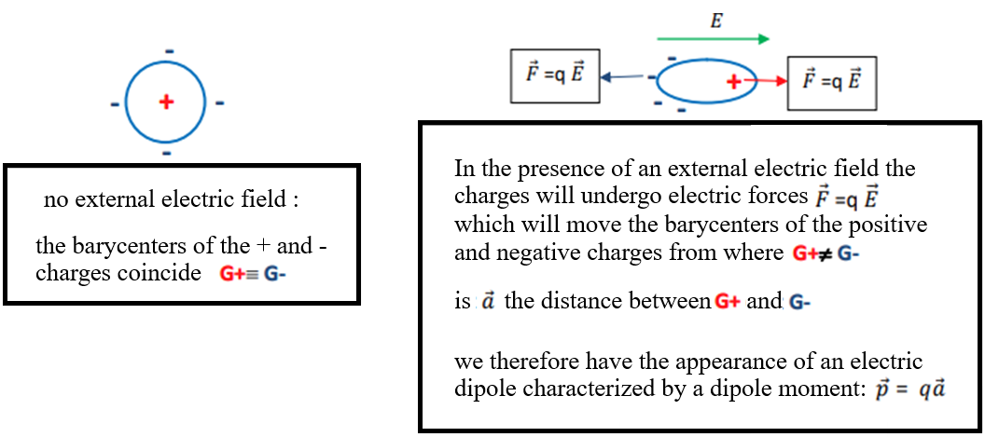

**3.2.2.2. Macroscopic polarization**

Let us examine a set of atoms or molecules in a dielectric (electrically neutral) in the absence and then in the presence of an electric field.

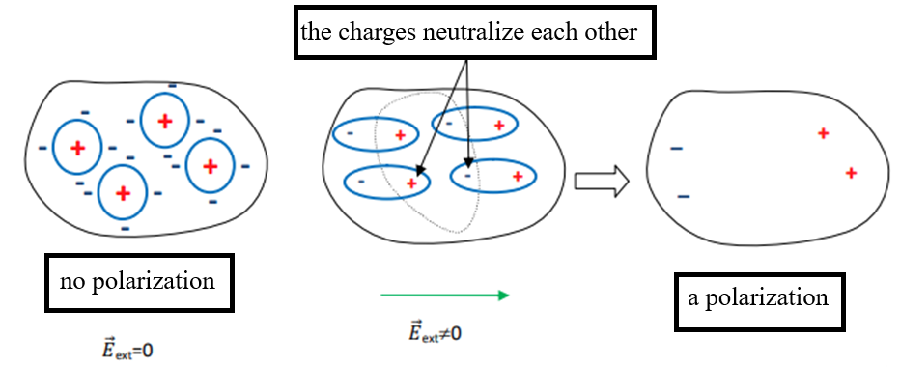

Polarization is proportional to the field that created it. It is noted and is defined as being the dipole moment per unit volume:

**3.2.3. Electrical susceptibility:**

Electric susceptibility is a quantity characterizing the polarization created by an electric field. This phenomenon occurs only through a material medium (often a dielectric material). Electric susceptibility () is a dimensionless complex number. To calculate electric susceptibility, the types of polarization must be taken into account:

* Electronic polarization, always present, due to the displacement and deformation of the electronic cloud.
* Atomic or ionic polarization due to the movement of atoms or ions in the structure of the material.
* Macroscopic polarization due to charge displacements throughout the material.

In most cases, several of these phenomena are present and cumulative. The main difficulty in the calculation lies in the fact that the macroscopic electric field in which the material is immersed is often different from the local electric field which actually acts on the microscopic constituents and therefore creates the polarization.

**3.2.4. The dielectric constant**

is a dimensionless complex number. To calculate the susceptibility

The dielectric constant or electric constant, also called vacuum permittivity or vacuum dielectric permittivity, is a physical constant. It is denoted by:

With :

the magnetic constant.

C: the speed of light in a vacuum.

In the SI unit system, the dielectric constant has a well-defined value which is:

The dielectric constant is defined as the ratio between the permittivity of the material considered and that of vacuum. The dielectric constant describes the response of a given medium to an electric field. The dielectric constant () can be seen as the intrinsic permittivity of vacuum. For a given material of permittivity (), it is possible to define the relative permittivity (), normalized with respect to that of vacuum. This value has no unit and is always greater than 1.

**3.2.5. Dielectric Strength**

The dielectric strength of an insulating medium represents the maximum value of the electric field that the medium can withstand before the triggering of an electric arc (therefore a short circuit). We also use the expression disruptive field. The maximum value of the electric voltage applied to the terminals is called the breakdown voltage of the capacitor. If the electric field exceeds the dielectric strength of the material, we speak of breakdown, and the material can see its physical properties modified, sometimes reversibly, and sometimes irreversibly. In the case of a gaseous insulator, the dielectric strength depends on the pressure of the gas. The rigidity of a material is evaluated in

|  |  |
| --- | --- |
| Material | dielectric strength  (MV/m) |
| Air | 3 |
| Quartz | 8 |
| Strontium titanate | 8 |
| Neoprene | 12 |
| Nylon | 14 |
| Pyrex | 14 |
| Silicon buile | 15 |