**Chapter 02 : Ferromagnetic materials**

**2.1. Introduction**

Ferromagnetic media are widely used in industry: electrical machines, transformers, but also in spin microelectronics (hard disks). Here we are considering the notion of magnetization of a magnetic medium, a new source of the magnetic field, which requires adding a term to the Maxwell-Ampère equation. We then define the magnetic excitation, directly linked to the free electric current, a quantity that can be controlled by the experimenter. Ferromagnets are non-linear media and the curve connecting the magnetic field to the magnetic excitation has a hysteresis cycle. For most of the applications that we will study, where we want to minimize the energy losses associated with the hysteresis phenomenon, we will prefer narrow-cycle, quasi-linear ferromagnets: soft ferromagnets.

**2.2. Description of the field created and the actions undergone by a magnet**

**2.2.1. Map of the magnetic field created by a magnet**

A magnet is similar to a magnetic dipole, characterized by its magnetic moment . A magnetic moment creates a magnetic field, for which an approximate expression can be given at any point sufficiently far from the magnet. For a point identified by the spherical coordinates , the axis being chosen according to , the expression below is only valid for r 'large enough' (large compared to the size of the magnet for example):

This expression is allowed and does not need to be memorized. The program states that one should be able to draw the field map from this formula, given the formula. Note that the field decreases rapidly with distance.



**2.3. Actions undergone by a magnet in an external magnetic field**

Here we consider a magnetic dipole (magnet for example) subjected to a magnetic field created by an unspecified external device. We will not confuse the external magnetic field with that created by the dipole, the latter not being involved here.

In any external magnetostatic field:

The torque exerted on the dipole tends to align the dipole in the same direction and sense as:

The potential energy of the dipole subjected to the external field is written:

If is non-uniform, the dipole is also subject to a force:

)

A magnet placed in a non-uniform field rotates to become colinear with the external field, then moves toward areas of strong field.

**2.4. Properties of ferromagnetic media**

**2.4.1. Magnetization of a magnetic medium**

Under the effect of a magnetic field, certain bodies can acquire and maintain a significant magnetization, called induced; they remain sources of magnetic field even in the absence of electric current: they are called ferromagnetic. Examples: iron, Ni, Co and some of their oxides.

In 1821, Ampère suggested that the magnetic fields created by material media originated from small elementary current loops, on a microscopic scale, similar to magnetic dipoles. There are indeed at the atomic scale magnetic moments due on the one hand to the movement of electrons (orbital magnetic moments) and on the other hand to their spin (spin magnetic moments). It is mainly the latter which are at the origin of ferromagnetism. It should be noted that the existence of a permanent magnet cannot therefore be understood without quantum physics (the notion of spin is purely quantum).

**2.4.2. Definition of magnetization**

Let the magnetic moment of a small volume of matter be:

The power supply is therefore the volume density of magnetic moment.

**2.4.3. MA equation in magnetic media**

The modeling proposed by Ampère stipulates the existence of internal currents in matter, at the origin of microscopic magnetic moments, whose magnetization is the density at the mesoscopic scale. This is a natural idea within the framework of the planetary model of the atom, the electrons orbiting the nucleus appearing as currents linked to the atom. This term is chosen in opposition to free currents, created by the movement of free charge carriers.

In the context of this model, it is therefore necessary to add a term to the Maxwell-Ampère equation. This is naturally the only Maxwell equation that needs to be modified. By referring to the definition of the magnetic moment of a current loop and thanks to Stokes' Theorem, it can be shown that these linked currents can be expressed as a function of the magnetization by the expression:

These bound currents are not controllable by the experimenter. The free currents are. Thus it is interesting to reformulate the MA equation by leaving as a source term on the right of the equality only the term of the free currents.

**2.4.4. Definition of magnetic excitation**

**2.4.5. Maxwell-Ampère in a magnetic medium**

**Remarks :**

* In this version of MA and Ampere's Theorem, the constant u0 does not appear
* Another vocabulary can be used in magnetic media and are then respectively called induction field and magnetic field…
* Free currents are the source of magnetic excitation
* Free currents and magnetization are the two sources of the magnetic field

The experimenter generally controls the free currents, therefore the field. This is why this field is used to excite the magnetic material. It is this excitation which fixes the magnetization of the material, therefore the magnetic field inside the material.

**2.5. Different types of magnetic media**

For most crystalline substances, the magnetization is weak. We distinguish:

* paramagnetic bodies: and are of the same direction, so the response of the material adds to the excitation to give a magnetic field greater than that which would have been created by the free currents alone (Al, Ca, O2, etc.). In the left figure below, the magnetic field lines clearly show that the field is greater in the material than in the outside air.
* diamagnetic bodies: and are in opposite directions, so the response of the material moderates the excitation to give a magnetic field lower than that which would have been created by free currents alone (Cu, Pb, Ag, water, etc.). In the figure on the right below, the magnetic field lines clearly show that the field is weaker in the material than in the outside air.



On the contrary, a certain number of materials have a strong magnetization. Ferromagnetic materials are among them (Ex simple bodies: Fe, Ni, Co) (Ex composite bodies: CrO2) (Ex alloys: AlNiCo, TiCoNAl). They have a behavior similar to paramagnetic materials: their induced magnetization tends to align in the same direction as the excitation to give a magnetic field greater than that which would be obtained in a vacuum. There are other types of magnetic media: antiferromagnetic, ferrimagnetic, etc. The French physicist Louis Néel was awarded the Nobel Prize in Physics for his studies in this field (1970).

**Ferrimagnetism**: for high frequency transformers, eddy current losses, proportional to the square of the frequency, are predominant: ferrites are then used because they are insulating.

Ferrites are compounds with the formula MO,Fe2O3, where M is a divalent metal (Mg, Fe, Co...). They are not ferromagnets but ferrimagnets: the macroscopic properties are similar; their hysteresis cycles are practically square, which is why they have long been used as bistables in computer memories.

**2.6. Magnetization curve – Hysteresis cycle of a ferromagnet**

Ferromagnetic media are nonlinear: there is no simple relationship between excitation and response. The behavior of a ferromagnet is described by its magnetization curve: or ..

Subsequently, the scalar fields denoted M, H, B are the projections of the vector fields according to the direction of the excitation. The latter being fixed by the experimenter, its direction is generally known.

**2.6.1. First magnetization curve**

If a ferromagnetic material that has never been magnetized is excited, the resulting M(H) curve is called the first magnetization curve. As H increases, M tends toward a limit called saturation magnetization.

Likewise the first magnetization curve giving .

At the following pace:

Order of magnitude, It depends on the material.



* ***Hysteresis cycle***

After having magnetized a magnetic material, we note that if H decreases, M does not return to the values ​​obtained at the first magnetization: there is hysteresis.

By continuing the variations of H, we finally obtain a symmetrical cycle called the hysteresis cycle M(H). The curve B(H) also presents a hysteresis cycle which can of course be deduced from that of M(H).

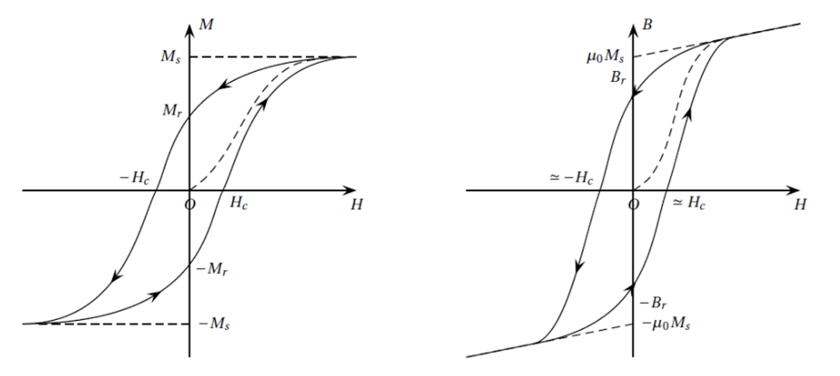

cycle in magnetization M(H) cycle in magnetic field B(H)

When H is zero, M keeps a non-zero value Mr: Mr is the remanent magnetization. This explains why a piece of iron subjected to magnetic excitation (free currents, or external magnet) remains magnetized after the excitation is removed. The corresponding field B is the remanent field. A permanent magnet has then been produced.

**2.7. Applications**

▪ **soft ferro**: power conversion (transformers, high inductance coil) because we will see that the hysteresis phenomenon is the cause of energy losses, all the lower as the cycle is narrow.

▪ **hard ferro**: permanent magnets because their high coercive excitation makes them insensitive to external magnetic disturbances which could demagnetize them.

**2.7. Soft ferromagnets – Relative permeability**

Ferromagnets used in industry generally have a cycle narrow enough to be assimilated to a straight line outside the saturation zone.

**Linear approximation of soft ferromagnets**

A proportionality relationship between and allows us to define the absolute permeability μ of the material:

To compare it to the permeability of a vacuum, we jointly define the relative permeability by:

It can be interpreted as a factor of amplification of the field due to the presence of the ferromagnet.

Orders of magnitude: relative permeability varies from approximately 100 to 106.

When μr, it can be considered infinite in calculations. The ferromagnetic material is said to be perfect.

**2.8. Examples of use of ferromagnets**

**2.8.1. Study of the electromagnet**

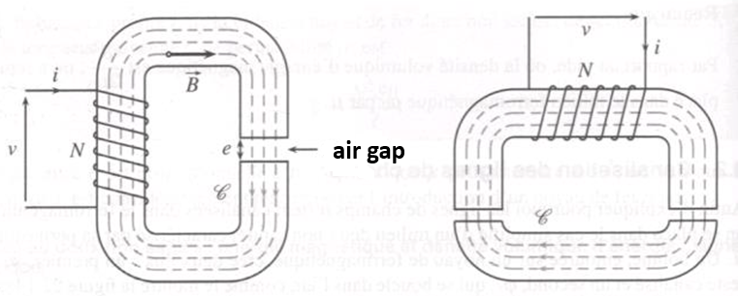

Electromagnets: single on the left, lifting on the right

An electromagnet is a device consisting of a coil surrounding a quasi-closed "magnetic circuit" with one or more air gaps. The aim is to create a strong magnetic field at the air gap. If part of the magnetic circuit is movable (on one side of the air gap) the electromagnet can then be used to generate a magnetic force.

**2.8.2. Field lines in the presence of a ferromagnetic material**

Magnetic field lines are channeled along magnetic materials. When a field line exits a ferromagnet into air, it exits orthogonally to the interface.

We admit these two properties:

The first statement can be made by analogy with electrokinetics: the current flows through the areas of the circuit with the greatest conductivity. Here the magnetic field lines flow through the areas of space with the greatest permeability.

The second statement can be demonstrated from the magnetic passage relations. They are obviously modified in the presence of a ferromagnet since these replace MA in the case of a surface current modeling, and MA is modified in the presence of a ferro. The new passage relations are to be written with H and without . In short, it can be demonstrated that the field lines undergo at the interface between two linear magnetic media a sort of "refraction" mathematically similar to Descartes' laws, by replacing the index by the relative permeability. Those of the ferros being very large compared to 1, we understand that the field lines exit orthogonally at the interface whatever their orientation in the ferro.

**2.8.3. Energy losses in a core coil**

Energy losses that occur inside a ferromagnetic material are called "iron losses".

They appear when the medium is subjected to a time-dependent excitation.

There are two distinct phenomena that cause these losses:

* hysteresis losses: generated by the irreversible displacement of the Bloch walls
* eddy current losses: Joule losses associated with currents induced in the ferro.

Eddy current losses are proportional:

* Squared frequency
* Squared as the amplitude of the magnetic field.
* Squared by the section of the conductor S4 (power 4 of the radius a4 if circular section) It has been shown that these losses can be minimized by laminating the material. Alloys can also be produced that reduce the conductivity while maintaining a high relative permeability.

**2.9. Other applications**

A computer hard drive consists of several aluminum or glass disks covered with a layer of ferromagnetic material on both sides. This ferromagnetic layer is protected by a thin layer of carbon.

Two reading heads are used to read the information recorded on both sides of each disk. These heads move at a distance of about 10 nm from the surface. Their position is controlled with a precision of the order of a few micrometers. A head makes about 50 round trips between the center and the periphery of the platter in one second.

The writing head consists of a coil that creates a magnetic field in the ferromagnetic layer of the disk. This field is greater than the coercive field of the material: it therefore allows the material to be permanently magnetized. Magnetization in one direction codes “0”, magnetization in the other direction codes “1”: this technique therefore allows any message to be recorded in binary.

The reading head is made of a material with a characteristic discovered in 1988 by Albert Fert (Nobel Prize in 2007): giant magnetoresistance. The resistance of these materials varies greatly when they are immersed in a magnetic field (the resistance is sensitive to the orientation of the electron spin). This effect makes it possible to read the direction of the magnetic field created by the disk. The shield makes it possible to attenuate, in the vicinity of the reading head, the magnetic field created by the area adjacent to the one being read.

Spintronics studies spin transport in circuits, just as electronics studies charge transport in circuits. Since the main manifestation of electron spin is the associated magnetic moment, it will come as no surprise that spintronics uses the properties of magnetic materials to interact with electrons via their spin.