**I. General:**

# T 7: Chloroplasts and Photosynthesis

# & Plant Wall

It is the bioenergetic process that allows plants, algae and certain bacteria to synthesize organic matter through light.

1. The plant needs CO2 from the air, water and minerals from the soil.

– Plants are **autotrophs** for carbon, which allows the release of O2 molecules.

**Photosynthesis consists of 3 steps:**

1. Light is absorbed thanks to pigments, such as chlorophylls a and b, carotenoids, etc.
2. This energy is transformed into chemical energy.
3. Chemical energy is ultimately used to produce energy-rich organic compounds.

Photosynthesis takes place in **the chloroplasts** of cells, there are membrane structures, the thylakoids, which are very rich in pigments and proteins.

The chloroplast is surrounded by an double membrane that delimits an intramembrane space and surrounds the internal environment called the stroma. In the latter, there are stacked saccules, called thylacoids, which communicate with each other. Their membrane delimits the intrathylacoid space. The stacking of saccules is called granum. Its main role is to carry out **photosynthesis**. There is About 70 chloroplasts in a plant cell and About 5 billion chloroplasts per leaf

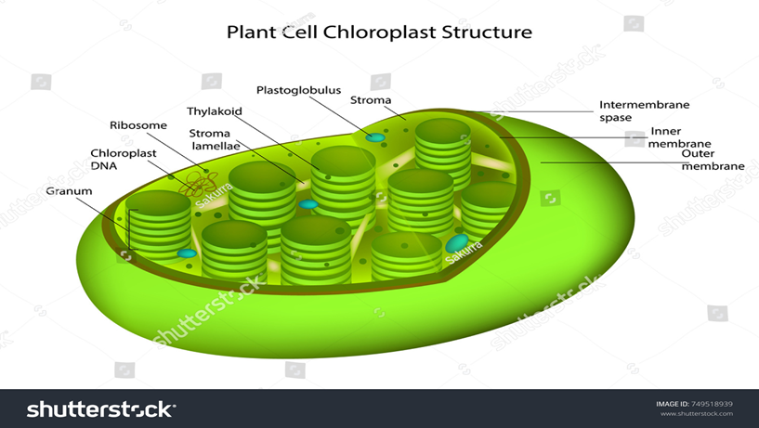

**The 2 phases** **of photosynthesis:**

1. **The light phase** : which is a set of photochemical reactions, which depend on light. It directly allows the transformation of light energy (photons) into chemical energy.

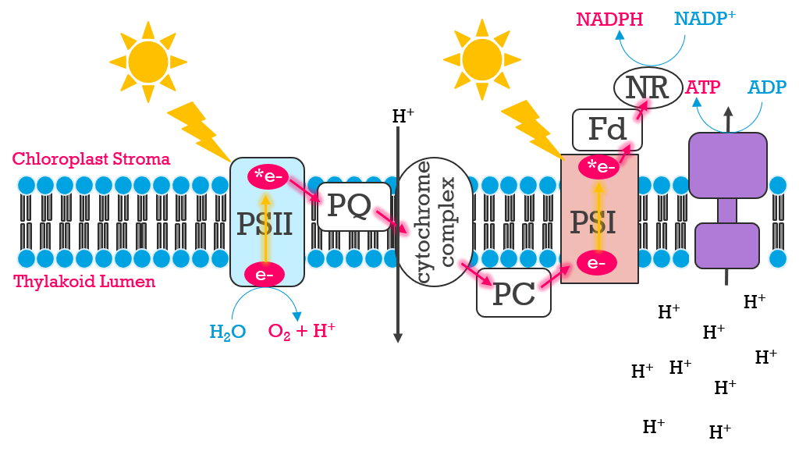

**Light-Dependent Reactions of photosynthesis**

It takes place in the thylakoids. Light is captured in the form of photons that have an energy potential according to their wavelength. The energy carried by a photon is inversely proportional to the wavelength. The absorption of this energy will have 2 consequences: a transport of electrons and a release of protons.

1. **The dark phase :** corresponds **to the Calvin cycle**, which is entirely enzymatic and independent of light.
2. It helps change carbon dioxide and water into carbohydrates. This is the phase of assimilation of carbon dioxide.

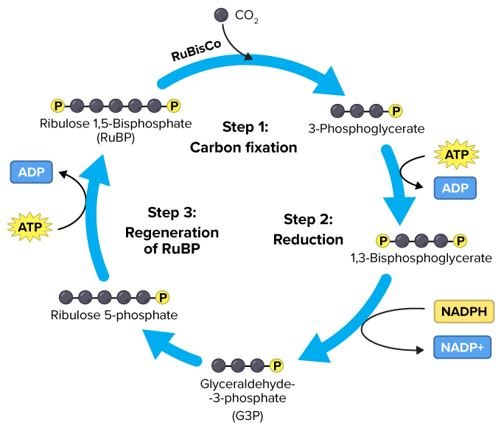

**Overview of the Calvin Cycle Pathway**

**The Calvin cycle :**

## Step 1: Fixation of carbon dioxide or Carboxylation by the action of an enzyme, rubisco.

6 RUBP + 6 CO2 + 6 H2O 12 APG + 12H+

## Step 2: Reduction of APG to triose-phosphate: phosphoglyceric aldehyde

It takes place in two stages:

## phosphorylation of phosphoglyceric acid (APG)

12 APG + 12 ATP 12 ABPG (bisphosphoglyceric acid) + 12 ADP

## reduction of bisphosphoglyceric acid ABPG

12 ABPG + 12 (NADPH + H+) 12 aldéhyde phosphoglycérique (triose-phosphate) + 12 NADP+ + 12 Pi

## Step 3: Regeneration of Ribulose-Biphosphate RUBP

1. **Recycling of 3P glyceraldehyde to ribulose-phosphate**

This step consists of converting the 3-carbon molecules back into 5-carbon molecules so that they can be reused in the cycle.

## Regeneration of Ribulose-Biphosphate RUBP

RuP needs an additional inorganic phosphate and it is ATP that will provide it: 6 RuP + 6

ATP 6 RUBP (Ribulose BiPhostate) + 6 ADP + 6H+

This phosphorylation reaction is carried out under the action of an enzyme: phosphate ribulose kinase. Once the cycle round is complete, there are 2 molecules of phosphoglyceric aldehyde (aldPG) left unused. They will be used for the production of glucose.

2 aldéhyde phosphoglycérique (triose-phosphate) + H2O Glucose-phosphate The total sum of the reactions of the Calvin cycle is:

6 CO2 + 12 NADPH2 + 18 ATP + 11 H2O → C6H11O9P2- (glucose-6-phosphate) + 12 NADP+ + 18 ADP + 16 Pi + 6 H+(aq)

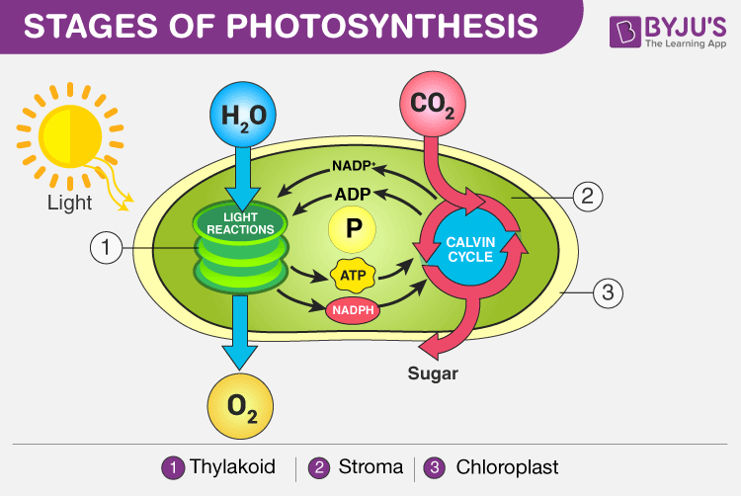

**Summary diagram of photosynthesis**

**Plant cell wall**

Two types of envelopes surround plant cells. The pectocellulosic wall is thick and rigid, composed mainly of cellulose. Its role is to ensure the maintenance of the cell and its physical links with neighboring cells. The cell membrane, for its part, is also present in the plant cell, it is located inside the cell wall and contains the cell organelles.

-**The middle lamella (rich in pectins**) is a layer that separates two plant cells

**-The pectocellulosic wall** is formed by several layers that are from the outside to the inside :

-**The primary wall:** It is located between the middle lamella and the secondary wall. It is pectocellulosic in nature. It is expandable, which allows cell growth (elongation)

1. **The secondary wall:** It is located between the membrane

cytoplasmic and primary wall. It appears during cell differentiation. It is made up of cellulose and hemicellulose and is rich in phenolic compounds.

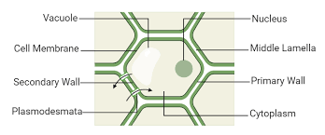



**Plant cell wall under microscope**

## Composition of the plant wall:

The general constituents of all spermaphyte walls are **polysaccharides,**  **cellulose,**  **pectins and hemicelluloses** , as well as other constituents (structural proteins, enzyme proteins, ions and, of course, water).

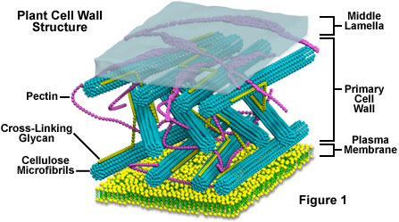

**Architecture of Plant Cell Wall**

## The secondary wall

**It is located** between the cytoplasmic membrane and the primary wall.

**It is of the same** composition as the primary wall, but with different proportions:

## Richer in cellulose,

**Low** in **water** and **hemicellulose**,

## Free of pectins and glycoproteins

1. **Wall biogenesis** The wall is put in place towards the telophase, when the two cells formed will be separated.

At the end of cell division (telophase), **the microtubules assemble** to form the **phragmoplast.**

The **phragmoplast orients** the **Golgian vesicles** rich in pectins at the beginning, towards the equatorial plate, thus forming **the cell plate**.

## 2. Formation of the primary wall:

## The Golgi apparatus synthesizes pectins and hemicelluloses.

## The vesicles by exocytosis will pour their contents on either side of the middle lamella.

## Glycoproteins come from the REG and the Golgi apparatus, they are also secreted by exocytosis.

**For cellulose microfibrils**, the polymerization of B-glucoses takes place at the level of enzymatic complexes called cellulose synthetase located in the lipid bilayer.

## Formation of the secondary wall:

The secondary wall is also formed by deposition, this time on the primary wall.

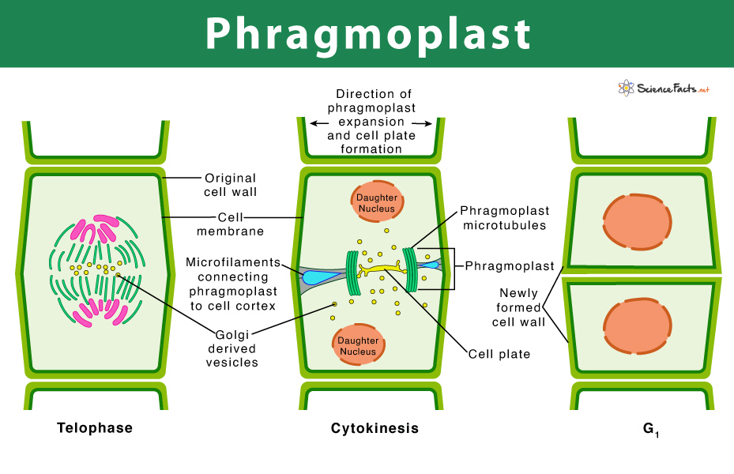

**Phragmoplast**