**Parazoa**

**Definition:** Parazoa is the animal sub-[kingdom](https://www.thoughtco.com/six-kingdoms-of-life-373414) that includes organisms of the phyla ***Porifera*.** Members of this phylum are commonly known as sponges. They are generally marine and mostly asymmetrical animals. These are primitive multicellular animals and have cellular level of organization.

Sponge parazoans are unique invertebrate animals characterized by **porous bodies**. This interesting feature allows a sponge to filter food and nutrients from water as it passes through its pores (ostia). Water enters through minute pores (ostia) in the body wall into a central cavity, spongocoel, from where it goes out through the osculum. This pathway of water transport is helpful in food gathering, respiratory exchange and removal of waste. Sponges typically feed on [bacteria](https://www.thoughtco.com/bacteria-friend-or-foe-372431), [algae](https://www.thoughtco.com/major-types-of-algae-373409), and other tiny organisms in water. To a lesser degree, some species have been known to feed on small crustaceans, like krill and shrimp. Since sponges are non-motile, they are typically found attached to rocks or other hard surfaces.

[Sponges](https://www.thoughtco.com/sponges-profile-2291833) can be found at various depths in both [marine and freshwater habitats](https://www.thoughtco.com/aquatic-communities-in-marine-biology-373404) and come in a variety of colors, sizes, and shapes.

Their varied shapes (tube-like, barrel-like, fan-like, cup-like, branched, and irregular shapes) are structured to provide optimal water flow. This is vital as sponges do not have a [circulatory system](https://www.thoughtco.com/circulatory-system-pulmonary-and-systemic-circuits-3999090), [respiratory system](https://www.thoughtco.com/respiratory-system-4064891), [digestive system](https://www.thoughtco.com/digestive-system-373572), [muscular system](https://www.thoughtco.com/muscle-tissue-anatomy-373195), or nervous system as do many other animals.

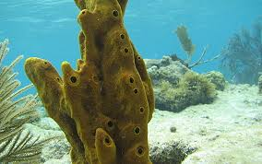

**Sponge Body Structure**

**Body Wall**

Structurally, the sponge body is studded with numerous pores called ostia that lead to canals for channeling water to internal chambers. Sponges are attached at one end to a hard surface, while the opposite end, called the osculum, remains open to the aquatic surroundings. Sponge cells are arranged to form a three-layered body wall:

* **Pinacoderm** - the outer surface layer of the body wall that is equivalent to the [epidermis](https://www.thoughtco.com/integumentary-system-373580) of higher animals. The pinacoderm consists of a single layer of flattened cells called pinacocytes. These cells are able to contract, thus reducing the size of a sponge when needed.
* **Mesohyl**- thin middle layer that is analogous to [connective tissue](https://www.thoughtco.com/connective-tissue-anatomy-373207) in higher animals. It is characterized by a jelly-like matrix with collagen, spicules, and various cells embedded within. Cells called archaeocytes found in the mesohyl are amebocytes (cells capable of movement) that can transform into other sponge cell types. These cells aid in digestion, nutrient transport, and are even capable of developing into [sex cells](https://www.thoughtco.com/sex-cells-meaning-373386). Other cells called sclerocytes produce skeletal elements called spicules that provide structural support.
* **Choanoderm -** The inner layer of the body wall consisting of cells called choanocytes. These cells contain a flagellum, which is surrounded by a collar of [cytoplasm](https://www.thoughtco.com/cytoplasm-defined-373301) at its base. Through the beating movement of the [flagella](https://www.thoughtco.com/cilia-and-flagella-373359), water flow is maintained and directed through the body.

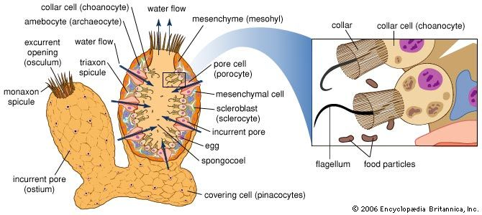

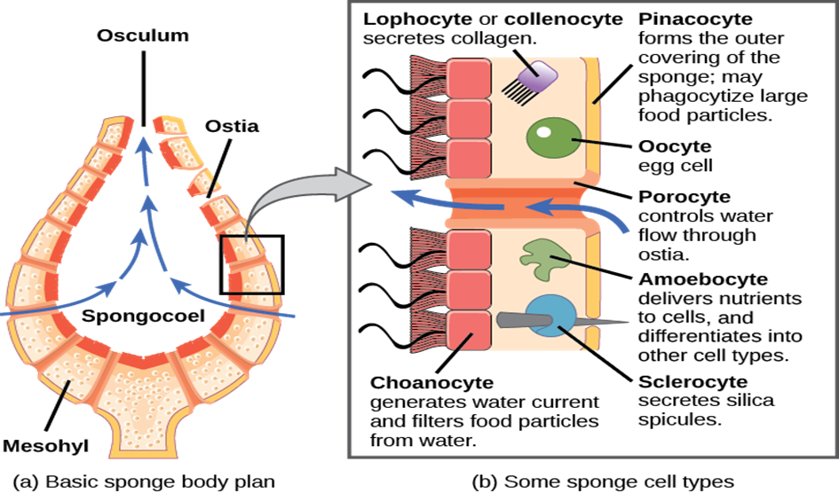

**Body Plan**

Sponges have a particular body plan with a pore/canal system that is arranged into one of three types: asconoid, syconoid or leuconoid.

**Asconoid** sponges have the simplest organization consisting of a porous tube shape, an osculum, and an open internal area (**spongocoel)**that is lined with choanocytes.

**Syconoid** sponges are larger and more complex than asconoid sponges. They have a thicker body wall and elongated pores that form a simple canal system.

**Leuconoid** sponges are the most complex and largest of the three types. They have an intricate canal system with several chambers lined with flagellated choanocytes that direct water flows through the chambers and eventually out the osculum.

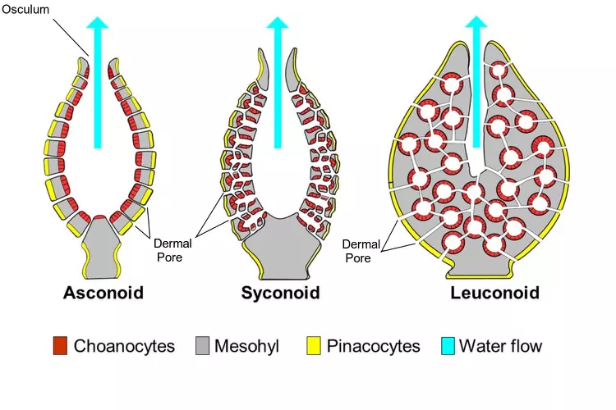

**Sponge Reproduction**

**Sexual Reproduction**

Sponges are capable of both asexual and sexual reproduction. These parazoans reproduce most commonly by [sexual reproduction](https://www.thoughtco.com/sexual-reproduction-373284) and most are **hermaphrodites**, that is, the same sponge is capable of producing both male and female [gametes](https://www.thoughtco.com/gametes-373465). Typically only one type of gamete (sperm or egg) is produced per spawn. [Fertilization](https://www.thoughtco.com/sexual-reproduction-types-of-fertilization-373440) occurs as sperm cells from one sponge are released through the osculum and carried by water current to another sponge.

As this water is propelled through the receiving sponge's body by choanocytes, the sperm is captured and directed to the mesohyl. Egg cells reside in the mesohyl and are fertilized upon union with a sperm cell. In time, the developing larvae leave the sponge body and swim until they find a suitable location and surface on which to attach, grow, and develop.

**Asexual Reproduction**

[Asexual reproduction](https://www.thoughtco.com/asexual-reproduction-373441) is infrequent and includes regeneration, budding, fragmentation, and gemmule formation. **Regeneration** is the ability of a new individual to develop from a detached part of another individual. Regeneration also enables sponges to repair and replace damaged or severed body parts. In budding, a new individual grows out of the body of the sponge. The new developing sponge may remain attached to or separate from the body of the parent sponge. In fragmentation, new sponges develop from pieces that have fragmented from the body of the parent sponge. Sponges may also produce a specialized mass of cells with a hard outer covering (gemmule) that can be released and develop into a new sponge. Gemmules are produced under harsh environmental conditions to enable survival until conditions become favorable again.

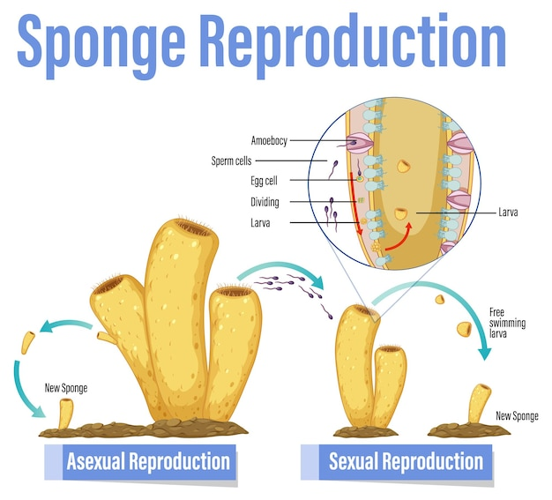

**Classification of parazoa:**

The three main classes of **sponges** include:

1. **Glass sponges** (*Hexactinellida*)
2. **Calcareous sponges** (*Calcarea*)
3. **Demosponges** (*Demospongiae*).

Parazoa from the phylum ***Placozoa*** include the single species ***Trichoplax adhaerens***. These tiny aquatic animals are flat, round, and transparent. They are composed of only four types of cells and have a simple body plan with just three cell layers.

**1.Glass sponges** of the class *Hexactinellida* typically live in deep sea environments and may also be found in Antarctic regions. Most hexactinellids exhibit radial symmetry and commonly appear pale with regard to color and cylindrical in form. Most are vase-shaped, tube-shaped, or basket-shaped with leuconoid body structure. Glass sponges range in size from a few centimeters in length to 3 meters (almost 10 feet) in length.

The hexactinellid skeleton is constructed of **spicules** composed entirely of silicates. These spicules are often arranged into a fused network that gives the appearance of a woven, basket-like structure.

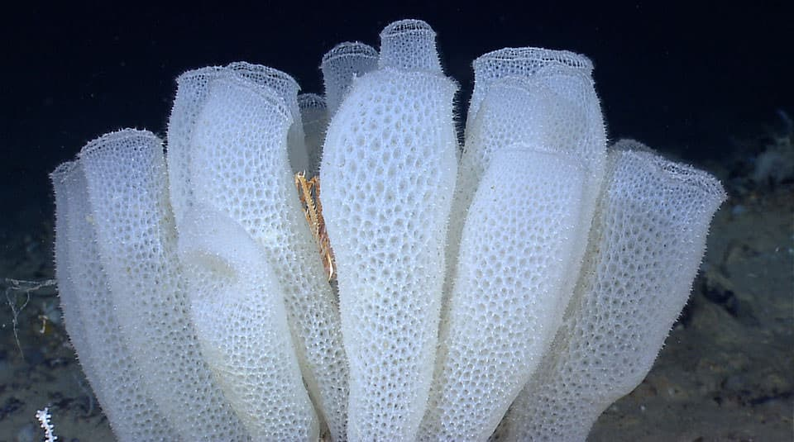

2. **Calcareous sponges** of the class *Calcarea* commonly reside in tropical marine environments at more shallow regions than glass sponges. This class of sponges has fewer known species than *Hexactinellida* or *Demospongiae* with around 400 identified species. Calcareous sponges have varied shapes including tube-like, vase-like, and irregular shapes. These sponges are usually small (a few inches in height) and some are brightly colored. Calcareous sponges are characterized by a skeleton formed from **calcium carbonate spicules**. They are the only class to have species with asconoid, syconoid, and leuconoid forms.

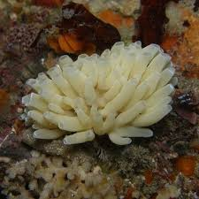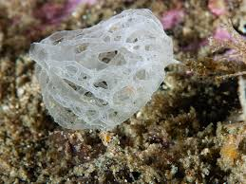 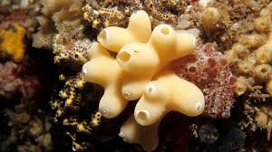

**3.Demosponges** of the class *Demospongiae* are the most numerous of the sponges containing 90 to 95 percent of *Porifera* species. They are typically brightly colored and range in size from a few millimeters to several meters. Demosponges are asymmetrical forming a variety of shapes including tube-like, cup-like, and branched shapes. Like glass sponges, they have leuconoid body forms. Demosponges are characterized by skeletons with **spicules** composed of collagen fibers called **spongin**. It is the spongin that gives sponges of this class their flexibility. Some species have spicules that are composed of silicates or both spongin and silicates.

