Exercise 1
1. What are the 2 main types of nucleic acids?
The 2 main types of nucleic acids are DNA and RNA
2. For these two nucleic acid segments,
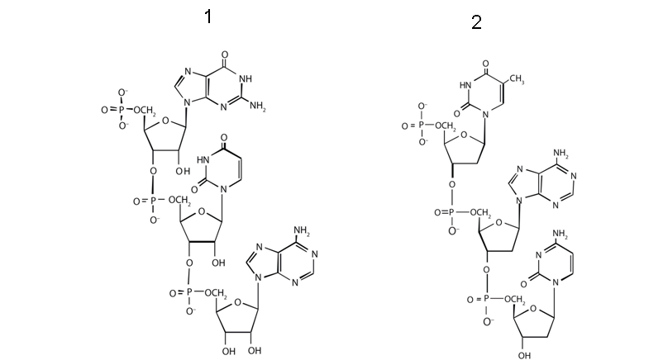

A. Define the type of nucleic acid for each of the two molecules 1 and 2. ? Justify your response?
Molecule 1: RNA; the sugar is a ribose (OH on carbon 2’), rather than deoxyribose
Molecule 2: DNA; the sugar is a deoxyribose (H on carbon 2’)

B. Determine the 5’ and 3’ ends? Circle the atoms that form the backbone of the nucleic acid chain
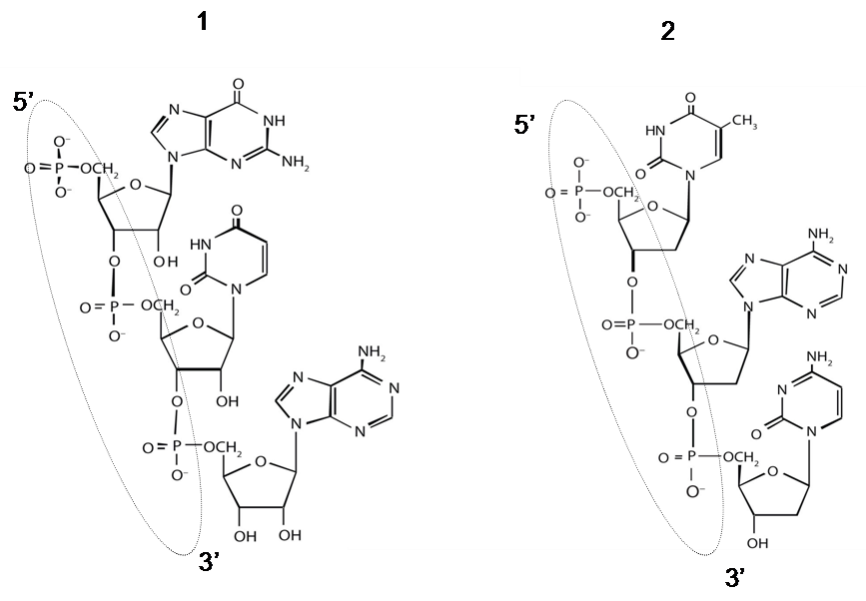
Dotted skeleton

C. Determine the nucleotide sequence of each of the two segments?
sequence 1 : 5 'GUA 3'
sequence 2 : 5 'TAC 3'

Exercise 2
1. What are the 3 main types of RNA and what is their percentage in cells?
mRNA (messenger RNA), rRNA (ribosomal RNA) and tRNA (transfer RNA)
Their percentage in cells varies depending on the cell type. For example, in E. coli
Type | Function | approximative nombre of nucleotides | % in total RNA
mRNA | Code proteins | 100–6,000 | ~3
rRNA | Component of ribosomes | 120–2900 | 83
tRNA | Adapter molecule that brings the amino acid to the ribosome | 75–90 | 14

2. What type of RNA contains codons? What type of RNA contains anticodon?
RNA containing codons is mRNA, RNA containing anticodon is tRNA

3. a part of a gene's template strand has the sequence 5 'CCATGGAATCGA 3'.

a) What is the sequence of the complementary strand??
complementary strand: 3'GGTACCTTAGCT 5'

b) What is the sequence of the RNA that is formed from this sequence?
The RNA sequence
3’GGUACCUUAGCU 5′ (or 5’UCGAUUCCAUGG 3’).

Exercise 3
1) If we count the nucleotides of double-stranded (double-stranded) DNA, what is the correct statement?:
A = C / A+G = C+T / A+T = G+T / A = 2C / A = 2T ?
In a double-stranded DNA, the complementary bases are equal in number: A = T et C = G ===> A+G = C+T

2) here the following single-stranded DNA: 5’-TACGCCTAGCTTACGCAT-3’
a) How many phosphodiester bonds are there in the double-stranded sequence?
18 nucleotides in the sequence therefore 17 phosphodiester bonds ===> 34 phosphodiester bonds in the double-stranded sequence

Example
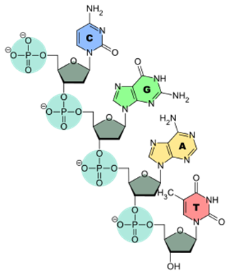
b) How many hydrogen bonds are there in the double-stranded sequence?
A-T (adenine - thymine) = 2 bonds of H
G-C (guanine - cytosine) = 3 bonds of H
===> (9x2) + (9x3) = 45 bonds of H
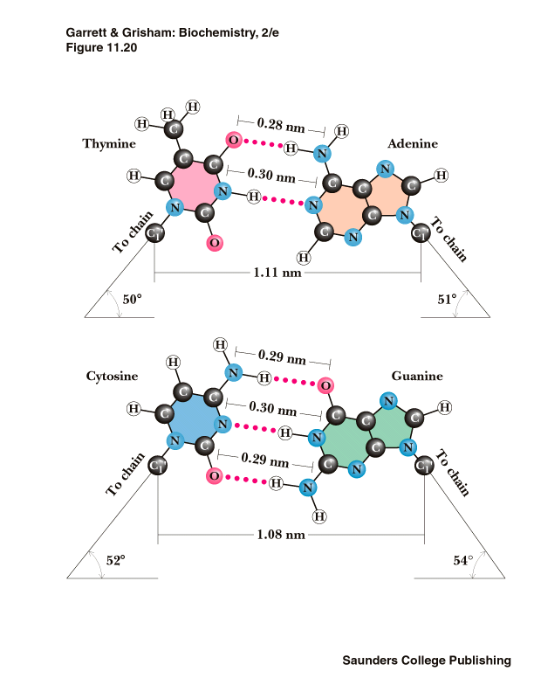

3. a) What bases are likely to pair in the following single-stranded RNA strand?: 5’-AUGGAACGCCUUUACGUUC-3’

in red, the nucleotides likely to form a double strand.
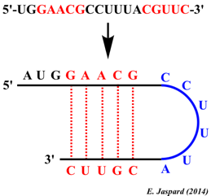
3. b) How many hydrogen bonds are there in the folded strand?
A-U = 2 bonds of H
G-C = 3 bonds of H
===> (2x2) + (3x3) = 13 bonds of H

Exercise 4 (chromatin in eukaryotes)
1) Define the chromatin? What is the difference between DNA, chromatin and chromosomes?
Chromatin is the material that chromosomes are made of (mainly DNA + protein). DNA is a component of both chromatin and chromosomes.

2) If species A has 4 chromosomes and species B has 6 chromosomes. Could you tell from this information which species has more DNA? Can you tell which species has more genes?
No, since chromosomes vary considerably in size, chromosome number does not correlate with total DNA content. Also, gene number is not closely correlated with DNA content.

3) The answer to question 2 implies that not all the DNA on a chromosome encodes genes. Could you give examples of chromosomal regions that contain relatively few genes?
Heterochromatic regions (including repeated DNA sequences), such as centromeres and telomeres, are examples of gene-poor regions of chromosomes.

4) How many centromeres are found in a typical chromosome ?
One

5) What would happen if there were more than one centromere per chromosome?
The chromosome could wrap around itself

6) What would happen if a chromosome has zero centromeres?
There would have to be another process to control its movement during mitosis and meiosis.

7) For a diploid with 2n=16 chromosomes, how many chromosomes and chromatids are found in the zygote and in the gamete?
The zygote (diploid cell) has 16 chromosomes (8 pairs), and each chromosome is composed of a single chromatid. The gamete has 8 chromosomes (half), and each chromosome is composed of a single chromatid.

