**Prepared by Dr Zemieche**

**Lecture 2: Learning Objectives**

**What Are Learning Objectives?**

What is a Learning Objective? Why should we use learning objectives?

Learning objectives refer to **brief, clear, specific statements** of what learners will be able to do at the end of a lesson as a result of the activities, teaching and learning that has taken place. They can also be referred to as learning outcomes. Any learning objective used by the teacher should be based on three **areas of learning: knowledge, skills and attitudes.** Learning objectives define learning outcomes and focus teaching. They help in the clarification, organization and prioritization of learning. In addition to their role in helping the teacher and the learners to measure progress, learning objectives boost learners’ autonomy and taking responsibility of their own learning.

A learning objective should describe what students should know or be able to do at the end of the course that they **were not able to do before.**

1. The objectives must be clear to students. They all must know what they are learning

and why they are doing it. They also need to see the point of the objectives in the bigger picture; that is, how they relate to the last lesson’s learning, the course they are following and the big overall goal. This means that you cannot simply write the objectives on the board and hope that the students copy them down. It implies that you have fully explained them in context; the students have engaged with them and can explain them to any observer.

2. The objectives and outcomes must be differentiated for the individual student. All the learners should be able to see where they are and what they need to do to get to the next level. This should link into subject standards and progression where possible. It is crucial to have high expectations of what can be achieved and engage the students with that belief.

3. Success criteria for achieving the outcomes need to be negotiated with the students for optimum engagement to enable them to be clear about what it will look like and feel like and sound like when they have made that progress.Example from an English Functional Skills lesson

OBJECTIVE: To recognise the power of different types of language

OUTCOMES: I will be able to:

Use formal and informal language (Entry level)

Explain how to speak and write in appropriate language (Level 1)

Teach others how to use a range of writing and speaking styles appropriate for different

audiences (Level 2)

**What is the difference between an aim and a learning objective?**

A lesson aim is a very general statement of what the overall goal is in a lesson – the intention behind the teaching. The lesson objective/objectives are the measurable stages that a learner will go through and need to achieve in order to achieve the overall goal.

**How to write learning objectives?**

As part of planning, one needs to decide what students need to be able to do after they have learned something that has been taught. Beginning planning with the learning objectives will also help ensure that the tasks and activities are appropriate and will help students achieve their objectives.

A learning objective must not include the phrases 'to know' or 'to understand' but instead active verbs such as 'state', 'explain', 'outline', 'list' or 'describe'. Avoid using verbs that are difficult to measure objectively. The following verbs are difficult to assess and measure and therefore should be used with caution:

Know, comprehend, understand, appreciate, familiarize, study, be aware, become

acquainted with, gain knowledge of, cover, learn, realize. Know and understand do not specify any overt 'doing' and although knowing and understanding

underpin learning, objectives are always written using active doing verbs. They are statements of what you want your learners to do and should

- Be stated clearly

- define or describe an action

- Are *measurable, in terms of time, space, amount, and/or frequency.

- Be differentiated

**Bloom’s Taxonomy of Educational Goals**

Bloom’s Taxonomy is an educational classic. Its formal title is Taxonomy of Educational Objectives. The Classification of Educational Goals. Handbook I: Cognitive Domain. A committee of college and university examiners wrote the book, which was edited

by Benjamin S. Bloom and published in 1956. **Bloom’s Taxonomy offered a classification system for educational goals that could be used in the construction of test items and in the formulation of instructional objectives.**

The volume presents six categories of educational objectives:

1. Knowledge

2. Comprehension

3. Application

4. Analysis

5. Synthesis

6. Evaluation

Bloom’s classification of objectives was revised in 2001.

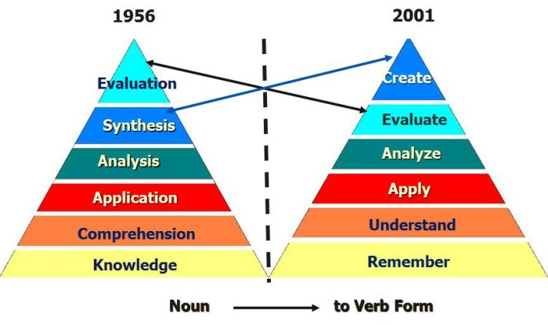

**Figure1: Bloom’s taxonomy and its Revised Version**

**Examples of Measurable Action Words**

Relevant Action Verbs to use in your lesson objectives:

**Knowledge:** Bloom defined knowledge as ‘‘those behaviors and test situations, which emphasize the remembering, either by recognition or recall, of ideas, material, or phenomena’’ (Bloom, 1956, p. 62)

-Tell, uncover, show, state, define, name, write, recall,

-recognize, list, label, reproduce, identify, acquire,

-distinguish, state, order, locate, repeat, count, describe,

-enumerate, find, match, read, recite, record, select,

-sequence, state, view

**Comprehension** ‘To understand the information and restate in your own words, paraphrasing, summarizing, translating’

-Comprehend, appreciate, select, indicate, illustrate,

-represent, formulate, explain, classify, translate,

-extrapolate, convert, interpret, abstract, transform, select,

-indicate, relate, experiment, simple comparisons, demonstrate, explain, reword, discuss, cite, conclude,

-describe, discuss, estimate, generalize, give examples,

-locate, make sense of, paraphrase, predict, report, restate,

-review, summarize, trace

**Apply/Application** ‘To use information to solve problems, transfer abstract or theoretical ideas to actual situations, identifying connections and relationships and how they apply ’

-Assess, change, chart, choose, demonstrate, determine,

-develop, establish, produce, relate, report, select, show,

-use, try, diagram, perform, make a chart, put into action,

-build, report, employ, relate, draw, construct, adapt, apply,

-sequence, carry out, solve, prepare, operate, generalize,

-plan, repair, explain, predict, instruct, compute, use,

implement, solve,

**Analysis** ‘To take information apart, identifyingcomponents, determining arrangement,

logic and semantics’

-Analyze, study, combine, separate, categorize, detect,

-examine, inspect, discriminate, take apart, generalize,

-scrutinize, estimate, compare, observe, detect, classify,

-discover, explore, distinguish, catalogue, investigate,

-breakdown, order, determine, differentiate, dissect,

-contrast, examine, interpret, identify, dissect, characterize,

-correlate, diagram, illustrate, infer, limit, outline, point out,

-prioritize, relate, separate, sub-divide.

**Synthesis** The fifth category of educational objectives is synthesis. To Bloom, synthesis is ‘‘putting together of elements and parts so as to form a whole’’ (Bloom, 1956, p. 162)

‘To create new ideas or things, combininginformation to form a unique product’

-Write, plan, integrate, formulate, propose, specify,

-produce, organize, theorize, design, build, systematize,

-combine, summarize, restate, argue, hypothesize, predict,

-create, invent, produce, modify, extend, design, formulate,

-develop, build, compile, discuss, derive, relate, generalize,

-conclude, combine, précis, discuss, integrate, conclude,

-adapt, categorize, compose, construct, create, design,

-requiring of creativity and originality’ generate, incorporate, integrate, modify, organize,

-perform, propose, reinforce, reorganize, rewrite, structure

**Evaluation** ‘To make judgements about knowledge,to make decisions and supporting views,

requires understanding of values. ’

-Evaluate, interpret, decide, solve, rate, appraise, verify,

-assess, test, judge, rank, measure, appraise, select, check,

-evaluate, determine, support, defend, weigh, judge, justify,

-attach, criticise, weigh up, argue, choose, compare and

-contrast, conclude, critique, defend, predict, prioritize, prove, reframe,

**References:**

Salkind, N.J. ( 2008). Encyclopedia of Educational Psychology. California: SAGE Publications, Inc

http://batchwood.herts.sch.uk/files/Learning-Objectives.pdf