***Tutorial session 4: Adhesion and intercellular junctions***

1. ***Cell adhesion***
2. **Definition**

Cell adhesion is the set of cellular and molecular mechanisms used to bind cells to each other or to the surrounding environment. This cell adhesion is essential for cell integrity, cell growth and communication with other cells.

1. **Adhesion molecules *(Figure 1)***

They are membrane glycoproteins expressed on the surface of cells where they are involved in intercellular contact and interactions between the cell and the extra-cellular matrix. Adhesion molecules are classified into two main families:

* ***CAM (Cell Adhesion Molecules)***

Which allow adhesion between two cells; they are divided into 4 families: ***Cadherins, selectins, immunoglobulins*** and ***integrins.***

* ***SAM (Substrate Adhesion Molecules)***

Which ensure the adhesion of cells with a substrate, most often the extracellular matrix. ***Integrins*** are involved in cell adhesion with the extracellular matrix.

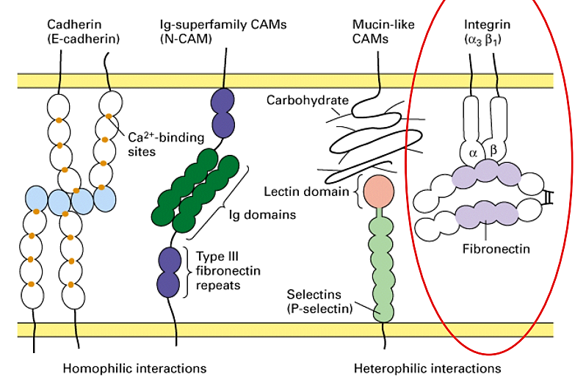

***Figure 1:*** *Schematic representation of the different classes of adhesion molecules.*

1. ***Intercellular junctions (Figure 2 & 3)***
2. **Definition**

Intercellular junctions are specialized regions of the plasma membrane that allow the attachment of cells between them and the extracellular matrix (the basal blade). The formation and function of tissues is facilitated by them.

1. **Classification of intercellular junctions**

Intercellular junctions differ according to their shape, function and the width of the intercellular space.

1. ***According to their form*:** there are three types:

* ***Macula***: it is a junction of circular or oval shape.
* ***Fascia***: it is a large task with irregular outline.
* ***Zonula***: it is a junction in the form of a belt that surrounds the apical part of the epithelial cell (intestinal epithelium).

1. ***According to their function***: they are of three types:

* ***Occludens:*** if they obtain intercellular space.
* ***Adherens:*** if they intervene mainly in cohesion.
* ***Communicans:*** if they allow communications from one cell to another.

1. ***According to the width of the intercellular space:*** We use the terms:

* ***Tight junctions (or zonula occludens) (Figure 3)***
  + Zonular junctions with a width of 0.1 µm surrounding the apical pole of epithelial cells.
  + Tight and impermeable joints: The outer sheets of the two membranes are joined which prevents the passage of any substance.
  + Adhesion molecules involved in tight junctions are ***claudins*** and ***occludins***.
* ***Adherent junctions (desmosomes) (Figure 3)***
  + At the level of the desmosomes, the intercellular space widens.
  + Opposite cytoplasmic surfaces have ***plate-shaped*** densifications on which converged ***cytoplasmic filaments*** are anchored.
  + Desmosomes are widely found in tissues subjected to sudden mechanical strain, such as the heart muscles, dermal epithelium and cervix.
  + Desmosomes exist in three different forms:
    - Point desmosomes: macula type (macula adherens): most common.
    - Surrounding desmosomes: zonula (zonula adherens): surround the apical pole of epithelial cells.
    - Hemidesmosomes: located only at the basal pole. They resemble point desmosomes, but they join the basal surface of epithelial cells to the underlying basal membrane.
* ***Connecting junctions (gap junction or macula occludens) (Figure 3)***
  + These are maculas with a diameter of 0.5 µm.
  + These junctions allow small molecules (vitamins, amino acids, oses...) to pass from one cell to another.
  + Each of the two cell membranes that are part of the gap junction, has proteins called ***connexins*** that bind in ***connexon*** (connexin hexamer).
  + Each connexon of a membrane is connected in the extracellular space to a connexon of the second junctional membrane, forming a ***central channel*** connecting the internal media of the two adjacent cells.

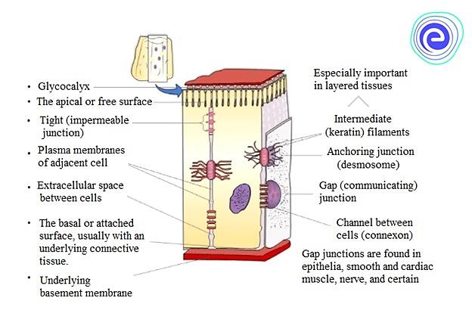

***Figure 2:******Representation of an epithelial cell connected to adjacent cells by the three main types of junctions: tight junction, anchor junction and communicating junctions.***

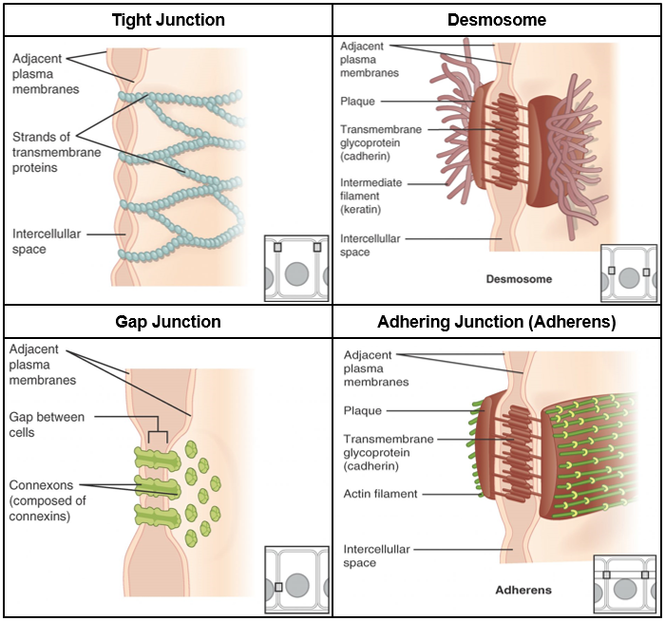

***Figure 3:* *The three types of cell junctions.***

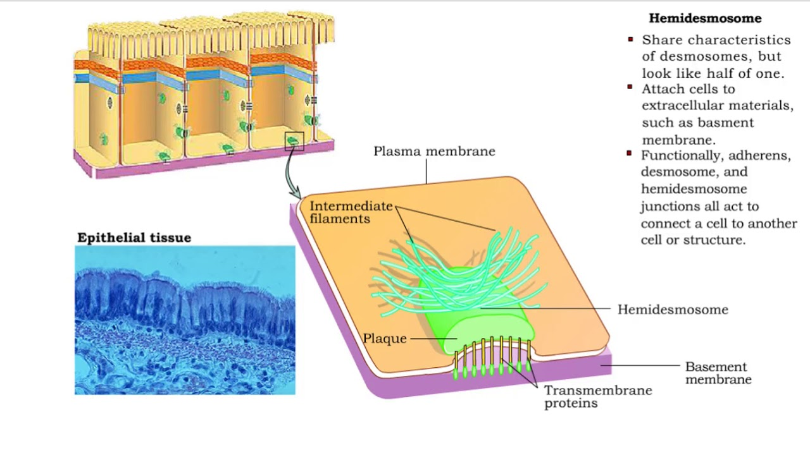

***Figure 4 : Hemidesmosome structure.***