**Phylum Nemathelminthes**

**General characteristics**:

• The phylum ‘Nemathelminthes’ (Gr; nematos = thread ; helminths = worm) or Nematoda comprises the roundworms.

• Nematodes are ubiquitous and are found in freshwater, marine, as well as terrestrial environments.

• Most of the species of nematodes live a parasitic life, though a number of free-living forms are also present.

• These are triploblastic, bilaterally symmetrical animals with organs system level of body organization with pseudocoel (i.e pseudocoelomate). Pseudocoelom ; False coelom derived from embryonic blastocoel.

• Body is elongated, cylindrical, unsegmented and vermiform.

• Body round in cross section and covered with transparent cuticle composed of scleroprotein.

•A syncytial epidermis ; the nuclei are not separated from each other by cell membranes.

• Body wall has only longitudinal muscles.

• No distinct head, digestive tract complete usually surrounded by lip bearing sense organs include amphids, phasmids, papillae, bristles and ocelli.

• The digestive system is complete with a distinct mouth and anus.

• Both respiratory and circulatory system are absent.

• Excretory system comprised of one or two renette cells or protonephridia.

• Nervous system consists of circumpharyngeal nerve ring and six longitudinal nerve cords. Presence of sensory papillae. (Amphids : in mouth, Phasmids : in anus)

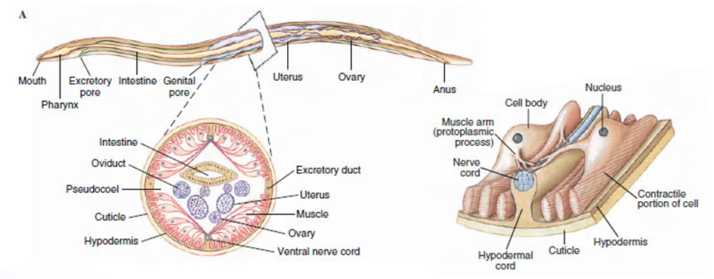 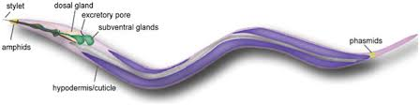

• Sexes are separate (gonochoristic). The male is smaller than females.

•Tubular gonad is present in them. Male genital duct leads into the cloaca. Female genital ducts with a separate opening.

•No asexual reproduction.

•Fertilization is internal

•Development may be direct, with or without an intermediate host or indirect.

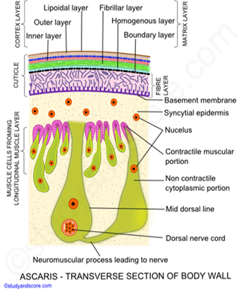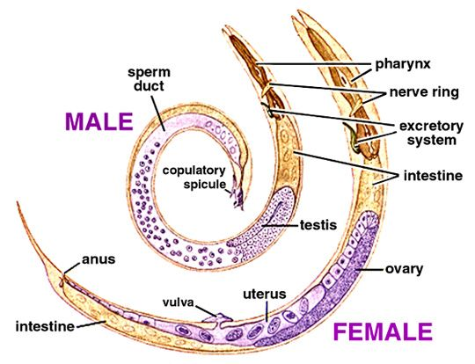

**Classification of nemathelmimthes:**

Phylum Nemathelminthes is divided into two classes based on the presence or absence of phasmids.

**a) Adenophorea or Aphasmidia**

• are XiphinePhasmids, the sensory organs in the caudal end, are absent.

• Amphids are variably-shaped and are present behind the lips.

• Excretory canals are absent

• Most species are free living and some are parasitic.

• Free living species include almost all marine forms; and some terrestrial and freshwater forms

• A few examples ; *Mermis and Enoplus.*

**b) Secerenentea or Phasmidia**

• Phasmids are present which open through minute pore on each side near tip of tail.

• Amphids are pore-like and are present in the lateral lips.

• Excretory canals are present.

• Most of the species are parasitic in nature.

• Free living species are soil inhabitants.

• A few examples are *Ascaris, Wuchereria, Oxyuris, Ancylostoma and Dracunculus*

**Example:**

***Ascaris lumbricoides]*** these species are very large (adult females: 20 to 35 cm; adult males: 15 to 30 cm) nematodes (roundworms) that parasitize the human intestine.

**Life Cycle:**

Adult worms image live in the lumen of the small intestine. A female may produce approximately 200,000 eggs per day, which are passed with the feces image . Unfertilized eggs may be ingested but are not infective. Larvae develop to infectivity within fertile eggs after 18 days to several weeks image , depending on the environmental conditions (optimum: moist, warm, shaded soil). After infective eggs are swallowed image , the larvae hatch image , invade the intestinal mucosa, and are carried via the portal, then systemic circulation to the lungs image . The larvae mature further in the lungs (10 to 14 days), penetrate the alveolar walls, ascend the bronchial tree to the throat, and are swallowed image . Upon reaching the small intestine, they develop into adult worms. Between 2 and 3 months are required from ingestion of the infective eggs to oviposition by the adult female. Adult worms can live 1 to 2 years.

