**Module: American Civilization**

**Lesson 1: Early America**

**Level: Second Year**

**Groups: 1/2/3/4**

**Lecturer: Dr. Rania Khelifa Chelihi**

1. **Objectives:**

At the end of the course, students will be able to:

* Identify the main European explorers and the reasons behind their arrival in the Americas.
* Explain the initial attempts at colonization and the founding of Jamestown, the first permanent English settlement.
* Evaluate the effects of early colonization on the economy, society, and politics.

1. **Pre-requisites:**

To be able to properly follow the lesson of American Early Cultures, the students must have some prior knowledge, likewise:

* Students should be familiar with regions like the Southwest and Midwest, and how the environment shaped different cultures.
* Learners should be familiar with one or more groups of Native American peoples.

**Warm-up:**

Why do you think people migrated across this land bridge?

What challenges might they have faced?

Discuss how climate, food sources, and survival needs influenced migration.

Which large Ice Age animal did early Americans hunt for food, clothing, and tools?

**Introduction**

This lesson covers how humans first came to America and the societies that they formed. We will begin with the Native American cultures such as the Anasazi and Hohokam, followed by the European explorers Columbus and Cabot, and finish up with the first English colony at Jamestown. Understanding these initial contacts will expose you to how they laid the ground for America's history. Get ready to learn the beginning of American history!

1. **Early Inhabitants of the Americas**

At the height of the most recent **Ice Age**, about **35,000 years ago**, much of the world’s water was locked up in vast continental ice sheets and **a land bridge** as much as **1,500 kilometres** wide connected **Asia and North America**.

By **12,000 years ago**, the earliest Americans arrived in North America along **the Pacific Coast**.

They crossed **the land bridge** from Asia and were believed to have stayed in what is now **Alaska** for thousands of years.

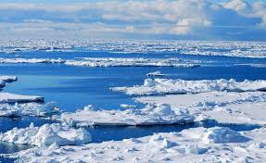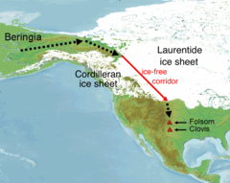

<https://youtu.be/plAQVgZVjUA?si=z0_7Df9GS4Wc5xB4>

Among the earliest Americans were **the Ancestral Pueblo** and **Mound Builders**, two groups that later gave rise **to Native American groups** in the American **Southwest**, **Midwest**, **Southeast**, and **Eastern Woodlands**.

They then **moved south** into **the land** that was to become **the United States**.

They settled along **the Pacific Ocean** in the Northwest, in the mountains and deserts of the Southwest, and along the Mississippi River in the Middle West.

These early groups are known as **Hohokam**, **Adenans**, **Hopewellians**, and **Anasazi**. They built villages and grew crops. Some built **mounds of earth** in the shapes of **pyramids**, **birds**, or **serpents**.

<https://youtu.be/7ctyLnRinSc?si=2M8jEZsbIizn9yvW>

<https://youtu.be/FCAxPG0JoHA?si=axqcterTEG8eOJ9>

<https://youtu.be/d1PpveDGQiM?si=p6cLW3Lp-CE_5iZP>

[**https://youtu.be/vrdq8YEEK0k?si=bYo9zwT3Rz7iJOFl**](https://youtu.be/vrdq8YEEK0k?si=bYo9zwT3Rz7iJOFl)

[**https://www.google.com.sa/books/edition/The_Adena_People/V1WobBXAdcIC?hl=fr&gbpv=1&dq=adena+culture+history&pg=PA346&printsec=frontcover**](https://www.google.com.sa/books/edition/The_Adena_People/V1WobBXAdcIC?hl=fr&gbpv=1&dq=adena+culture+history&pg=PA346&printsec=frontcover)

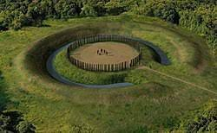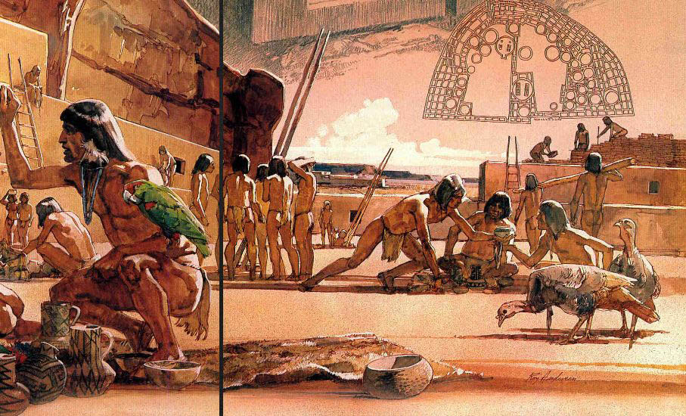

Figure 2: Anasazi

*Figure 1: Adena culture 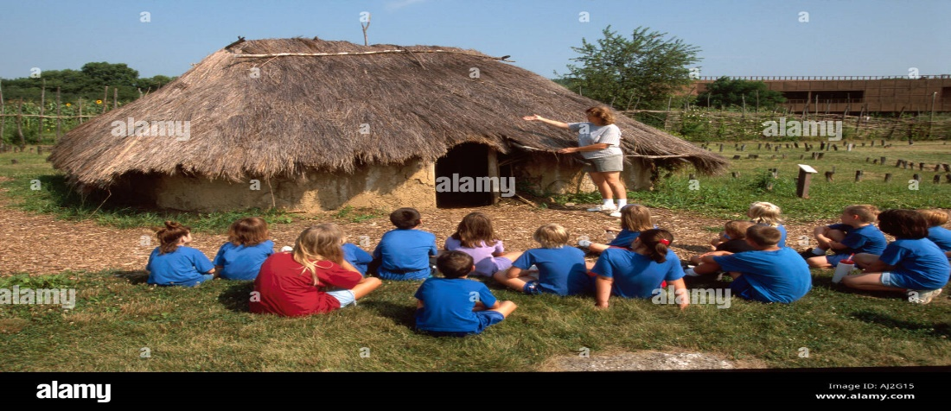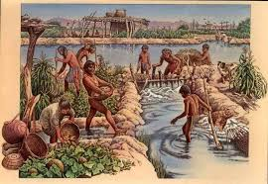 Figure 3: Hopewell culture Figure 4: Hohokam Culture*

Their **life** was closely tied to the land.

Their **society** was clan-oriented and communal.

**Elements of the natural world** played an essential part in **their spiritual beliefs**.

Their **culture** was primarily oral, although some developed **a type of hieroglyphics** to preserve certain texts.

Evidence shows that **there was a good deal of trade** among **the groups** but also that some of their relations were hostile.

For reasons not yet completely understood, **these early groups disappeared over time** and were replaced by other groups of Native Americans, including **Hopi and Zuni**, who flourished. By the time Europeans reached what is now **the United States**, about two million native people, maybe more, lived here.

1. **European Exploration:**
   1. **Norse (Vikings):** The first Europeans to arrive in **North America** — at least the 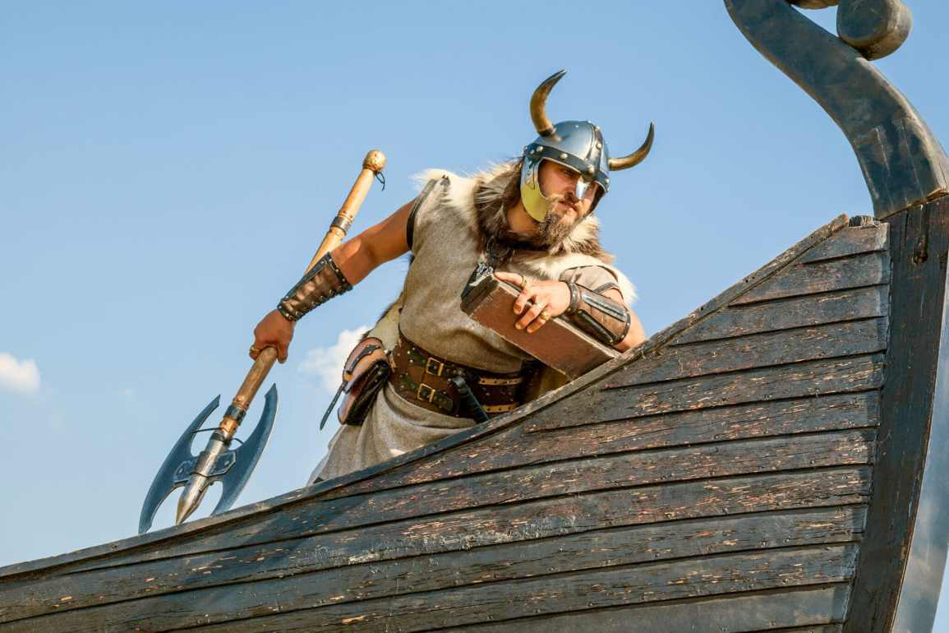 They traveled west from **Greenland**, where **Erik the Red** had founded a settlement around the year 985.

* In 1001, his son Leif is thought to have explored the northeast coast of what is now Canada.
* Ruins of Norse houses dating from that time have been discovered at L’Anse-aux-Meadows in northern Newfoundland.
* No permanent settlements; their presence was forgotten for centuries.
  1. **Other Europeans Arrive 500 Years Later:**
* Early explorers sought a sea route to Asia (Northwest Passage).
* Later explorers came for land, riches, and colonization (British, Dutch, French, Spanish).
  1. **Christopher Columbus (1492):**

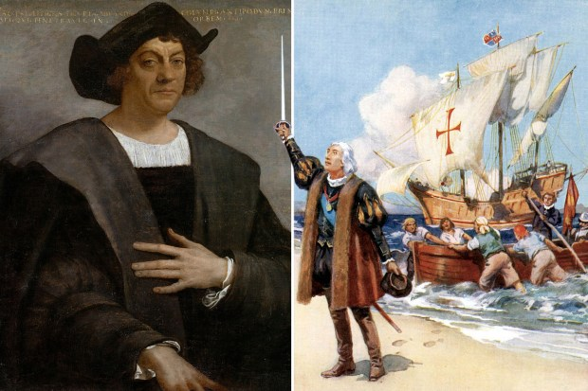

[**https://youtu.be/-E9T6UWaDRA**](https://youtu.be/-E9T6UWaDRA)

* Funded by Spain’s Queen Isabella.
* Reached the Caribbean islands but never mainland North America.
* Opened the way for further Spanish exploration.
  1. **Spanish Explorers in the Americas 1950s:**

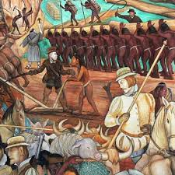

* + 1. **Juan Ponce de León (1513)**
* Landed in what is now **Florida** (first recorded European to do so).
* Searched for the **Fountain of Youth** (mythical spring believed to restore youth).
  + 1. **Hernando de Soto (1539–1542)**
* Reached **Florida** in 1539.
* Explored the southeastern U.S., becoming the first European to cross the **Mississippi River** (1541).
* Died during the expedition (1542); his men continued exploring.
  + 1. **Francisco Vázquez de Coronado (1540–1542)**
* Set out from **Mexico** (conquered by Spain in 1522) in search of the **Seven Cities of Cibola** (mythical golden cities).
* Explored present-day **Arizona** (Grand Canyon) and the **Great Plains**.
* Found no gold but expanded Spanish knowledge of North America.
  1. **European Explorers (Northern U.S.)**

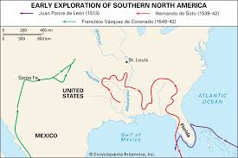

* + 1. **Giovanni da Verrazzano (1524)**
* Sailed for France; explored the **Atlantic Coast** (Carolinas to Canada).
  + 1. **Jacques Cartier (1534–1542)**
* Claimed **Canada** for France; searched for the **Northwest Passage**.
  + 1. **Amerigo Vespucci (1499–1502)**
* Explored South America’s coast; realized it was a new continent, not Asia.
* The continent was later named **"America"** in his honor.

1. **First Permanent European Settlement**

* **St. Augustine, Florida (1565)** – Founded by the Spanish.
* Did not play a major role in the future U.S. nation.

1. **Later British & French Colonization**

* The **13 original colonies** (like Virginia, Massachusetts, New York) were established by **British settlers** in the 1600s.
* These colonies eventually formed the **United States**.

**Note**

* **Spain dominated early exploration** (Florida, Southwest U.S., Mexico).
* **Myths drove exploration** (Fountain of Youth, Seven Cities of Gold).
* **France and Italy** also contributed to mapping North America.
* **Amerigo Vespucci’s name** was given to the continents (North & South America).

**Exercise:** Based on the information above and you external sources answer the following questions in a form of essay

1. Why did the Norse settlements fail, while later European colonies succeeded?
2. How were Spanish and British goals different in North America?

**Please submit the two essays on the 15th of April 2025.**

Email: [k.rania@centre-univ-mila.dz](mailto:k.rania@centre-univ-mila.dz)

**References:**

**U.S.A History in Brief : Learner English Series.**