**PLANT BIOLOGY**

**SAFETY INSTRUCTIONS IN THE LABORATORY**

In general, handling and carrying out experiments in the laboratory require the use of products that may be toxic, flammable or explosive. Carrying out this work can therefore be a source of accidents or serious poisoning whose consequences are immediate or insidious. Anyone working in a laboratory who does not follow safety regulations runs a significant risk, the results of which for themselves and their colleagues can be frightening. The various practical activities scheduled do not present any serious danger during handling, except in the case where the students do not follow the teacher's advice and basic safety instructions.

**CLOTHING AND BEHAVIOR IN THE LABORATORY:**

Access to the laboratory is strictly prohibited without a coat.

• Gowns should be made of durable cotton fabric.

• They must be long enough to protect the legs, with long sleeves.

• It is desirable to wear closed shoes that cover the entire foot.

•IT is obligatory to tie up long hair during the TP session.

• Within the laboratory and during sessions, it is prohibited to;

• Eat, drink, chew Schwingum and smoke.

• Wear unsuitable clothing and shoes (scarves, loose, flammable clothes, etc.);

• Talk on the phone or listen to music with a hand kit.

• Take photos (off topic) during the TP session

**BEFORE LEAVING THE LABORATORY:**

• Turn off the microscope lamps, unplug the sockets and carefully put the different instruments in their places.

• Clean the benches, put away the chairs and submit the TP report.

• Wash hands at the end of each session.

**RECOMMENDATIONS AND PRODUCTION OF TP REPORTS**

It is absolutely important to:

Avoid delay, so as not to disturb or interrupt the practical session;¬

the practical work can be carried out in pairs or threes depending on the number of students present and the instruments necessary for the practical work, but the report must be individual;

At the start of each session, the student must carefully read the work to be done;

During all practical sessions, the student must have the drawing materials: white unsquared A4 sheets, HB graphite pencil, ruler, eraser, paper clip or engraver;

The drawing must be in black pencil, neither color nor pens;

In general, the drawing must represent the image produced by the observation tool which is in the majority of cases the microscope (enlarge the image while retaining its

proportions and arrangement);

The magnification used must be mentioned in each drawing;

The complete legend must be mentioned in each drawing, written in a legible, orderly, and written on one side with parallel arrows; The title must be complete and include all key words (organ, cut, name ¬ scientific and the common name of the plant).

The TP report includes the 1st sheet “the cover page”, plus the sheets of drawings. It must be written in the form shown in the following figure, and not double-sided.

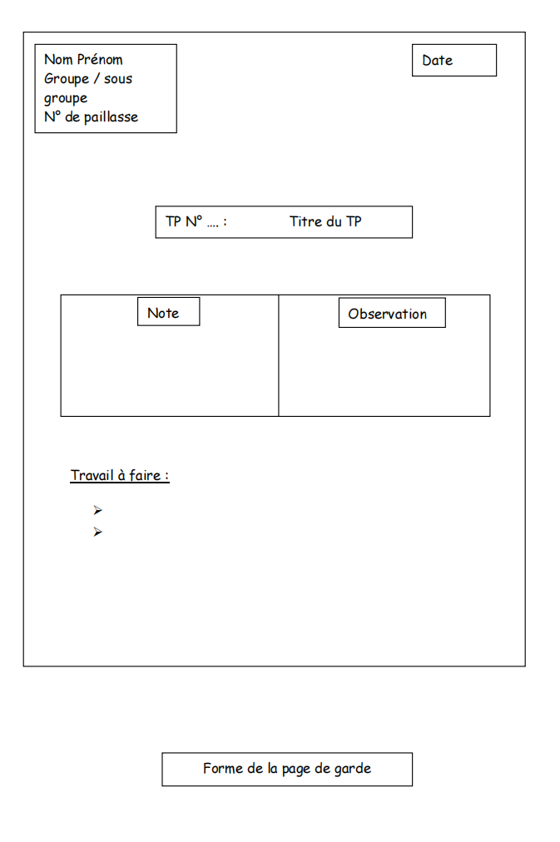

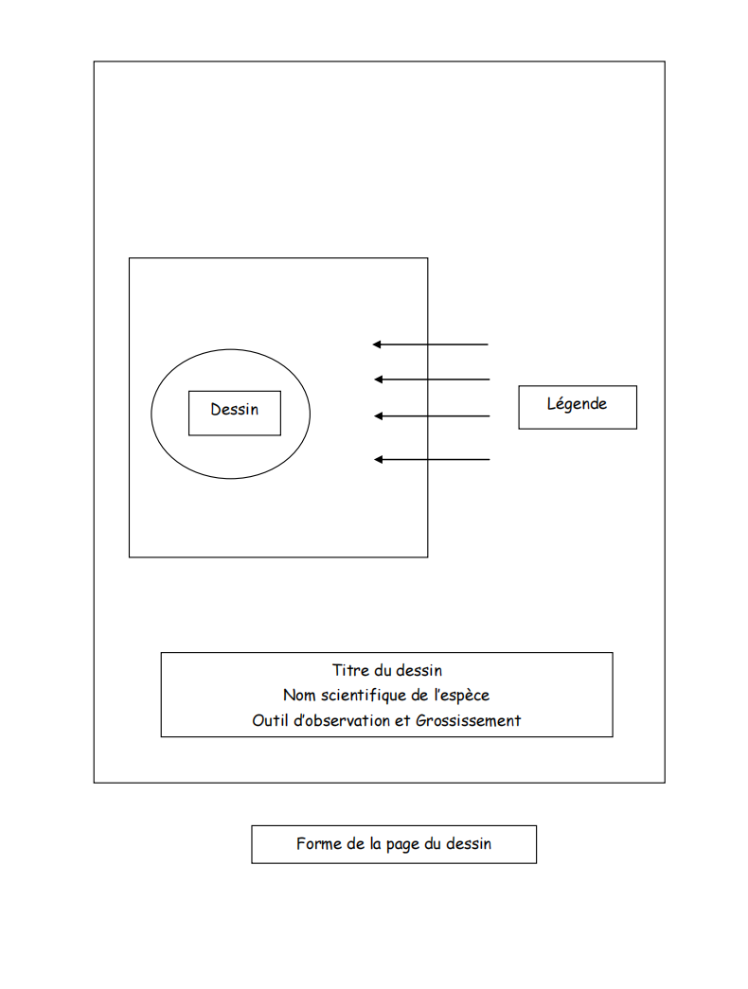

**TP No. 1: Microscopy**

**Objective :**

Know how to use the optical microscope, which is the main tool used for all practical work.

**Introduction :**

The visual capacity of the human being is limited to 0.2mm, which requires the use a microscope for observing biological constituents and organisms whose dimensions are very small, of the order of Micron (µm).

The device which allows you to magnify the image and also see the smallest details in the preparation is the MICROSCOPE.

In etymology, Microscope includes two words; micro = small and scopein = see. It is an optical device that allows you to see very fine objects whose light can cross them, magnifying them from 32 to 1000 times or more depending on the type of microscope used. The different parts of the MO are presented in the plate.

The sample to be observed is called “preparation”, it is placed between a slide and a glass slide.

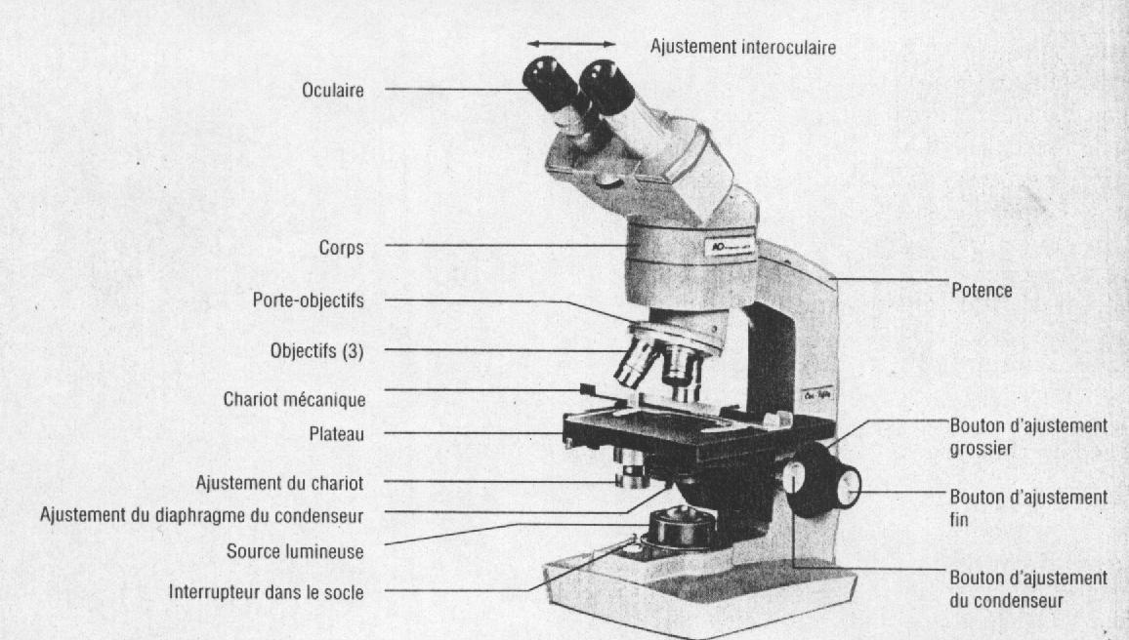

MATERIALS AND REAGENTS NECESSARY FOR MANIPULATIONS

Microscope, blade and coverslip, fine forceps, scalpel, any plant (for preparation of an observation) or a prepared slide. Handling Plug in the plug and turn on the microscope (ON/OFF button). Clean the lenses and objectives to remove any kind of dust.

Adjust the direction and intensity of the light.

Place the slide prepared for observation on the stage, between the jacks, so that . that it is perpendicular to the light and the lens.

Choose and put on the objective which has the lowest magnification (X4).

Move the plate upwards using the macrometric screw, until the appearance of the image. If the image is not clear and sharp, it must be adjusted using the screw micrometric.