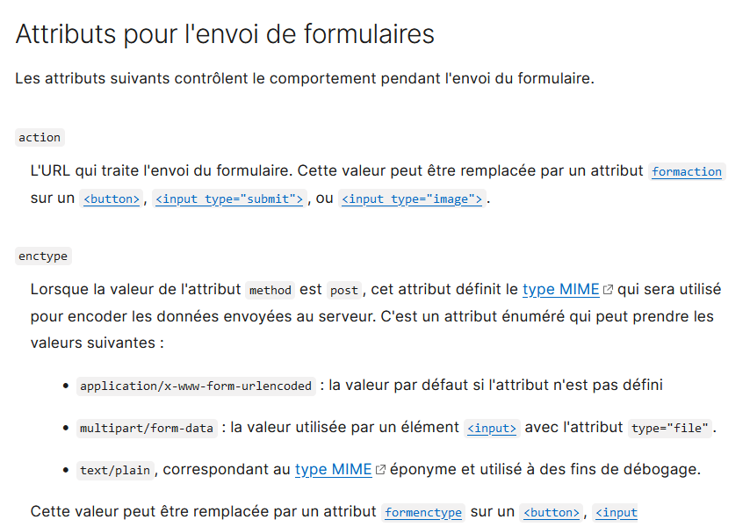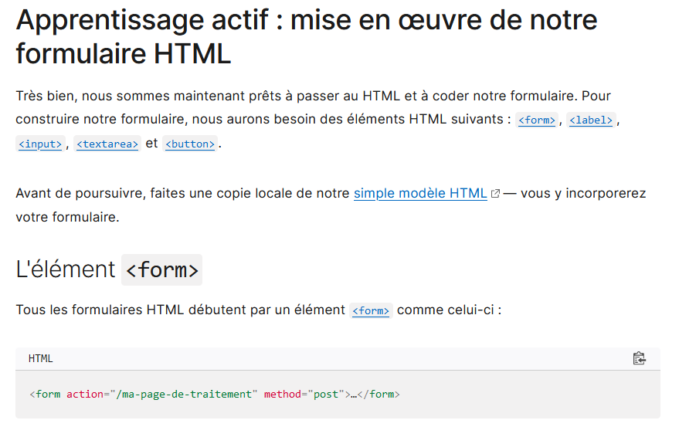 **CSS suite : Question : Réalisez cette page et appliquez le fichier css**

**Appliquez ce fichier CSS**

**html** {

font-size: 62.5%;

}

**body** {

background-color: #fff;

color: #000;

font-family: "Century Gothic", helvetica, arial, sans-serif;

font-size: 1.4em; /* equiv 14px */

line-height: 1.5; /* adapt to your design */

}

**p, ul, ol, dl, blockquote, pre, td, th, label, textarea, caption, details, figure** {

font-size: 1em; /* equiv 14px */

line-height: 1.5;

margin: 1.5em 0 0;

}

**h1, .h1-like** {

font-size: 1.8571em; /* equiv 26px */

font-weight: normal;

line-height: 1.6154em;

margin: .8077em 0 0 0;}

**h2, .h2-like** {

font-size: 1.7143em; /* equiv 24px */

font-weight: normal;

line-height: 1.75em;

margin: .875em 0 0 0;}

**h3, .h3-like** {

font-size: 1.5714em; /* equiv 22px */

font-weight: normal;

line-height: 1.909em;

margin: .9545em 0 0 0;}

**h4, .h4-like** {

font-size: 1.4286em; /* equiv 20px */

font-weight: normal;

line-height: 1.05em;

margin: 1.05em 0 0 0;}

**h5, .h5-like** {

font-size: 1.2857em; /* equiv 18px */

font-weight: normal;

line-height: 1.1667em;

margin: 1.1667em 0 0 0;

}

**h6, .h6-like** {

font-size: 1.1429em; /* equiv 16px */

font-weight: normal;

line-height: 1.3125em;

margin: 1.3125em 0 0 0;

}

**.smaller** {

font-size: .7143em; /* equiv 10px */

line-height: 2.1em;

}

**.small** {

font-size: .8571em; /* equiv 12px */

line-height: 1.75em;

}

**.big** {

font-size: 1.1429em; /* equiv 16px */

line-height: 1.3125em;

}

**.bigger** {

font-size: 1.2857em; /* equiv 18px */

line-height: 1.1667em;

}

**.biggest** {

font-size: 1.4286em; /* equiv 20px */

line-height: 1.05em; }