**Chapter II: Structure of microorganisms**

**I- The cell wall**

The cell wall is a rigid structure that ensures the integrity and shape of bacterial cells while protecting them from osmotic pressure variations (ranging from 5 to 20 atmospheres). It is absent in certain bacteria, such as Mollicutes (e.g., Mycoplasma). In most bacteria, the fundamental component of the cell wall is peptidoglycan (or murein), which acts as an internal envelope and represents approximately 30% of the bacterium's total weight. This "exoskeleton" not only determines the cell’s morphology but also provides mechanical strength. The bacterial cell wall is a defining feature of prokaryotic cells and can be visualized using Gram staining, which allows the classification of bacteria into two major groups: Gram-positive and Gram-negative.

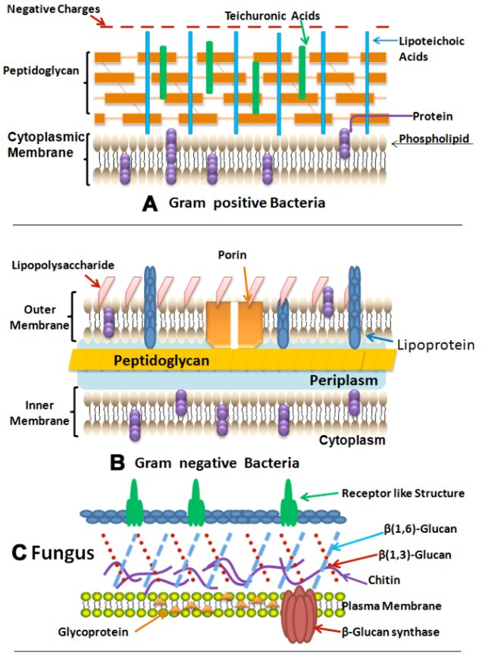

1- **Chemical composition of the bacterial cell wall**

The bacterial cell wall, a key structural component, contains peptidoglycan (also known as murein or mucopeptide), a complex heteropolymer essential for maintaining the cell's integrity and shape. Peptidoglycan is composed of alternating molecules of N-acetylglucosamine (NAG) and N-acetylmuramic acid (NAM), linked by β-(1,4) glycosidic bonds, which can be hydrolyzed by lysozyme. Attached to NAM are short peptide chains made of four amino acids, connected by inter-peptide bridges.

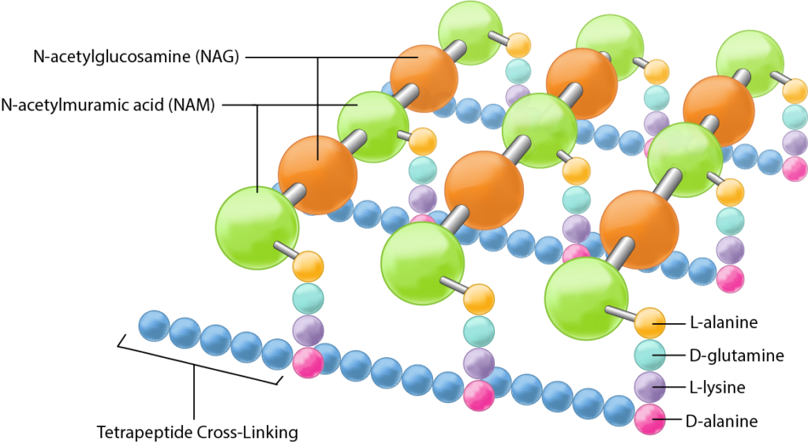

**Figure**: Peptidoglycane structure

Gram-positive bacteria have a thick layer of peptidoglycan, representing the primary structure of their cell wall, to which teichoic acid polymers are attached. Teichoic acids are glycopolymers embedded in the peptidoglycan layers of Gram-positive bacteria, playing crucial roles in cell function. They generate the net negative charge necessary for proton motive force, contribute to cell wall rigidity for shape maintenance (especially in rod-shaped bacteria), and participate in cell division by interacting with peptidoglycan synthesis. Additionally, they enhance resistance to high temperatures, high salt concentrations, and β-lactam antibiotics. Teichoic acids exist in two forms: wall teichoic acids (WTA), which are covalently linked to peptidoglycan, and lipoteichoic acids (LTA), which are anchored to the cell membrane via a lipid.

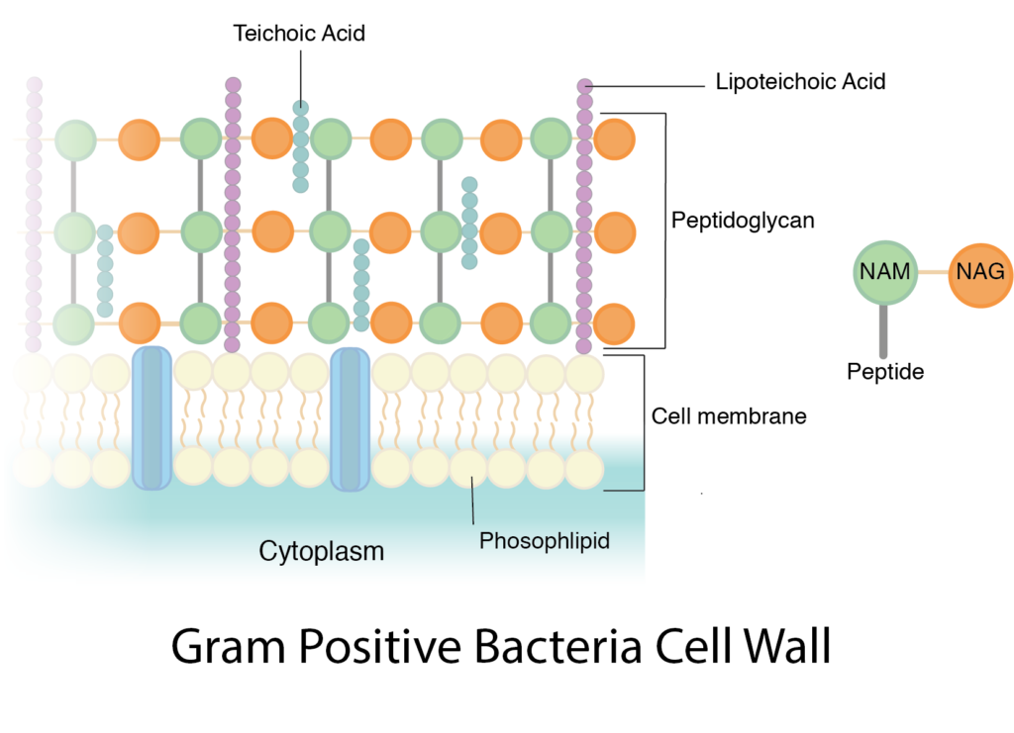

**Figure:** Gram positive bacteria cell wall

Gram-negative bacteria possess a thinner peptidoglycan layer surrounded by an outer membrane. This membrane contains lipopolysaccharides (LPS), including lipid A, which acts as an endotoxin contributing to bacterial pathogenicity. The outer membrane is connected to the peptidoglycan layer through Braun's lipoprotein, forming a bilayer with phospholipids on the inner leaflet and LPS on the outer leaflet.The unique composition of bacterial cell walls, including the presence of peptidoglycan and specific structural differences between Gram-positive and Gram-negative bacteria, underpins their physiological functions and interactions with the environment.

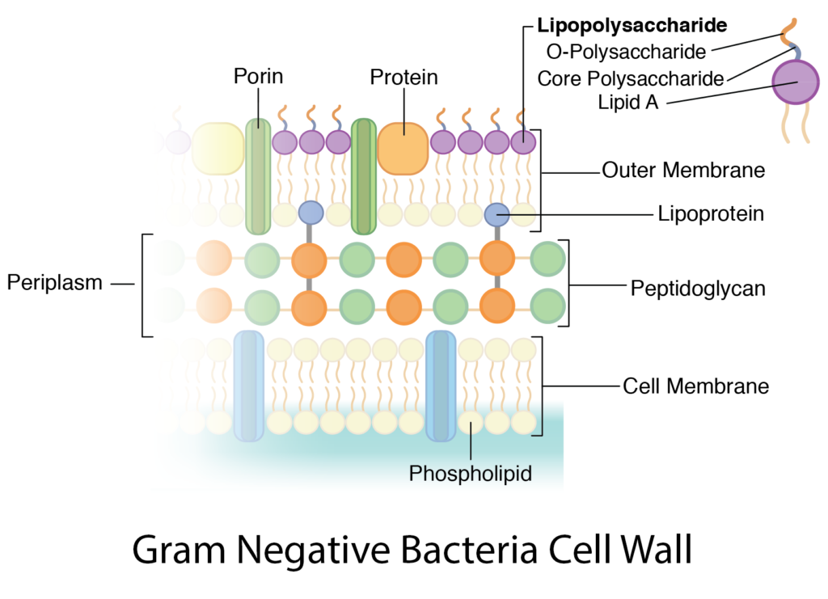

**Figure**: Gram negative bacteria cell wall

**3- Functions of the bacterial cell wall**

The bacterial cell wall serves several critical functions essential for the survival, shape, and interaction of bacteria with their environment. Its main roles include:

**i- Maintaining shape and structural integrity:** The rigidity of the cell wall, provided by peptidoglycan, determines the specific shape of the bacterium and is essential for its structural integrity, protecting the cell from mechanical damage and osmotic pressure.

**ii- Protection against osmotic stress:** The wall prevents the bacterium from lysing due to high internal osmotic pressure caused by a high concentration of metabolites within the cell.

**iii- Permeability:** The wall acts as a selective barrier, allowing small molecules such as water, mineral salts, and simple metabolites to pass through while being variably permeable to certain solvents like alcohol.

**iv- Immunological role:** The cell wall contains components like lipopolysaccharides (LPS) and peptidoglycan, which have antigenic properties. These components activate non-specific immune responses, such as complement activation, contributing to bacterial defense mechanisms.

**v- Bacteriophage fixation:** The wall facilitates the attachment of bacteriophages to specific receptors located on the peptidoglycan in Gram-positive bacteria or on the outer membrane in Gram-negative bacteria. This property is used in bacterial identification techniques like lysotyping.

**vi- Division and genetic material distribution:** The cell wall is involved in the formation of the septum during bacterial cell division, ensuring proper segregation of genetic material into the two daughter cells.

**II- The Plasma membrane**

The plasma membrane is a crucial internal structure located at the interface between the cytoplasm and external cell components. It plays a vital role as the primary point of contact with the external environment, mediating exchanges between the cell and its surroundings. Unlike eukaryotic membranes, the bacterial plasma membrane lacks sterols, such as cholesterol, except in Mycoplasma species.

**1- Chemical composition and molecular structure**

The membrane’s structure is a phospholipid bilayer, similar to that of eukaryotic cells, but with fewer carbohydrates and no sterols. The absence of sterols contributes to the membrane's extreme fluidity, allowing lipid groups to move and rotate dynamically within the bilayer.

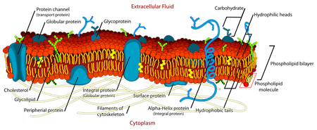

The plasma membrane is composed of three main components:

**1- Proteins (60-70%)**: These include intrinsic (integral) proteins that span the entire lipid bilayer and extrinsic (peripheral) proteins attached to one side of the membrane. Some proteins, known as penicillin-binding proteins (PBPs), are involved in peptidoglycan synthesis and serve as targets for beta-lactam antibiotics like penicillin.

**2- Lipids (30-40%)**: The lipids are amphipathic, featuring a polar hydrophilic head and nonpolar hydrophobic tails. This property allows the lipids to form a bilayer where the hydrophilic heads face outward toward the aqueous environment, while the hydrophobic tails are buried inward, away from water.

**3- Carbohydrates (minor component)**: These include glucose and glucosamine, present in small quantities.

**2- Functions of the plasma membrane**

The plasma membrane plays several critical roles in bacterial cells, functioning as a structural, metabolic, and transport interface.

**i- Structural support**

* + Maintains the integrity of the cytoplasm and separates it from the external environment.
  + Acts as a semi-permeable barrier, allowing selective passage of lipophilic molecules while restricting hydrophilic ones.

**ii- Selective permeability and transport**

* + Contains systems that enable the transport of molecules unable to cross the membrane independently, ensuring nutrient uptake, waste excretion, and secretion.
  + Two main types of transport mechanisms are:
    - **Passive transport**: Movement of molecules along the concentration gradient, requiring no energy.
    - **Active transport**: Movement against the concentration gradient, requiring energy, usually in the form of ATP.

**iii- Metabolic functions**

* + Serves as a site for key metabolic processes:
    - **Respiration**: Facilitates electron transport and oxidative phosphorylation in aerobic bacteria.
    - **Photosynthesis**: Involved in photophosphorylation for photosynthetic bacteria.
    - **Lipid and peptidoglycan synthesis**: Plays a role in synthesizing membrane lipids and cell wall components.
  + Responsible for excreting hydrolytic enzymes essential for nutrient breakdown and absorption.

**iv- Flagellar Attachment**

* + Serves as the anchoring site for bacterial flagella, enabling rotational movement critical for motility.

**v- Target for antimicrobial agents**

* + Certain antibiotics (e.g., polypeptides) and antiseptics disrupt the membrane, compromising bacterial survival.

**III- Cytoplasm**

The cytoplasm is a colloidal hydrogel enclosed by the cytoplasmic membrane, with a pH ranging from 7 to 7.2. It consists of a dispersing phase made up of a solution of minerals and soluble lipoproteins, and a dispersed phase of nucleoproteins and lipids. The cytoplasm contains ribosomes, which play a crucial role in protein synthesis and are often found in chains along mRNA as polysomes. It also contains reserve substances, or cytoplasmic inclusions, which are typically one type per bacterial group. These reserves can be carbohydrates (starch, glycogen), lipids (polyhydroxybutyrate), polyphosphates, or sometimes minerals like iron or sulfur. Additionally, specialized organelles can be present, including chromatophores involved in photosynthesis and gas vacuoles that allow aquatic bacteria to float on water surfaces.

**1- Ribosomes**

Ribosomes are small, spherical structures, measuring 10 to 30 nm in diameter, and are abundant in the bacterial cytoplasm (with approximately 18,000 ribosomes in *Escherichia coli*). These complex entities are composed of proteins and ribonucleic acid (RNA), and they are essential for protein synthesis. Bacterial ribosomes consist of two subunits: the 30S and 50S units.

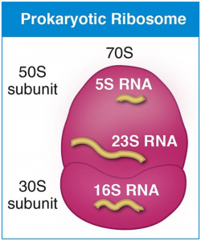

**Figure:** bacteria ribosome

**2-Granules and reserve substances**

Bacteria can accumulate both organic and inorganic substances, typically serving as energy reserves. When these reserves accumulate to a certain size, they form granules, which can sometimes be observed under a microscope. Each bacterial group typically synthesizes a specific type of reserve substance, which aggregates, sometimes forming large structures. These reserves can include carbohydrates such as starch and glycogen, lipids like polyhydroxybutyrate, polyphosphates, and occasionally minerals such as iron and sulfur.

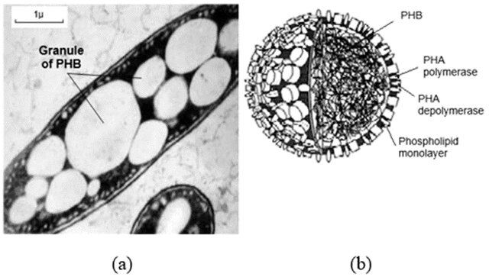

**Figure**: (a) Granules of PHB accumulated in the cell of the bacterium Azobacter chroococcum (b) Structure of the granule of PHB

**3- Gas vacuoles**

Gas-filled vesicles are found in members of three major groups of photosynthetic prokaryotes: cyanobacteria, purple bacteria, and green bacteria. Under electron microscopy, these vacuoles appear cylindrical in shape, surrounded by a single-layer membrane approximately 5 nm thick. Gas vacuoles enable these aquatic microorganisms to float and ascend to the water's surface.

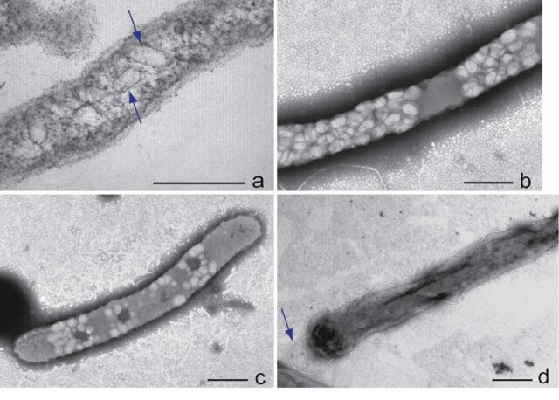

**Figure**: Gas vesicles in bacteria

**IV-**  **Bacterial chromosome**

**1- Morphology and structure**

The bacterial chromosome consists of a single, continuous, circular filament composed of double-stranded DNA. Its molecular weight is approximately 3 x 109 daltons, with around 5 x 106 base pairs arranged along the double helix. Most bacteria have a single circular chromosome, while *Vibrio cholerae* possesses two: a large one with 2.9 million base pairs and a smaller one with 1 million base pairs. The chromosome of *Escherichia coli* is compacted and located in a region called the nucleoid or nuclear body, measuring 1400 μm in length and 300 Å in thickness.

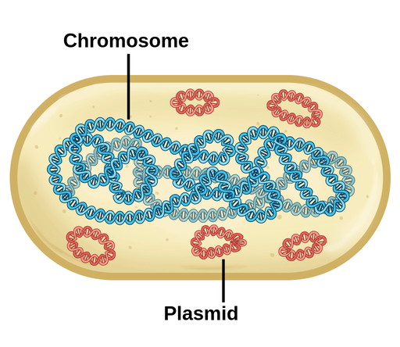

**2- Composition**

DNA (deoxyribonucleic acid) is a high molecular weight polymer composed of units known as nucleotides. A nucleotide consists of a phosphate group, a pentose sugar (deoxyribose), and a purine base (A or G) or a pyrimidine base (C or T). The ratio of adenine (A) to thymine (T) is equal, and similarly, the ratio of cytosine (C) to guanine (G) is also equal. However, the ratio of (A + T) to (G + C), known as Chargaff’s rule, varies between species. This is often expressed as GC%, for example, 50% in E. coli, 60% in Pseudomonas, and 25-45% in Clostridium.

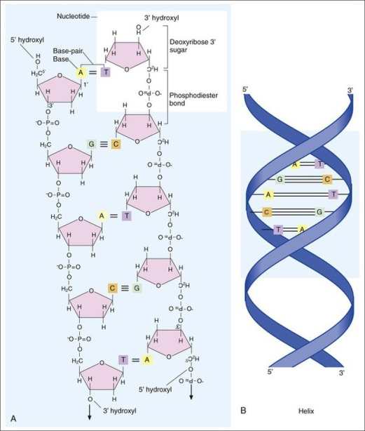

**3- Role of the chromosome**

The bacterial chromosome plays a crucial role in the genetic properties of the cell, as it carries the hereditary traits of the bacterium. The genetic information encoded in the DNA is transcribed into messenger RNA (mRNA) and then translated into polypeptide sequences, which ultimately form structural proteins or enzymes.

**4- Chemical replication**

DNA replication is the process by which DNA makes an identical copy of itself. The sequence on one strand automatically determines the sequence on the complementary strand.

* **Semi-conservative replication**: Each parent strand remains associated with a newly synthesized strand, serving as a template for the new strand.
* **Bidirectional replication**: Research by J. Cairns, using radioactive thymidine incorporation in *E. coli* cells, revealed that replication always begins at a single point called the origin. A region of replication, shaped like a Y (the replication fork), moves along the parental double helix, separating the two strands and using them as templates for the synthesis of new DNA. Replication occurs in the 5' to 3' direction, with the template strand being read in the opposite direction (3' to 5').

In these conditions, a question arose: how could both new strands be synthesized simultaneously? The answer was provided by Okazaki, who demonstrated that one of the new strands is synthesized in fragments of several hundred nucleotides, now called Okazaki fragments. Consequently, one strand, known as the leading strand, is synthesized continuously in the same direction as the movement of the replication fork, while the other strand, known as the lagging strand, is synthesized discontinuously in the opposite direction. This results in an asymmetrical structure of the replication fork.

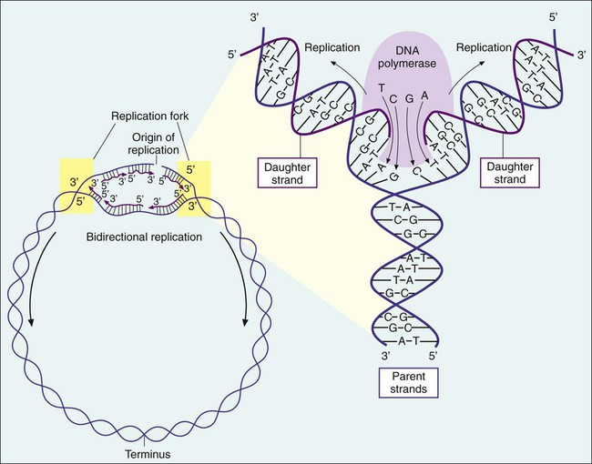

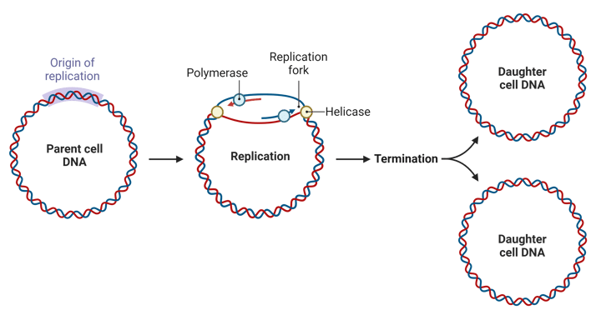

**Figure :** Prokaryotic chromosomal replication

**V- Plasmids**

Plasmids are extrachromosomal genetic elements capable of self-replication and play a crucial role in bacterial adaptation to environmental changes. They were first discovered by Lederberg in 1952, with the first plasmid identified being the F factor (involved in conjugation), followed by the R factor in 1959 (responsible for antibiotic resistance).

**1- Structure of plasmids**

Plasmids are generally double-stranded DNA molecules, usually circular, although linear plasmids also exist. Sometimes, they can integrate into the bacterial chromosome, becoming episomes. Their size ranges from 1 kb to 400 kb, about 1/100 of the size of the bacterial chromosome. Plasmids carry a small number of genes (usually fewer than 30), and while their main function is to enhance bacterial adaptation, their genetic content is highly diverse.

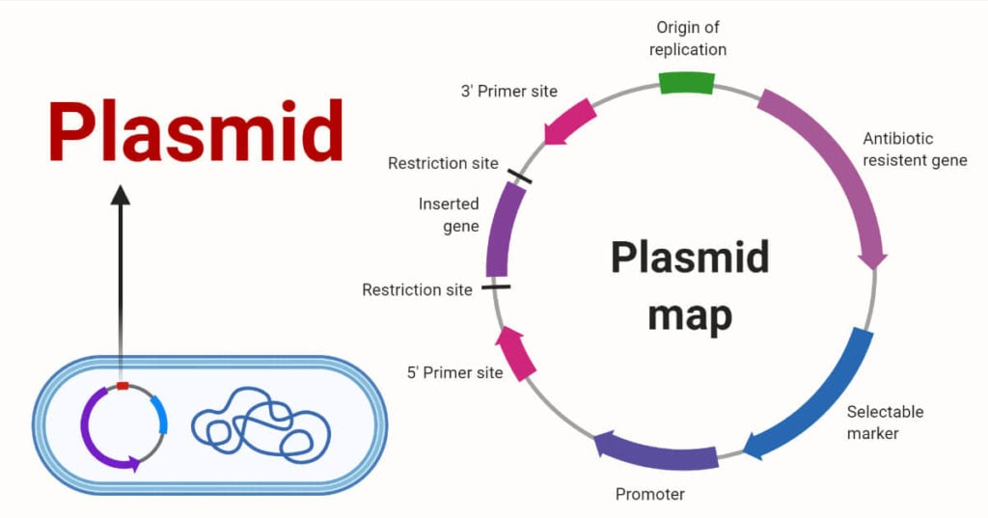

**Figure**: structure of plasmid

**2- Types of plasmids**

Plasmids are classified based on their **functions** and **propagation** methods:

* **Conjugative Plasmids**: Carry genes necessary for the formation of **sex pili**, which are required for **conjugation** (horizontal gene transfer between bacteria).
* **R Plasmids (Resistance Factors)**: Provide bacteria with resistance to **antibiotics**.
* **Col Plasmids**: Encode for **bacteriocins** (e.g., colicin from **Escherichia coli**), which allow bacteria to kill closely related strains.
* **Virulence Plasmids**: Carry genes that code for **toxins** responsible for the symptoms caused by pathogenic bacteria.
* **Metabolic Plasmids**: Encode enzymes capable of degrading complex molecules (e.g., pesticides, lactose) or facilitating biochemical processes like **nitrogen fixation** in **Rhizobium**.

**3- Plasmid replication**

Plasmids replicate via two main mechanisms:

* **Theta (θ) replication**: Unidirectional or bidirectional, starting from a replication origin and using the host bacterium's enzymatic machinery.
* **Rolling circle replication**: A strand is cut by a nuclease, unwinds around the other strand, and serves as a template for the synthesis of a complementary strand.

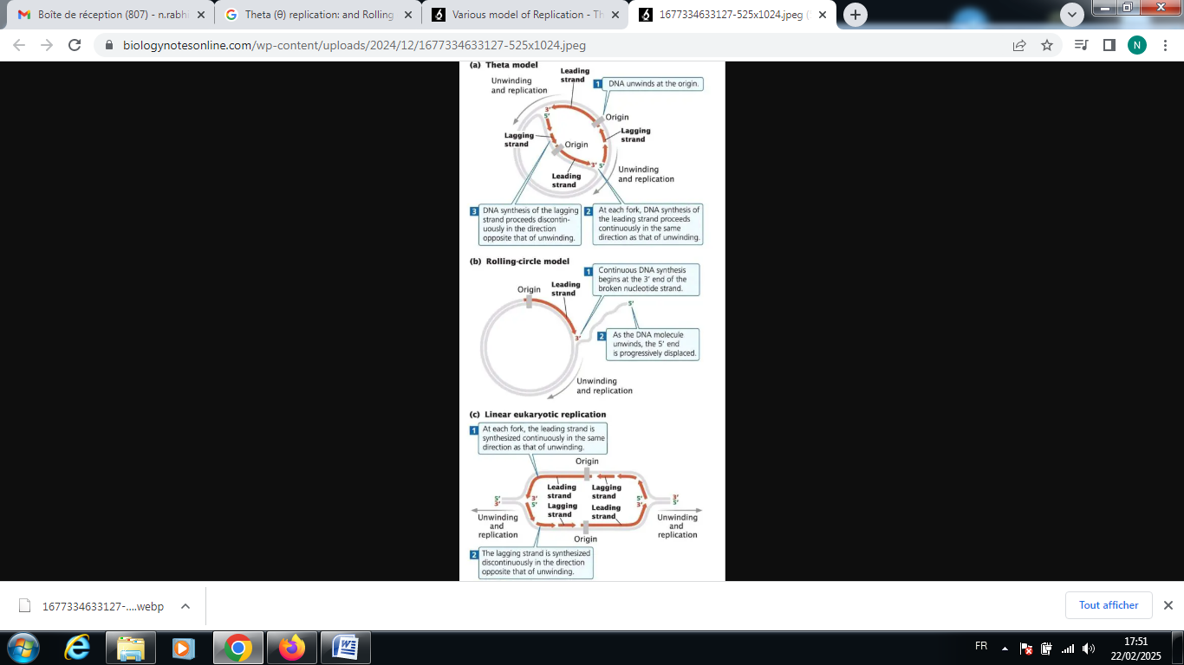

**Figure:** Various model of plasmid replication.

**4- Plasmid transfer**

Plasmids can be transferred between bacteria via three primary mechanisms:

**i- Transformation**: The uptake of free DNA from the environment by a bacterium, followed by its stable incorporation into the recipient's genome.

**ii- Conjugation**: Direct transfer of DNA through sex pili, typically involving self-transferring plasmids such as F or R plasmids.

**iii- Transduction**: Transfer of bacterial genes via a bacteriophage, which accidentally packages bacterial DNA and injects it into another bacterial cell.

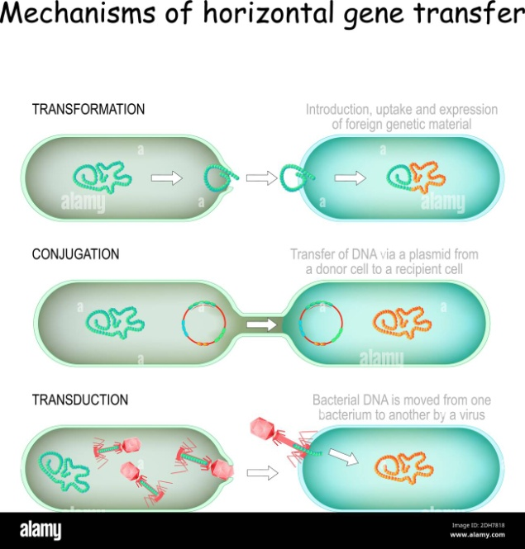

**Figure:** mechanisms of horizontal gene transfer

**5- Plasmid properties**

Plasmids confer several important properties to bacteria:

* Antibiotic resistance: Around 90% of antibiotic resistance is plasmid-mediated.
* Resistance to heavy metals: Plasmids can confer resistance to toxic metals such as mercury, cadmium, arsenic, and lead.
* Production of pathogenic substances: For example, some plasmids code for enterotoxins that cause diarrhea, as seen in certain E. coli strains.
* Production of bacteriocins: These proteins allow bacteria to kill or inhibit the growth of other closely related bacteria.
* Metabolic traits: Many biochemical characteristics of bacteria, such as the ability to degrade complex substances or fix nitrogen, are plasmid-encoded.

**VI- Capsule**

The capsule is a layer of slime that lies outside the [bacterial cell](https://www.sciencedirect.com/topics/immunology-and-microbiology/bacterial-cell) wall. It is secreted by bacteria and diffuses into the surrounding medium. Based on its appearance when examined by light microscope, the [bacterial capsule](https://www.sciencedirect.com/topics/immunology-and-microbiology/bacterial-capsule) is classified into two types: microcapsule, which is less than 0.2 μm in thickness and escapes optical detection; and capsule or large capsule, which is over 0.2 μm in thickness, binds tightly to the cell wall, and presents an obvious boundary under optical microscope. The capsule shows up as negatively stained when ordinary staining techniques are used. It appears as a clear halo around the bacterium when stained samples are examined by light microscope. Using special staining, the capsule can be stained differently from the bacterial cell. Most bacterial capsules are composed of polysaccharides, but a few capsules are made of [polypeptides](https://www.sciencedirect.com/topics/pharmacology-toxicology-and-pharmaceutical-science/polypeptide).

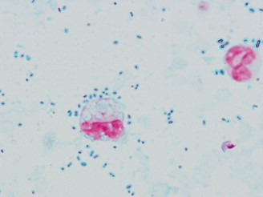

**Figure**:  Capsule of S. pneumoniae (Murs staining method).

Bacterial cells are stained red and the capsule around the cell appears as blue transparent circles.

**1. Morphology**

The capsule is a gel-like layer distinctly separated from the bacterium, which can be detected using various techniques:

* **India Ink staining**: By combining a mixture of India ink and a bacterial suspension, the capsule appears as a clear halo surrounding the bacterial body against a dark background. This method is commonly used to visualize the capsule under a light microscope.
* **Immunochemical techniques**: Anti-capsular antibodies bind to capsular antigens, forming an antigen-antibody complex that precipitates and thickens the capsule, making it visible under the microscope. This process is known as the **Neufeld capsule swelling reaction**.
* **Electron microscopy**: This method reveals fine details of the capsule structure, especially in bacteria with more rigid layers like the S-layer.

There are three types of layers that surround the bacterial cell wall:

* **Capsule**: Well-organized and difficult to detach.
* **Mucoid Layer**: Less structured and easily detached, commonly found in aquatic bacteria.
* **S-layer**: Highly structured, found in certain bacteria and archaea, and only visible through electron microscopy.

**2. Chemical composition**

The capsule and mucoid layers are typically composed of **polysaccharides**, forming a network called the **glycocalyx**. Some Gram-positive bacteria, such as *Bacillus anthracis*, have a proteinaceous capsule, while the **S-layer** is mainly composed of **proteins** and **glycoproteins** organized in a tiled pattern. Some bacterial-produced **polysaccharides** are industrially significant, such as those produced by *Leuconostoc mesenteroides* (dextrans) or *Xanthomonas* (xanthan gum), which are used as **gelling agents** in the food industry.

**3. Functions of the capsule**

Although bacteria can survive without their capsule, this structure provides several benefits:

* **Protection**: The capsule shields the bacterium from environmental factors such as **ultraviolet radiation**, **desiccation**, and **physical and chemical agents**. It enables the bacterium to survive in hostile environments.
* **Virulence**: The capsule plays a crucial role in **pathogenicity**. It protects bacteria from **phagocytosis** by reducing adhesion to macrophages and exerts a **negative chemotaxis** on leukocytes, allowing the bacterium to evade the immune system.
* **Antigenicity**: **Capsular antigens** (Ag K) are responsible for the serological specificity of bacteria, allowing their classification (for example, **70 serological types** in *Streptococcus pneumoniae*).

The **S-layer**, found in some **archaea** (e.g., *Methanococcus*) and bacteria (e.g., *Chlamydia*, *Treponema*, *Helicobacter*, *Bacillus*, *Clostridium*), acts as an additional structure to the cell wall. It is involved in adhesion, resistance to macrophage proteases, and protection against bacteriophages. Additionally, the S-layer serves as a filter, preventing the entry and exit of large molecules.

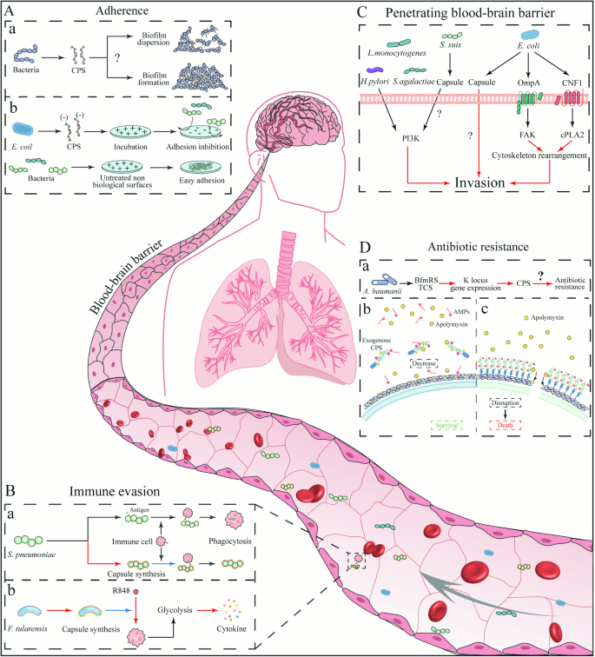

Figure:

**VII- Cilia and Flagella**

Bacteria that are capable of movement typically do so using **flagella**, which are locomotor appendages that extend outside the plasma membrane and cell wall. These structures are thin, approximately 20 nm in diameter and 15–20 μm in length.

**1- Flagella Visualization:**

Flagella are so thin that they are difficult to observe under dark-field microscopy but can be stained using special techniques that increase their thickness (e.g., Rhodes stain).

* **Rhodes Staining Technique:**
  + A new slide is prepared with two drops of a young culture (6 to 12 hours old) in broth. The slide is dried and treated with a mordant for 3 minutes, followed by washing with distilled water.
  + The slide is then covered with ammoniacal silver nitrate, heated almost to boiling, and allowed to act for 3–5 minutes before rinsing and drying.
  + The preparation can then be observed under immersion oil.

**2- Structure of flagella**

Transmission electron microscopy has revealed that bacterial flagella consist of three parts:

1. **Filament** – The longest and most prominent part, extending from the cell surface. It is a hollow cylinder made up of a single protein called **flagellin**.
2. **Hook** – A short, curved segment that connects the filament to the basal body.
3. **Basal Body** – Embedded in the cell membrane, it anchors the flagellum to the cell.

Flagella arrangements:

* **Monotrichous**: A single flagellum at one end.
* **Amphitrichous**: A flagellum at each end.
* **Lophotrichous**: A tuft of flagella at one or both ends.
* **Peritrichous**: Flagella distributed all over the surface of the cell.

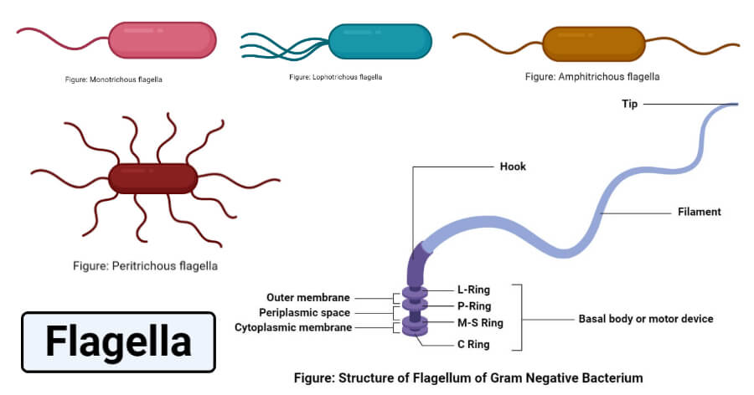

**Figure**: Structure of flagella of Gram negative bacteria

**3- Function of flagella**

* **Locomotion**: Flagella are primarily responsible for bacterial movement. Their rotation allows the bacterium to move toward or away from environmental stimuli, a process known as **chemotaxis**.
* **Antigenic role**: Flagella contain flagellin, which acts as an antigen (Ag H) and determines different bacterial serotypes (e.g., Salmonella serotyping). This allows for specific immune responses, such as bacterial agglutination in the presence of corresponding antibodies.
* **Bacteriophage attachment**: Some bacteriophages use flagella as a site for attachment.

**VIII- Pili or fimbriae**

In addition to flagella, many Gram-negative bacteria also possess **pili** or **fimbriae**, which are short, hair-like structures that are involved in adhesion but not in movement.

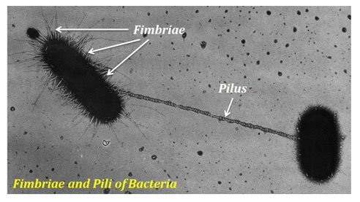

**1- Structure of Pili**

Pili are much thinner than flagella, with diameters of about 3 to 10 nm and lengths of several micrometers. They are composed of polymerized protein subunits called **pilin**, along with minor components such as **adhesins** that help with bacterial attachment.

**2- Function of Pili**

* **Common Pili**: These are short, rigid, and distributed around the bacterial surface. They play a crucial role in the ability of bacteria to adhere to eukaryotic cells, an essential function in pathogenesis (e.g., Escherichia coli in urinary infections, Vibrio cholerae on intestinal cells).
* **Sex Pili**: These are involved in conjugation, the process by which bacteria exchange genetic material.

**VIIII- The Spore**

Some bacteria have the ability to transform into small, oval or spherical units that are extraordinarily resistant when the medium runs out of nutrients or when external physicochemical conditions change. These are called spores or endospores because their formation occurs intracellularly. Endospores develop within the vegetative cells of certain bacterial genera, notably *Bacillus* and *Clostridium*, all of which are Gram-positive bacteria. Other genera are also capable of sporulation.

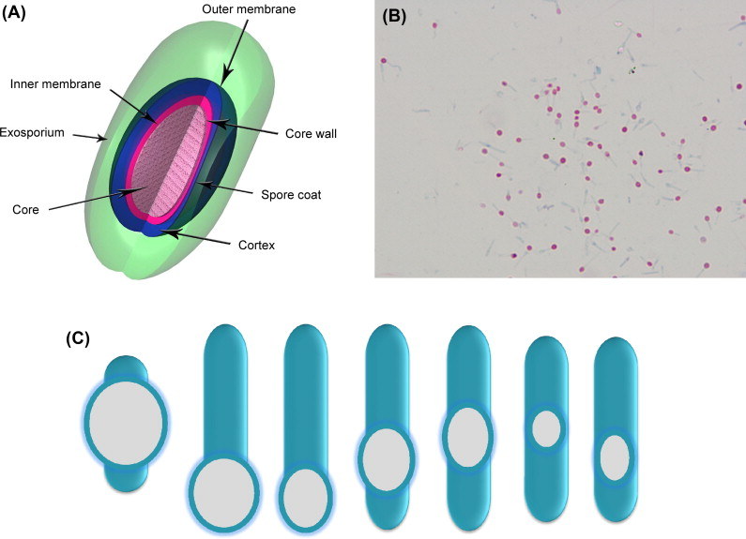

**Figure:**  (A) Schematic representation of the bacterial spore. (B) Spore stain of C. tetani (fuchsin-methylene blue stain). (C) Size, morphology, and location of bacterial spores.

**1- Morphology**

Spores are small, oval or spherical units. They may or may not distort the bacterial body. Their position within the cell varies: central, terminal, or subterminal (Fig. 21). This characteristic is also used for bacterial identification. The spore may be free or not. The observation of these features is conducted for taxonomic purposes.

**2- Spore structure**

The spore has a wall and a plasma membrane similar to those of the vegetative cell. The outermost envelope is thin, called the exosporium. Below the exosporium, there is the coat or tunic, composed of several protein layers. The cortex is located just under the tunic. Finally, the protoplast (cytoplasm) or core of the spore contains ribosomes, the nucleoid, and inactive enzymes.

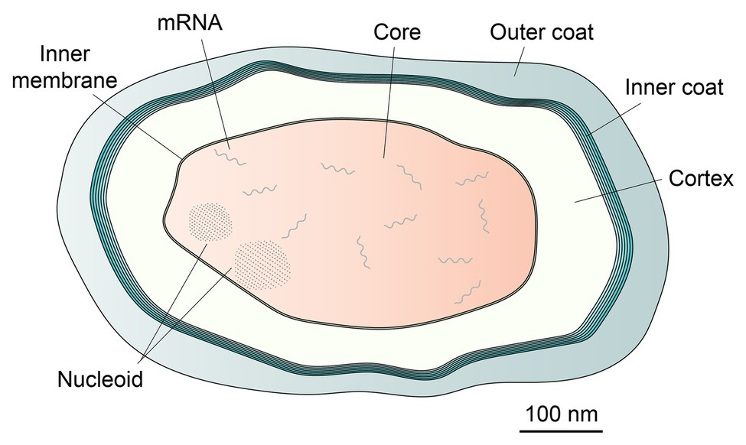

**Figure**: Structure of a bacterial spore (Meyer et al., 2004).

**3- Sporulation process**

The sporulation process is triggered by nutrient depletion in a physicochemical context that may vary between species: lack of oxygen for *Clostridium*, or presence of oxygen for *Bacillus anthracis*. Sporulation begins at the end of the exponential phase and proceeds in six stages:

1. **Stage I:** Formation of the axial filament. Nuclear division occurs but is not followed by cell division, resulting in the fusion of the two genomes to form an axial chromatic filament.
2. **Stage II:** The two genomes separate, and simultaneously, the cytoplasmic membrane invaginates near one pole of the cell to form a sporulation septum that divides the cell into two unequal parts. This septum will envelop the cytoplasm of the smaller part to form a pre-spore.
3. **Stage III:** Engulfment of the pre-spore.
4. **Stage IV:** Between the two membranes surrounding the pre-spore, the spore wall forms, and the cortex rapidly appears.
5. **Stages V and VI:** The appearance of the coats and development of the exosporium.
6. **Stage VII:** The vegetative cell lyses and releases the spore.

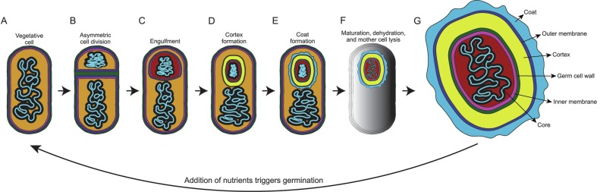

**Figure**:  Depiction of the sporulation cycle in B. subtilis. (A) Nutrient deficiency causes the vegetative cell to initiate sporulation. (B) A septum forms toward the pole of the cell during asymmetric cell division. (C) The cell wall material of the septum is degraded and the prespore is engulfed by the plasma membranes of the mother cell. (D) The cortex forms on top of the germ cell wall surrounded the prespore. (E) The coat forms on the exterior of the outer membrane of the cortex. (F) The spore fully matures, dehydrates, and lytic enzymes are released to degrade the mother cell. (G) Enlarged depiction of the fully formed spore.

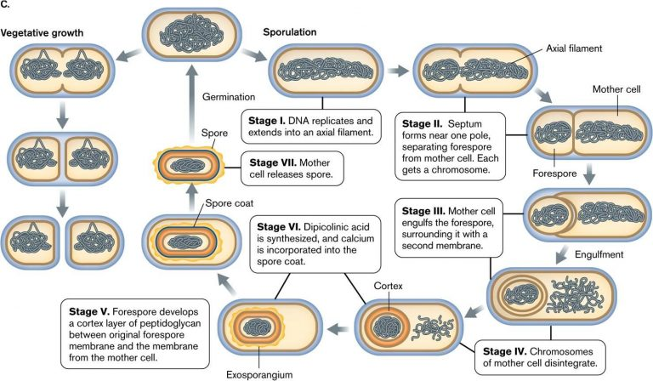

**4- Properties**

The spore exhibits new properties compared to the vegetative cell:

* **Thermal Resistance:** Spores generally resist temperatures of 70-80°C for 10 minutes or more. This property is due to the presence of dipicolinic acid, spore dehydration, and "SASP" (small, acid-soluble proteins) that can bind to DNA.
* **Resistance to Physical and Chemical Agents:** Spores are resistant to ultraviolet rays, gamma rays (calcium and SASP), antiseptics, disinfectants, and antibiotics (due to the coat).
* **Antibiotic Synthesis:** Some bacteria synthesize antibiotics during the early phase of sporulation. For example, *Bacillus licheniformis* synthesizes bacitracin, and *Bacillus polymyxa* produces polymyxin. They may also synthesize toxins (e.g., enterotoxins from *Clostridium perfringens*) or bio-pesticide substances (toxins that kill insects).

**5- Germination**

When a spore is placed in favorable growth conditions, it undergoes a series of progressive transformations and eventually becomes a vegetative cell. This process is called germination, which includes three stages:

1. **Activation:** This corresponds to the damage of the spore's envelopes by physical (thermal shock), chemical (acids, lysozyme), or mechanical (abrasion, shock) agents. Thermal activation is particularly well known in the process of tyndallization, which involves heating the product three times: 30 minutes at 60°C (destroying vegetative forms and inducing spore germination), a second heating at 60°C for 30 minutes (killing spores from germination and inducing the germination of residual spores), and a third heating to destroy the last vegetative forms.
2. **Initiation:** This begins in the presence of favorable conditions such as hydration and effector metabolites (alanine, magnesium, adenosine), which penetrate through the damaged spore envelopes. Hydrolytic enzymes break down spore components, releasing calcium dipicolinate. As the cortex is destroyed, the spore absorbs water and swells.
3. **Outgrowth:** This is a visible swelling resulting from the rehydration of the spore via osmosis and the synthesis of new proteins, DNA, RNA, and other molecules. The vegetative cell can begin to grow if the nutritional and physicochemical conditions of the environment are favorable.