**PW 03 : SAND EQUIVALENT**

1. **Objective of the Experiment**

Measure the cleanliness of sand by determining the percentage of fines.

1. **Required Materials**

* 5 mm sieve, 500 mm ruler
* Balance, spatula, stopwatch, funnel
* Piston
* Plexiglass test tubes
* Washing solution

1. **Materials Used**

* A sample of sand

1. **Procedure**

* Pass the sample through a 5 mm sieve.
* Fill the washing solution up to the first mark.
* Introduce 120 g (dry) of sand into the test tube.
* Let it rest for 10 minutes.
* Cap the test tubes and shake them with a sinusoidal horizontal movement of 20 cm amplitude using a shaking machine (90 back-and-forth movements in 30 seconds).
* Wash and fill the test tubes up to the second mark.
* Let it rest for 20 minutes, avoiding any vibrations.
* Measure the height of sand h1​ from the sand and flocculent mixture, and the height h2′​.
* Measure the height of sand h2 with the piston (slowly lower the piston into the test tube until it rests on the sediment, hold it steady, and measure h2​).

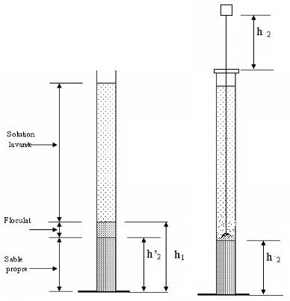

***Figure.1.*** *Sand equivalent device*

1. **Requested Work**

* Fill in the table
* Comment on the results

**Table. 1.** Results

| **Test** | **(h1)** | **(h'2)** | **(h2)** | **ESV (%)** | **ES (%)** |
| --- | --- | --- | --- | --- | --- |
| Test 1 |  |  |  |  |  |
| Test 2 |  |  |  |  |  |
| Test 3 |  |  |  |  |  |
| **Average** |  |  |  |  |  |

**With:**

|  |  |
| --- | --- |
| **Visual Sand Equivalent (VSE):** **ESV(%)** 100 | **Sand Equivalent (SE):** 100**(%) ES** |

**Table 2:** Sand Equivalent Values (ESV) and Quality of Sand

| **ESV (%)** | **ES (%)** | **Quality of Sand** |
| --- | --- | --- |
| ESV < 65 | ES < 60 | Clayey sand: Risk of shrinkage or swelling; to be rejected for quality concrete. |
| 65 ≤ ESV < 75 | 60 ≤ ES < 75 | Slightly clayey sand: Acceptable cleanliness for quality concrete, provided there is no significant risk of shrinkage. |
| 75 ≤ ESV ≤ 85 | 70 ≤ ES ≤ 80 | Clean sand: Low percentage of clay fines; perfectly suitable for high-quality concrete. |
| ESV ≥ 85 | ES ≥ 80 | Very clean sand: Almost total absence of clay fines, which may lead to a plasticity defect in the concrete; adjustments may require an increase in water dosage. |

This classification helps determine the suitability of sand for various construction applications, particularly in concrete production.