**Cause and Effect**

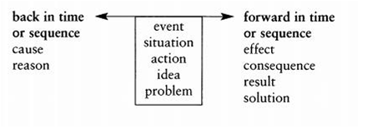

Here is an example,

For the last hundred years the climate has been growing much warmer. This has had a number of different effects. Since the beginning of the twentieth century, glaciers has been melting rapidly. For example, the Muir Glaciers in Alaska has retreated two miles in ten years. Secondly, rising temperatures has been causing the snowline to retreat on mountains all over the world. In Peru, for example, it has risen as much as 2700 feet in 60 years. As a result of this, vegetation has been changing. In Canada, the agricultural cropline has shifted 50 to 100 miles northward. In the same way cool-climate trees like birches and spruce have been dying over large areas of Eastern Canada. In Sweden the treeline has moved up the mountains by as much as 65 since 1930.