**Chapter I: Introduction to plant biology**

**Introduction**

• **Definition of plant biology**

Plant biology is a broad discipline that encompasses all aspects of plant life, both aquatic and

terrestrial, including their morphologies, modes of reproduction (sexual and asexual),

adaptations to various environments, and the mechanisms enabling sustainable interactions

(such as parasitism and symbiosis) (**Campell et al., 2008**).

The living world consists of an immense collection of organisms in constant evolution. It is

divided into two biotic groups (prokaryotes and eukaryotes) and six kingdoms: Archaea,

Eubacteria, Protists, Fungi, Animals, and Plants (**Margulis & Schwartz, 1988; Raven et al.,**

**2013**).

• **Major stages of discoveries in plant biology**

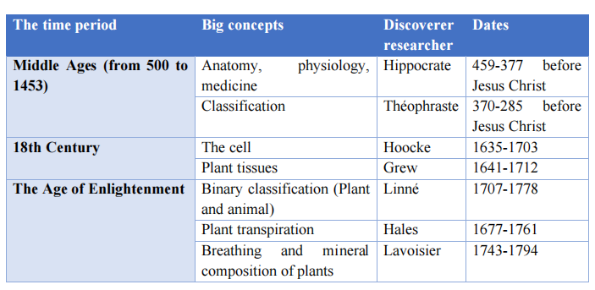

**I.1 Systematic**

**I.1.1. Introductory definitions**

• **Taxonomy**: Concerned primarily with naming and classifying organisms into a hierarchical

structure.

• **Systematics**: Encompasses taxonomy but also includes the study of evolutionary

relationships and the processes driving biodiversity.

• **Classification:** The systematic grouping of living organisms (plants, animals, etc.) based

on shared characteristics or traits.

• **Nomenclature**: The formal system of assigning names to taxonomic groups.

• **Hierarchy**: A structured system where each classification is part of a larger group and may

contain smaller, subordinate categories.

• **Morphology**: The study of the form and structure of organisms, particularly plants.

• **Phylogeny**: The evolutionary history and ancestral relationships among organisms.

Historically, plant taxonomy was based on morphology, but advances in molecular genetics

now allow for the confirmation and expansion of these relationships through DNA sequence

comparisons (**Tudge, 2000; Raven *et al*., 2005; .Simpson, 2010**).

**I.1.2. Classification system of living world**

The classification of living organisms follows a **hierarchical system** composed of **eight major taxonomic ranks**: Domain, Kingdom, Phylum (or Branch), Class, Order, Family, Genus, and Species. These main categories can be further subdivided into additional ranks, such as subphylum, super-class, sub-class, and sub-species, allowing for finer levels of classification within each group (**Campbell *et al*., 2002**) (see **Figure 1**).

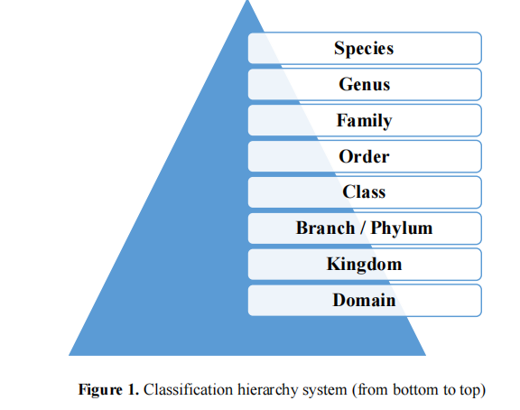

**I.1.2.1. Binomial nomenclature**

In biology, a plant (or animal) is identified by a **binomial nomenclature** consisting of two

Latin names (**Simpson, 2010)**:

• The **genus name**, with the first **letter capitalized**.

• The **species name**, with the first **letter in lowercase**.

Both names are either italicized or underlined. For example, *Pinus halepensis* or *Pinus*

*halepensis*.

**I.1.2.2. Historical and organization of the living world**

• ***Classification of Carl von Linné (1707-1778)***

**Carl von Linné**, also known as **Carl Linnaeus**, was a Swedish naturalist who laid the

foundation for modern biological classification. Based on morphological characteristics, he

subdivided the living world into two kingdoms: **Animalia** (Animals) and **Plantae** (Plants)

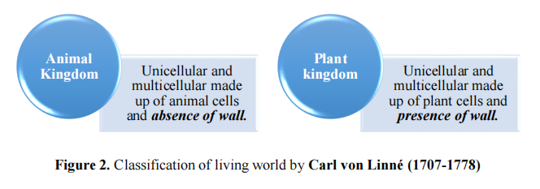

• ***Classification of Ernest Haeckel (1886)***

Classify the living world into three kingdoms: Animals, Plants and Prokaryotes (unicellular

prokaryotes).

• ***Classification of Robert Whittaker (1969)***

Classify the living world into five kingdoms (see **Figure 3**

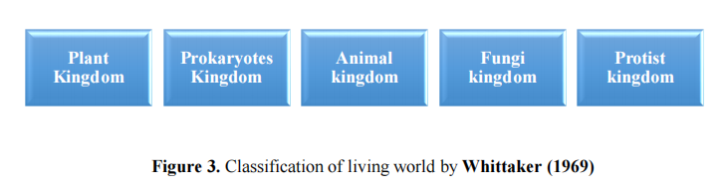

• ***Classification of Carl Woese et al. (1977***

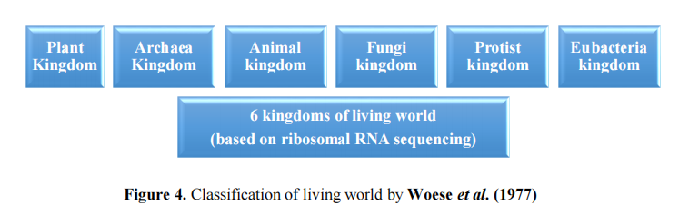

Based on ribosomal RNA sequences, we can now distinguish six major groups of life:

• **Archaea** (unicellular, prokaryotic)

• **Eubacteria** (unicellular, prokaryotic)

• **Protists** (unicellular, eukaryotic)

• **Plants** (multicellular, eukaryotic)

• **Animals** (multicellular, eukaryotic)

• **Fungi** (unicellular or multicellular, eukaryotic)

Archaea and Eubacteria possess ***prokaryotic cells***, characterized by the absence of a nucleus.

Their cells consist of an outer cell wall, a plasma membrane, and circular DNA floating within the cytoplasm (**Woese, 1990; Margulis, 1998)**.

Protists, Fungi, Animals, and Plants are composed of ***eukaryotic cells***, which have a plasma

membrane (sometimes protected by an external wall), a cytoplasm containing a nucleus, a

cytoskeleton, and an endomembrane system. These cells may also have locomotor structures,

such as flagella, and include various intracellular organelles acquired through endosymbiosis,

such as mitochondria and chloroplasts (**Woese, 1990; Campbell, 2008)**.

• ***Classification of Carl Woese (1999)***

The creation of a taxon higher than the kingdom is referred to as a **"Domain."** All living

organisms are now classified into three major domains based on differences in ribosomal RNA

sequences and cellular organization (**Woese, 1990; Campbell, 2008)**. (see **Figure 5**)

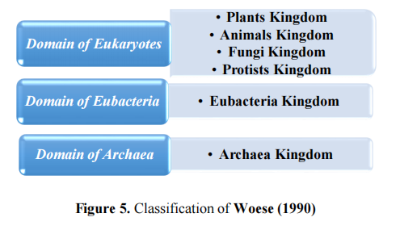

**I-1-3. Systematic**

The living world, to which plants belong, is divided into two fundamentally different groups

of organisms “prokaryotes, eukaryotes” and in five kingdoms (Prokaryotes,Protists/Protoctists, Fungi, Animals and Plants). Thus the plant kingdom is subdivided intotwo major groups according to the structural organization of the plant: Thallophytes and Cormophytes The systematics of plants intervenes to give them a name and classify them as well as to studythe relations between them

**1-. Thallophytes**

Thallophytes have a simple vegetative apparatus so: thalli have no stems, leaves, roots, or conductive vessels, they are composed by cells that look alike without physiological differentiation. Their size is very variable, depending on the species, some thallophytes are unicellular such as cyanobacteria (blue-green algae), and sometimes the thallus presents complex and pluricellular structures, such as fungi, algae and yeasts. Reproduction is done by spores or gametes, or duplicate by vegetative multiplication

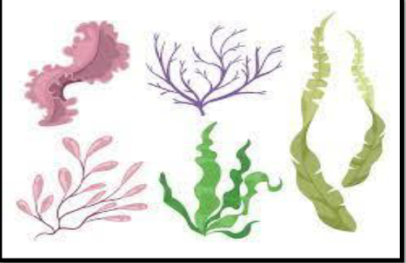

**Thallophytes**

**.2. Cormophytes**

Cormophytes whose vegetative apparatus is a cormus (from the Latin “cormus” meaning stem, from the Greek “kormos” meaning trunk), they are much more complex than a thallus, they contain group of higher plants that correspond to organisms that are alwayspluricellular and whose eukaryotic cells are joined into tissues forming organs. Cormophytes are divided into several branches.

**• 1st branch: Bryophytes**

Bryophytes include plants more commonly called mosses, they have a stem and leaves but

no roots, rhizoids having a role of fixation. They are also devoid of the vessels conducting

the sap, are avascular plants . Bryophytes most often live on land, growing in humid places

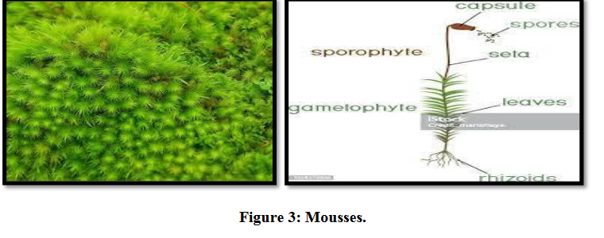

**2nd Branch: Pteridophytes**

Pteridophhytes (ex: ferns) are characterized by a cormus more developed than that of bryophytes, they consist of leaves and an underground stem called rizhome, are thin roots, little ramified.the latter allow fixation and absorption (Fig. 4). Pteridophytes are vascular plants (presence of conductive elements) and they are cryptogamous (hidden reproductive organs). They generally live in wetlands and some are aquatic.

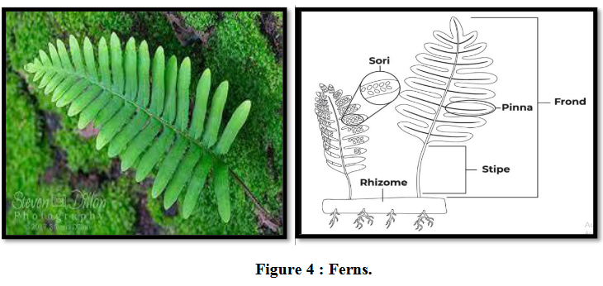

**• 3rd Branch: Spermaphytes**

This group represents more than 90% of plant species. They are characterized by a more

developed stem and root system (vascular plants). Are phanerogamous plants whose reproductive organs are apparent in the cone or in the flower. The spermaphytes branch includes two sub branches

**a- Gymnosperms:**

Ovules and seeds are naked, ie they are not included in a protective organ. Most Gymnosperms are conifers, such as Fir (Abies), Spruce (Picea), Larch (Larix), Redwood (Sequoiadendron), Pine (Pinus), Juniper (Perus), Cypress (Chamaecyperis), orThuyas (Thuja) (Fig. 5).

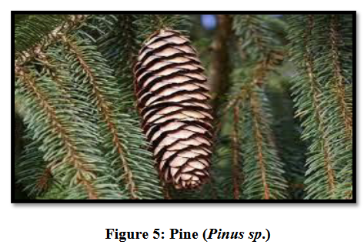

**b- Angiosperms**

They contain most of the plant kingdom of 250,000 to 300,000 species. They are characterized by the presence of the ovule in an ovary and the seed in a fruit (Fig. 6). They have two classes. Monocotyledons (the seed has a single cotolydon) and Dicotolydons (the seed has two cotyledons) (Fig. 6).

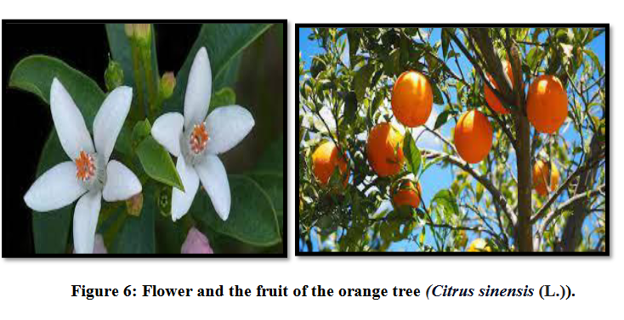

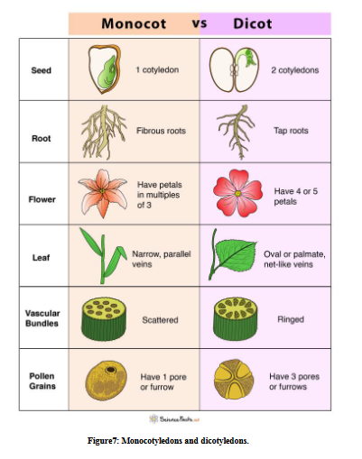

**II -Plant cytology (reminder of cell membrane, cell wall, vacuole and plastid concepts)**

The organization of plant cells is very similar to that of animal cells. However, they are characterized by the absence of a centriole, and by the presence of three specific structures that we will describe in greater detail below: the cell wall, the plastids and the vacuoles.

The size of plant cells is 10-15 μm in young cells, 100-200μm in adult cells, and up to several centimetres in some specialized cells (e.g. 4 cm for cotton fibre).

**a- Cell membrane**

Also known as the plasma membrane, composed of phospolipids and proteins. Also present in plant cells, it is located inside the cell wall and contains the cell's organelles. It's a flexible, fluid membrane surrounding the cell and separating it from anything external, like a border. It plays an important role in controlling exchanges essential to cell activity, such as the passage of carbon dioxide, nutrients and oxygen. In the plant cell, there are two important membranes: the plasmalemma, a thin envelope

delimiting the intracellular from the extracellular environment, formed by a double lipid layer, and the tonoplast (containing water, carbohydrates, organic and inorganic ions and pigments), a membrane separating the vacuole from the cytoplasm, which is permeable to elements stored in the vacuole. Under a transmission electron microscope, a cross-section of the plasmalemma appears as a sandwich made up of two dark layers 2 nm thick surrounding a light layer 3.5 nm thick (1nm = 10-9 m) (Fig. 8).

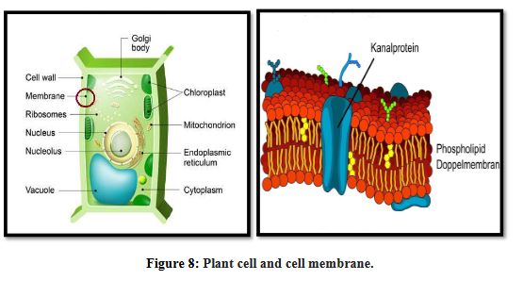

**b- Cell wall**

The cell wall is the rigid envelope of the plant cell, forming the external skeleton of the cell. It is essentially composed of carbohydrate polymers, cellulose and pectin, proteins and other phenolic compounds (lignin and suberin). The thickness of the cell wall varies from 0.1 to several μm.

Cellulose is organized in a hierarchical fibrillar structure. Cellulose fibrils are partially bound together by a homogeneous amorphous matrix composed of protopectins and hemicellulose. Around a hundred cellulose molecules are organized parallel to each other in a micellar bundle or elementary fibrils, within which the molecules establish hydrogen bridges that maintain a constant distance between the chains and stabilize them (Fig. 9).

• It is composed of:

Middle lamella: or median lamella, is the outermost part of the plant wall. It consists mainly of pectin and is common to two adjacent cells. Primary wall: pecto-cellulosic in nature, it exists alone only in juvenile cells. It is extensible,enabling cell growth (elongation).

Secondary wall: Appears during cell differentiation. It consists of cellulose andhemi cellulose, and is enriched with phenolic compounds: - lignin, - cutin, - suberin. This differentiation can be observed in the sap-conducting cells of the xylem (wood) and in various support tissues (sclerenchyma) or protective tissues (cork). Its chemical composition is a heterogeneous structure made up of cellulose in the form of microfibrils embedded in a glycoprotein matrix, pectin and hemicellulose, and proteins.

Walls are highly hydrated structures: water can represent up to 3/4 of the wall's weight. The cell wall or skeletal wall is permeable to water and dissolved substances, enabling the exchange of matter between plant cells. These exchanges are facilitated by the existence of punctata (a thinning of the cell wall) and plasmodesmata (intercellular communications that cross the wall)

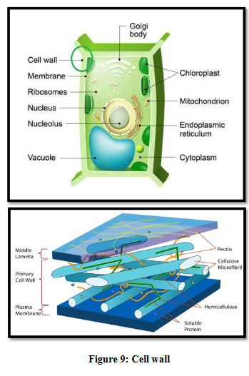

**c- Vacuole**

The vacuolar apparatus, characteristic of plant cells, contributes to water exchange and ensures cell turgor. In this respect, its physiological role is essential. Under the electron

microscope, a vacuole appears as a large, clear enclave bounded by a simple membrane or tonoplast. In a “meristematic” cell, vacuoles are small, numerous and scattered throughout the cytoplasm

During cell differentiation, all these small enclaves tend to group together into two or three, then into a single large vacuole, pushing the cytoplasm back along the cell membrane. The vacuole is where the cell's water-soluble substances accumulate, and can contain a wide variety of substances, such as the anthocyanins and flavones that give flowers and fruit their color

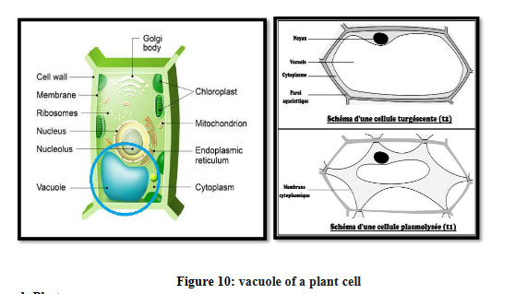

d- Plasts

All plant organs contain plastids, which can vary in size and are derived from pro-plasts, which are simple, undifferentiated structures generally found in meristems. The plastid is a cellular organelle with its own DNA. A plastid has an inner and an outer membrane, forming a plastid envelope. They are found in chlorophyllous eukaryotic cells (algae and plants) Several types of plastids can be distinguished:-Proplasts: these are small, structurally simple, undifferentiated organelles specific to plantcells, generally found in meristems.

- Chloroplasts: these are organelles found in the cytoplasm of plant cells. They often take the form of flattened discs 2 to 10 μm in diameter. They are sensitive to different wavelengths of the light spectrum. Through the chlorophyll they contain. This is where photosynthesis takes place.

- Etioplasts: these are either chloroplasts that have not yet differentiated, or chloroplasts that

have etiolated due to lack of light. They are generally found in plants that have grown in the dark.

- Chromoplasts: these are organelles found in the cells of plant organs rich in non-chlorophyll pigments, such as xanthophylls and carotenes, colored from yellow to orange (e.g.flower petal cells).

- Leucoplasts: these represent a category of plastids that have no pigments. Leucoplasts are not green, suggesting that they are located in roots and non-photosynthetic tissues. They can specialize to store starch, lipid or protein reserves, in which case they are respectively called amyloplasts, found in potato tubers, oleoplasts, found in the petals of some irises, or proteinoplasts, found in many seeds such as peanuts A plastid can change type, a process known as plastid interconversion. For example, a potato eucoplast can be transformed into a chloroplast in the presence of light, while a lemon

