**Phylum Arthropoda (Arthropods)**

. **Phylum Arthropoda Characteristics**

* They are bilaterally symmetrical, triploblastic, metamerically segmented animals.
* Body organization is of an **organ-system level.**
* The body is covered with a thick chitinous cuticle forming an exoskeleton which molts periodically and their appendages are joined.
* Body segments usually bear lateral and jointed appendages with varied functions as jaws, gills, legs, etc.
* Body divisible into head, thorax, and abdomen. Head and thorax often fused to form a cephalothorax.
* The musculature is not continuous but comprises separate striped muscles capable of rapid contraction.
* The body cavity is hemocoel. The true coelom is reduced to the spaces of the genital and excretory organs.
* The complete digestive system with mouth and anus. Mouthparts adapted for various modes of feeding.
* Open circulatory system with dorsal heart and arteries but without capillaries.
* Respiration by general body surface, gills in aquatic forms, trachea, or book-lungs in terrestrial forms.
* No true nephridia. Excretion organs are green glands or Malpighian tubules or coxal glands.
* The nervous system is typically annelidan, with a dorsal brain connected with a nerve ring to a double ventral nerve cord.
* [Cilia](https://microbenotes.com/cilia/) are entirely absent from all parts of the body.
* Sensory organs comprise eyes (simple and compound), chemo- and tactile receptors, balancing and auditory organs.
* Sexes usually separate (dioecious). Reproduction organs and ducts paired.
* Internal fertilization. Oviparous or ovoviviparous.
* Development is usually indirect through larval stages. Parthenogenesis in some.
* Parental care is often well marked in many arthropods.
* Most diversified groups inhabiting the land, water, and air.

**Phylum Arthropoda Classification**

**Subphylum 1- Trilobitomorpha (Gr., tria=tree+ lobos=lobe+ morphe=form)**

* Represented by only fossil trilobites.
* All marine forms.
* All are bottom dwellers i.e. benthozoic and existed from Cambrian to Permian.
* The body is three lobes separated by two longitudinal furrows.
* Distinct head with one pair of antennae.
* Except for the last segments, all bears biramous appendages.
* Examples: *Triarthrus*, *Dalmanites*.

**Subphylum 2- Chelicerata (Gr., chele=claw+ keros=horn+ ata=group)**

* Body divisible into anterior cephalothorax or prosoma and posterior abdomen or opisthosoma.
* Prosomatic appendages 6 pairs. First pair of preoral chelicerae with claws with feeding in function.
* The second pair of appendages are postoral pedipalpi and followed by 4 pairs of walking legs.
* No antennae and true jaws.
* Mostly terrestrial and predaceous.

**Class 1. Merostomata (Gr., meros=thigh+ stoma= mouth)**

* Exclusively aquatic, all marine with median simple and lateral compound eyes.
* 5 to 6 pairs of abdominal appendages modified as gills or branchiae for respiration.
* Abdomen ending in a sharp telson or spine.
* Excretion by coxal glands. No Malpighian tubules.

**Subclass 1. Xiphosura (Gr., xiphos=sword+aura=tail)**

* Prosoma is convex covered by the abroad horseshoe-shaped carapace.
* Prosoma bears 6 pairs of appendages.
* Unsegmented abdomen with a long terminal telson.
* Genital openings paired covered by a genital operculum.
* Respiration is by lamelliform gills or book-gills attached to the abdominal appendages.
* Example: *Limulus* (horseshoe or king crab).
* 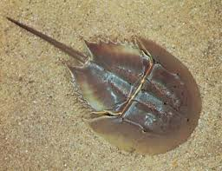

**Subclass 2. Eurypterida (Gr., eurys=broad+ pteryx=wing)**

* Extinct marine, giant water scorpions.
* Large-sized arthropods.
* Small cephalothorax covered by a dorsal carapace.
* 12-segmented abdomen followed by cephalothorax which is narrow behind.
* Cephalothorax with 6 pairs of appendages.
* Examples: *Eurypterus*, *Pterygotus*.

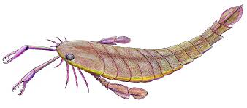

**Class 2. Arachnida (Gr., arachne=spider+ oid=like)**

* Terrestrial or aquatic forms.
* Simple eyes. No compound eyes.
* Prosoma bears 6 pairs of appendages; 1 pair of chelicerae, 1 pair of pedipalpi, and 4 pairs of walking legs.
* No appendages in the abdomen.
* Tracheae, book-lungs, or book-gills as a respiratory organ.
* Excretion by coxal glands and Malpighian tubules.
* Sexes separate (dioecious). mostly oviparous and courtship before mating.
* Development direct.

**Order 1. Scorpionida (=scorpiones)**

* Terrestrial forms found under stones in tropical and subtropical regions.
* Elongated fair-shaped true scorpions.
* Small prosoma broadly joined to large opisthosoma.
* Prosoma covered dorsally by carapace and bears a pair of chelicerae, pair of pedipalpi, and 4 pairs of walking legs.
* Opisthosoma divisible into broad anterior 7-segmented mesosoma and narrow posterior 5-segmented metasoma.
* Metasoma ending in a telson and poison sting.
* 2 ventral comb-like pectines on the 2nd abdominal segment.
* Book-lungs as a respiratory organ.
* Examples: *Buthus*, *Palamnaeus*, *Androctonus*.
* 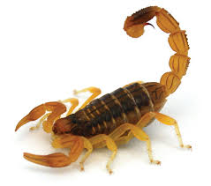

**Order 2. Pseudoscorpionida (=Chelonethida)**

* Tiny false scorpions.
* Found under the bark of a tree.
* Prosoma forms 6 fused segments covered dorsally by the carapace.
* Abdomen 11-segmented, without sting and telson.
* Chelicerae 2-jointed, with comb-like secretions.
* Respiration by trachea.
* Examples: *Chelifer*, *Microcreagris*.

**Order 3. Palpigradi**

* Small-sized micro whip scorpions.
* No eyes.
* Prosomal carapace made of large anterior and smaller posterior portions.
* Opisthosoma of 10-segments and jointed to prosoma by a pedicle.
* Telson with the along jointed flagellum.
* Chelicerae are chelate and pedipalpi leg-like.
* 3 pairs of book-lungs as respiratory organs.
* Example: *Koenenia*. 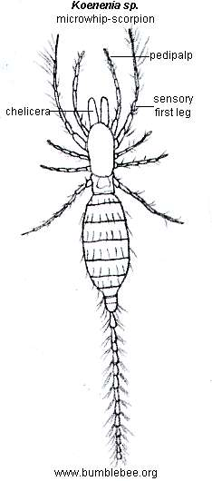

**Order 4. Solifugae (=solifugida)**

* False spiders. Commonly called sun spiders or wind spiders.
* The body consists of prosoma and opisthosoma.
* Prosoma divided into a large anterior and a small posterior part.
* Opisthosoma of 10 or 11 segments. No spinnerets.
* Chelicerae large and chelate, pedipalpi are elongated and leg-like.
* No poison glands.
* Respiration by trachea.
* A flagellum on each chelicera of male, for sperm transfer.
* Example: *Galedodes*.
* 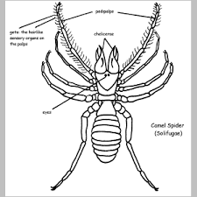

**Order 5. Amblypygi (= Phrynichida)**

* Flattened scorpion-spiders or taillers whip scorpions.
* Undivided carapace. Large and rhaptorial pedipalps.
* Moderate size chelicerae.
* 12-segmented abdomen without flagellum.
* First pair of walking legs long, whip-like sensory in nature.
* Example: *Charinus*.
* 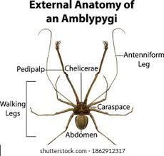

**Order 6. Uropygi (=pedipalpi)**

* Commonly referred to as a whip scorpion.
* Consist of a pair of eyes.
* Prosomal carapace entire.
* Chelicerae 2-jointed and moderate in size.
* Large, heavy, and usually with terminal pincers pedipalpi.
* 12-segmented opisthosoma. Last segment with a long flagellum or telson.
* Examples: *Thelyphonus*, *Mastigoproctus*.
* 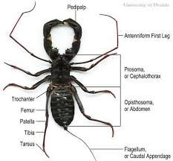

**Order 7. Araneae**

* True spiders.
* The body consists of prosoma and opisthosoma.
* Prosoma and opisthosoma without visible segments and jointed by a narrow pedicle.
* Prosoma bears 6-pairs appendages.
* Chelicerae 2-jointed, with a poison duct in terminal claw.
* Simple leg-like pedipalps used for a transfer of sperms in males.
* Opisthosoma with 3 pairs of spinnerets. No telson.
* 8 eyes are arranged dorsally in 2 rows on the carapace of the prosoma.
* Respiration by book-lungs or trachea or both.
* Examples: *Argiope* (writing spider), *Aranea* (house spider), Lycosa (wolf spider), *Agelena* (funnel-web spider).
* 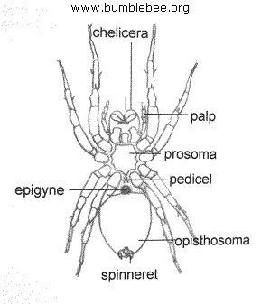

**Order 8. Ricinulei (=Podogna)**

* Rare, small, tick-like, heavy-bodied arachnids.
* The body consists of prosoma and opisthosoma.
* Prosoma with an anterior hood-like movable plate (Cucullus).
* Opisthosoma 9 segments and connected to prosoma by a pedicle.
* Chelicerae and pedipalpi are chelate.
* The third pair of legs in males form copulatory organs.
* Respiration by trachea.
* Examples: *Cryptocellus*, *Ricinoides*.
* 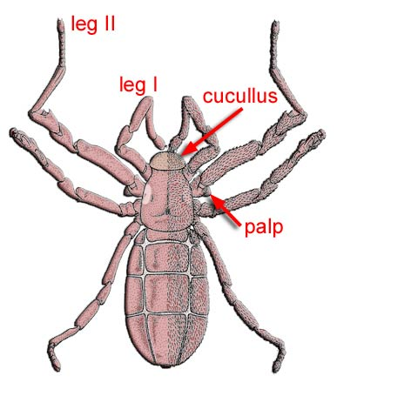

**Order 9. Phalangida or Opiliones**

* Spider-like Harvest-men, Harvest-spiders, or daddy longlegs.
* Small oval body. Extremely long, slender legs.
* Unsegmented prosoma, opisthosoma bears 10 segments.
* Prosoma broadly jointed to opisthosoma.
* No spinning glands.
* Respiration by trachea.
* Examples: *Phalangium*, *Leiobunum*.
* 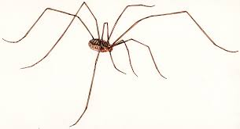

**Order 10. Acarina**

* Commonly referred to as ticks and mites.
* Free-living or parasitic.
* Small, oval, and unsegmented body in which prosoma is fused with opisthosoma.
* Chelicerae and pedipalpi are small and associated with the mouthparts which are adapted for biting, piercing, and sucking.
* Respiratory organs trachea or skin.
* Examples: *Chorioptes* (Mites), *Sarcoptes* (Itch-mite), *Idodex* (Tick).
* 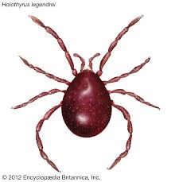

**Class 3. Pycnogonida**

* Commonly referred to as sea spiders.
* Very small in size.
* The body mainly consists of the cephalothorax, abdomen reduced.
* Short segmented pedipalpi and very small chelicerae.
* Usually 8 pairs of long walking legs.
* Mouth placed on the long proboscis.
* Simple eyes and 4 in numbers.
* No respiratory or excretory organs.
* Sexes separate (Dioecious). Females with a pair of ovigers for carrying eggs.
* Examples: *Pycnogonum*, *Nymphon*.
* 