**Chapter 4: Geometric Characteristics of Sections**

1. **Static Moments**

Let there be a flat surface S in the coordinate system (0,,) (Figure 1), considering an element dS relative to point M on this surface. The static moment AΔ​ of S relative to an axis Δ located at a distance δ from M is defined by:

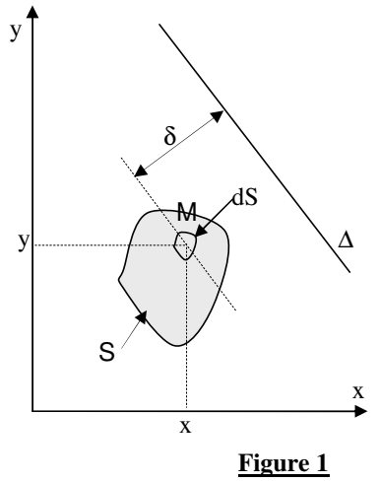

AΔ=∫∫Sδ dS

If Δ coincides with one of the axes (0,) or (0,), we then obtain:

* The static moment of the surface S relative to the axis (0,):

A0x=∫∫S y.dS

* The static moment of the surface S relative to the axis (0,):

A0y=∫∫S x.dS

The unit of the static moment is obviously m3.

1. **Center of Gravity**

The center of gravity or center of mass of surface S is the point G defined by its coordinates XG​ and YG​ such that:

XG=A0y/S= (∫∫S y.dS)/S YG= A0X/S= (∫∫S x.dS)/S

If a surface S is composed of n surfaces Si, then we have:

and

with:

* XGi ​​: x-coordinate of the center of gravity Gi ​ of the surface Si
* YGi​​: y-coordinate of the center of gravity Gi ​ of the surface Si

1. **Quadratic Moments**

Let the flat surface S be in the coordinate system (0,,) as shown in Figure 1. The quadratic moment (or moment of inertia) IΔ​ of S relative to an axis Δ is defined by:

IΔ=∫∫Sδ2.dS

If Δ coincides with one of the axes (0,) or (0,), we then obtain:

* The quadratic moment of the surface S relative to the axis (0,):

IOx=∫∫S y2.dS

* The quadratic moment of the surface SSS relative to the axis (0,):

IOy=∫∫S x2.dS

The unit of the quadratic moment is obviously m4.

**Huygens' Theorem**

Let the axis Δ′ pass through the center of gravity G of the surface S. The quadratic moment IΔ​ is calculated from the quadratic moment IΔ′​ using the formula:

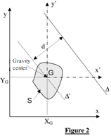

IΔ=IΔ′+S⋅d2

where d is the distance between the axis Δ and Δ′.

Applying Huygens' theorem to the axes (0,) and (0,) gives:

IOx​=IGx′ ​+ S⋅YG2

IOy=IGy′ + S⋅XG2​

If a surface S is composed of nnn surfaces Si​, we have:

IOxi=∑1nIOx and IOyi=∑1nIOy

with:

* IOxi: quadratic moment of surface Si​ relative to the axis(0,)
* IOyi​​: quadratic moment of surface Si relative to the axis (0,):

1. **Polar Quadratic Moment**

The polar quadratic moment of a surface S relative to a point is defined by:

Ip=∫S r2.dS

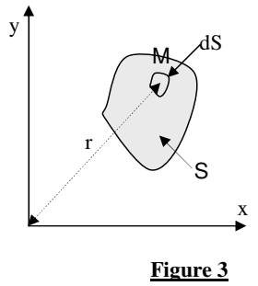

After integration, the expressions for Ip​ for the most commonly used sections are found (see table alongside):

| **Section** | **Ip​** |
| --- | --- |
| Solid Shaft | ​ |
| Hollow Shaft |  |