**Chapter IV: Anatomy in higher plants**

**Introduction**

The word anatomy comes from the Greek “***ana = through***” and “***tomie = cut***”, translated exactly by the word dissection.

Plant anatomy, specifically the study of higher plants (or *phanerogams*), focuses on the internal structure of plant organs such as roots, stems, leaves, flowers, and seeds. This discipline plays a critical role in understanding how these structures are adapted to perform specific biological functions. Higher plants, which include both **Angiosperms** (flowering plants) and

**Gymnosperms** (non-flowering plants), have complex tissues and organs that enable them to grow, reproduce, and respond to environmental stimuli **(Evert & Eichhorn, 2013)**.

The field of plant anatomy explores the classification of tissues into different categories, including meristematic (actively dividing cells), protective tissues, support tissues, and vascular tissues. Understanding the distribution and organization of these tissues across plant organs helps explain the growth patterns, water and nutrient transport systems, and adaptations of plants to their environments **(Raven *et al.,* 2005).**

This knowledge is not only fundamental for students of botany but also essential for fields such as agronomy, horticulture, and plant breeding. The study of plant anatomy allows scientists and researchers to understand how plants grow and develop, how they respond to different environmental conditions, and how they can be improved or protected in agriculture **(Esau, 1977)**.

Depending on the development of the root and stem (see **Figure 67**), two types of structures can be distinguished:

• ***Primary Structure***: This structure is found in young roots and stems and is formed by

**primary meristems**, which are responsible for primary growth, resulting in the elongation of the plant's roots and shoots **(Raven *et al.,* 2005)**.

• ***Secondary Structure***: This structure develops in older roots and stems and is produced by **secondary meristems**. Secondary growth increases the thickness of the plant and involves two main generating zones:

❖ **The cambial zone (liber-woody cambium)**: This is the first to form and is located between the **xylem** and **phloem**. The cambium produces secondary xylem (wood) towards the inside and secondary phloem (bark) towards the outside **(Esau, 1977).**

❖ **The cork cambium (phellogen)**: This meristem is formed later and is located in the outer layers of the bark, usually close to the epidermis. The cork cambium generates

**phellem (cork)** on the outer side and **phelloderm** on the inner side, contributing to the plant's protective outer layers **(Evert & Eichhorn, 2013)**

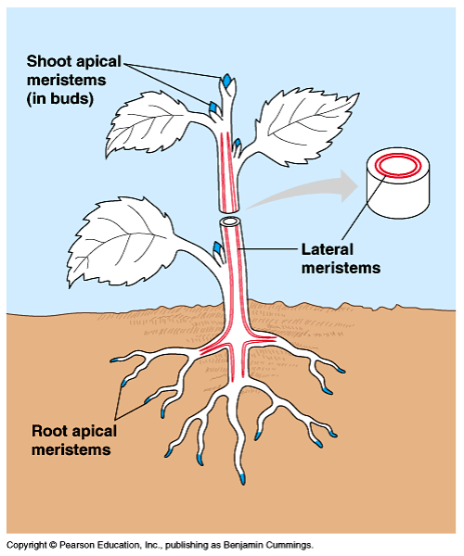

**Figure 67.** Primary and secondary meristems (Shoot apical and lateral meristems)

**I.1. Anatomic structure of the root**

**I.1.1. Primary structure of the root**

**I.1.1.1. In Monocotyledons**

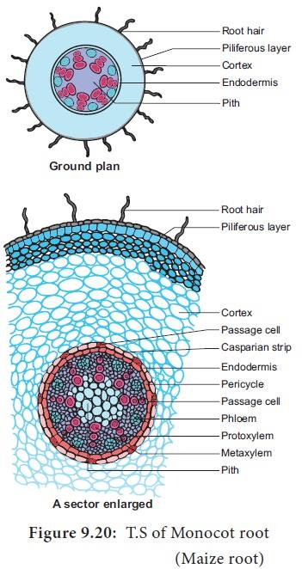

**Figure 69.** Anatomy structure of Dicot root (Bean root)

***a) Axial symmetry*** : The axial symmetry of dicot roots can be observed in the shape of cross sections, which display a distinct arrangement of tissues (shape of the cut) **(Esau, 1977)**.

***b) A bark***: More developed, formed by:

• **Hair base**

• **Suberous layer**: formed of a single layer of suberified cells.

• **A non-chlorophyll cortical parenchyma with meatus**

• **An endoderm (Evert & Eichhorn, 2013)**

***c) A central cylinder***

• **A pericycle**: reduced to a single layer of parenchymal cells.

• **Medullary rays**: They represent the regions of parenchyma located between the bundles of xylem and phloem.

• **Bundles of xylem and phloem**: are not numerous from 2 to 5, and arranged alternately.

The xylem develops at the level of the rays or in the shape of an X, and the phloem between these rays.

• **Absent marrow (Raven *et al.,* 2005)**

**I.1.2. Secondary structure of the root**

**I.1.2.1. Monocots**: No secondary structure.

**I.1.2.2. Dicotyledons and gymnosperms**

We distinguish two formations:

***a) Secondary libero - woody formation (Cambium)***: is located on the internal face of the phloem bundles and it gives rise to the pachyte (the collection of wood and bast).

The differentiation of the wood is towards the inside (which partly explains the absence of the pith = centripetal), while the bast is towards the outside (centrifugal). The cambium only functions during the summer, that is to say its activity is greater in spring than during summer and autumn **(**

***b) Secondary subero-phellodermal formation***: phellogen is formed deeply, most often from the pericycle. In certain plants this zone is more superficial and it can appear in the middle of the bark or under the hair base (Jasmine). Phellogen divides in a radial direction. The first fabric formed on the outer side is cork or suber. Then, on the inner side, some layers of parenchymatous tissue, the phelloderm, appear

**Note:** In roots, the epidermis is absent and is replaced by the suberized layer and the corky base in monocots and dicotyledons, respectively

**I.2. Anatomic structure of the stem**

**I.2.1. Anatomy of the stem**

**I.2.1.1. Primary structure of the aerial stem**

On a cross section of a stem, we observe the following characteristics:

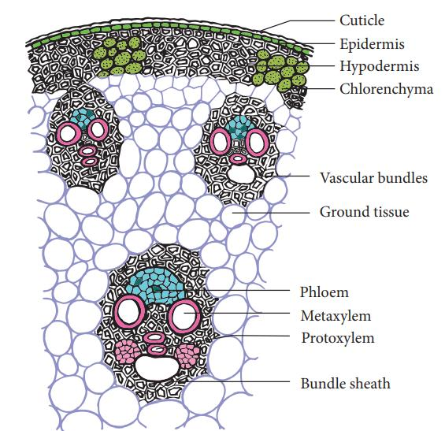

**Figure 70.** Anatomy structure of Monocot stem

***a) Axial symmetry*** (shape of the cut)

***b) A bark***: much smaller than in the case of the roots, formed by

• **An epidermis:** made up of a superficial layer of cells with a rectangular section, strongly cutinized by small stomata **(Esau, 1977)**.

• **A chlorophyll cortical parenchyma with meatus**: menu of small cells with cellulose primary walls **(Raven *et al.,* 2005)**.

***c) A central cylinder***: which occupies the largest part, formed by:

• **A continuous ring of sclerenchyma**: which delimits the central cylinder and encloses the outermost conducting bundles **(Evert & Eichhorn, 2013).**

• **Cribrovascular bundles**: are numerous, arranged in several concentric circles, and their size decreases from the center to the periphery. Each cribrovascular bundle is a collateral bundle where phloem and xylem are superimposed (xylem inwards, phloem outwards). The xylem forms a sort of V shape, the hollow of which is occupied by the phloem. A layer of sclerotized fibers superimposes each cribrovascular bundle (outwards) **(Raven *et al.,* 2005).**

• **A medullary parenchyma with meatus**: is located in the center of the central cylinder, which has cells larger than those of the cortical parenchyma **(Esau, 1977).**

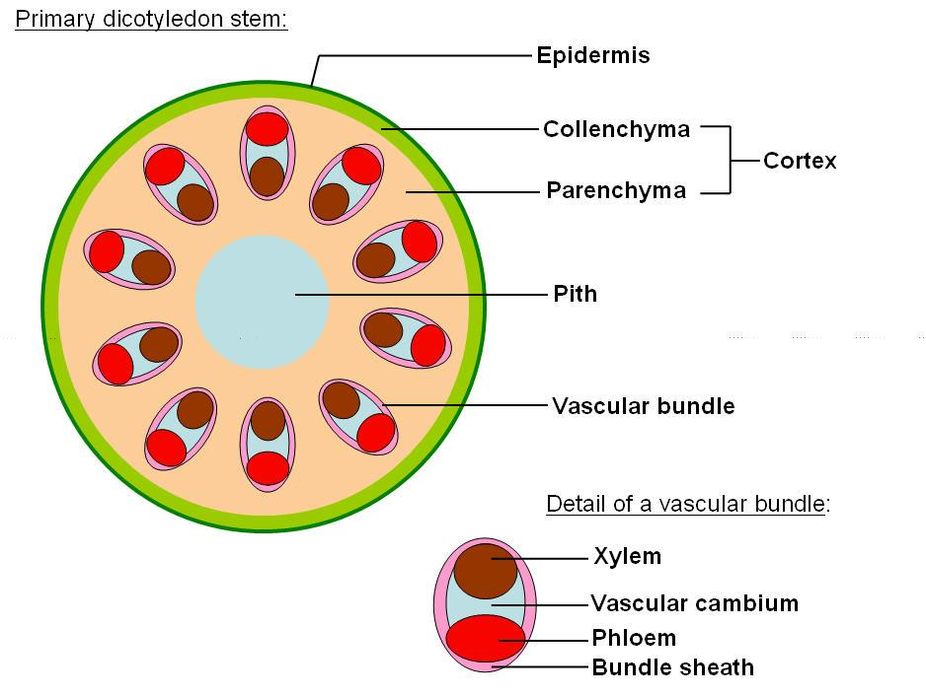

**Figure 71.** Anatomy structure of Dicot and Gymnosperm stem

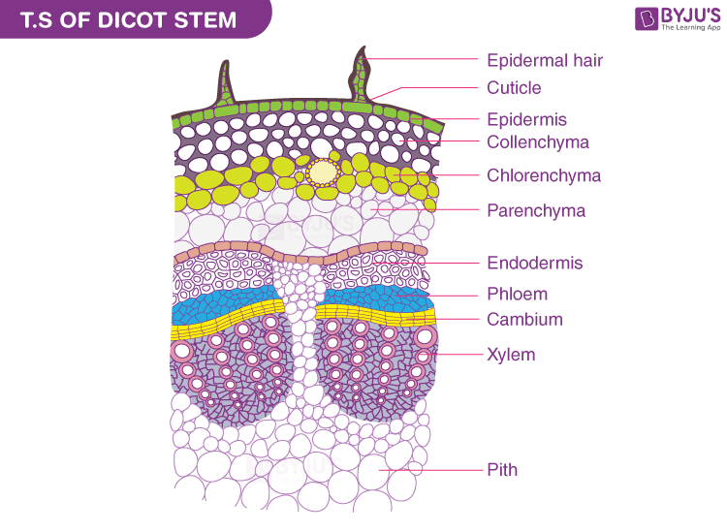

**Figure 72.** Details of different tissues of Dicot and Gymnosperm stem

**a) *Axial symmetry*** (shape of the cut)

**b) *A bark****:* formed by:

• **An epidermis**: made up of a superficial layer of cells with a rectangular section, strongly cutinized by small stomata and hairs **(Esau, 1977)**.

• **A collenchyma**: made up of two or three superficial cellular layers (seats) of the bark, located under the epidermis **(Raven *et al.,* 2005)**.

• **A cortical parenchyma with meatuses**: not very thick, with rounded, irregularly arranged cells **(Evert & Eichhorn, 2013).**

• **A chlorophyll parenchyma**: dispersed in the cortical parenchyma **(Raven *et al.,* 2005)**.

**c) *A central cylinder****:* which occupies the largest part formed by:

• **A ring of sclerenchymatous cells**: which delimits the central cylinder **(Esau, 1977)**.

• **Cribrovascular bundles**: forming one or two circles. In each bundle we observe towards the inside of the stem the xylem and towards the outside the phloem: the two are superimposed (collateral), forming a triangle, with the phloem on the base of the triangle.

• **A medulla**: is located in the center of the central cylinder, formed by a medullary parenchyma with large cells **(Evert & Eichhorn, 2013).**

• **Medullary rays:** between the cribrovascular bundles there are large sections of parenchyma connecting the medulla to the bark **(Esau, 1977)**.

**I.2.1.2. Secondary structure of the aerial stem**

**I.2.1.2.1. Monocots:** No secondary structure.

**I.2.1.2.2. Dicots and Gymnosperms**

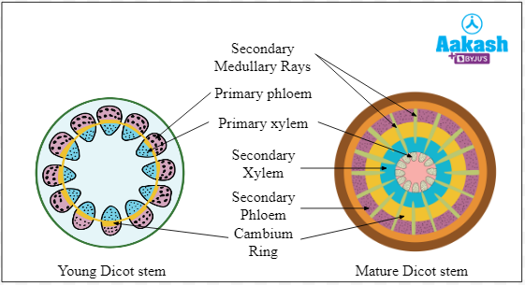

**Figure 73.** Secondary structure of the aerial stem (Dicots and Gymnosperms)

**a) Libero-woody secondary formation**: This is the formation of the Pachytes; wood (centrifugal) and bast (centripetal), and depending on the formation of the conductive tissues we can classify the secondary structures of the stems into two different types:

• **Continuous pachyte**: bast and wood are produced over the entire extent of the cambium.

This results in the formation of a continuous ring of conductive tissue **(Raven *et al.,* 2005)**.

• **Discontinuous pachyte**: bast and wood are only produced at the level of the conducting bundles of the primary structure, by the cambium. This results in the formation of a discontinuous ring of conductive tissue **(Esau, 1977)**.

**b) Secondary subero-phellodermal formation**: It appears later than the cambium by several years.

In most herbaceous plants with reduced secondary structure, it does not form. Whereas in woody plants it presents the same mode of root formation **(Evert & Eichhorn, 2013)**.

**I.2.1.2.3. Primary and secondary structure of the underground stem (Rhizome)**

It presents characteristics of the stem (structure and arrangement of the conductive apparatus) and characteristics of the roots (general appearance, significant bark, and the endoderm clearly differentiated) **(Raven *et al.,* 2005)**.

**I.3. Anatomic structure of the leaf**

On a cross section of a leaf, we can distinguish the following characters:

**I.3.1. Monocots**

**I.3.1.1. Primary structure**

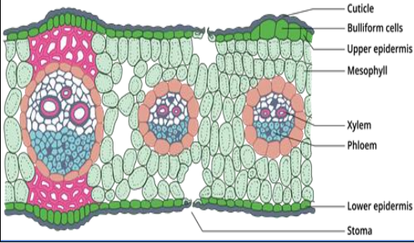

**Figure 74.** Anatomy of primary structure of Monocot Leaf

• **Bilateral symmetry**

• **An upper epidermis (ventral epidermis**): on the upper surface of the leaf

• **A lower epidermis (dorsal epidermis)**: on the underside of the leaf

• **A homogeneous mesophyll**: made up of parenchymal cells with meatus

• **Numerous parallel veins**: each has a liberolinous bundle formed of xylem (towards the upper surface) and phloem (towards the lower surface), and which are superimposed

**(Raven *et al.,* 2005)**.

**I.3.2. Dicots**

**I.3.2.1. Primary structure**

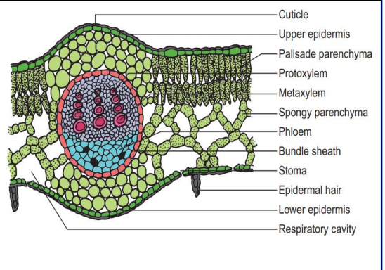

**Figure 75.** Anatomy of primary structure of Dicot Leaf (Sunflower)

• **Bilateral symmetry**

• **An upper epidermis (ventral epidermis)**: sometimes followed by a hypodermis on the upper surface of the leaf.

• **A lower epidermis (dorsal epidermis)**: on the underside of the leaf.

• A heterogeneous mesophyll: made up of palisade parenchymal cells towards the upper

surface and lacunar parenchymal cells towards the lower surface.

• **A main rib:** located in the center, and with an upper face less protruding (curved) than the lower face. It has a large liberoligneous bundle made up of xylem (towards the upper surface) and phloem (towards the lower surface) superimposed.

It has two supporting tissues, collenchyma followed by sclerenchyma respectively on both sides (outwards and inwards).

• **Secondary veins:** each has a small liberoligneous bundle of the same arrangement as the main vein.

Each secondary vein has outward supporting tissue on both sides, the sclerenchyma **(Raven *et al.,* 2005)**.

**I.3.2.2. Secondary structure**: Between each bundle of xylem and phloem we observe the cambium, which develops into secondary structure (wood and bast).

**I.3.3. Gymnosperms**

**I.3.3.1. Primary structure**

• **Bilateral symmetry**: Gymnosperm leaves display bilateral symmetry, where structures on both sides of a central axis mirror each other **(Esau, 1977).**

• **Ventral (upper) epidermis**: The upper surface of the leaf, often followed by a hypodermis.

The ventral epidermis is less cutinized than the dorsal epidermis, providing a barrier while allowing gas exchange **(Fahn, 1982).**

• **Dorsal (lower) epidermis**: Strongly cutinized, this epidermis is found on the underside of the leaf, protecting it from water loss and mechanical damage **(Raven *et al.,* 2005).**

• **Homogeneous mesophyll**: The mesophyll consists of undifferentiated chlorophyllous parenchyma cells, meaning there is no distinct separation into palisade or spongy mesophyll layers **(Beck, 2010).**

• **Cribrovascular bundles**: Vascular bundles with xylem positioned towards the ventral side and phloem towards the dorsal side. This arrangement allows efficient transport of water and nutrients within the leaf **(Esau, 1977).**

• **Transfusion tissue**: Specialized tissue surrounding the cribrovascular bundles, helping in water and nutrient movement between vascular tissues and the mesophyll **(Fahn, 1982).**

• **Protective sheath**: Surrounding the transfusion tissue, this sheath offers structural support and protection for the vascular elements **(Beck, 2010).**

• **Resin secretion channels**: Located within the mesophyll, these channels produce resin, which serves as a defense mechanism against herbivores and pathogens **(Raven *et al.,***

**2005).**

**I.3.3.2. Secondary structure**

• **Secondary vascular growth**: Between each vascular bundle, a cambium layer develops, leading to the production of secondary xylem (wood) and secondary phloem (bast), contributing to thickening and strengthening of the leaf structure **(Esau, 1977; Beck, 2010).**