**Chapter 3: Simple Tension and Compression**

1. **Definition**

A beam or a segment of a beam is said to be subjected to simple tension (or compression) if the internal force vector can be summarized as:

; Where N is the normal force in the cross-section.

* When N>0 it indicates tension
* When N<0 it indicates compression

1. **Stress/Normal Force Relationship**

The only non-zero stress in the cross-section is the normal stress σ\sigmaσ defined as:

σ = N/S​

where:

* N: normal force, unit: Newton (N)
* S: area of the cross-section, unit: square meter (m²)
* σ: normal stress, unit: Pascal (Pa), with 1 Pa=1 N/m2

σ is uniformly distributed over the section S.

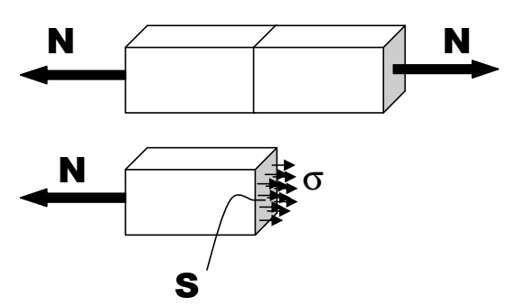

1. **Tensile Test**

The tensile test is performed on standardized specimens, which are generally cylindrical or prismatic, depending on the standard and the material being tested.

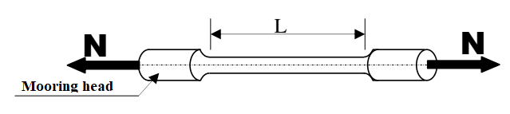

The specimen is subjected to a gradual tensile force using a testing machine. During the test, the tensile force N and the elongation ΔL of the specimen are measured, and the test is conducted until complete failure occurs.

The graph of N-ΔL varies somewhat from one material to another. For steel, the typical graph is represented in the following figure:

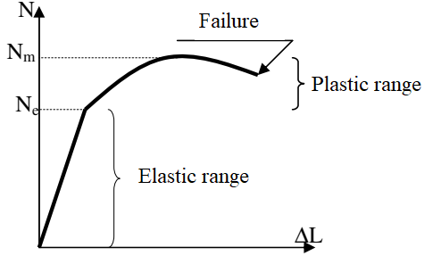

This graph is not practical because the force and elongation are specific to the specimen used. A more practical graph is obtained by replacing N with σ and ΔL with ε.

With: σ =N/S ​ and ε=ΔL/L

ε is the relative elongation or axial strain of the specimen and can be calculated from the measurement of ΔL or measured directly using devices called extensometers or other means such as strain gauges. It is a dimensionless value typically expressed as a percentage(%).

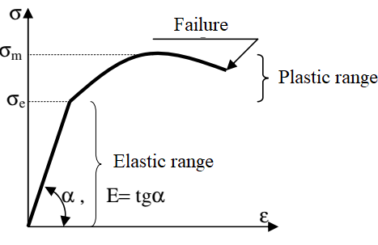

This graph is characterized by two domains:

* **Elastic Domain**: The graph is a straight line, and when the load is removed, the specimen returns to its original dimensions.
* **Plastic Domain**: The graph is a curve, and when the load is removed, the specimen does not return to its original dimensions; it is permanently deformed.

The elastic domain is limited by a value of σ called the yield strength (σe​); this is an important characteristic of the material. The maximum value that σ\sigmaσ can reach is also a characteristic of the material, known as the tensile strength (σm​).

1. **Stress-Strain Relationship**

As seen in the graph of σ vs. ε, in the elastic domain, the relationship between the normal stress σ and the axial strain ε is linear (a straight line). This is expressed by the relationship: σ = E.ε

It is called Hooke's Law. E is the slope of the elastic line and is also an important characteristic of the material known as the modulus of elasticity or Young's modulus.

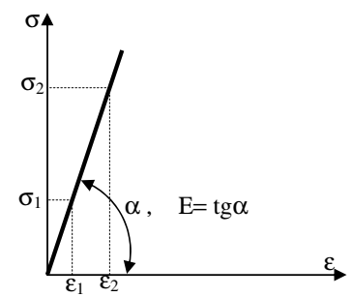

E can be calculated using the formula:

1. **Design Criteria**

To size a beam (calculate its cross-sectional dimensions), two criteria can be used: the stress criterion or the deformation criterion.

The stress criterion states that the material must remain (with a safety factor s) within the elastic domain, thus: σ ≤ σe\s​

where:

* σ: actual applied stress
* σe​: yield strength of the material
* s: safety factor (≥1).