1. **Phonetics and Phonology: The Sounds of English**

**Introduction**

Phonetics and phonology are two fundamental branches of linguistics that deal with the sounds of language. While phonetics focuses on the physical production, acoustic properties, and perception of sounds, phonology examines how sounds function within a particular language, including their patterns and rules.

**1. Phonetics: The Study of Speech Sounds**

Phonetics is divided into three main branches:

* **Articulatory Phonetics**: Studies how speech sounds are produced by the vocal organs.
* **Acoustic Phonetics**: Examines the physical properties of sound waves.
* **Auditory Phonetics**: Focuses on how sounds are perceived by the human ear.

**1.1 The English Sound System**

The English language has approximately **44 phonemes**, categorized into vowels and consonants:

* **Vowels**: Monophthongs (e.g., /ɪ/, /æ/) and diphthongs (e.g., /aɪ/, /oʊ/)
* **Consonants**: Plosives (e.g., /p/, /t/), fricatives (e.g., /f/, /s/), nasals (e.g., /m/, /n/), etc.

**1.2 Place and Manner of Articulation**

Consonants are classified based on **place of articulation** (e.g., bilabial, alveolar) and **manner of articulation** (e.g., stop, fricative).

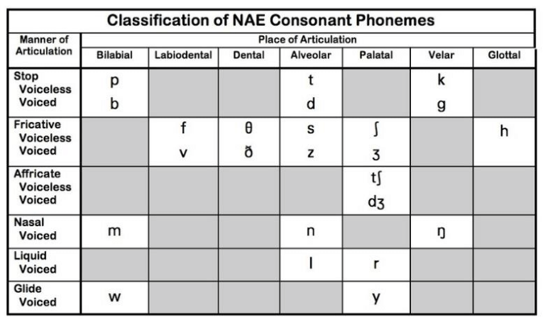

**2. Phonology: The Study of Sound Patterns**

Phonology explores how sounds are organized and function within a language. It involves:

* **Phonemes and Allophones**: Phonemes are the smallest units of sound that distinguish meaning, while allophones are variations of a phoneme.
* **Phonological Rules**: These describe systematic sound changes, such as assimilation (e.g., "input" pronounced as [ɪnpʊt̚] → [ɪmpʊt]).
* **Syllable Structure**: English syllables typically follow patterns like CV (consonant-vowel) or CVC (consonant-vowel-consonant).
* **Stress and Intonation**: Stress can change meaning (e.g., ‘record’ (noun) vs. ‘record’ (verb)), while intonation affects sentence meaning (e.g., rising intonation for questions).

**3. Differences between phonetics and phonology**

Phonetics studies speech sounds in terms of their physical properties, how they are produced, transmitted, and perceived. It is universal, applying to all languages. Phonology, on the other hand, focuses on how these sounds function in a specific language, analyzing patterns, rules, and structures that determine meaning. While phonetics deals with individual sounds (phones), phonology examines phonemes, the abstract units that influence word meaning.

**Conclusion**

Phonetics and phonology are essential to understanding how English sounds function. While phonetics provides the foundation for studying speech sounds, phonology explains their role in communication.

**References**

* Ladefoged, P. (2005). *A Course in Phonetics*. Cengage Learning.
* Roach, P. (2009). *English Phonetics and Phonology: A Practical Course*. Cambridge University Press.
* Yule, G. (2016). *The Study of Language*. Cambridge University Press.