**TP N° 3 : Plant tissues**

**Objective:**

Highlighting of cauline and root meristematic tissues, covering tissues and reserve parenchymatous tissues.

**Introduction:**

**Meristematic tissues**

In embryophytes (green plants), a meristem is a biological tissue made up of undifferentiated (or poorly differentiated) cells forming a growth zone where cell divisions (mitoses) take place. We distinguish between primary meristems, which ensure the plant's growth in length, at the level of the stem, leaves or roots, and secondary meristems, responsible for the growth in diameter of the organs of certain plants, such as the stem

**.**

**Epidermis:**

The epidermis is the outer layer of cells of the leaves. This layer is generally transparent (these cells do not have chloroplasts) and covered by a waxy cuticle that limits water loss during excessive heat. In plants from dry climates, this cuticle is therefore thicker. The cuticle is sometimes thinner on the lower epidermis than on the upper epidermis

**Reserve parenchyma:**

It is an abundant tissue in underground organs (root, stem, seed), devoid of chloroplasts. The reserves can be of different natures e.g.: carbohydrate, lipid, protein. Starch is considered among the most frequent reserve carbohydrates, its storage is carried out in amyloplasts (starch grains)

**Materials and reagents needed for manipulations:**

Microscope, slide and coverslip, onion, potato, olive leaf, fine tweezers, scalpel. Prepared slides of the root apex of the onion

**Manipulation:**

* Put the onion slide under a microscope for observation.
* Put the tape on the inner side of the olive leaf, apply a little pressure to have the maximum of the upper layer, remove the tape from the leaf and put it on a slide to observe under a microscope.
* Cut the potato in half, take a very thin layer and put it on a slide, cover the latter with a coverslip and observe under a microscope.
* For all manipulations, observe, draw carefully and label your drawings.

⮚ **Observation results:**

1. Root meristem of the onion

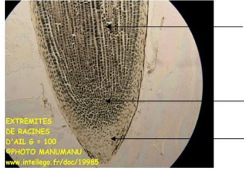

1. olive tree covering fabrics

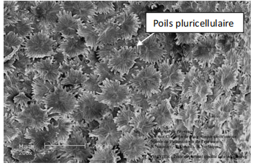

1. Potato parenchymal reserve tissues

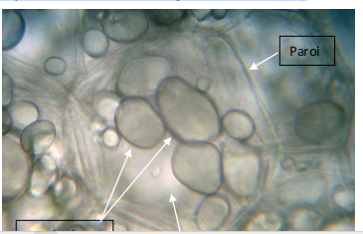

At the end of the TP3 session, the student can distinguish the difference between the tissues studied, and know their characteristics