University Center A. Elhafidh Boussouf Mila

Institute of Science and Technology

Department of Mechanical and Electromechanical Engineering Process Engineering 2nd year

**Solution Chemistry practical’s Works**

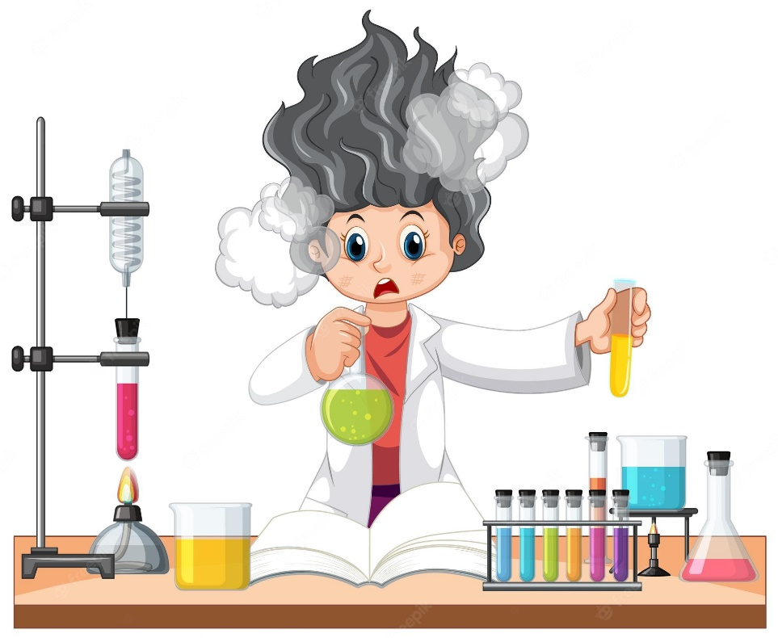

**Dr : Merzouki S.**

**2022/2023**

**Experiment 4 : determination of alkalinity of water using gran methode**

  We will calculate the amount of alkalinity in water by titrating the sample water with an acid, using pH-meter.

# Introduction :

Alkalinity is a measure of the capacity of a solution to neutralize a strong acid. Titration does not tell us the actual types of alkalinities present in the water (though we can make an educated guess, as discussed below).

The pH of water determines what type(s) of alkalinity can be found in the water.  By performing different endpoint pH values, we are able to estimate the proportions of carbonate, bicarbonate, and hydroxide alkalinity in the water.  The two values also help us determine whether the water is corrosive and whether it is caustic.

**and**

# reagents

solution of HCl (0,01N).

# Procedure:

1. Clean the burette and fill almost to the chlorohydric acid.
2. Measure out 100 mL of the water to be tested and pour into a beaker.
3. Insert the measuring electrode into the beaker.
4. Slowly and carefully add HCl acid from the burette to the contents of the beaker.  While adding the acid, the solution should be gently stirred with the stirring bar.
5. Record the value of pH for each volume of HCl acid.
6. Draw the curve pH=f(VB).

# QUESTIONS:

1. Determine endpoints
2. Calculate the alkalinity
3. Calculate the total alkalinity
4. Is the sample of water corrosive or caustic