***Chapiter III :***

***Binders***

**III.1. Introduction**

Binders are substances that have the ability to unite other materials together. In the field of construction, binders play an essential role in the formation of composite materials like concrete and mortar. When mixed with water, they create a sticky paste that gradually hardens to become a type of artificial stone. They ensure the cohesion of aggregates to form a strong and durable material.

**III.2. Binders Throughout History:**

Binders have played a crucial role in construction throughout history, with the use of various materials depending on technological knowledge and resources available at the time. Here is an overview of the evolution of binders over time:

1. **Antiquity:** The earliest known binders are clay and mud, used to bond raw earth bricks or stones in ancient structures. Lime (calcium oxide), made from heated limestone, was used by the Romans as a binder in Roman concrete. Roman concrete also utilized a type of volcanic ash called "pozzolana," which, when mixed with lime, created a chemical reaction that formed a hydraulic binder.
2. **The Middle Ages**: During the Middle Ages, lime became a common binder in masonry construction. Plaster, made from heated gypsum, was also used as a binder, particularly for interior finishes.
3. **The Industrial Revolution**: In the 19th century, with the Industrial Revolution, Portland cement was invented. Made from clay and limestone heated at high temperatures in a kiln, Portland cement hardens when mixed with water and became the standard binder in modern construction.
4. **The 20th Century and Beyond**: In the 20th and 21st centuries, innovation in construction materials led to the use of various additives and admixtures to improve the properties of Portland cement, such as fly ash, blast furnace slags, and plasticizers. Alternative binders, such as calcium aluminate cement (also known as geopolymer cement), have also been developed.

Future innovations in binders for construction will likely continue to evolve to improve durability, strength, environmental impact, and other important properties of construction materials..

Haut du formulaire

**III.3. Classification of Binders**

Binders, which are substances that harden and adhere to other materials to bond them together, can be classified in various ways. A common classification is based on their behavior in contact with water and air. In this classification, two main families of binders are distinguished:

1. **Air Binders**: These are binders that harden through a reaction with carbon dioxide in the air. An example is air lime (slaked lime or quicklime slaked with water), which is used in lime or plaster mortars.
2. **Hydraulic Binders**: These are binders that harden through a reaction with water. The most well-known hydraulic binder is Portland cement, which is used in the production of concrete. There are different types of hydraulic cements, including masonry cements, sulfate-resistant cements, rapid-setting cements, etc.

Each of these types of binders has its own characteristics and uses, and the choice of the appropriate binder depends on the specific requirements of the construction project. For example, air lime can be used for finishes and coatings in the restoration of historical buildings, while Portland cement would be more suitable for constructing concrete structures that require high strength.

It should be noted that binders can also be classified according to other criteria, such as their origin (natural or artificial), chemical composition, or strength

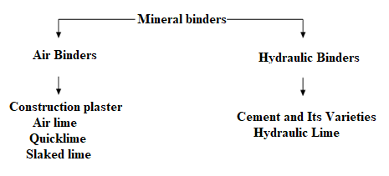  
Figure III.1. Binders classification

**III.4. Air Binders (Air Lime)**

**III.4.1. definition**

Air lime is a type of air binder, primarily composed of calcium hydroxide (Ca(OH)₂), commonly used in construction. It is produced by heating limestone at a high temperature in a process called calcination, resulting in quicklime. When exposed to air, quicklime absorbs carbon dioxide and hardens, forming slaked lime.

Air lime is widely used in mortars and plasters for its flexibility, vapor permeability, and ability to react with atmospheric acids to self-repair. It is also used to stabilize clay soils and improve their suitability for construction.

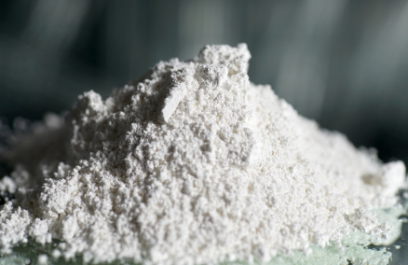

**Figure.III.2.** Lime

**III.4.2. Main Component of Air Lime:**

Lime is produced by calcining either limestone (CaCO₃) or dolomitic rock (a mixture of CaCO₃ and MgCO₃), then slaking it with water, which gradually solidifies in the air. This is why it is often referred to as air lime.

1. **Calcium Hydroxide [Ca(OH)2]** :

This is the main component of air lime. It is produced when quicklime is mixed with water in a slaking process. When exposed to air, slaked lime absorbs carbon dioxide (CO₂) and transforms into calcium carbonate (CaCO₃), allowing the lime to harden and bond with other materials.

1. **Additions to Air Lime:**

Although air lime is generally used alone, certain additions can be made to enhance its properties or meet specific construction needs.

1. **Pouzzolana** : Pozzolanas are siliceous or silico-aluminous materials that, while not binders themselves, can react with calcium hydroxide in the presence of water to form compounds with binding properties. Adding pozzolana to air lime can improve its strength and durability.
2. **Admixtures**: Various admixtures can be added to air lime to improve its properties. For example, water-retaining admixtures can be used to enhance the workability of lime, while set accelerators can be used to speed up the hardening time of lime.

It is important to note that additions to air lime must be made carefully, as they can affect the properties of the lime and its compatibility with other materials.

**III.4.3. Manufacturing**

To produce lime, calcite (CaCO₃) is heated to a temperature of around 800–900 °C.

This calcite will decarbonate to form calcium oxide, or CaO, also known as quicklime. Quicklime must be slaked by mixing it with water to become a usable product as a binder in construction. This results in a hydration reaction that leads to the production of slaked lime, or Ca(OH)₂, also known as portlandite.

Slaked lime is commercially available in powder or paste form, still referred to as air lime. The acquisition of its mechanical properties will occur through recarbonation and will take several days, weeks, or months.

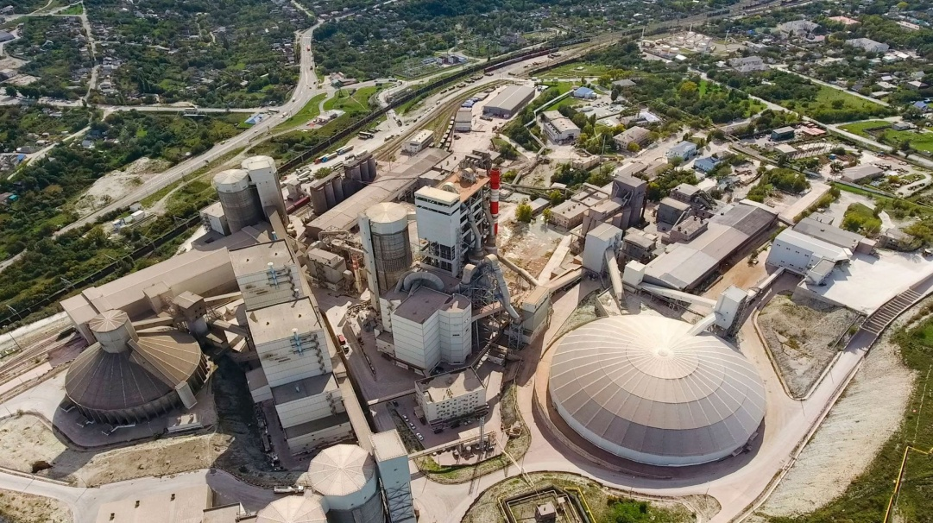

**Figure III.3**: Binders factory

**III.4.3.1 Extraction**

Limestone extraction takes place in quarries. In the past, this extraction was traditional and done manually using tools such as hammers, picks, and shovels. Nowadays, to simplify the extraction of rock, explosives are used. This can be more dangerous, but it is faster and more efficient.

The extracted rock blocks are then gathered using excavators and transported by trucks to specialized workshops for processing and transformation, which includes crushing, screening, and grading to achieve a stone size compatible with the type of kiln used

**III.4.3.2 Calcination**

In addition to traditional batch kilns, there are two types of kilns: vertical kilns and rotary kilns.

* **Vertical kilns:** Old vertical kilns, typical of batch processes, were designed for the successive stacking of layers of coke and limestone. They had a maximum capacity of a few tens of tons. Modern vertical kilns operate with liquid fuels like fuel oil or gaseous fuels like natural gas, allowing for better thermal efficiency through heat recovery and achieving exceptional capacities for a still discontinuous process, producing 150 to 500 tons per day. The limestone and fuel are added from the top in successive layers. The material progresses slowly downward, first passing through a preheating zone that allows for the evaporation of free water and dehydration at around 200 °C. It then enters the calcination zone where it is decarbonated at approximately 900 °C. At this stage, quicklime is obtained in the form of lumps. During this cooking process, calcium (CaCO₃) and, where applicable, magnesium (MgCO₃) carbonates decompose to form calcium and magnesium oxides, releasing carbon dioxide.
* CaCO3 CaO + CO2
* MgCO3 MgO + CO2

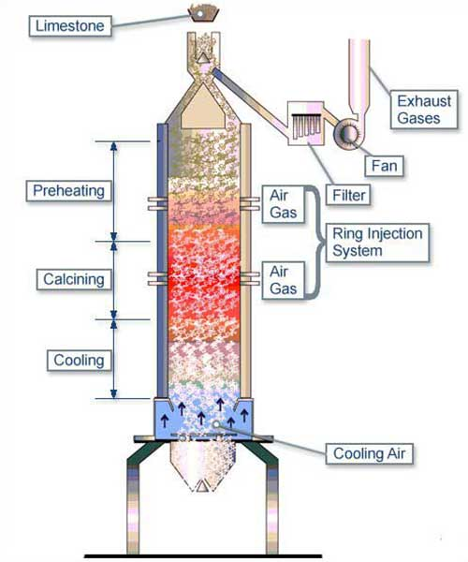

**Figure. III. 4.** Vertical kiln

* **Rotary kilns:** Rotary kilns have a lower thermal efficiency but continuous loading capacity, allowing for the production of over a thousand tons per day.

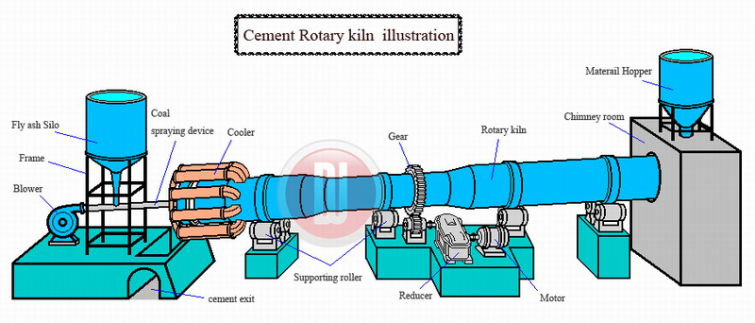

**Figure. III. 5.** Rotary kiln

The feeding of crushed limestone occurs continuously to prevent smothering the kiln. The rotary kiln has specifications similar to those in the cement industry. For lime production, the material is heated to a temperature between 1000 °C and 1300 °C, depending on the desired type of lime. Limestone is introduced from one end. Before calcination, it goes through a preheating phase. Once the lime is formed, it is cooled before being removed from the kiln. Horizontal kilns consume more fuel than vertical kilns. However, they have the advantage of producing up to 1000 tons per day. Another advantage of horizontal kilns is their more flexible management, allowing for the use of smaller-sized stones and quick starts. However, due to their high fuel consumption, industry professionals tend to favor vertical kilns today. During the process, the stone slowly descends, first passing through a preheating zone. This crucial step aims to evaporate the water present in the stone, preventing the blocks from bursting. The stone then moves to another zone where it is calcined. This decarbonation process leads to the release of CO₂ starting at 900 °C. For dolomites, this decarbonation occurs at a lower temperature, around 400 °C, producing magnesia (MgO). The water vapor generated is expelled along with the smoke. This vapor effectively contributes to the decarbonation of limestone, due to its strong affinity for carbon dioxide.

**III.4.3.3. Slaking**

After the baking operation, quicklime is obtained, which will then be slaked and transformed into slaked lime through several processes, depending on the type of slaking chosen:

* **Spontaneous Slaking:** This occurs when quicklime is exposed directly to open air or when atmospheric moisture gradually hydrates it.
* **Water Spraying Slaking:** This method is done manually by sprinkling small amounts of water onto the quicklime.
* **Immersion Slaking:** In this process, quicklime is immersed in water, and after drying, it is stored to complete the slaking process. Incorporating the lime must be done with caution, as the reaction can lead to splashing and bubbling.

**III.5. Uses**

Air lime, often referred to as hydrated lime or slaked lime, has several applications in the construction field. Here are some of its main uses:

1. **Plasters and Mortars:** Air lime is commonly used in plasters and mortars for walls, both indoors and outdoors. It offers excellent vapor permeability, allowing walls to "breathe."
2. **Lime Paints:** These paints are valued for their unique aesthetic appearance and their ability to allow moisture evaporation.
3. **Restoration**: Air lime is ideal for the restoration of historic buildings, as it is compatible with traditional materials and construction techniques.
4. **Soil Stabilization**: Lime is used to improve soil properties, particularly in soils that contain a large amount of clay.
5. **Masonry**: It is used as a binder in masonry, especially for natural stone and bricks.
6. **Water Treatment**: Although not directly related to construction, air lime is sometimes used to treat water by adjusting pH levels.
7. **Moisture Protection**: Lime-based plasters can help regulate humidity inside buildings, preventing condensation and mold.
8. **Thermal Insulation**: Lime has a natural ability to regulate temperature, which can enhance thermal comfort in buildings.

Using air lime offers numerous advantages such as flexibility, the ability to "heal" microcracks, and improved indoor air quality by regulating humidity. It is also appreciated for its ecological properties, being a natural material with a relatively low carbon footprint compared to modern Portland cements.

**III.6. Hydraulic Binders (Portland Cements)**

Cement is a hydraulic binder, meaning it is a finely ground inorganic material that, when mixed with water, forms a paste that sets and hardens due to hydration reactions and processes. After hardening, it retains its strength and stability, even underwater (NF P 15-301 standard of 1994).

Portland cement is the most commonly used hydraulic binder in construction. It is produced by heating a mixture of limestone and clay in a rotary kiln at a temperature of 1450°C, resulting in a product called clinker. The clinker is then ground into a fine powder and mixed with a small amount of gypsum to produce Portland cement.

Portland cement hardens when mixed with water, forming a solid matrix that binds aggregates together to create concrete or mortar. It is widely used due to its water resistance, durability, and high strength.

**III.6.1. Classification of Cement**

Cement classification varies based on standards and regulations in different countries. However, a general classification is based on performance, constituents, and possible applications of cement. Here is an overview of this classification:

1. **By Composition**:
   * **Portland Cements** :
     + Ordinary Portland Cement (OPC)
     + Sulfate-Resistant Portland Cement (SRPC)
     + High Early Strength Portland Cement
   * **Blended Cements**:
     + Portland Slag Cement (or Steel Slag Cement)
     + Portland Pozzolana Cement
     + Composite Portland Cement (which may include additions of slag, pozzolana, fly ash, etc.)
   * **Special Cements**:
     + Low Heat Hydration Cement
     + White Cement (used for its aesthetic color)
     + Acid-Resistant Cement (designed to withstand chemical attack)
     + Rapid Hardening Cement
     + Calcium Aluminate Cement (or High-Alumina Cement)

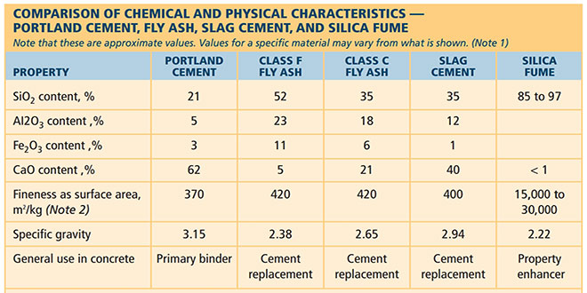

1. **By Strength**:
   * Class 32,5
   * Class 42,5
   * Class 52,5 (The numbers refer to the minimum compressive strength in MPa, typically measured at 28 days.)

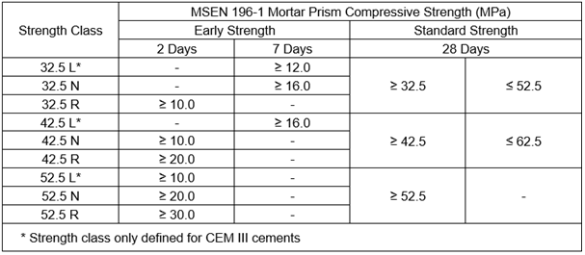

1. **By Specific Use**:
   * Masonry Cement
   * Underwater Use Cement
   * Well Drilling Cement

It is important to note that each type of cement is formulated to meet specific needs, and the choice of the appropriate cement will depend on the intended application, exposure conditions, and desired properties of the finished material.

Additionally, classification standards may vary by region, with ASTM (American Society for Testing and Materials) standards in the U.S. and EN (European Norm) standards in Europe presenting variations in classification and specifications.

**III.6.2. Cement Manufacturing**

Cement manufacturing is a complex process that involves several steps and can be done through two main methods: dry and wet, as demonstrated in Figure 125. Each method includes sub-methods, such as dry and semi-dry for the dry method, and wet and semi-wet for the wet method.

The main constituents of cement are limestone (about 80%) and clay (about 20%). Several steps and transformations are necessary to produce the final product. The following outlines these different steps:

1. **Raw Material Extraction:** The primary raw materials for cement production are limestone (which provides calcium) and clay or shale (which provides silicon, aluminum, and iron). These materials are extracted from quarries, typically located near the cement plant.

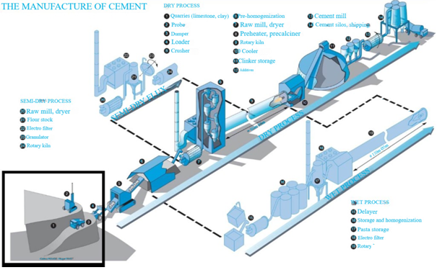

1. **Grinding and Mixing of Raw Materials (Raw Meal Preparation):** The raw materials are ground into a fine powder in a mill. The mixture, called raw meal, is carefully controlled to ensure the correct chemical composition. Raw meal processing can follow four distinct methods:
   * **Wet Method:** Now almost obsolete due to high energy consumption. In this approach, limestone and clay are mixed and finely ground with water to form a liquid paste (containing 28% to 42% water). This paste is then homogenized and stored, mainly used when extracted materials have a high moisture content.
   * **Semi-Wet Method:** Involves filtering the paste (prepared similarly to the wet method) and then forming cylinders that are fired on a grate.
   * **Semi-Dry Method:** Requires moistening the powder obtained after grinding and drying it to transform it into granules, which are then fired on a moving grate.
   * **Dry Method (the most common):** The raw material is prepared as powder, with the following steps:

a) **Pre-Homogenization:** This step aims to produce a uniform mixture, which can be done by layering the material horizontally and collecting it vertically with specific equipment or in a vertical silo by agitation with compressed air. b) **Grinding-Drying:** The mixture is then transferred to the grinding station, where it is transformed into a powder with particles smaller than 160 microns. c) **Homogenization:** During this step, through pneumatic or mechanical mixing, a completely uniform substance is obtained, ready to be fired.

1. **Calcination:** Calcination occurs in rotary kilns, typically measuring about 5 m in diameter and 80 to 100 m in length, although they can extend up to 200 m. This process takes place at temperatures between 1400 and 1500 °C and aims to convert the raw meal into clinker. Key steps in the processing cycle include:
   * **Preheating:** Conducted in a heat exchanger upstream of the kiln. Hot gases from the kiln flow counter-currently to heat the meal.
   * **Decomposition of Clays:** Occurs at temperatures above 500 °C.
   * **Decarbonation of Limestones:** Takes place at a temperature of 950 °C in the kiln's midsection, where temperatures vary between 550 and 1000 °C.
   * **Clinkering:** The formation of clinker occurs at a temperature of 1450 °C in the kiln's final section, near the burner.

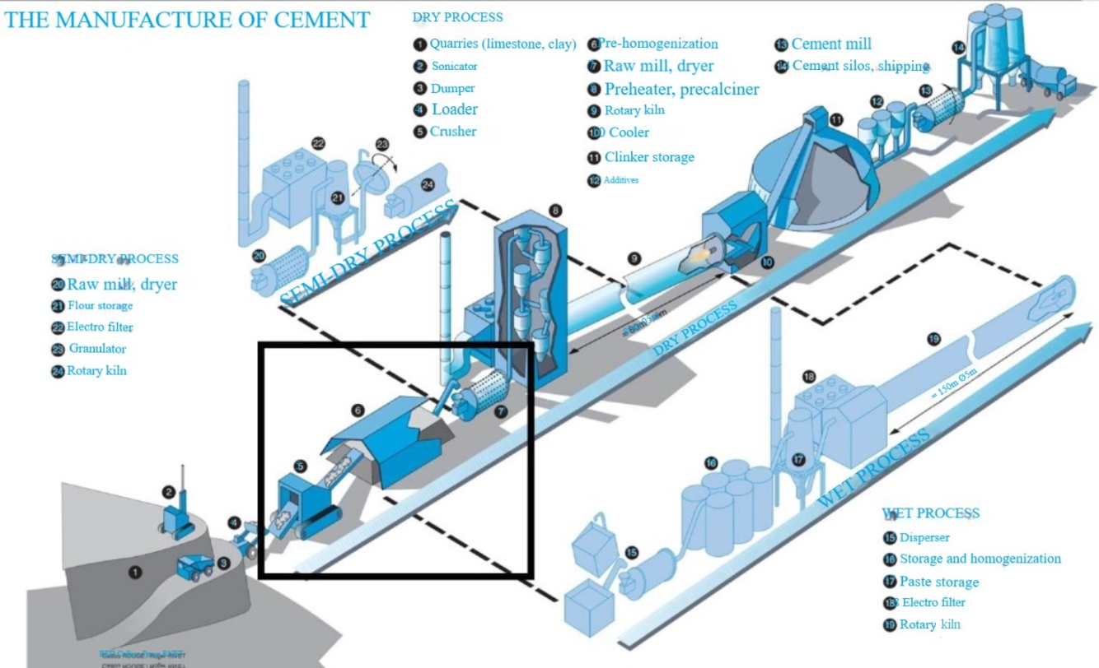

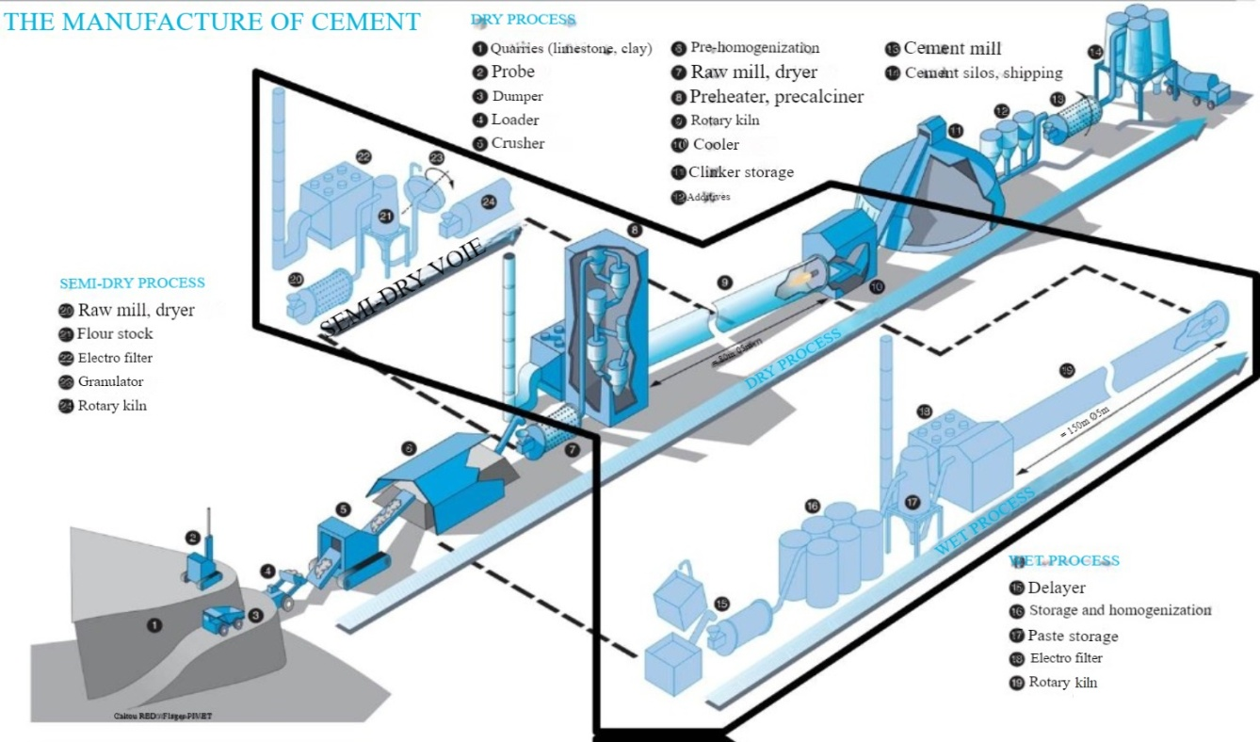

1. **Cooling (Quenching):** The clinker is then rapidly cooled to stop ongoing chemical reactions.

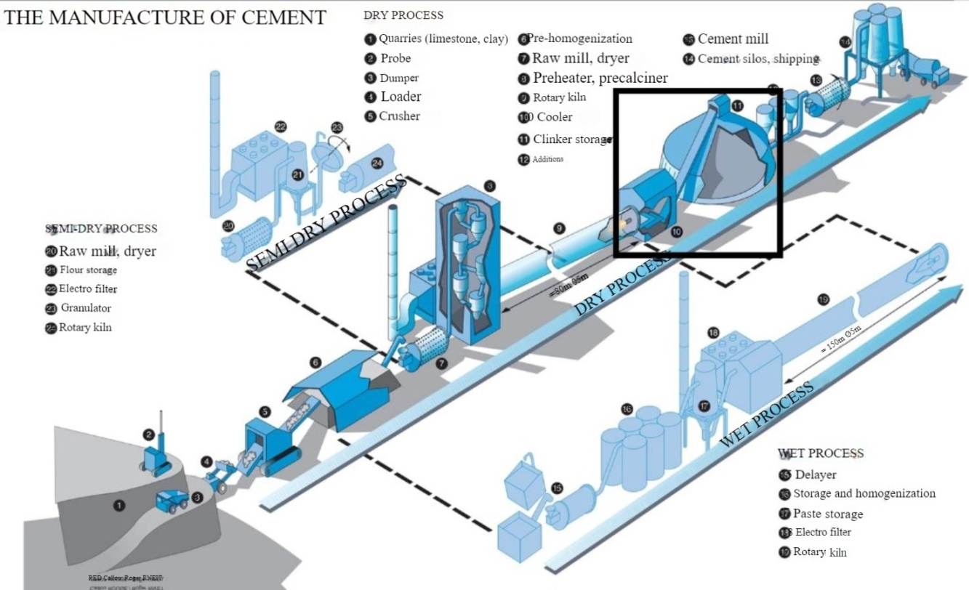

1. **Grinding the Clinker:** The clinker is ground into a fine powder. Sometimes, additions such as gypsum (to control the setting time of the cement) or blast furnace slag, fly ash, and pozzolana (to improve cement properties) are added during grinding.

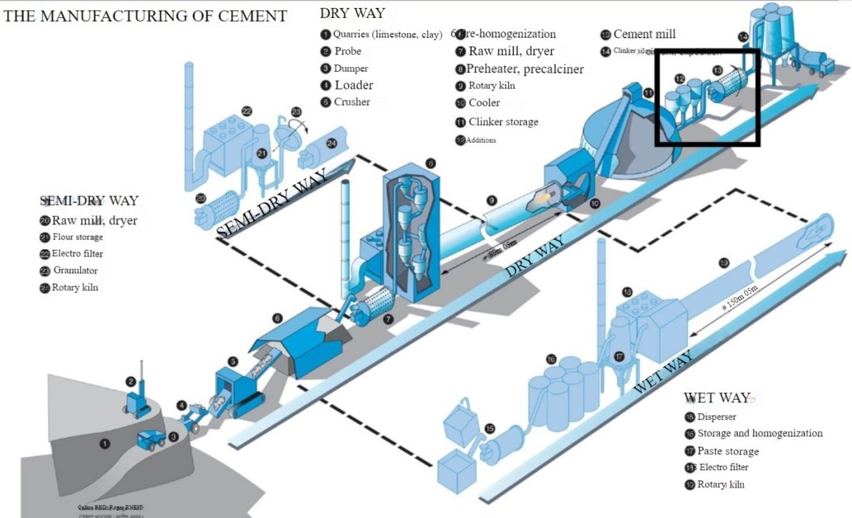

1. **Packaging and Shipping:** Finally, the cement is packaged in bags or shipped in bulk for use in construction.

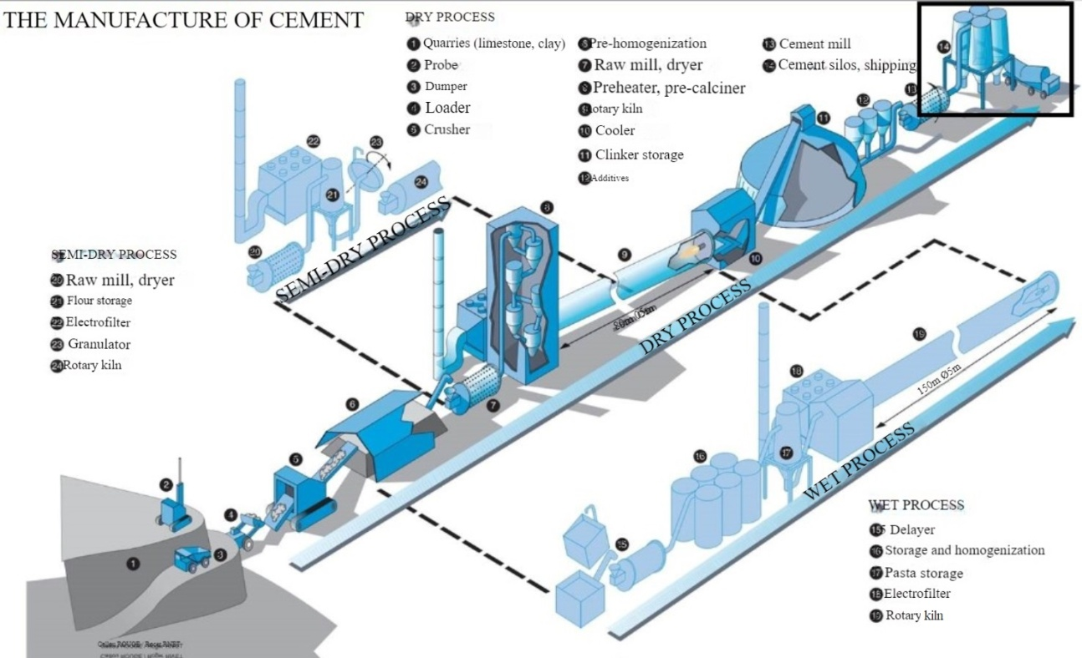

**III.6.3. Uses**

Portland cement is essential in the construction field due to its binding properties. It is used in various applications. Here are some of the main uses of Portland cement in construction:

1. **Concrete:** Portland cement is the primary component of concrete, which is a mixture of cement, aggregates (such as sand and gravel), and water. Once mixed and hydrated, concrete hardens into a solid mass used in a wide variety of structural applications.
2. **Mortar:** A mixture of Portland cement, sand, and water, mortar is used to assemble masonry units such as bricks and concrete blocks.
3. **Screeds and Slabs:** Cement is used to create screeds or slabs that serve to level or form a base for other floor finishes.
4. **Repairs:** Cement mixtures are often used for repairing damaged concrete structures, including roads, bridges, and buildings.
5. **Precast Concrete:** Portland cement is used to manufacture precast concrete elements, such as beams, columns, slabs, pipes, and other structural or non-structural components.
6. **Adhesives and Sealants:** Special cement-based mixtures are used as adhesives to bond different materials or as sealants to make structures waterproof.
7. **Coatings:** Portland cement is often used as a base for exterior coatings, such as stucco.
8. **Foundations and Pillars:** Foundations, whether shallow or deep, use Portland cement-based concrete to support structures like houses, buildings, or other infrastructures.
9. **Roads and Bridges:** Portland cement-based concrete is used for constructing roads, pavements, sidewalks, and bridges.
10. **Sewer and Drainage Systems:** Concrete pipes and channels are commonly used for drainage and sewer systems.
11. **Plasters:** Portland cement is also used as a main component in various types of plasters for construction. Using Portland cement in plasters offers excellent durability and protection against moisture. However, it is essential to prepare the surface properly before applying the plaster, maintain proper mixing proportions, and ensure adequate curing to achieve the best results and avoid issues such as cracking. Here’s how it is employed in this context: a. **Cement Plaster:** A mixture of Portland cement, sand, and water, this plaster is particularly resistant to weather and moisture, making it a popular choice for exterior coatings of buildings. It can also serve as a sub-layer or base for other finishes. b. **Polymer-Modified Cement Plaster:** Polymers are added to the traditional cement-based plaster to improve certain properties, such as flexibility, adhesion, or water resistance. These plasters are especially useful in areas subjected to structural movements or mechanical stresses. c. **Sprayed Plaster:** Portland cement is also used in sprayed plasters applied using machines. This technique is often employed to quickly apply plaster over large surfaces. d. **Decorative Plasters:** Although cement-based plasters are generally gray due to the natural color of Portland cement, pigments can be added to achieve a variety of colors and textures. e. **Repair and Restoration:** Cement-based plasters are often used for repairing and restoring deteriorated or damaged facades.

Portland cement is valued for its durability, strength, and ability to set and harden under almost any condition. It has played a central role in the development of modern infrastructure.

**III.7. Main Constituents and Additions**

**III.7.1. Main Constituents**

* Clinker (K)
* Granulated Blast Furnace Slag (S)
* Natural Pumice (Z)
* Fly Ash (V and W)
* Limestones (L)
* Silica Fume (D)

**III.7.2. Secondary Constituents**

They must not exceed 5% by mass.

* Fillers (F)
* Calcium Sulfate

**III.7.3. Additives**

Additives are components that are not included in the list above and are added to improve the manufacturing process or the properties of the cement.

**III.8. Characteristics of Portland Cement**

**III.8.1. Normal Consistency**

The consistency of cement characterizes the amount of water required to mix with the powder to obtain a paste with what is known as normal consistency. To assess this fluidity, the Vicat apparatus and the Vicat needle are used. The distance (d) characterizes the suitability of the consistency of the paste being tested.

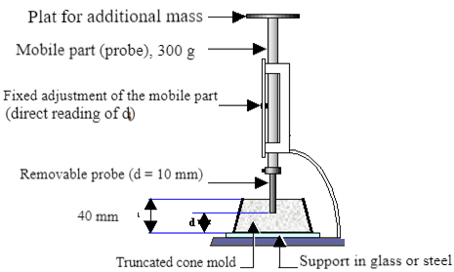

**Figure III.6.** Vicat’s apparatus

* If **d = 6 mm ± 1 mm**, the paste is said to have normal consistency.
* If **d** does not reach this value (**d > 7 mm** or **d < 5 mm**), the test should be repeated with a different **water-to-cement ratio (E/C)** until the desired consistency value is reached.

The amount of water required to obtain a paste of normal consistency for all types of cement typically ranges from **24% to 30%** of the mass of the cement.

**III.8.2. Setting Time**

The setting time is typically measured on a pure cement paste with normal consistency (24% to 30% water) using the Vicat apparatus. It is also possible (though not standard) to measure the setting time of a mortar using the same apparatus by placing a 700-gram weight on the upper plate. The weight of the needle that penetrates the mortar is 1000 grams.

* The initial setting time is the moment when the needle stops at a distance of d = 4 ± 1 mm from the bottom of the paste or mortar.

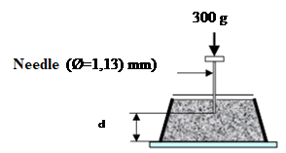

**Figure III.7.** Measurement of the penetration depth of the needle (initial setting time)

The final setting time is the moment when the needle stops at a distance of d = 39.5 mm.

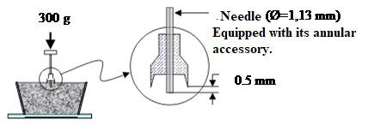

**Figure III.8.** Measurement of the penetration depth of the needle (final setting time)

Depending on their strength class, the standards specify a minimum setting time, which at a temperature of **20°C**, is:

* **1 hour 30 minutes** for cements of classes 35 and 45.
* **1 hour** for cements of classes 55 and HP.

**III.8.3. Fineness of Grinding (Blaine Fineness)**

It is characterized by the specific surface area of the cement grains, expressed in **cm²/g**. In typical cases, this is in the range of **3000 to 3500 cm²/g**.

The mass surface area of cement is not measured directly. Instead, a known volume of air is passed through a cement powder. All other factors being equal, the greater the surface area of the powder, the longer the time **t** it takes for the air to pass through the powder.

Under standardized conditions, the apparatus used to determine the cement grinding fineness is called the "**Blaine Permeameter**." This apparatus is shown schematically in **Figure III.12**. It mainly consists of a cell in which the cement to be tested is placed, and a manometer consisting of a U-shaped glass tube, filled with a light oil up to its lower mark (No. 4). The cell is equipped with a grid at the bottom. A piston is used to compact the cement in the cell under a defined volume **V**.



* **K** – constant of the apparatus
* **P** – porosity of the cement layer (assumed to be 0.5)
* **t** – time for air to flow between two markers (2–3)
* **ρ** – absolute density of the cement (g/cm³)
* **η** – viscosity of the air at the temperature of the test

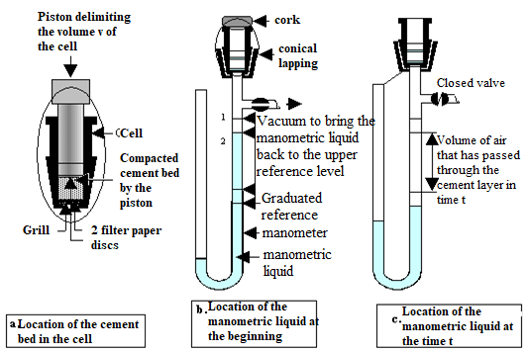  
**Figure III.9.** The principle of operation of the Blaine Permeability Tester

1

2

3

4

1

2

3

4