**Phylum Molluscs (Mollusca)**

**General Characteristics of Molluscs**

**-** Molluscs are aquatic and terrestrial animals, non-segmented, with bilateral symmetry sometimes altered by torsion.

- Their body is soft. It generally consists of a head, a visceral mass, and a foot which ensures locomotion.

- Presence of lateral folds called mantle which delimit the pallial cavity

**-** Presence of a calcareous shell secreted by the edges of the mantle

- The general cavity is more or less reduced to the pericardium, nephridia and gonads.

- In the oral cavity there is a chitinous rasp (the radula).

- The digestive tract with salivary glands and hepatopancreas.

- The typical nervous system of a mollusk includes cerebroid ganglia (which can fuse to form a brain) connected on the one hand to pedal ganglia, on the other hand to visceral ganglia, by a double perioesophageal collar.

- The circulatory system is open, circulation is incomplete. The heart is made up of at least one ventricle and two atria. From the heart there are short arteries but there are no veins or capillaries. The blood is colorless, or lightly colored by dissolved hemoglobin or hemocyanin.

- The excretory system includes one or two kidneys or metanephredia

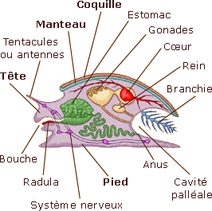**-** The respiratory system is either with gills or with lungs

Organization of a typical mollusc

## Reproduction

Most species are gonochoric. But some groups are hermaphrodites (gastropods in particular). Reproduction is exclusively sexual. Fertilization is external, it takes place in water. The trochophore type larva called veliger.

**Haut du formulaire**

**Systematic**

Haut du formulaire

Classes belonging to the phylum Molluscs

**Haut du formulaire**

**Class Aplacophora :** They are very primitive molluscs, exclusively marine. Their body is vermiform, the foot is rudimentary, the shell and radula are reduced.

**Haut du formulaire**

**Class Polyplacophora** or chitons : The body is elongated. The shell is made up of eight articulated plates

**Class Monoplacophora :** Primitive patelliform molluscs with a single shell. They have eight pairs of shell-fixing muscles, five pairs of gills, six pairs of nephridia.

**Class Gastropoda or univalves :** Molluscs with a single shell: reduced, simple or spiral for the most evolved species.

**Class Scaphopoda :** Molluscs with horn-shaped or tooth-shaped shells open at the ends.

**Class of Bivalvia or lamellibranches** : Molluscs having two distinct valves, generally asymmetrical, articulated.

**Class Cephalopoda :** Molluscs with a crown of eight or ten tentacles surrounding the mouth.

Bas du formulaire

Bas du formulaire

Bas du formulaire

**Phylum Arthropoda**

Haut du formulaire

General characteristics of Arthropods

- Arthropods are bilaterally symmetrical invertebrates.

- Their body is segmented into two or three distinct parts.

- Presence of a rigid cuticle forming a thick chitinous exoskeleton which protects the body.

- Each metamere is framed by several skeletal plates, a dorsal piece or tergite, a ventral piece or sternite and two lateral skeletal pieces or pleurites.

- Presence of articulated appendages on the segments (arthron = joint, podo = foot) - Specialization of the different regions of the body and their appendages (heteronomic segmentation)

- The body cavity is the hemocoel - The digestive system is made up of a differentiated digestive tract which carries salivary glands, liver and pancreas. The digestive tract is divided into three parts: stomodeum (foregut), mesenteron (midgut), and proctodeum (hindgut).

-The excretory apparatus is of the metanephredial type which appears in the form of Malpighian tubes.

-The respiratory system is made up of specialized organs, gills (e.g.: Crustaceans), tracheas (e.g.: Myriapods, Hexapods) or lungs and tracheas (e.g.: Spiders).

-The circulatory system is open with a dorsal tubular heart (figure 35). The blood is colorless or bluish.

- The nervous system is well developed, the head ganglia are fused into the brain.

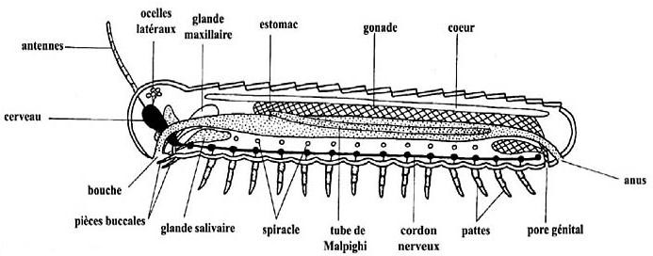

Diagram of a primitive Arthropod

## Reproduction

The sexes are separated. Fertilization is internal. Presence of sexual dimorphism. Arthropods develop with metamorphosis (significant transformation of the body and lifestyle), followed by molts (change of the integument).

## Systématic

## This branch is subdivided into five sub-branches

## A- Trilobitomorpha sub-phylum

## -They are made up of a single class of Trilobites. These are fossil arthropods, the most primitive, marine or living in sand.

## - Their size varied from a few cm to a few tens of cm.

## - They had three longitudinal lobes, one axial lobe and two lateral lobes.

## -The biramous legs (two lobes), internal lobe for locomotion and external lobe for swimming (figure 36).

Trilobite 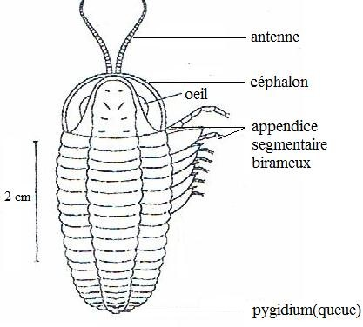

**Haut du formulaire**

**B- Sub-phyllum of Crustacea**

-Crustaceans are mainly marine, rarely freshwater and terrestrial. Many forms are parasitic.

- Their body is divided into cephalothorax and abdomen.

- All metameres bear appendages which are often biramous.

-They are distinguished by one or two pairs of sensory antennae followed by a pair of cutting mandibles and one or two nutritional appendages and walking legs.

- Their exoskeleton is reinforced with calcium salts.

- They have gill breathing, even for terrestrial forms.

-Their development is either dilated (the animal goes through various larval and adult stages and presence of metamorphosis) e.g. shrimp, or condensed (a small crustacean emerges from the egg which resembles the adult) e.g. crayfish.

- Crustaceans are divided into several classes, among these classes

**Haut du formulaire**

**Class Branchiopoda**

They are free, often have a carapace and two large biramous antennae ensuring swimming e.g. Daphnia pulex

**Class Ostracoda**

They are fast swimming aquatic crustaceans. They have a carapace which encloses the body and head ex: Cythereis sp

**Class Maxillopoda**

They are characterized by a reduction of the abdomen and appendages. They include free or fixed aquatic forms in the adult state, but there are parasitic forms of aquatic animals (such as fish) e.g. Cyclops sp, Argulus foliacens, Balanus sp (barnacle).

**Class Malacostraca**

They are the largest marine, freshwater and terrestrial crustaceans. The number of thoracic and abdominal segments is fixed (8 in the thorax and 6 in the abdomen). The head is fused with the thorax in a cephalothorax (figure 37) e.g. shrimp, lobsters, crabs.

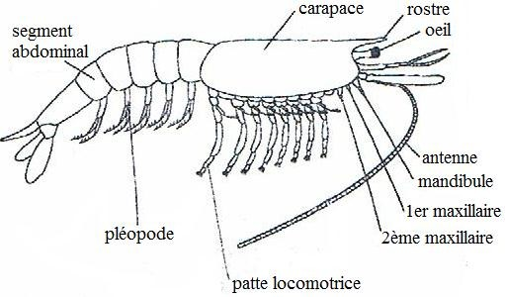

Haut du formulaire

Shrimp Morphology

**Haut du formulaire**

**C- Sub-phyluml of Myriapoda (Myrias = ten thousand = innumerable)**

**-** Myriapods are tracheally breathing terrestrial arthropods.

- The exoskeleton contains a pigmented protein.

- The appendages are uniramous, the most anterior form the antennae. - The locomotor limbs are located behind the head, clearly separated from the rest of the body.

- Among the classes belonging to this branch

**Class Diplopoda (millipeds)**

The abdominal segments each carry two pairs of locomotor appendages. The head bears a pair of short antennae and two pairs of mouthparts. Diplopods are vegetarian or saprophages. These animals are all terrestrial, e.g. Spirobolus sp.

**Haut du formulaire**

**Class Chilopoda (centipedes)**

Each segment bears a pair of legs. The head has a pair of long antennae and three pairs of mouthparts. Their bite is dangerous and sometimes fatal. They have poisonous claws. Chilopoda are carnivorous, e.g. centipede, lithobia.

**Haut du formulaire**

**D- Hexapoda sub-phylum**

Hexapoda have three pairs of legs and they group together four classes: Collembola, Diplura, Protura and Insecta.

-Collembola, Diploura and Protoures are the most primitive Hexapods. Small in size, wingless. The mouthparts are internal. They live in cool and humid places (soil, humus). The abdomen bears appendages on the first segments. Development takes place without metamorphosis, these are Ametaboles, the egg gives an individual similar to the adult and which will molt until the imaginal or imago molt which gives the adult.

- Insects are terrestrial, aerial or aquatic Hexapods. Their body is divided into three parts: the head, thorax and abdomen.

The head: bears simple (ocelli) and compound (ommatidia) eyes, a pair of antennae, the mouth and external mouthparts (labrum, mandibles, maxillae and labium).

- The thorax has 3 segments (prothorax, mesothorax and metathorax) each carrying a pair of walking legs. The mesothorax and metathorax can each carry a pair of wings.

- The abdomen has no appendages and ends in the anus.

Hexapoda have three pairs of legs and they group together four classes: Collembola, Diplura, Protura and Insecta.Hexapoda have three pairs of legs and they group together four classes: Collembola, Diplura, Protura and Insecta.Hexapoda have three pairs of legs and they group together four classes: Collembola, Diplura, Protura and Insecta.Bas du formulaire

[The respiratory system is made up of tracheas (terrestrial insects) and false gills (aquatic insects) and stigmata. - The sexes are separated. The phenomenon of parthenogenesis exists in some, e.g.: aphids, bees. - The digestive tract is differentiated (pharynx, esophagus, crop, gizzard, intestine](https://www.google.com/url?esrc=s&q=&rct=j&sa=U&url=https://translate.google.com/%3Fhl%3Dar&ved=2ahUKEwigiL6Gg4WKAxWI-gIHHZbjLfkQFnoECAYQAg&usg=AOvVaw1QK2ZREojwvJ57LCtrH592)

Haut du formulaire

The development of insects is achieved either by:

o Incomplete or heterometabolous metamorphosis

If the larva differs from the adult in its morphology and biology, we speak of a hemimetabolous insect e.g.: Dragonfly♣If the larva resembles the adult in its morphology and biology, we speak of a paurometabolic insect, e.g. grasshopper, bedbug.

o Complete or holometabolous metamorphosis: All larval stages are present (Presence of the nymphal stage) e.g.: Mosquito, butterfly.

The development of insects can stop and this stop is called: Diapause

- The class of insects includes two groups

o **Apterygote insects**: These are primitive flightless insects, e.g. Silverfish (silverfish).

o **Pterygote insects**: These are winged insects. There are more than 25 orders.

Among the heterometabolous orders

Ephemeroptera Odonata

Dictyoptera Orthoptera

Dermaptera Isoptera

Haut du formulaire

Among the holometabolous orders

Lepidoptera Diptera

Siphonaptera Hymenoptera Coleoptera

**E- Sub-phylum of Chelicerata: (chele = pincer).**

-Most are terrestrial, lacking antennas.

-They have six pairs of appendages, the first two of which are different. One represents the chelicerae (preoral appendages most often in the form of pincers) and the other represents the pedipalps. The other pairs are walking legs.

- The body is divided into 2 parts, the prosoma and the opisthosoma

Haut du formulaire

Chelicerates are divided into three classes

* **Class of Merostomata**: These are primitive aquatic Chelicerates with branchial breathing e.g. marine crab
* **Class of Pycnogonida** (Sea Spiders): These are marine Chelicerates with a spindly appearance, small in size. The opisthosoma is rudimentary. No respiratory or excretory system. The larvae are parasites of Cnidarians.
* **Class Arachnida**: These are terrestrial Chelicerates whose respiration is ensured by lungs (and) or tracheas. Among the best known orders

o **Order of Scorpions (Scorpions):** The body is elongated and segmented. The opisthosoma ends in a sting equipped with a venom gland. The pedipalps are transformed into pincers and the chelicerae are small.

o **Order Araneae (Spiders):** The prosoma and opisthosoma connected by a thin pedicle. The chelicerae are with venom gland.

o **Order of Opiliones (Opilions):** The globose body resulting from the fusion of the prosoma and the opisthosoma. The walking legs are long and slender, several times larger than the size of the body.

o **Order Acari (Mites):** They are generally small. The prosoma and opisthosoma are completely fused into a single mass. The number of pairs of legs varies during the cycle, three pairs in the larva, and four in the adult. The pedipalps are transformed into a biting device, e.g. ticks.

Class of Merostomata: These are primitive aquatic Chelicerates with branchial breathing e.g. marine crab • Class of Pycnogonida (Sea Spiders): These are marine Chelicerates with a spindly appearance, small in size. The opisthosoma is rudimentary. No respiratory or excretory system. The larvae are parasites of Cnidarians. • Class Arachnida: These are terrestrial Chelicerates whose respiration is ensured by lungs (and) or tracheas. Among the best known ordersClass of Merostomata: These are primitive aquatic Chelicerates with branchial breathing e.g. marine crab • Class of Pycnogonida (Sea Spiders): These are marine Chelicerates with a spindly appearance, small in size. The opisthosoma is rudimentary. No respiratory or excretory system. The larvae are parasites of Cnidarians. • Class Arachnida: These are terrestrial Chelicerates whose respiration is ensured by lungs (and) or tracheas. Among the best known ordersBas du formulaire

### 

Bas du formulaire

### 

Bas du formulaire

Bas du formulaire

### 

Class Diplopoda (millipedsBas du formulaire

### 

Bas du formulaire

### 

Bas du formulaire

### 