**Chapter 6: Torsion**

**1. Definition**

A beam or a segment of a beam is said to be subjected to simple torsion if the internal force system can be reduced to:

Where Mt​ is the torsion moment around the x-axis.

**Note:** In this course, we only consider the torsion of beams with circular cross-sections.

**2. Stress/Strain Relation**

Consider a beam with a circular cross-section fixed at one end and subjected to a torsion moment Mt ​at the other end. It is experimentally observed that each cross-section of the beam rotates by an angle proportional to its abscissa. There is no longitudinal deformation, so there is no normal stress; only tangential stresses exist.

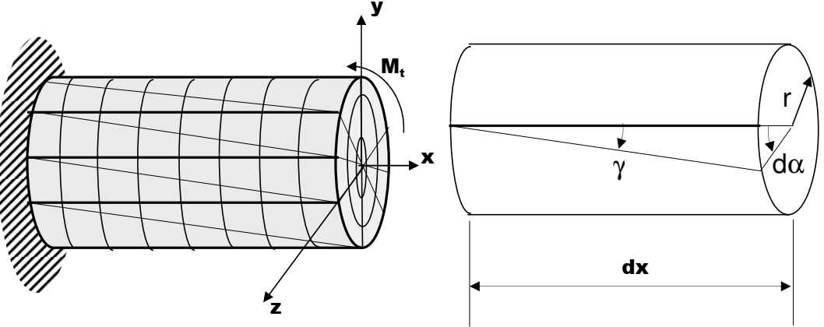

The angle of deformation γ is called the distortion. Since γ is small, we can approximate γ by tan(γ), and we obtain:

γ = r .(dα/dx)= r.θ​

Where:

* γ is the angular distortion,
* r is the radius of the section,
* θ is the rotation of the section,
* dx is the infinitesimal length.

The diagram resulting from the torsion test is similar to that from a tensile test, and it has an elastic domain and a plastic domain.

The elastic domain is governed by the shear Hooke's law:

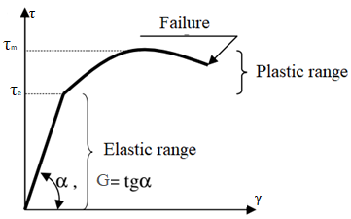

τ=G.γ

τ=G.r. θ

Where:

* τ is the shear stress,
* G is the shear modulus of the material.

We note that G is related to the Young's modulus E by the formula:

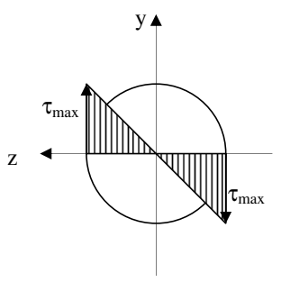

G=E/2(1+ν)

Where ν is Poisson's ratio.

The formula τ=G.r.θ​ also gives the distribution of shear stress .

over the beam's cross-section.

The shear stress is zero at the center and maximum at the outer surface.

**3. Stress/Moment Relation**

Consider a surface element ds of a beam's cross-section subjected to a torsion moment. This surface element, located at a distance r from the center of the section, is subjected to the shear stress τ.

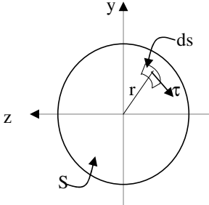

The torsion moment relative to this surface element ds is:

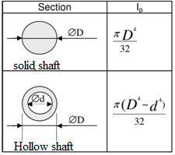

dMt = τ.ds.r

Since τ=G.r.θ ​, we obtain:

dMt=G.r2.θ.ds

The total moment is obtained by integrating dMt

over the surface S:

Mt=∫SG.r2.θ.ds = G. θ ∫S r2.ds = ∫S r2.ds; then Mt = . Ip

The term ∫S r2.ds is the polar moment of inertia Ip​

of the section and can be easily calculated.

The maximum shear stress occurs at r=R, and is given by:

τmax = Mt.R / Ip

**4. Relation between Rotation Angle and Moment**

To calculate the rotation angle of a cross-section at abscissa x:

θ = dα /dx = Mt / (G.​Ip)​ then α = ∫x0 (Mt / (G.​Ip))​ dx

Thus, the rotation angle between two extreme sections of a beam of length L is:

α=∫L0 (Mt / (G.​Ip))​ dx = Mt .L / (G.​Ip) Where:

* Ip​ is the polar moment of inertia of the cross-section,
* G is the shear modulus,
* Mt​ is the torsion moment.

**5. Design Criteria**

As with tension, two criteria can be used to calculate the transverse dimensions of a beam subjected to simple torsion:

* The **stress criterion** and
* The **rotation criterion**.

The stress criterion imposes that the material stays within the elastic domain (with a safety factor):

τmax ≤ τe/s Where:

* τmax​ is the maximum applied shear stress,
* τe​ is the shear yield strength of the material,
* s is the safety factor (s≥1s \geq 1s≥1).

The rotation criterion imposes that the angle between the extreme sections does not exceed a given limit.

**6. Power Transmission**

In mechanics, a shaft rotating at an angular speed ω (rad/s) and subjected to a torsion moment Mt​ transmits power P such that:

P = Mt . ω = 2 π f Mt

Where f is the rotational speed (in revolutions per second).