**1st Year Grammar Adjectives**

1. Definition

Adjectives are words that modify (describe) a noun or pronoun by providing descriptive or specific detail.

Adjectives usually precede the noun or pronoun they modify. Adjectives do not have to agree in number or gender with the nouns they describe. Adjectives answer the following questions: What kind?, How many?, or Which ones?

Example: Tom bought a used car. (used describes what kind of car Tom bought.)

Sally baked ten pies for the school bake sale. (ten tells how many pies Sally baked.)

Bob climbed that tree in the backyard. (that specifies which tree Bob climbed.)

1. ***Position***

Adjectives can come in 2 positions:

* 1. **Attributive position:** (before nouns): *a* ***rich*** *man /a* ***happy*** *girl*
  2. **Predicative position**: after a verb such as be, become, seem, appear, feel, get/grow (= become), keep, look (= appear), make, smell, sound, taste, turn: *He got/grew* ***impatient .*** *He made her* ***happy***

***3. How many Kinds of adjective?***

The different types of adjectives are described in detail with examples.

**1- What are the proper adjectives**? The adjective which is formed from a proper noun is called proper adjective. For example Proper nouns : China, India, Pakistan, America

Proper adjectives: Chinese, Indian, Pakistanis, Americans

**2- What are the adjectives of quality?** The adjectives which describe the quality, weakness or state of a person or the thing are known as the adjectives of quality. For example: 1) He is a good boy.

2)It is a beautiful flower.

**3.What are the adjectives of quantity?** It describes the quantity or idea of a thing. Some examples of adjectives of quantity are: much, a little, more, some, sufficient, enough etc.

**4. What are numerical adjectives?** The adjectives which denote the number of persons or the things are known as the numerical adjectives. There are further two types of numerical adjectives:

a**- Definite numerical adjectives** are one, two, three etc. There were two elephants in the Zoo.

b- **Indefinite numerical adjectives:** All, some, many, any, several are the indefinite numerical adjectives. All men must die.

**5. What are demonstrative adjectives?** The demonstrative adjectives points out towards a person or a thing. For example: this, that, he, she, it etc.

**6. What are distributive adjectives?** It denotes a person or a thing separately. For example: each, every, either, neither etc. Every word of the Holy Quran is a truth. Everyone should do his duty.

**7.What are interrogative adjectives?** It is used before a noun to ask something. For example: who, whose, what, which etc. Who is knocking at the door? What game do you like?

**8. What are the possessive adjectives?** It denotes possession. For example: my, our, your, own, his, her, their etc. He has ruined his health. This is my book.

**9. What are emphasizing adjectives?** The emphasizing adjectives denote stress on a noun. For example: Idleness is the very reason of his failure.

He is the only heir too his property.

**10. What are the exclamatory adjectives?** Exclamatory adjectives show the feelings and emotions. “what and how” are the exclamatory adjectives.

How beautiful the bird is!

What a lovely scene of nature!

**4.Coordinate Adjectives**

A coordinate adjective consists of two or more adjectives separated by a **comma** instead of by a coordinating conjunction. Example: a cold, rainy day

To determine if you can replace the coordinating conjunction with a comma, see if the adjectives can be reversed or if and can be added between the adjectives without changing the meaning. If the adjectives can be reversed, they are coordinate and a comma can be used.

Example: The clowns arrived in a bright, shiny car. The clowns arrived in a shiny, bright car. (Reversing bright and shiny does not change the meaning.) The clowns arrived in a bright and shiny car. (Adding and between bright and shiny does not change the meaning.)

However, if the adjectives cannot be reversed or if and cannot be used, a comma cannot be used. Example: The clowns arrived in two colorful cars. The clowns arrived in colorful two cars. (Reversing two and colorful changes the meaning.) The clowns arrived in two and colorful cars. (Adding and between two and colorful changes the meaning.)

**5. Compound Adjectives**

Compound Adjectives consist of two or more words that function as a unit. Depending on its position within the sentence, the compound adjective is punctuated with or without a hyphen. When a compound adjective comes before the noun it modifies, use a hyphen to join the adjectives. When a compound adjective follows the noun it modifies, do not use a hyphen to join the adjectives.

Example: She is taking a class on **nineteenth-century** literature. (The adjective nineteenth-century precedes the noun literature so a hyphen is used.)

She is studying literature from the **nineteenth century**. (The adjective nineteenth century comes after the noun literature so no hyphen is used.)

6.Comparison

|  |  |  |
| --- | --- | --- |
| **Positive** | **Comparative** | **Superlative** |
| Dark Tall  Useful | Darker Taller  More useful | Darkest Tallest  Most useful |

* Short (**One-syllable)** adjectives form their comparative and superlative by adding ***er*** and

***est*** to the positive form: *bright brighter brightest*

* Long adjectives (**three or more syllables)** form their comparative and superlative by putting ***more*** and ***most*** before the positive form: *interested more interested most interested*
* Adjectives of two syllables follow one or other of the previous rules: *clever cleverer cleverest obscure more obscure most obscure*
* **Irregular adjectives :**

|  |  |  |
| --- | --- | --- |
| **Positive** | **Comparative** | **Superlative** |
| Bad Good Far  Old | Worse Better  Farther (distance) Further (additional) Older (people/things )  Elder (people only) | Worst Best Farthest Furthest Oldest  Eldest |

The+ adjective

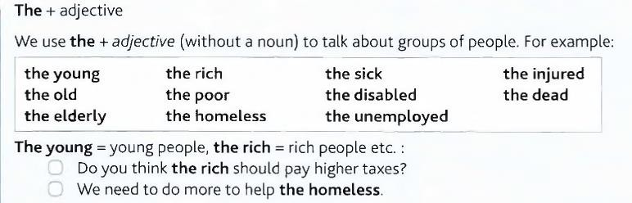

* These expressions have a plural meaning; they take a plural verb and the pronoun is ***they***:

*The poor get poorer, the rich get richer*.

Adjectives ending in ing and ed

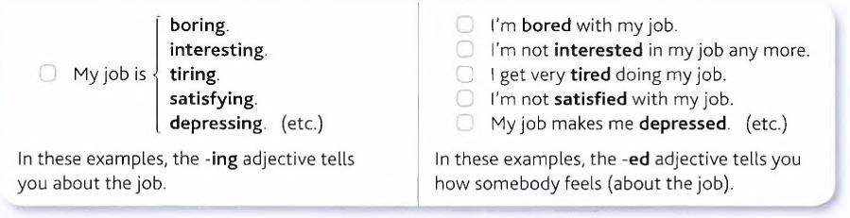

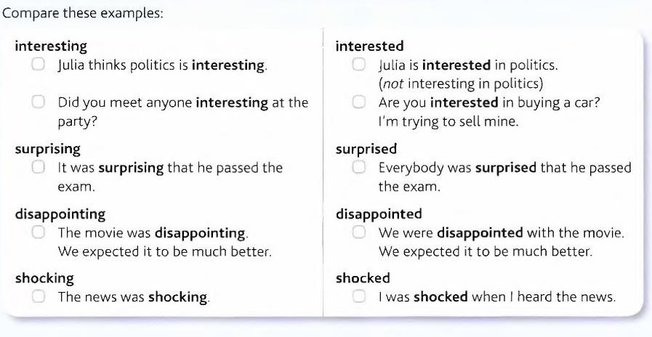

***Determiners as Adjectives***

Determiners, such as articles, pronouns, and numbers, can function as adjectives. When a determiner is used as an adjective, it restricts the noun it modifies, like a limiting adjective. Determiners functioning as adjectives tell Which one?, How many?, and Whose?

* Articles (a, an, the)
* Possessive pronouns (my, our, your, his, her, its, their) Relative pronouns (whose, which, whichever, what, whatever)
* Demonstratives (this, these, that, those)
* Indefinite pronouns (any, each, other, some, etc.) Cardinal Numbers (one, two, three, etc.)
* Ordinal Numbers (last, first, second, etc.)
* Possessive proper nouns (Bob’s, Sarah’s)

**Example:** Bob’s house is only three blocks from that house. (Bob’s answers the question: Whose house? Three answers the question: How many blocks? That answers the question: Which house is three blocks from Bob’s house?)

***7. Order of Adjectives***

Placement and Order of Adjectives A single noun can be described as a list of adjectives. When more then one adjective is used to modify a noun, it is important to consider the order in which the adjectives appear. Generally, the adjectives most important in completing the meaning of the noun are placed closest to the noun. Following is the usual order of adjectives in a series:

1. **Determiners:** articles (a, the), demonstratives (this, those), and possessives (his, our, Mary’s, everybody’s), amounts (one, five, many, few), order (first, next last)
2. **Coordinate adjectives** (subjective evaluations or personal opinions): nice, nasty, packed, pitiful
3. **Adjectives describing size**: big, huge, little, tiny
4. **Adjectives describing shape**: long, short, round, square
5. **Adjectives describing age:** young, old, modern, ancient
6. **Adjectives describing color**: blue, green, red, white
7. **Adjectives describing nationality**: Italian, French, Japanese
8. **Adjectives describing architectural style or religion**: Greek, Gothic, Catholic, Jewish, Muslim
9. **Adjectives describing material**: cardboard, plastic, silver, gold
10. **Nouns functioning as adjectives**: soccer ball, cardboard box, history class

*Example:* -A big brick house (article, size, and material)

-These old brown cardboard boxes (demonstrative, age, color, material) .

-A beautiful young Italian woman (article, personal opinion, age, nationality)

**8.Using Adjectives**

1. **Adjectives as Subject Complements**

The subject complement is a word that follows a linking verb and modifies the sentence’s subject, not its verb. Linking verbs: appear, become, believe, feel, grow, smell, seem, sound, remain, turn, prove, look, taste, and the forms of the verb to be. Example: The crowd appeared calm. (The linking verb appeared links the noun the subject crowd with the adjective calm)

1. **Adjectives as Object Complements**

The object complement is a word that follows a sentence’s direct object and modifies that object and not the verb. An object complement answers the question what? after the direct object. Example: Bob considered the experiment a success. (Success is the object compliment that modifies the sentences direct object experiment.)

1. **Adjectives with Past and Present Participle Verbs**

Adjectives are frequently formed by using the past participle (-ed, -t, or -en) and the present participle (-ing) verb forms. Example: The group of children scared the sleeping dog. (Sleeping describes the baby.) The students refused to eat the dried fruit. (Dried describes the cookies.)

<https://www.southeastern.edu>

<https://englishgrammarpdf.com/>