**Chapter III: Different types of tissues**

**Introduction**

Meristematic tissues are regions of actively dividing cells in plants that give rise to new cells and contribute to the plant's growth and development. These tissues are responsible for primary and secondary growth in plants. There are two main types of meristematic tissues

• ***Primary meristem (Apical meristem)***

• ***Secondary meristem (Lateral or Cambial meristem)*** .

**1.1.Primary meristems**

Primary meristems appear first during embryogenesis (the formation of the embryo),

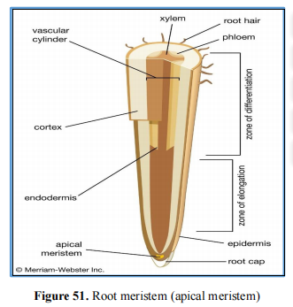located at the apex of stems (cauline meristems) and roots (root meristems), and at the base of leaves laterally (axillary meristem), these functioning primary meristems will give rise to different tissues. These are referred to as primary tissues, to distinguish them from secondary tissues, which appear in some plants at a later stage. They are typically responsible for the lengthy growth of plants, and the tissues derived from them undergo slight thickening in the absence of secondary meristems. Their cells are characterized by:

➢ Small and isodiametric, perfectly joined.

➢ A chromatin-rich central nucleus occupying a large part of the cell volume (high nucleocytoplasmic ratio).

Organelles with little structure, undifferentiated plastids (proplasts),

➢ Numerous small vacuoles Thin walls (primary walls).

➢ Numerous mitochondria.

***a) Root meristem***

• ***Localization and role***: The root meristem is found at the tip of a plant root. It's responsible

for facilitating the growth in length of the root system.

• ***Structure:*** The root meristem called ***apical meristem*** is protected by a ***root cap***, a structure

made of specialized cells that cover and shield the delicate meristematic cells as the root

pushes through the soil. The root cap also helps in navigating through the soil particles and

protects the meristem from abrasion damage.

Root meristems are classified into different zones based on the stages of cell development

and differentiation

***b) Stem meristem***

• ***Localization and role***: Stem meristem refers to the specialized meristematic tissue found in

the tips of plant stems. It's responsible for the increase in length or height of the stem.

• ***Structure***: The stem meristem is protected by a structure known as the ***apical meristem***.

The apical meristem is found at the growing tips of the stem, specifically the terminal bud.

It contains a group of undifferentiated cells that divide rapidly, generating new cells that contribute to the elongation of the stems, leaves, lateral buds and flower buds. The regions of the stem meristem are somewhat analogous to those found in the root meristem

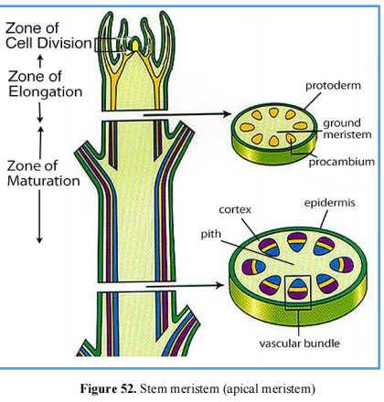

**III.1.1. Primary tissues**

In plants, primary tissues refer to the initial tissues formed from the activity of the primary

meristems during the growth of the plant. These primary tissues are the fundamental building

blocks of the plant body and are classified into 4 main types (see **Figure 53)**:

• ***Protective tissue (epidermis/ dermal tissue)***

• ***Ground tissue***

• ***Vascular tissue***

• ***Secretory tissues***

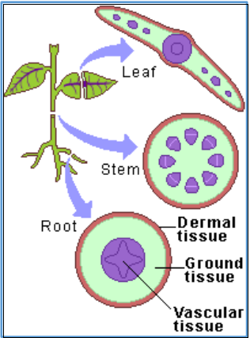

**Figure 53.** Different types of primary meristem tissue

**III.1.1.1. Protective tissue (epidermis / dermal tissue)**

In plants, the epidermis is a specialized protective tissue that serves as the outermost layer of

various plant organs (see **Figure 54)**.

• ***Structure:*** The epidermis is typically composed of a single layer of cells, but the cells may

vary in shape, size, and structure depending on the plant organ and its function.

• ***Type:*** Including two types:**DR. N. . 45**

***a- Epidermis***

- ***Epidermis***: Outermost cell layer of the stems, leaves, and flowers. It consists of

stomata.

- ***Rhizodermis***: Outermost cell layer of the roots forms of a long hair-like structures

which creates larger absorptive surface area. Epidermal cells can help in the absorption

of water in roots.

***b- Cork (suber)***: Cork is constituted by a layer of cells formed by cortex, located in a strip of

secondary meristem. It exists in old, brown stems (branches and tree trunks), as well as in

old roots. Cork cells are dead and compactly arranged without intercellular spaces. Cork

have a substance called suberin in their walls that makes them impervious to gases and

water.

• ***Function:*** The epidermis plays several essential roles in plant function and protection:

- ***Protection:*** It serves as the first line of defense against environmental stresses, such as:

a protective barrier, safeguarding the plant against physical damage, pathogens, and

excessive water loss.

- ***Regulation of water loss***: The epidermis contains a waxy, waterproof layer called the

cuticle, which covers the outer surface of aerial parts of the plant. The cuticle helps

reduce water loss by limiting transpiration, thereby minimizing dehydration.

- ***Gas exchange***: Small specialized structures known as stomata are present in the

epidermis of leaves and some stems. Stomata regulate the exchange of gases; such as

O2, CO2, and H2O allowing for photosynthesis and respiration.

- ***Secretion and absorption***: The epidermis can include specialized structures like

trichomes (hair-like structures), glandular cells, or root hairs that aid in the secretion of

substances, such as resins or nectar, or in the absorption of water and nutrients from the

soil.

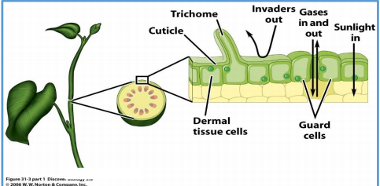

**Figure 54.** Dermal tissue cells

**II.1.1.2. Ground tissue6**

The ground tissue system comprises the bulk of the plant's body and is responsible for various

functions such as storage, photosynthesis, and support. The primary ground tissues consist of 2 types :

• ***Filling tissue (Parenchyma)***

• ***Supporting tissue (Collenchyma and sclerenchyma)***

**III.1.1.2.1. Filling tissues (Parenchyma)**

Parenchyma tissue are fundamental to building blocks and perform several essential functions

in plant growth and development. Parenchyma cells have thin cell walls, a prominent nucleus,

and a large central vacuole. They often have intercellular spaces between them. There are 2

major types:

***a- Chlorenchyma*:** Is characterized by the presence of numerous chloroplasts. It is abundant

in aerial organs (leaves and young stems), to which they give their green color. It role is

mainly photosynthesis, and the gaps ensure respiration. Within the mesophylls of the leaves

we distinguish 2 types:

• ***Homogeneous chlorenchyma:*** in the leaves of Monocotyledons; there are 2 kinds:

- ***Chlorenchyma with meatus***: These are small rounded cells, detached from their

apexes, constituting meatus.

- ***Chloroenchyma with gaps***: The same formation as chlorophyll parenchyma with

meatus, but the cells may be separated by large gaps.

• ***Heterogeneous chlorenchyma:*** in the leaves of Dicotyledons; it is made up of 2 regions

(see **Figure 55**):

-***Palisade parenchyma***: towards the upper surface of the leaf, formed by one or two

layers of elongated cells, tightly packed against each other and rich in chloroplasts.

-***Spongy parenchyma***: towards the underside of the leaf, formed of short cells, more or

less rounded, less rich in chloroplasts and reserving large gaps between them with a

spongy mesophyll.

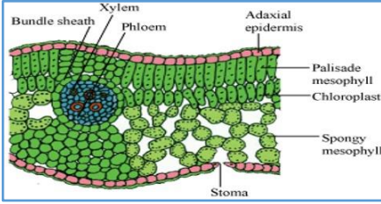

**Figure 55.** Heterogeneous chlorenchyma

**47**

***b- Aerenchyma***: Parenchyma cells with extensive air spaces, commonly found in aquatic

plants, aiding in buoyancy and gas exchange.

***c- Aquiferous parenchyma****:* These are very large cells, provided with a very developed

vacuole, rich in water and often in mucilage. They are abundant in the stems and leaves of

succulents (fat plants: Cactus), where they provide a usable water reserve during periods of

drought.

***d- Storage parenchyma***: Cells that store protein, starch, oils, water, and other nutrients, often

found in roots, tubers, and fruits. They act as a food and water reserve.

• ***Function***

- ***Metabolic functions***: They participate in various metabolic activities, including

photosynthesis, storage of starch, proteins, and other nutrients, as well as secretion and

gas exchange.

- ***Locations***: Parenchyma cells are found in various plant organs, including the leaves,

stems, roots, and fruits. In leaves, they constitute the bulk of the mesophyll tissue and

perform photosynthesis. In stems and roots, they function in storage and contribute to

the plant's flexibility.

- ***Plasticity***: These cells possess a high degree of plasticity, allowing them to differentiate

into other cell types when needed, such as during wound healing or in response to

specific developmental signals.

**III.1.1.2.2. Supporting tissues (collenchyma and sclerenchyma)**

Support tissues are tissues providing flexibility and rigidity to plant organs. They have small,

thick-walled cells. This is collenchyma which forms in young organs and sclerenchyma which

is found in organs whose elongation is completed.

**a- Collenchyma**

• ***Structure:*** It is made up of small cells, living, flexible, strongly elongated or isodiametric,

with rectangular or acute ends. They are usually applied closely against each other and

grouped in chains or cylinders in the cortex (= bark) of young shoots mainly such as stems,

petioles or along the veins of the leaves (see **Figure 56**). Collenchyma has a cellulosic

primary wall that is very thick and rich in water.

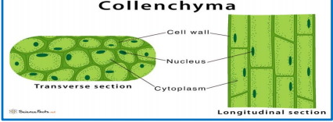

**Figure 56.** Collenchyma tissue**48**

• ***Function***: It provides support for the young parts of the shoots which are at the beginning

of growth through flexibility and rigidity.

• ***Types***: Depending on the thickening of the primary wall, collenchyma can be classified into

4 categories (see **Figure 57**):

- ***Lacunar collenchyma*:** Lacunar Collenchyma contains intercellular spaces, and

thickening is more around these spaces.

- ***Angular collenchyma*:** In this type, the thickening occurs at the corners of the cells,

giving them a distinct angular appearance. It is the most common collenchyma tissue.

- ***Annular collenchyma*:** In annular collenchyma, the cell wall is uniformly thickened.

- ***Lamellar collenchyma*:** Lamellar Collenchyma cells have continuous layers of

thickening in their cell walls. The cell walls are unevenly thickened, with the thickest

regions forming these layers.

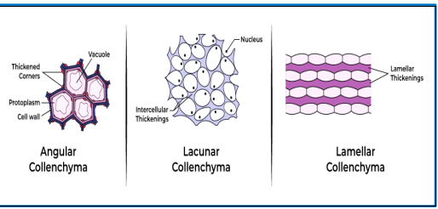

**Figure 57.** Different type of collenchyma (Angular, lacunar and lamellar collenchyma)

**b- Sclerenchyma**

• ***Structure***: It is formed by dead, elongated, flexible cells scattered throughout the plant.

Sclerenchyma is much stiffer than collenchyma. However, sclerenchyma cells produce a

thick secondary wall, usually reinforced by lignin (lignin = cellular organic compound,

nitrogen glycoside) and impermeable (see **Figure 58**).

**49** 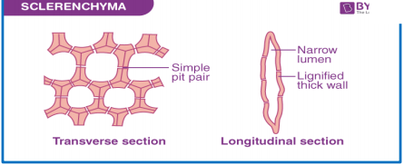

**Figure 58.** Sclerenchyma tissue

• ***Function***: It provides support for the plant through rigidity and hardness.

**50**

**III.1.1.3. Secretory tissues**

Cells or tissue associated with or facilitate the secretion is termed as the secretory cell or

secretory tissue. The secretory tissue is broadly classified into 2 categories based on their

position in the plant body. They are:

***a- External secretory tissue***: Its unicellular or multicellular occur in the external surface of the plant, usually develop from the epidermis or sub-epidermal layers. There are 3 types:

• ***Glandular trichomes***:)

• ***Nectaries***:

• ***Hydathodes***

***b- Internal secretory tissue***: Is embedded inside the plants and they cannot be visualized

externally. They store secretory products. There are 3 types:**2**

• ***Internal secretory cells (Idioblasts)***:

• ***Cavities and ducts***:

• ***Laticifiers***:

**III.1.1.4. Conductive tissue (primary xylem and primary phloem)**

**Primary conductive tissues** are formed from the activity of primary meristems, which are

responsible for the elongation of plant organs. They are typically found in young plants or

species with shorter lifespans (see **Figure 63)**. The primary conductive tissues consist of:

• **Primary Xylem**:

❖ This tissue is primarily responsible for the transport of water and dissolved minerals from

the roots to aerial parts of the plant.

❖ It consists of specialized cells, including **tracheids** and **vessels**. Tracheids are long,

narrow cells that facilitate water conduction and provide structural support, while vessels

are wider cells that allow for more efficient water transport.

❖ The xylem also has a lignified cell wall, which provides strength and rigidity, allowing

the plant to withstand various stresses **(Esau, 1977).**

• **Primary Phloem**:

❖ This tissue transports photosynthates (primarily sugars) produced during photosynthesis

from the leaves to other parts of the plant, including growing tissues and storage organs.

❖ The primary phloem consists of **sieve elements** and **companion cells**. Sieve elements

are responsible for the transport of sugars, while companion cells assist in the metabolic

functions of sieve elements **(Raven *et al.,* 2005).**

❖ Unlike xylem, phloem is living tissue at maturity and can facilitate the bidirectional flow

of nutrients within the plant.

**54** 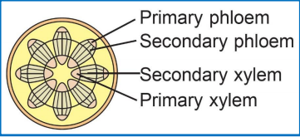

**Figure 63.** Primary and secondary conductive tissue (Phloem and xylem)

**III.2. Secondary (lateral) meristems (the cambium and phellogen**

**III.2.1. Types of secondary tissues**

**III.2.1.1. Conductive tissues (secondary xylem and secondary phloem)**

**Secondary conductive tissues** are primarily found in most dicotyledons and are characterized

by their development over several years or decades. These tissues arise from secondary

meristems, particularly the cambium, which lies between the xylem and phloem. The cambium

is responsible for producing additional layers of vascular tissue, leading to an increase in the

plant's girth (see **Figure 63)**. The secondary conductive tissues include:

• **Secondary Xylem (Wood):**

❖ Secondary xylem is produced by the cambium and provides structural support to the

plant.

❖ It consists of tracheids, vessels, fibers, and parenchyma. The lignin in the secondary

xylem enhances its mechanical strength, enabling trees and shrubs to grow taller and

withstand environmental pressures.

❖ Secondary xylem can also serve as a storage tissue for water and nutrients and plays a

crucial role in the plant's overall physiology **(Esau, 1977).**

• **Secondary Phloem (Liber)**:

❖ This tissue transports nutrients and plays a role in the storage of carbohydrates.

❖ Unlike secondary xylem, secondary phloem does not accumulate indefinitely, as the

older layers are often crushed and replaced by newer layers, ensuring efficient nutrient

transport **(Raven *et al.,* 2005).**

**III.2.1.2. Protective tissues (cork and phelloderm)**

• **Cork (Suber)**:

❖ **Structure**: Composed of dead, thick-walled, and suberized cells filled with suberin,

making it impermeable to water and gases.

❖ **Function**:**5**

o **Protection**: Shields against physical damage, pathogens, and herbivores.

o **Water Retention**: Prevents excessive moisture loss.

o **Insulation**: Protects from temperature fluctuations.

❖ **Location**: Found in the outer layers of stems and roots, forming the periderm in woody

plants.

• **Phelloderm**:

❖ **Structure**: Made up of living, thin-walled parenchyma cells, located on the inner side

of the cork cambium.

❖ **Function**:

o **Storage**: Stores nutrients and water.

o **Photosynthesis**: May contain chloroplasts for limited photosynthesis.

o **Support**: Contributes to structural integrity.

• **Formation**: Both tissues are produced by the cork cambium, which divides to create cork

cells outward and phelloderm cells inward.

• **Significance**: Cork and phelloderm are crucial for plant survival, helping to regulate water

loss, protect against environmental challenges, and provide mechanical support, especially

in woody plants.

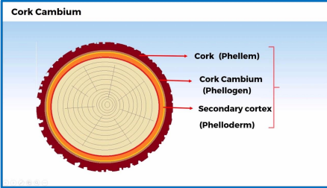

**Figure 64** Crok and phelloderm tissue

**III.2.2. Functions of conductive tissues**

Conductive tissues are essential for the following functions:

• **Transport of Water and Nutrients**: Primary xylem is responsible for the upward

transport of water and minerals, while primary phloem facilitates the downward and

lateral movement of sugars and other nutrients.

**56**

• **Structural Support**: Secondary xylem provides the mechanical strength necessary for

plants to grow tall and withstand physical stresses.

• **Storage**: Both xylem and phloem can serve as storage sites for essential nutrients and

carbohydrates, aiding in the plant's survival during adverse conditions.

• **Adaptation and Growth**: The presence of secondary conductive tissues allows plants

to adapt to their environments by increasing their girth, thereby improving their ability

to compete for light and resources.

• **Regulation of Water Loss**: Conductive tissues play a role in regulating water loss

through stomata, contributing to the plant's overall water management strategy (Raven

et al., 2005).