**Cell’s study methods**

**Tutorial session N°1: cell’s observation methods**

**Tutorial session goals:**

1. Know the operating principle of optical and electron microscope.
2. Ability to differentiate between photonic and electron microscopy.

The observation of cells is delicate because of their very small sizes, and requires a number of devices including microscopes. There are two main types of microscopes according to their resolution: optical microscopes and electron microscopes.

**1. Optical Microscopes (O.M)**

Optical microscopes (light or photonic) use visible light and allow the observation of living or dead cells, thanks to very fine sections of fixed preparations.

***1.1. Bright field optical microscope***

The bright field optical microscope is equipped with three transparent glass lens systems:

• An objective performs primary magnification and gives a real image.

• An eyepiece performs secondary magnification. It allows the eye to form an enlarged virtual image of the actual image formed by the objective’s lens.

• A condenser concentrates light on the object.

The separator power (or resolution) is the smallest distance between two neighboring points that can be distinguished using microscope. The resolution limit of a conventional photonic microscope is about 0.2 μm and the magnification can reach up to 2000.

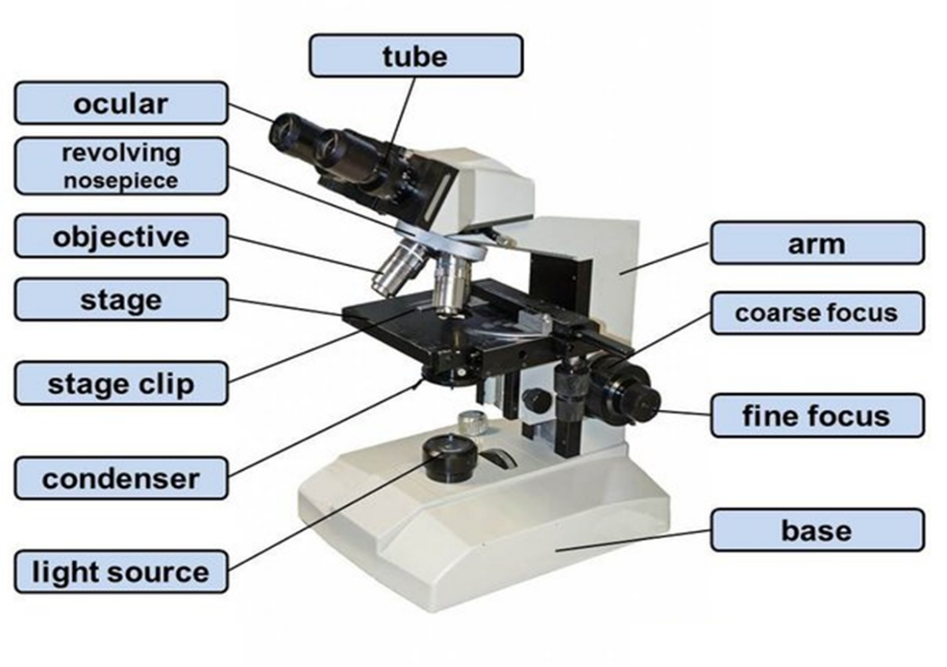

***Figure 1: The main part of an optical microscope.***

***1.2. Types of optical microscopes***

There are several types of optical microscopes each having special optical fixtures, have been developed to allow the observation of cells in some conditions.

Table 1: The different types of optical microscopes.

|  |  |
| --- | --- |
| **Types** | **Used for** |
| 1. OM bright field | Observation of internal cell cells after staining. |
| 1. OM dark field | Observation of uncolored samples and living and moving cells |
| 1. OM florescence | Fluorescent marker of structure and macromolecular compound marking |
| 1. OM phase contrast | The identification of refractive index and contrast differences |
| 1. OM inverted | Observation of cells in culture |

1. **Electron microscopes (EM)**

The operating principle of an electron microscope is somewhat similar to that of an optical microscope except that instead of photons, this microscope works with electrons, the beam is produced and accelerated by an electron gun (pierced cathode and anode). These electrons have compartments with a perfect vacuum to keep the electron beams straight, the electrons pass through the treated sample by heavy metals (dehydratater) and thus the cells' death and due to the weak penetrating power of electrons the samples must be in the form of ultra-fine slices, therefore subject to inclusions. Glass lenses are replaced by electromagnetic coils (electromagnetic "lenses" ) only capable of focusing electrons, and creating clear and enlarged images. The separating power of these microscopes is of the order of a few A°. We will therefore have access to the ultra structure of organelles.

1. **Types of electron microscopes**
2. ***Transmission Electron Microscope (TEM):*** In the TEM, electrons pass through the treated sample with heavy metals. On the TEM screen appears a clear and enlarged image. The image is due to the differential absorption of electrons by the sample’s different structures. The TEM consists mainly of:

• A source of electrons (metal wire heated to a very high degree under vacuum). Under vacuum, electrons will be accelerated by applying a potential difference of 10 to 100 kV

• Vacuum tube space.

• Electromagnetic lenses (Coils) allow electron’s path diffraction.

1. ***Scanning Electron Microscope (SEM):*** The SEM allows to observe the object in three dimensions. It is used in the study of massive objects surfaces after their treatment by reflective metallic substances such as platinum, silver and gold. The flow of electrons sweeps the surface of the object. These are the secondary electrons, returned by the metal surface, that are used to provide an image.
2. **Difference between optical and electronic microscopes**

The table below summarizes the main differences between optical and electron microscopes:

|  |  |
| --- | --- |
| **Optical microscope** | **Electron microscope** |
| Light beam (photons) | Electron beam |
| Glass lenses | Electromagnetic lenses (fields) |
| Magnification x 2000 times | Magnification x 2000 000 times |
| Resolution (0.2 μm) | Resolution (can reach 0.05 nm) |
| The image is observed directly by the eyepieces | The image is received on a fluorescent screen |
| Microtome slices: 2 to 10 μm | Ultramicrotome slices: 0.05 μm |

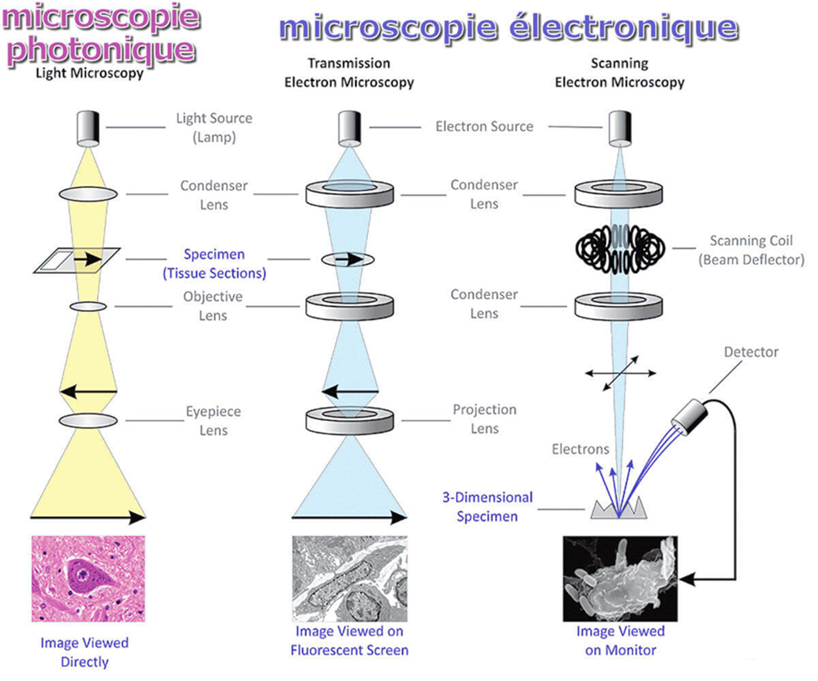

***Figure 2: Operating principle of optical and electronic transmission microscope.***