**Chapter 5: Pure Shear**

1. **Definition**

A beam or a section of a beam is said to be subjected to pure shear if the internal force tensor at each straight section can be summarized as:

where:

* Ty ​: Shear force in the y-direction
* Tz​: Shear force in the z-direction

This is the general case; particular cases arise when one of the shear forces is zero.

1. **Shear Stress/Shear Force Relationship**

​​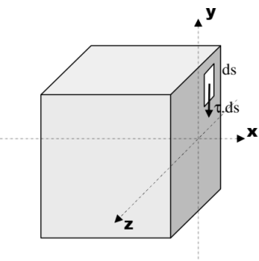

The shear stresses distributed over the cross-section of the beam are statically equivalent to the shear force:

Ty = s⌡τ ds

Assuming that the shear stress is uniform across the entire cross-section, we have:

τ=Ty/S

In the general case, we have:

where: A(y) = s1⌡y. ds Static moment of section S1

* Ty​: Shear force
* b(y): Width of the beam at distance yyy from the neutral axis
* IGZ ​: Quadratic moment of the section

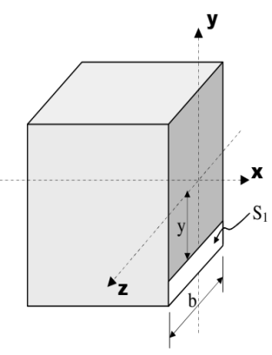

1. **Shear Deformation**

The diagram resulting from the shear test is similar to that from the tensile test; it includes an elastic region and a plastic region.

The elastic region is governed by Hooke's law in shear: τ=G⋅γ

Where:

* τ: shear stress
* G: shear modulus of the material

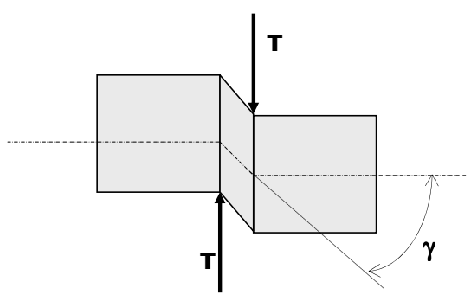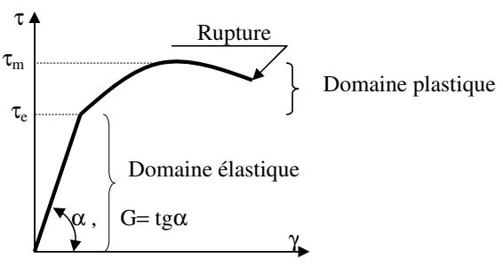

It is noted that G is related to E by the formula: G=E/(2.(1+ν))

Where: ν is Poisson's ratio.

1. **Design Criteria**

The main criterion used to calculate the transverse dimensions of a beam subjected to pure shear is the stress criterion, which requires that the material remains (with a safety factor), within the elastic region:

τmax≤ τe/s

Where:

* τmax​: maximum applied stress
* τe​: shear yield strength of the material
* s: safety factor (≥ 1)