**Phylum Ctenophora**

**Characteristics**

* Habitat: These species are only found in the sea.
* This Phylum’s animals are solitary and free-swimming.
* They are diploblastic acoelomate creatures with a diploblastic body organization. A pair of long, firm, retractile tentacles protrude from the body, which is translucent, gelatinous, soft, and lacks segmentation.
* These organisms have bi-radially symmetrical bodies.
* Tissue: Tissue-level organization is present in these invertebrates.
* Comb rows are eight strands of cilia that let them move around. The movement is aided by these comb-like rows.
* They are hermaphrodite creatures, which means they reproduce through sexual means.
* External fertilization and indirect development are used by these species.
* They have an external as well as an intracellular digestive system.
* They have an aboral sense organ called the statocyst for balance. Nervous system: They have an aboral sense organ called the statocyst for balance.
* They don’t have separate organs for respiration and excretion, thus they rely on the body surface to carry out these functions.
* Size and shape range from microscopic Phylum Ctenophora spheroids (0.04 inch) to long (4.9 foot) ribbons. Ctenophora are lobe-shaped animals.

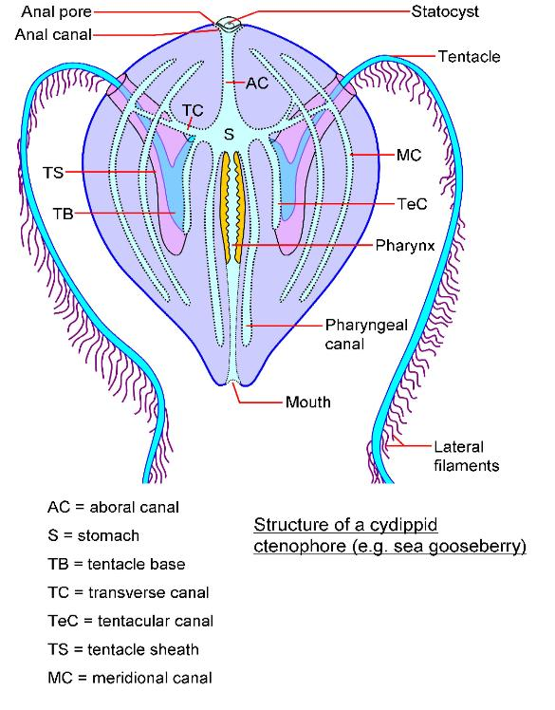

**Structure of Ctenophores:**

The spherical body can be divided into two hemispheres. The mouth lies at one end or oral pole and a sense organ at the opposite end or aboral pole.

**(i) Combplates:**

Eight equally spaced rows of paddle plates arranged on the sides of the body and are used in swimming. The comb rows are composed of a series of short ciliary plates or ctenes. The cilia are strong and propel the animal slowly through the water.

**(ii) Tentacles:**

Two in number, found nearer to the aboral end on opposite sides of the body. They are extremely long, solid and retractile. Tentacles emerge from deep ciliated epidermal blind pouch or tentacular sheath. Tentacle bears short lateral branches or pinnae. Nematocysts are absent, but tentacles possess peculiar adhesive cells called lasso cells or colloblasts which help in food capture.**Sense Organs of Ctenophores:**

Apical sensory organ is a deep seated statocyst at aboral pole. It is lined by tall, ciliated epithelial cells. Statocyst contain statolith and balancers. It is covered by a roof like a dome or bell, formed of fused cilia. The sensory organ serves as an organ of equilibrium.

**Body Wall of Ctenophores:**

Composed of an outer epidermis and an inner gastrodermis separated by a thick gelatinous mesogloea. The epidermis is syncytial and contains many gland cells, sensory cells and pigment

granules. Mesogloea contains amoebocytes, connective tissue fibres muscle fibres and some nerve cells.

**Digestive System of Ctenophores:**

Mouth slit-like situated in the centre of the lower end. It leads into a long tubular pharynx lined with epidermis. The pharynx opens into a small but wide stomach. It gives out a system of five

gastrovascular canals which extend throughout jelly in a definite arrangement. The stomach and gastrovascular canals are lined with gastrodermis. Two anal canals open to the outside near the aboral sense organ, each by an anal pore.

**Nervous System of Ctenophores:**

There is no localized control centre. The epidermal nerve plexus is concentrated in a ring around the mouth, and at the base of the comb rows, where it forms the radial nerves. The nerves are not true nerves, but the condensation of the nerve net. The nervous system controls muscular movements and determines the. activity of cilia on the combrows.

**Reproductive System and Development of Ctenophores:**

All are hermaphrodites. Reproduction is sexual only and asexual reproduction is totally absent.

Gonads develop from endoderm in the form of bands in the meridional canals of the gastrovascular system.

**Development:**

Generally fertilization is external. Cleavage is total, determinate and unique in ctenophores called disymmetrical. Usually free swimming characteristic cydippid larva occurs which undergoes gradual metamorphosis. Some ctenophores exhibit a strange phenomenon called dissogeny in which both the larva and adult reproduce sexually. There is no alternation of generation.Ctenophores have great powers of regeneration. Lost or wounded parts, even the statocyst, are replaced or repaired by regeneration.

**Classification of ctenophora**

The Ctenophora Phylum is separated into two classes, as listed below: **Tentaculata**

They have two tentacles with specialized sheaths and a tiny stomodaeum that can retract.

* Sea walnuts have a big mouth and eat mollusk larvae and copepods.
* Venus girdle is a flattened, ribbonlike Ctenophora that can be found in tropical waters.
* In sea gooseberries, secondary tentacles are smaller, and primary tentacles are reduced; secondary tentacles are smaller, and primary tentacles are reduced. On the Atlantic and Pacific coasts, these species are common.
* Sea Walnut, Sea Gooseberry, Venus Girdle, and other examples

**Nuda**

* Tentacles are not present in this class of animals.
* They eat jellyfish and other ctenophores and have largemouth.
* They are free-swimmers who can be found in all oceans and seas on the planet.
* Beroe, Mnepmiopsis, and other examples
* 