

TP No. 5:STUDY OF A CILIATED PROTOZOAN (PARAMECIA)

1. Introduction

The Protozoa (Protos = First, primitive and Zoon = animal), are the first animals in the evolutionary series. They are unicellular, microscopic and heterotrophic organisms.

Although reduced to a single cell; they have the fundamental functions of any animal where the organelles fundamental to any cell are represented (Mitochondria, Golgi apparatus, Lysosomes, microtubules, etc.).

Depending on the species, Protozoa feed either by osmosis (in the biological environment – parasitic forms) or by phagocytosis (in the aquatic environment – free forms). Reproduction occurs by division of the body (binary division) and under certain environmental conditions resorts to sexuality.

1. Characteristics of Ciliates

Ciliates are evolved protists, formerly called infusoria. Ciliates constitute a unique class. They live in all aquatic environments and are characterized by the presence of a mouth, an anus and, at least at one stage of their life cycle, by vibratile cilia, used for swimming, walking or for making move the water around them in order to obtain food. Their cell contains two nuclei: the*macronucleus* (polyploid) and the *micronucleus*(diploid), involved in sexual reproduction or conjugation. The ciliates also multiply by transverse fissiparity. Many ciliates live as commensals in the bellies of herbivores with which they share food. In a parasitic form, one of them lives in the human intestine where it causes an inflammation called balantidiosis.

Ciliates are currently divided into two subclasses. The holotrichs, with uniform ciliature, include the famous*paramecium*fresh waters; spirotriches, more differentiated, carry membranes and cirrhes (fused cilia).

1. Classification

It is essentially based on the arrangement and size of the vibrating cilia.

* + Alongside simple cilia, we find larger organelles made up of clumped cilia.

We distinguish two classes:

* + Class of holotrich:ciliates whose ciliature is made of simple cilia and membranes. The internal classification of this class is based on the position of the mouth.

Examples:*Colpodium colpoda*,*Paramecium caudatum*,*Vorticels.*

* + Class of Spirotriches:they present complex ciliary organelles like cirri or undulating membranes forming an adoral fringe.

Examples:*Stentors, Balantidium coli*,*Stylonychia*

1. Paramecium:***Paramecium caudatum***

Paramecium (Paramecium) is a well-known genus of ciliated protozoan, and is commonly studied as a type representative of this group (especially P. caudatum). It is one of the first unicellular organisms to be observed under a microscope. The size of the cell varies from 50 to 300 µm long depending on the species. Paramecium uses cilia to move and feed. Somatic ciliature, which covers the cell and beats in synchrony, allows it to move. A distinct oral ciliature covers the large funnel-shaped ventral invagination, the peristome, which leads to the cytostome (the mouth). It mainly feeds on bacteria by phagocytosis.

Paramecium lives isolated in fresh water. It is one of the “infusoria” of ancient authors: it appears in large numbers in plant infusions, making its cultivation and study easy.

Living in a hypotonic environment compared to its cytoplasm, the cell constantly absorbs water from its environment by osmosis. Excess water in the cytoplasm is then evacuated through pulsatile vacuoles, where the cytoplasm contracts periodically to expel water across the plasma membrane.

Like most ciliates, the paramecium has the particularity of having a nuclear apparatus in two parts: one (or more) small nuclei, the micronucleus, and a large nucleus, the macronucleus. The first ensures the sexual functions essential to generate genetic variations while the second directs daily trophic functions and asexual multiplication.

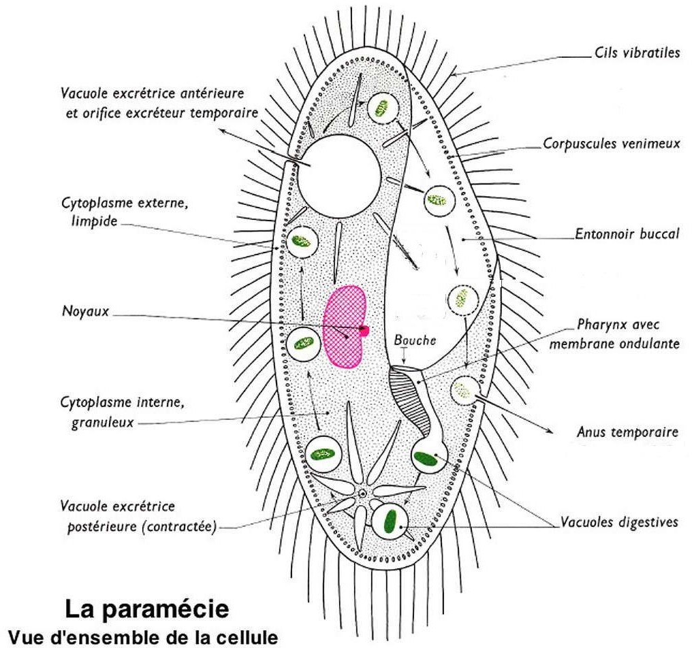

1. Ciliates close to Paramecium and common in the same environments
2. The podium collars:very common in macerations of watercress or hay, are smaller (100 microns) than the paramecium. Their ovoid body has an anterior lobe thrown to the side.
3. The Stentors:very large (from 500 microns to 1 millimeter), are easily recognized because they are shaped like a trumpet. Completely covered with eyelashes, they also have a fringe of membranes (clumped together eyelashes) around the mouth. They can attach themselves by the pointed rear end or swim freely. Their cytoplasm is contractile thanks to powerful fibrils.
4. The Stylonechies:ciliates whose flattened ventral face bears cilia clumped together in cirri which can relax, which causes the animal to move by leaps (size 300 microns).
5. Voricella:have an elongated peduncle that can spiral like a spring. These ciliates live in very dense colonies. The mouth is surrounded by a fringe of membranes.

When food becomes insufficient, the Vorticella may break off.

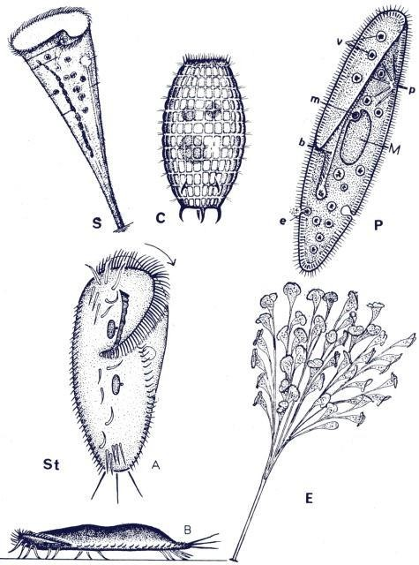

S = Stentor / C = Coleps / P = Paramecium / St = Stylonichia (A = lower surface view / B = profile view) E = Epistylis (colony fixed by a common peduncle)

Details of the paramecium and vacuole: b = mouth / e = “anus” / v = digestive vacuoles / p = pulsatile vacuole / m = small nucleus / M = large nucleus

1. Handling:

Using a pipette, take a drop of water from the maceration, place it between the slide and the coverslip and observe at low magnification. We see that the paramecia move quickly and do not stay in the field of the microscope. To limit their movement and facilitate observation, a drop of acetic acid is introduced into the drop of water to better fix them.

1. Work to be done:
   * Observation of some types of ciliates
   * Drawing of a Paramecium