**TP No. 2: Plant Cell**

**Objective:**

Knowledge and identification of the particularities of plant cells (pectocellulosic wall, vacuole, chromoplasts, and chloroplasts).

**Introduction:**  
The plant cell is characterized by the presence of three major cytological features:  
¬ **Pectocellulosic Wall**: Maintains the structure and defines the size and shape of the plant cell, primarily composed of pectins, hemicellulose, and cellulose. It participates in regulating interactions with other cells and the external environment.  
¬ **Vacuole**: Specific to plant cells, vacuoles allow for the storage of water, ions, sugars, nitrogenous compounds, and degradation products.  
¬ **Plastids**: Organelles surrounded by two membranes, all derived from protoplasts, including:

* **Leucoplasts**: Lacking pigments, such as amyloplasts, which store starch (reserve substance).
* **Chloroplasts**: Absorb solar energy and can convert this light energy into chemical energy through the process of photosynthesis.
* **Chromoplasts**: Store carotenoid pigments, giving some plant parts their yellow, orange, or red color.

**Materials and Reagents Required for the Procedures:**  
Microscope, slide and cover slip, onion, tomato, pepper, fine tweezers, scalpel………..

**2- Procedure:**  
- Place a fragment of the internal epidermis of an onion scale on the slide and add a drop of -distilled water. Cover with a cover slip and observe under the microscope.¬  
- Place a very thin layer of the epidermis (upper side) of a pepper between the slide and the cover slip, then observe.  
 -Place a smear from the soft gel of the tomato’s center on a slide, cover with a cover slip, and gently press with light pressure to flatten the sample and ensure the cells are not overlapping.

For all three procedures, observe, carefully draw, and label your findings.

**3-Observation Results:**

1. **Onion Cells:**

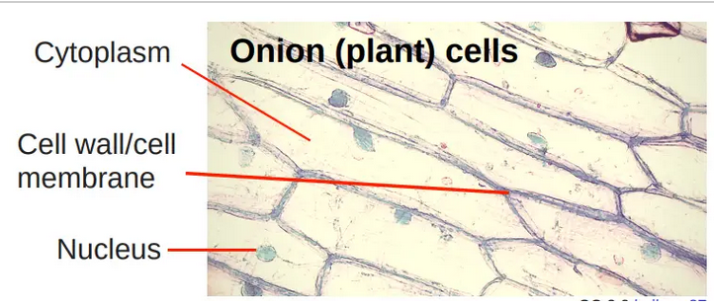

**2- Pepper Cells:**

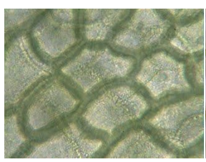

At the end of the lab session, the student should be able to distinguish the basic structure of the plant cell and its characteristics (shapes, components, etc.).