**Introduction to Zoology**

**Meaning of Zoology**

The word zoology originated from two ancient Greek words “zoion” meaning “animal” and “logia” meaning “the study of”. Therefore, the word literally means “the study of animals”. Zoology can be defined as the branch of biology that deals with the study of the fascinating world of animal biology and their various aspects. Zoology includes the identification, systematic, classification and exploration of the diverse physiology, and the complex ecological interaction of the members of the animal kingdom.

**History of Zoology**

Identification and study of animals around us has been a part of human civilization since its start. The ancient civilization of India, China, Egypt, Greece, etc has always been fascinated by the animal kingdom and we can see many descriptions and use of animals in the scripture. However, extensive modern scientific studies were undertaken and documented by many prominent scientists and philosophers which led to our current understanding of zoology. Some such scientists are listed below;

1. **Aristotle (384-322 BC):**He is often considered the father of zoology due to his significant work on the classification and characterization of animals.
2. **Carolus Linnaeus (1707-1778):**His work on [taxonomy](https://www.geeksforgeeks.org/taxonomic-hierarchy-in-biological-classification/)and classification laid the foundation of the current pretext of zoology.
3. **Georges Cuvier(1769-1832):**His work on paleontology and comparative anatomy of animals greatly contributed to the understanding of zoology.
4. **Charles Darwin (1809-1882):**Other than his work on evolution, his research on the Galapagos island also contributed significantly to zoological studies.
5. **Thomas Huxley (1825-1895):**His work on Darwin’s theory of evolution also contributed greatly to the field of comparative anatomy of animals.
6. **Konrad Lorenz (1903-1989):** His work on animal behavior has a significant impact on the understanding of zoology.
7. **E. O. Wilson (1929-2021):** His work on [biodiversity](https://www.geeksforgeeks.org/what-is-biodiversity-why-is-biodiversity-important-for-human-lives/)and sociobiology greatly contributed to our current understanding of ecology.

**Branches of Zoology**

Zoology is a vast and diverse field of biology having many major and minor branches. Some of them are listed below;

1. **Anatomy:**The study of the internal and external structures of animals is called anatomy.
2. **Physiology:**The study of the mechanisms that underlie various bodily functions is called physiology.
3. **Ecology:**The study of interactions between animals and their environment is called ecology.
4. **Ethology:**The study of animal-specific behavior is called ethology.
5. **Taxonomy:**The study of classification and naming of animals is called taxonomy.
6. **Evolutionary Biology:**The study of the evolutionary history of animals is called evolutionary biology.
7. **Entomology:**The study of insects is called entomology.
8. **Herpetology:**The study of amphibians and reptiles is called herpetology.
9. **Ornithology:**The study of birds is called ornithology.
10. **Ichthyology:**The study of fish is called ichthyology.
11. **Mammalogy:**The study of mammals is called mammalogy.

.

**Animal Classification: A Taxonomy for All Living Things**

**Key Takeaways**

* Animal classification, established by Carl Linnaeus, categorizes living beings into a hierarchical system, including domains, kingdoms, phyla, classes, orders, families, genera and species.
* This system helps scientists organize and study the diversity of life, grouping organisms based on their shared characteristics and evolutionary relationships.
* Modern taxonomy includes five kingdoms: Animalia, Plantae, Fungi, Monera and Protista, with further subdivisions to categorize all known life forms.

You can categorize every single living being. This classification system allows scientists to study plant and [animal diversity](https://science.howstuffworks.com/environmental/conservation/issues/biodiversity-important.htm) and to group closely related species. From horses to insects to worms, animal classification focuses on every animal in the so-called kingdom animalia.

**Origins of Animal Classification**

**The Five Kingdoms**

Kingdom follows domain — the largest classification in biology also known as dominion, empire or superkingdom. Each kingdom encompasses many living beings.

[Linnaeus](https://www.ncbi.nlm.nih.gov/pmc/articles/PMC4418965/) originally identified three kingdoms when he introduced "Systema Naturae": Regnum Amimale (animals), Regnum Vegetabile (plants) and Regnum Lapideum (minerals).

Today, we classify living things according to [five kingdoms](https://www.ruf.rice.edu/~bioslabs/studies/invertebrates/kingdoms.html):

* ***Animalia:*** Also known as the animal kingdom, this includes species that are multicellular and [eukaryotic](https://science.howstuffworks.com/life/cellular-microscopic/prokaryotic-vs-eukaryotic-cells.htm) (anything that contains a nucleus). Unlike plants, animals eat food for energy.
* ***Fungi***: The fungi kingdom includes multicellular species with organelles and a cell wall. They do not have chloroplasts. Chanterelle, penny bun and fly agaric belong to this kingdom.
* ***Monera***: These single-celled organisms have a cell wall, but they do not have organelles, chloroplasts or a nucleus. You will find bacteria in this kingdom.
* ***Plantae***: The kingdom is where plants belong. Plants are multicellular, and have organelles and chloroplasts.
* ***Protista***: These are single-celled organisms that have organelles and may have a cell wall and chloroplasts.

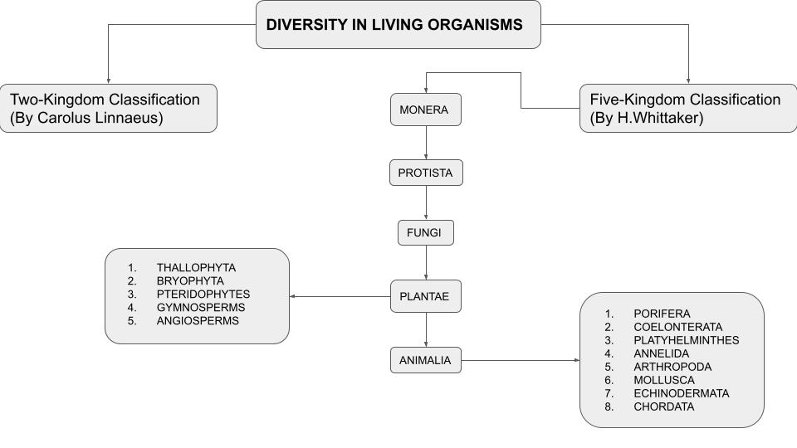

**Animal Species Classification**

Each living organism falls under eight categories. At the very top, there's the broadest category (domain), and each subsequent level gets more focused. Here is the system to follow for classifying animals:

1. **Domain**: There are three domains: *Archaea*, *Bacteria* and *Eukarya*. Animals belong to the latter group.

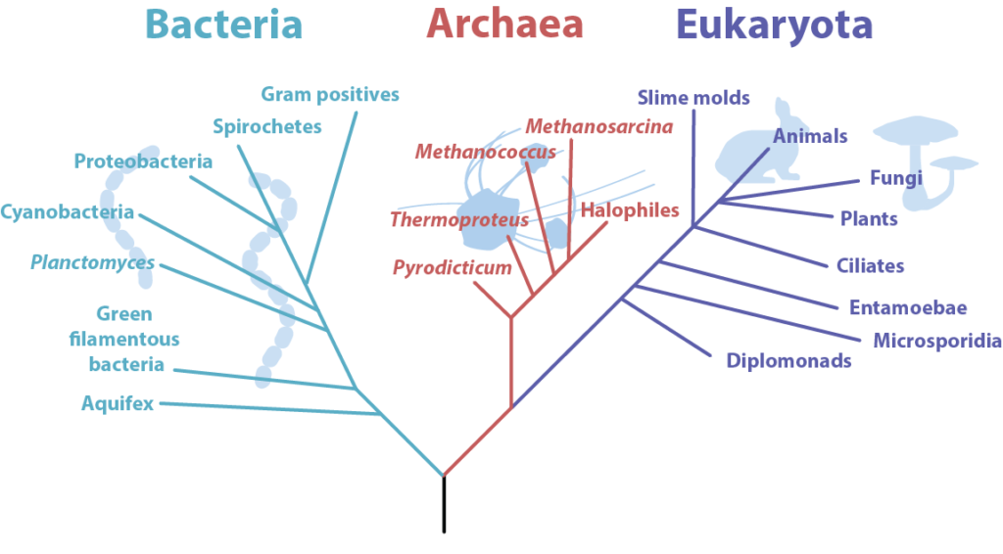

1. **Kingdom**: There are five kingdoms: *animalia*, *fungi*, *monera*, *plantae* and *protista*. Every and any animal belongs to the *animalia* kingdom, including marine life, snakes and lizards.
2. **Phylum**: There are dozens of other animal phyla that we don't have listed here, but most animals fall within a handful of categories, including arthropoda (millipedes, spiders and crayfish), cnidaria (corals, jellyfish and hydras), chordata (humans and dogs), mollusca (slugs, snails and chitons), nematoda (threadworms, hookworms, and whipworms) and porifera (sponges and other invertebrate animals).
3. **Class**: Each of the animal phyla divides into smaller groups. For example, the phylum chordata, which encompasses all vertebrates, has a few different classes like amphibians, birds, fish, reptiles, and mammals.
4. **Order**: If you look at the class mammalia, you will find several orders, such as carnivora, primates and rodentia.
5. **Family**: Within carnivora, or animals that share eating meat in common, there are 13 distinct [families](https://animaldiversity.org/accounts/Carnivora/), according to Animal Diversity Web. These include Ursidae (bears), Felidae (cats) and Canidae (dogs).
6. **Genus**: Within genus, there are even smaller categories. For example, within the Ursidae family, there are five genera: *Ailuropoda* (giant panda), *Helarctos* (sun bear), *Melursus* (sloth bear), *Tremarctos* (spectacled bear) and *Ursus* (black bear, brown bear and polar bear)
7. **Species**: Within the *Ursus* genus, there are four species, identified through their scientific names: *Ursus americanus* (American black bear), *Ursus arctos* (brown bear), *Ursus maritimus* (polar bear) and *Ursus thibetanus* (Asiatic black bear).

Some taxonomies account for nine categories, with suborder falling between order and family.

**Species Name**

Species names are a combination of genus and [species](https://www.csus.edu/faculty/c/rcoleman/natural%20history%20museums/sacramento_state_online_natural_history_museum/introduction%20to%20scientific%20names.html), with the first word capitalized and the second one written in lowercase.

Linnaeus created this binomial nomenclature to replace an ununiform naming convention, where some animals could have a short two-word name and other animals could have a longer phrase.

**Examples of Animal Classifications**

Here are a few examples of animal classifications.

**Blue Whale (*Balaenoptera musculus)***

* **Domain**: *Eukarya*
* **Kingdom**: *Animalia*
* **Phylum**: Chordata
* **Class**: Mammalia
* **Order**: Cetacea
* **Family**: Balaenidae
* **Genus**: *Balaenoptera*
* **Species**: *musculus*

**Gray Wolf (*Canis lupus)***

* **Domain**: *Eukarya*
* **Kingdom**: *Animalia*
* **Phylum**: Chordata
* **Class**: Mammalia
* **Order**: Carnivora
* **Family**: Canidae
* **Genus**: *Canis*
* **Species**: *lupus*

**Humans (*Homo sapiens*)**

* **Domain**: *Eukarya*
* **Kingdom**: *Animalia*
* **Phylum**: Chordata
* **Class**: Mammalia
* **Order**: Primates
* **Family**: Hominidae
* **Genus**: *Homo*
* **Species**: *sapiens*

**Classification of Animal Kingdom**

The classification of the animal kingdom is the process of classifying animals in a hierarchy. A predetermined number of levels, such as kingdom, family, or genus, form the basis of the ranking system. Depending on the goal of the categorization, the basis for that classification may change. A biological classification typically uses evolutionary and morphological similarities as its foundation.

**Animal Kingdom: Basis of Classification**

The animal kingdom, which includes all animals, is the largest of the five kingdoms. Animals share the same mechanism of nourishment, known as the heterotrophic mode. They are multicellular eukaryotes, lack a [cell wall](https://www.geeksforgeeks.org/cell-wall/) and [chlorophyll](https://www.geeksforgeeks.org/what-is-chlorophyll/), and are eukaryotes. They are connected to their cell arrangement, body symmetry, level of organization, coelom, existence or absence of notochord, etc. in addition to these similarities. The [animal kingdom](https://www.geeksforgeeks.org/animal-kingdom/) has been divided into 11 separate phyla based on these characteristics.

Animals are classified according to a number of fundamental characteristics, which include:

* Levels of Organization
* Symmetry
* Devlopment patway ; Diploblastic and Triploblastic Organization
* Coelom development
* Segmentation of the body
* Presence or absence of Notochord.

**Levels of Organization**

In this category, the organisms are divided on the basis of the**level of functioning**they have in their systems as explained as follows:

1. **Cellular level:** This category is for those animals in which cells are arranged as loose aggregates. For e.g. Sponges.
2. **Tissue level:** Organisms in which cells perform the same function get arranged as tissues fall under this category. For e.g. Coelenterates.
3. **Organ level:** In many organisms, there is an organ level of organizations, which means that tissues performing the same activities are grouped together to form an organ. Each organ has its specific function. For e.g. [Platyhelminthes](https://www.geeksforgeeks.org/platyhelminthes-overview-features-classification-faqs/).
4. **Organ system level:** This type of organization is seen more commonly in many species. For e.g., Arthropods, Echinoderms, Chordates etc. represent that organs form a group to perform a functioning system where every system (group of organs) is assigned to perform a certain physiological function.

**Symmetry**

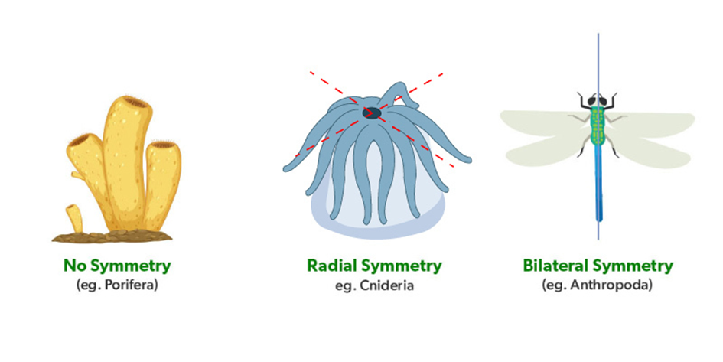

1. **Asymmetrical:** The organism which shows no symmetry after division through any axis are called asymmetrical organisms. For e.g. Sponges.
2. **Radial** **Symmetry:** The organism which divides into two exactly equal parts when any plane passes through the axis. Such organisms are called radially symmetrical. If a radially symmetrical animal is divided in any direction along the **oral/aboral axis** (the side with a mouth is “oral side,” and the side without a mouth is the “aboral side”), the two halves will be mirror images. For e.g. Ctenophores, Coelenterates etc.
3. **Bilateral** **Symmetry:**  **it involves the division of the animal through a** **midsagittal** plane, resulting in two superficially mirror images,**right and left halves**, such as those of crab or human body. Animals with bilateral symmetry have a “head” and “tail” (**anterior** vs. **posterior**), front and back (**dorsal** vs. **ventral**), and **right** and **left** sides. All Eumetazoa except those with secondary radial symmetry are bilaterally symmetrical. The evolution of bilateral symmetry that allowed for the formation of anterior and posterior (head and tail) ends promoted a phenomenon called **cephalization**, which refers to the **collection of an organized nervous system at the animal’s anterior end**. In contrast to radial symmetry, which is best suited for stationary or limited-motion lifestyles, bilateral symmetry allows for streamlined and directional motion. In evolutionary terms, this simple form of symmetry promoted active and controlled directional mobility and increased sophistication of resource-seeking and predator-prey relationships. For e.g. Molluscs, Arthropods etc.

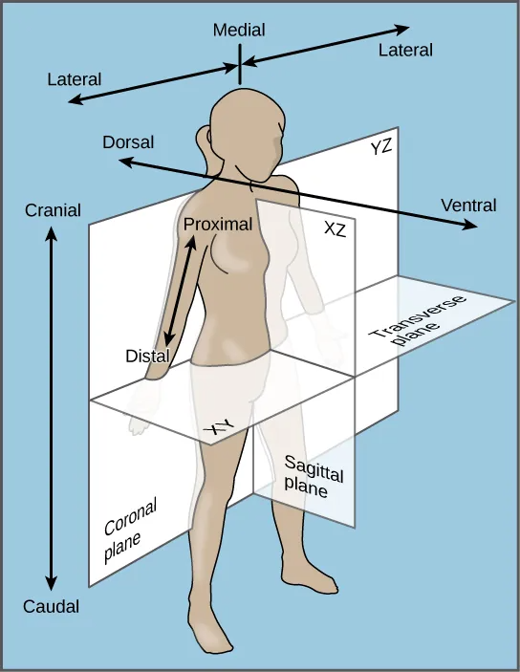

**Figure 3** Bilateral symmetry. The bilaterally symmetrical human body can be divided by several planes.

**Animal Characterization Based on Features of Embryological Development**

Developmental characteristics include the **number of germ tissue layers** formed during development, the **origin of the mouth and anus**, the presence or absence of an **internal body cavity**, and other features of embryological development, such as larval types or whether or not periods of growth are interspersed with molting.

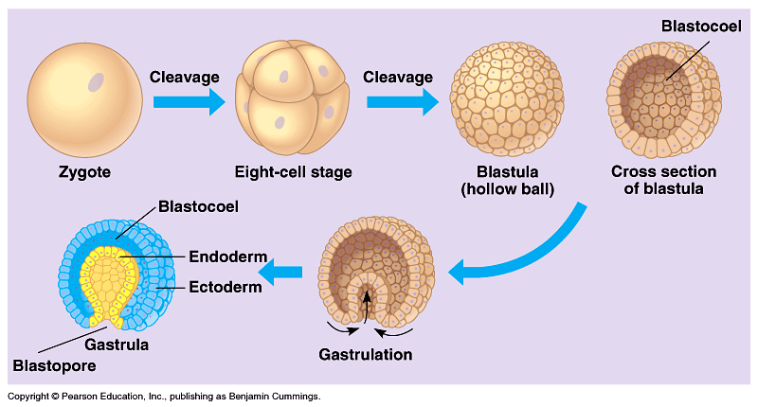

Most animal species undergo a **separation of tissues into germ layers during embryonic development.**Animals develop either**two or three embryonic germ layers** ([Figure 4](https://pressbooks.online.ucf.edu/bsc2011c/chapter/27-2-features-used-to-classify-animals/#fig-27-9)). The animals that display radial, biradial, or rotational symmetry develop two germ layers, an **inner** layer (***endoderm***) and an **outer** layer (***ectoderm***). These animals are called **diploblasts**, and have a **nonliving middle layer** between the endoderm and ectoderm (although individual cells may be distributed through this middle layer, there is no *coherent* third layer of tissue). The four clades considered to be diploblastic have different levels of complexity and different developmental pathways, although there is little information about development in Placozoa. More complex animals (usually those with bilateral symmetry) develop three tissue layers: an inner layer (**endoderm**), an outer layer (**ectoderm**), and a middle layer (**mesoderm**). Animals with three tissue layers are called **triploblasts**.

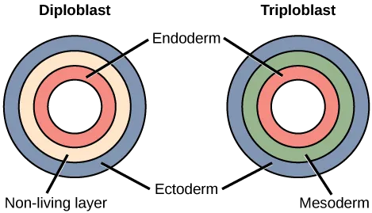

**Figure 4** Diploblastic and triploblastic embryos. During embryogenesis, diploblasts develop two embryonic germ layers: an ectoderm and an endoderm. Triploblasts develop a third layer—the mesoderm—which arises from mesendoderm and resides between the endoderm and ectoderm.

Each of the three germ layers is programmed to give rise to specific body tissues and organs, although there are variations on these themes. Generally speaking, the **endoderm gives rise to the lining of the digestive tract** (including the stomach, intestines, liver, and pancreas), as well as to the lining of the trachea, bronchi, and lungs of the**respiratory trac**t, along with a few other structures. The **ectoderm develops into the outer epithelial covering** of the body surface, the **central nervous system**, and a few other structures. The mesoderm is the third germ layer; it forms between the endoderm and ectoderm in triploblasts. This germ layer gives rise to all **specialized muscle tissues** (including the cardiac tissues and muscles of the intestines), **connective tissues such** as the skeleton and blood cells, and most other **visceral organs** such as the kidneys and the spleen. Diploblastic animals may have cell types that serve multiple functions, such as epitheliomuscular cells, which serve as a covering as well as contractile cells.

**Presence or Absence of a Coelom**

Further subdivision of animals with three germ layers (triploblasts) results in the separation of animals that may develop an internal body cavit*y* derived from mesoderm, called a **coelom**, and those that do not. This epithelial cell-lined **coelomic cavity**, usually filled with fluid, lies between the visceral organs and the body wall. It houses many organs such as the digestive, urinary, and reproductive systems, the heart and lungs, and also contains the major arteries and veins of the circulatory system. In mammals, the body cavity is divided into the **thoracic cavity**, which houses the**heart** and **lungs**, and the **abdominal cavity**, which houses the **digestive** organs. In the thoracic cavity, further subdivision produces the **pleural** **cavity**, which provides space for the lungs to expand during breathing, and the **pericardial** **cavity**, which provides room for movements of the heart. The evolution of the coelom is associated with many functional advantages. For example, the coelom provides cushioning and shock absorption for the major organ systems that it encloses. In addition, organs housed within the coelom can grow and move freely, which promotes optimal organ development and placement. The coelom also provides space for the diffusion of gases and nutrients, as well as body flexibility, promoting improved animal motility.

**Triploblasts that do not develop a coelom are called acoelomates**, and their mesoderm region is completely filled with tissue, although they do still have a gut cavity. Examples of acoelomates include animals in the phylum **Platyhelminthes**, also known as **flatworms**. Animals with a true coelom are called **eucoelomates** (or **coelomates**) ([Figure 5](https://pressbooks.online.ucf.edu/bsc2011c/chapter/27-2-features-used-to-classify-animals/#fig-27-10)). In such cases, a true coelom arises entirely within the mesoderm germ layer and is lined by an epithelial membrane. This membrane also lines the organs within the coelom, connecting and holding them in position while allowing them some freedom of movement. Annelids, mollusks, arthropods, echinoderms, and chordates are all eucoelomates. A third group of triploblasts has a slightly different coelom lined partly by mesoderm and partly by endoderm. Although still functionally a coelom, these are considered “false” coeloms, and so we call these animals **pseudocoelomates**. The phylum **Nematoda** (roundworms) is an example of a pseudocoelomate. True coelomates can be further characterized based on other features of their early embryological development.

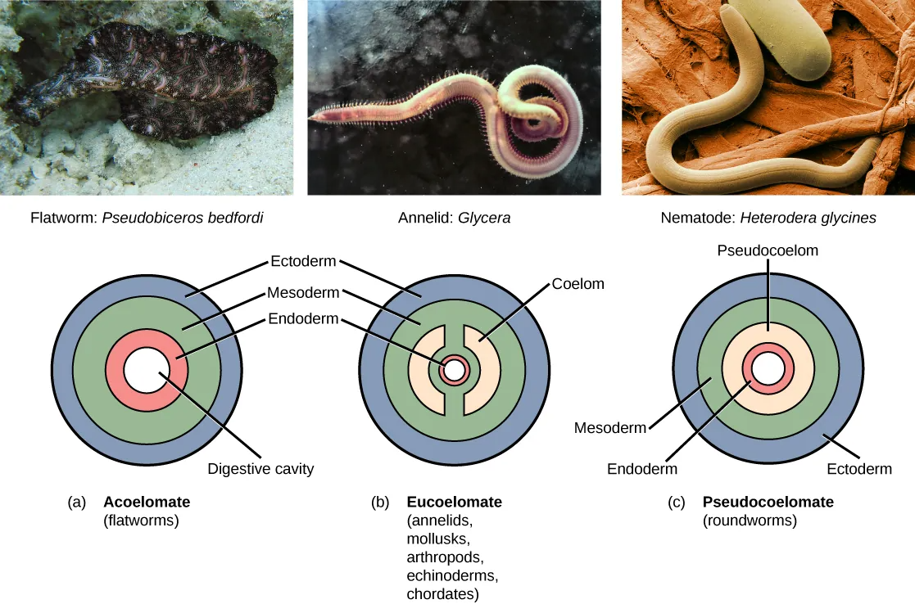**Figure 5** Body cavities. Triploblasts may be (a) acoelomates, (b) eucoelomates, or (c) pseudocoelomates. Acoelomates have no body cavity. Eucoelomates have a body cavity within the mesoderm, called a coelom, in which both the gut and the body wall are lined with mesoderm. Pseudocoelomates also have a body cavity, but only the body wall is lined with mesoderm.

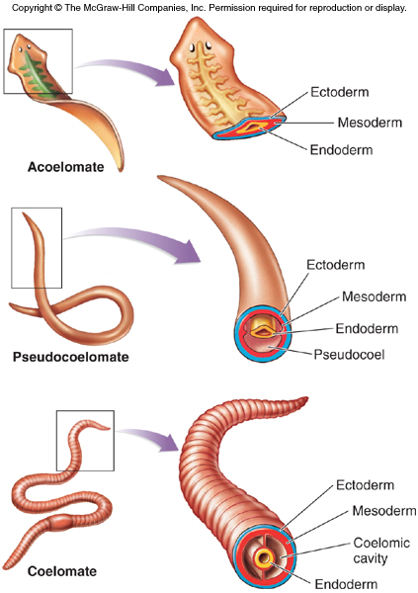

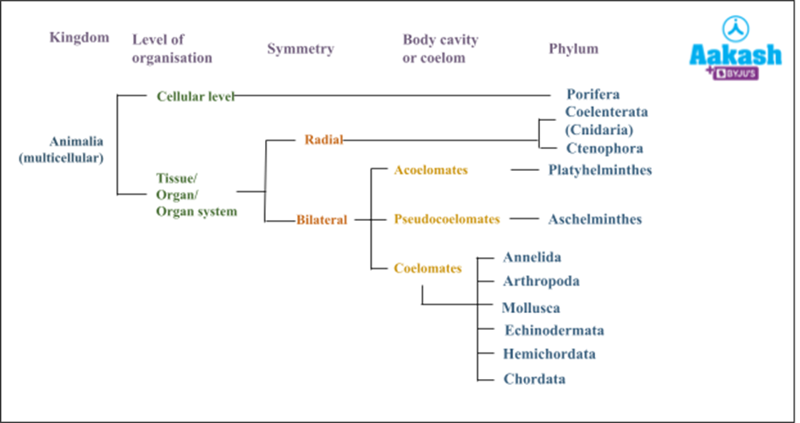

**Embryonic Development of the Mouth**

Bilaterally symmetrical, tribloblastic eucoelomates can be further divided into two groups based on differences in the **origin of the mouth**. When the primitive gut forms, the opening that first connects the gut cavity to the outside of the embryo is called the **blastopore**. Most animals have openings at both ends of the gut: mouth at one end and anus at the other. One of these openings will develop at or near the site of the blastopore. In **Protostomes** (“mouth first”), the **mouth develops at the blastopore** ([Figure 6](https://pressbooks.online.ucf.edu/bsc2011c/chapter/27-2-features-used-to-classify-animals/#fig-27-11)). In **Deuterostomes** (“mouth second”), the **mouth** **develops at the other end of the gu**t ([Figure 6](https://pressbooks.online.ucf.edu/bsc2011c/chapter/27-2-features-used-to-classify-animals/#fig-27-11)) and the**anus develops at the site of the blastopore**. Protostomes include arthropods, mollusks, and annelids. Deuterostomes include more complex animals such as chordates but also some “simple” animals such as echinoderms. Recent evidence has challenged this simple view of the relationship between the location of the blastopore and the formation of the mouth, however, and the theory remains under debate. Nevertheless, these details of mouth and anus formation reflect general differences in the organization of protostome and deuterostome embryos, which are also expressed in other developmental features.

\

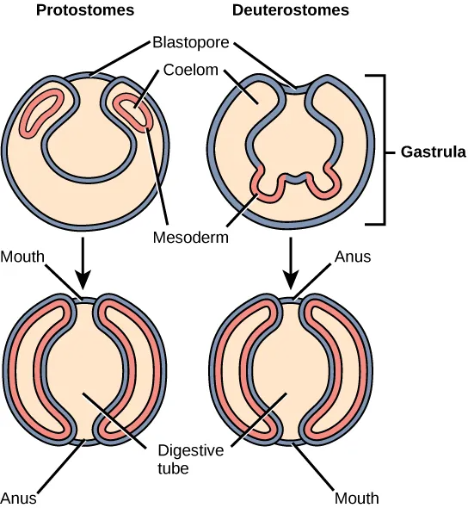

**Figure 6** Protostomes and deuterostomes. Eucoelomates can be divided into two groups based on their early embryonic development. In protostomes, the mouth forms at or near the site of the blastopore and the body cavity forms by splitting the mesodermal mass during the process of schizocoely. In deuterostomes, the mouth forms at a site opposite the blastopore end of the embryo and the mesoderm pinches off to form the coelom during the process of enterocoely.

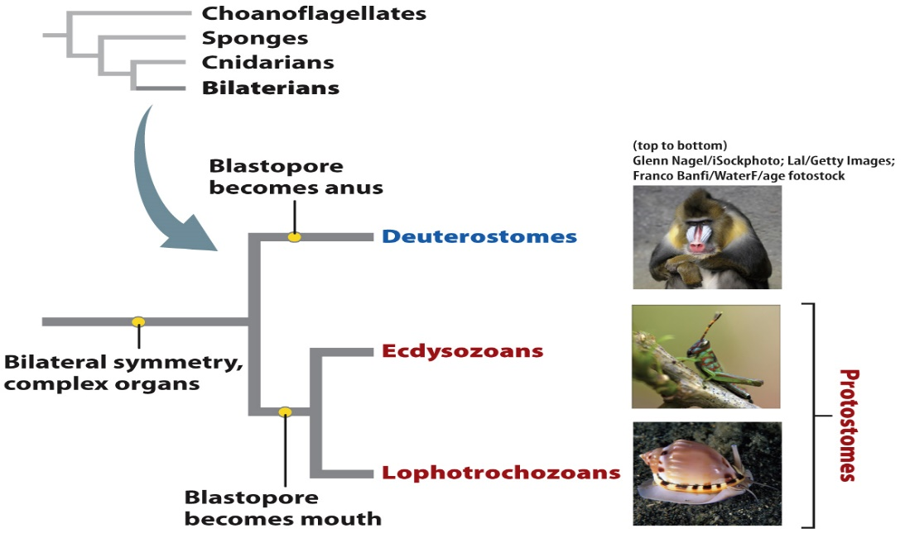

**Segmentation of the Body**

The organisms which have particular patterns on their body or segments come under this category. For e.g. Arthropods, Chordates, Annelids etc.

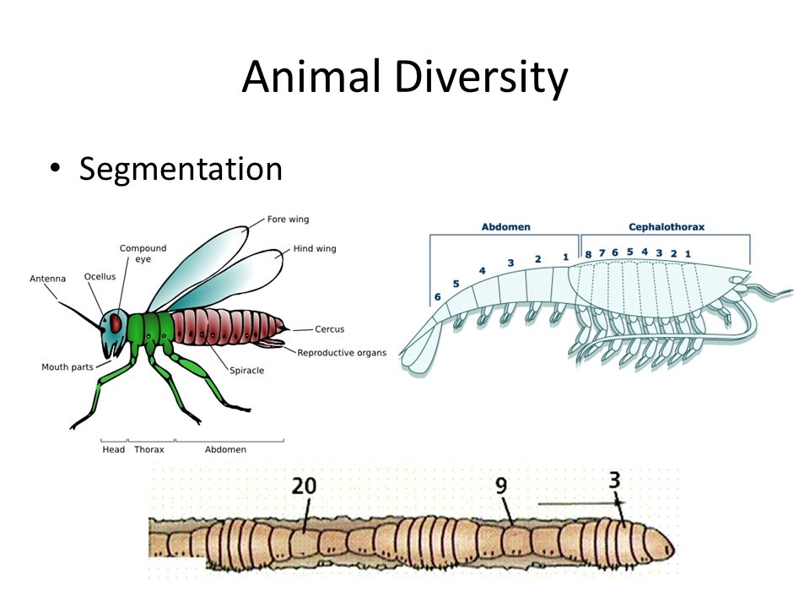

**Presence or Absence of Notochord**

Rod-like structure originated from mesoderm and provides support to organisms in the embryonic stage and as adults. Organisms are characterized by the presence and absence of notochord.

1. **Chordata** -Organisms having notochord are known as chordates. For e.g. Vertebrates, mammals, tunicates etc.
2. **Non**–**Chordata** – Organisms who lack notochord are called non-chordates. For e.g. Platyhelminthes, Ctenophores, Annelids etc.

