**Chapter IV: Bacterial growth**

Growth can be defined as an increase in cellular components, leading to either an increase in cell number when microorganisms multiply by binary fission (Fig. 26) or budding. In these cases, cells enlarge and divide to produce two daughter cells of roughly equal size. Growth also occurs when cells simply become longer or larger.

If the microorganism is coenocytic, meaning multinucleated, nuclear division occurs without cell division, leading to an increase in cell size rather than cell number.

Due to their small size, analyzing the growth and division of individual microorganisms is challenging. Microbiologists typically monitor numerical variations in an entire population.

**1- Measuring Growth**

Various methods can be used to measure microbial growth, allowing the determination of generation time and growth rate. Both the number and biomass of a population increase during growth, making them suitable indicators.

**1-1- Measuring cell number**

**1-1-1- Direct microscopic counting**

This method is simple, cost-effective, and relatively quick, providing information on cell size and morphology. It is commonly used for larger cells, such as yeasts, using a hemocytometer (e.g., Thoma or Malassez chamber). These specially designed slides contain chambers of known depth with a grid at the bottom (Fig. 27).

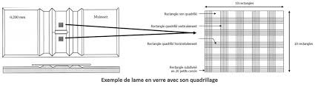



**Figure**: exemple of cellule de malassez

For smaller bacteria, counting can be performed using a Petroff-Hausser counting chamber, which has a much shallower depth than a hemocytometer.

The microbial count in a sample is calculated based on chamber volume and sample dilution. However, this technique has some limitations: the microbial population must be sufficiently dense, as only small sample volumes are analyzed.

**1-1-2- Particle counter**

This device automatically counts particles or larger microorganisms, such as yeasts. The microbial suspension passes through the counter via a narrow aperture. A constant electrical current flows through the aperture, and electrodes on either side measure electrical resistance. When a microbial cell passes through, resistance increases (or conductivity decreases), allowing the cell to be counted. A drawback of this method is that it also counts inert particles of similar size.

**1-1-3- Epifluorescence**

This method theoretically distinguishes between live and dead cells using acridine orange or other fluorochromes that bind to DNA. Under UV light, acridine orange fluoresces green when bound to double-stranded DNA (indicating live bacteria) and red when bound to single-stranded DNA (indicating dead bacteria).

• **DNA + AO → [DNA-AO]** (green fluorescence)

• **RNA + AO → [RNA-AO]** (red fluorescence)

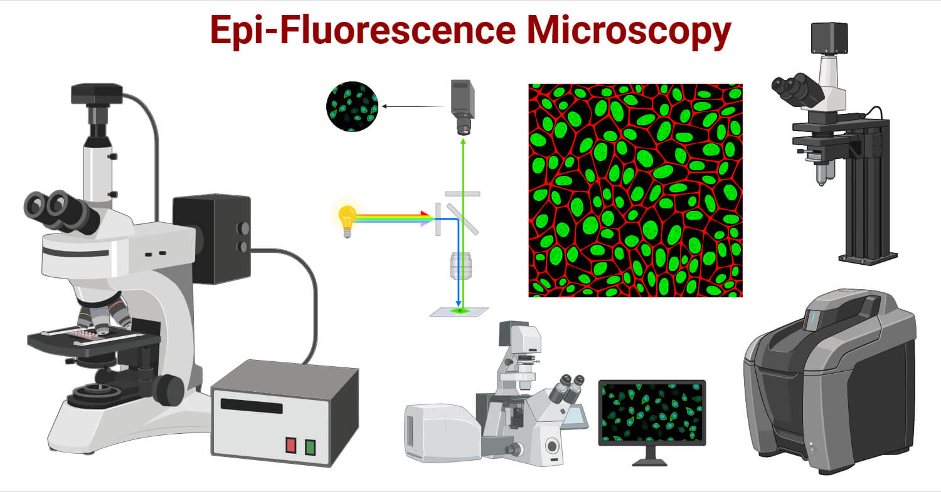

However, this technique has several limitations:

* Actively dividing bacteria exhibit red fluorescence due to DNA strand separation during replication.
* It is ineffective for populations below 10⁵ cells/mL for yeasts and 10⁶ cells/mL for bacteria.
* It is unsuitable for bacteria that form chains or mycelial structures.

**1-1-4- Viable Count (Colony-Forming Units)**

This method only counts living cells capable of reproduction. The most commonly used techniques are the spread plate and pour plate methods.

In both techniques, a diluted microbial sample is spread onto a solid medium. Each microorganism (or cluster) develops into a distinct colony. Since it is uncertain whether each colony originates from a single cell, results are expressed as **colony-forming units (CFU)** rather than the absolute number of microorganisms. Optimal results are obtained with sample concentrations yielding 30–300 colonies

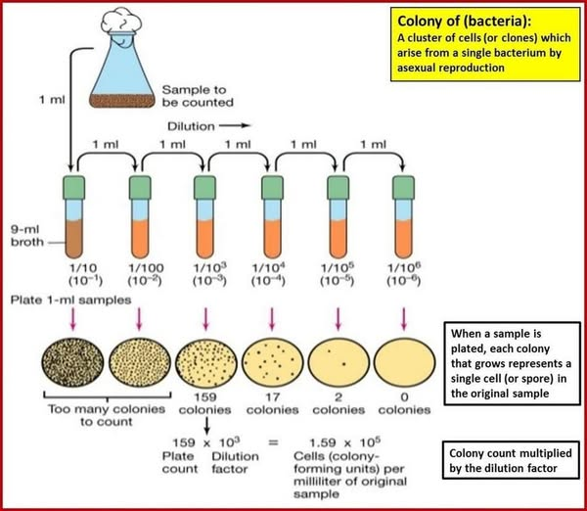

**Figure: Bacterial enumeration using the dilution method (Prescott et al., 2003).**

* **Membrane Filtration Technique**: In this method, bacteria from aqueous samples are retained on a membrane filter, which is then placed on agar or an absorbent pad soaked with liquid medium and incubated until distinct colonies form (Fig. 31).

This technique is particularly useful for water purity analysis, as specific media can be used to select for particular microorganisms.

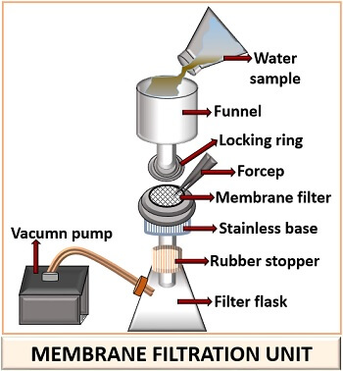

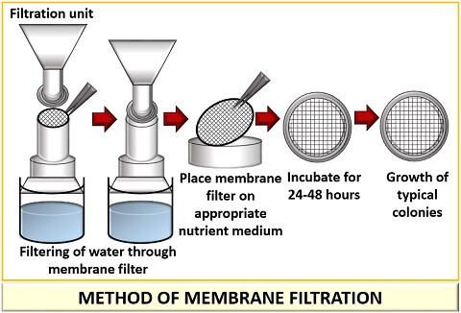

**Figure:** Membrane filtration method

**1-2- Measuring biomass**

Biomass can be quantified by:

* **Dry weight measurement**: Cells are harvested by centrifugation, washed with physiological saline, and dried at 100–110°C before weighing. The result is expressed as grams of dry matter per liter. This method is precise but time-consuming.
* **Turbidity measurement**: A simpler, widely used method for estimating microbial cell numbers, based on the absorbance of light by a bacterial suspension using a spectrophotometer.

**1-3- Measuring cellular components**

If a cellular constituent maintains a constant concentration within each cell, its total amount correlates directly with microbial biomass.

Total protein or nitrogen content can be analyzed in washed, collected cells from a known medium volume. An increase in microbial population corresponds to an increase in total protein content. Similarly, chlorophyll measurement can assess algae and cyanobacterial populations, while ATP content indicates viable microbial biomass.

**2- Growth parameters**

Bacterial growth is defined by two key parameters:

1. **Generation time (G)**: The time required for a population to double or for one cell division to occur. It depends on species and environmental conditions. Under optimal conditions, **Vibrio parahaemolyticus** has a generation time of 13 minutes, while **Escherichia coli** divides every 20 minutes.

**Formula:**

G=t/n

where **t** is time (in minutes) and **n** is the number of divisions.

1. **Growth rate (μ)**: The number of divisions per unit time (per hour). For example, **E. coli** divides three times per hour, giving a growth rate of 3.

**Formula:**

μ=n/t, n=µ/t => µ =1/G

**3- Growth Curve (Batch Culture)**

Population growth is studied by analyzing the growth curve of a microbial culture. In liquid medium, microorganisms typically grow in a **closed system** (batch culture), where no fresh medium is added during incubation. As a result, nutrient levels decrease while waste accumulates.

The growth curve represents biomass or cell number over time, following the equation:

X=f(t)

N=2nN0

It consists of **four distinct phases**:

1. **Lag phase** – Adaptation to new conditions, little to no cell division.
2. **Exponential phase** – Rapid, constant growth at the maximum rate.
3. **Stationary phase** – Growth rate slows as nutrients deplete and waste accumulates.
4. **Death phase** – Cells die due to unfavorable conditions.

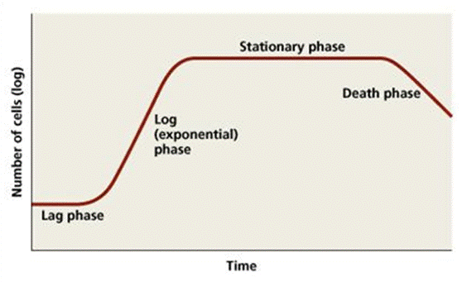

**Figure: Microbial growth curve in a closed system**

**4- Diauxic growth**

Diauxic Growth is observed much often that when bacteria are allowed to grow in the medium contalning **two different types of carbon/energy sources**, they show a characteristic diauxic growth. The diauxic growth is characterized by the occurrence of two lag phases which separate the log phase in two parts.

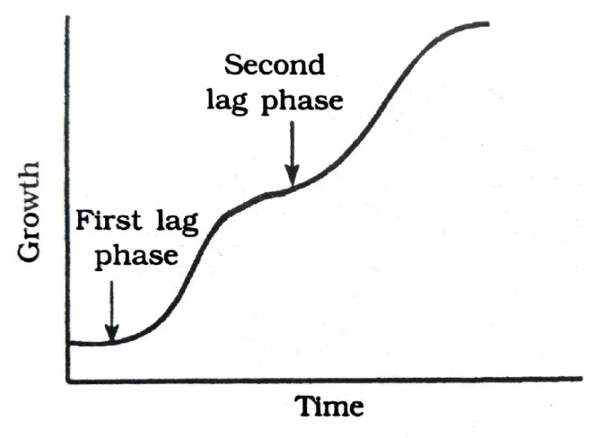

Diauxy is a phenomenon where bacteria, like *E. coli*, grow in two phases when provided with two different sugars, such as glucose and lactose. Here’s how it works:

1. **First Growth Phase (Glucose Utilization):**

Bacteria first use **glucose**, the easiest and fastest energy source. Enzymes for glucose breakdown are always present (constitutive enzymes). This leads to a **first log phase** of rapid growth.

1. **First Lag Phase (Adaptation):**

When glucose runs out, growth stops temporarily. This is called the **first lag phase**, where bacteria prepare to switch to lactose.

1. **Second Growth Phase (Lactose Utilization):**

Bacteria now start using **lactose**. To do this, they produce special enzymes like **β-galactosidase** (inducible enzymes). This leads to a **second log phase** of growth.

1. **Second Lag Phase (Enzyme Induction):**

Before using lactose, bacteria need time to make the required enzymes. This causes a **second lag phase**.

**Chapter V: Antimicrobial Agents**

**Definition**

Bacterial growth must be controlled to optimize its use in experimental or industrial applications. This can be achieved through various physical and chemical agents, collectively known as **antimicrobial agents**. These substances, when applied under specific conditions, either inhibit microbial growth or eliminate microorganisms through different processes:

* **Sterilization**: A process aimed at completely destroying all microorganisms in a given preparation. A material is considered sterile when no microorganism can develop on it.
* **Disinfection**: A temporary process that eliminates microorganisms and/or inactivates viruses on an inert surface.
* **Decontamination**: A temporary process that kills or inhibits undesirable microorganisms on either inert or living surfaces, depending on the intended objective.
* **Asepsis**: A set of measures designed to prevent the introduction of exogenous microorganisms or viruses.
* **Antisepsis**: A temporary process applied to living tissues within their tolerance limits, eliminating or inactivating microorganisms and viruses present at the time of application.

**1- Physical Agents**

**a) Temperature**

Temperature can be used for food preservation either through **cold storage** (refrigeration, freezing) or **heat treatment** (pasteurization). In both cases, microbial growth is slowed or stabilized.

Temperature is also employed for microbial destruction through **sterilization** and **appertization**. The effectiveness of heat treatment depends on the environment, microbial physiology, and cell density. Thermal destruction methods include:

1. **Moist Heat**:
   * **Boiling water** kills vegetative bacterial and fungal cells as well as viruses, but not bacterial spores (especially endospores).
   * **Appertization**: A method developed by Nicolas Appert in 1785 and later confirmed by Pasteur in 1801. It involves sealing food (e.g., vegetables) in airtight containers and immersing them in boiling water. This method is widely used in the canning industry.
   * **Autoclaving**: A sterilization technique using pressurized steam at **120°C and 1 atm for 15-20 minutes**, effectively denaturing proteins. Autoclaves come in various sizes and designs.
   * **Tyndallization**: A method for sterilizing heat-sensitive materials by subjecting them to repeated heating cycles at **60°C**, interspersed with rest periods at room temperature. This process allows for the activation and subsequent elimination of bacterial endospores.
   * **Pasteurization**: Developed by Pasteur between 1866 and 1876, this technique involves moderate heating (around **60°C**) to destroy **pathogenic bacteria** (e.g., *Salmonella, Listeria, Escherichia*) while preserving nutritional quality. It extends the shelf life of products without achieving full sterilization.
     + **High-temperature pasteurization**: Heating to **90°C for 30 seconds**, followed by rapid cooling to **10°C**.
     + **Low-temperature pasteurization**: Heating to **60-70°C** for longer durations.
2. **Dry Heat**:  
   Used for sterilizing materials that **cannot** be exposed to moisture. Heat is supplied by electric or gas ovens with air circulation. Effective sterilization is achieved at **160-180°C** for a specific duration.

**b) Radiation**

* **Ionizing Radiation** (gamma rays, X-rays, electron beams): These high-energy radiations ionize cellular water, generating hydroxyl radicals that chemically modify or break DNA strands, leading to microbial death.
* **Non-ionizing Radiation** (ultraviolet light, especially at **270 nm**): UV light induces abnormal thymine-thymine linkages in DNA, disrupting replication. While sunlight contains UV radiation, some bacteria produce protective pigments to counteract its effects.

**c) Filtration**

Filtration is used to sterilize **heat-sensitive solutions**, a process known as **cold sterilization**. The most common filters are **cellulose acetate membranes**, which are also employed in microbial enumeration in liquid samples.

**2- Chemical Agents**

Not all chemical antimicrobial agents can serve as **disinfectants** or **antiseptics**. Some are highly active but too toxic for living tissues, making them suitable only for inanimate objects. Others are highly penetrative, soluble but unstable, or quickly inactivated upon contact with organic matter.

**2-1- Modes of Action**

The activity of chemical agents against microorganisms varies significantly. Their mechanisms of action include:

1. **Oxidation and protein denaturation**:
   * **Hydrogen peroxide** oxidizes free sulfhydryl (SH) groups in enzymes.
   * **Heavy metal salts** (e.g., silver, mercury) bind to SH groups, inactivating proteins.
   * **Alcohols** coagulate proteins in a manner similar to heat.
2. **Disruption of cytoplasmic membranes**:
   * **Lipid-soluble agents** (e.g., phenols, soaps, detergents) degrade membranes, causing cytoplasmic leakage.
3. **Metabolic interference**:
   * **Cyanides and fluorides** disrupt the respiratory chain.
   * **Basic dyes** (e.g., methylene blue, gentian violet) interact with RNA.
   * **Mutagens** (e.g., acridine) and **chelating agents** (e.g., quinoline derivatives) interfere with microbial function.

**2-2- Classification of Chemical Agents**

Chemical disinfectants and antiseptics can be grouped based on their chemical structure and mode of action:

1. **Oxidizing Agents**: Hydrogen peroxide, bleach (*sodium hypochlorite*), and iodine-based alcohol solutions.
2. **Alcohols**: Ethanol (**most effective at 70% concentration**).
3. **Heavy Metals and Their Salts**:
   * **Silver salts**: Used in ophthalmology and ENT treatments.
   * **Mercury salts**: Formerly used as skin and mucous membrane antiseptics (*Mercurochrome, Mercryl, Merseptyl*).
   * **Copper sulfate**: An antifungal agent.
   * Heavy metals **precipitate microbial enzymes or bind to SH groups**, leading to cell death.
   * However, they are highly **toxic to humans**.
4. **Phenols and Aldehydes**: Highly **toxic** but **bactericidal, fungicidal, and virucidal**, disrupting membranes, DNA, and proteins.
5. **Soaps**: Act **mechanically** by increasing water’s wetting ability, trapping microbes in foam, and removing them upon rinsing. Some synthetic **detergents (surfactants)** are highly bactericidal.
6. **Dyes**: Used both as **local antiseptics** and **selective agents in microbiological media**.
   * **Malachite green and brilliant green**: Treat superficial wounds.
   * **Methyl violet**: Urinary antiseptic.
   * **Gentian violet**: Disinfectant.
   * Dyes are generally more effective against **Gram-positive bacteria**, selectively allowing **Gram-negative bacteria** to grow.
7. **Gas Sterilization**: Used to sterilize **heat-sensitive materials** and disinfect large spaces.