***DW5***

**Exercise 1**

A beam with a tubular section of length L is fixed at one end and subjected to a torsional moment Mt at the other end.

1. Calculate the stress on the inner surface of the beam
2. Calculate the stress on the outer surface of the beam
3. Plot the stress distribution on the cross-section
4. Check the strength of the beam
5. Calculate the angle of rotation of a section located at the midpoint of the beam
6. Calculate the angle of rotation of the section subjected to the torsional moment

Given:  
Mt=200 Nm.M, Dext=40 mm, Dint​=32mm, L=0.5 m, G=78GPa, τe=60 MPa, s=2

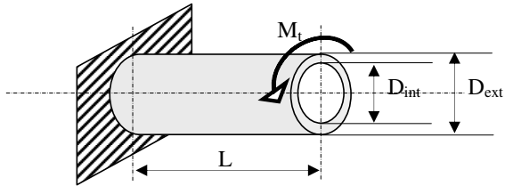

**Exercise 2**

A solid cylindrical shaft, with length LLL and diameter DDD, must transmit a maximum power of P=300 CH at a speed of 3000 rpm.

1. Determine the torsional moment Mt transmitted.
2. Determine the minimum diameter the shaft must have to safely transmit this torsional moment.

Given:  
L=3 m, τe=25×107 Pa, safety factor s=5, 1 CH=735.49 W

**Exercise 3**

A ship shaft 30 meters long must transmit a torsional moment of Mt=1.9 MNm. It is made from steel with a shear modulus G=82,000N/mm2 and a shear yield strength τe=50 N/mm2.

Calculate and compare its outer diameter, weight, and rotation between its two ends for two values of K= Dint/Dext

* K1=0 for a solid shaft
* K2​=0.9 for a hollow shaft

Given:

* Steel density ρs=7800 kg/m3
* Safety factor s=1