**CHAPTER 0 :INTRODUCTION**

**1. What is botany?**

This is the science that specializes in the study of plants.

The purpose of systematic botany is the description, nomenclature and classification of plant species, and their representation in a single hierarchical phylogenetically ordered body.

**2. Taxonomic units: or taxa :**

Taxonomic units are in descending order:

- Plant kingdom

- Branch line

- under branch

- Classy

- subclass

- Order

- by order

- Family

- subfamily

- tribe

- Gender

- subgender

- section

-Specie

- subspecies (or breed)

- variety

- under variety

The species is the elementary unit of systematics it can be defined as: a group of morphologically and genetically similar individuals capable of reproducing each other under favorable conditions and giving birth to fertile individuals.

**3. Nomenclature:**

Nomenclature of the species:

In the 18th century Linné (1707 - 1778) proposed a system that would prevail: binomial nomenclature. Each species is identified by two Latin words: gender and species.

Ex. Prunus armeniaca L. apricot.

armeniaca = species

Prunus = gender

**4. The Reigns of the Living:**

-In the 18th century Linné divided the living world into two great kingdoms: animals and plants. However, many organisms difficult to place in either of these categories were later discovered such as plant-like fungi (cellulosic wall cells, immobility); myxomycetes (fungal group) feed like animals by digesting organic matter. On the other hand, Linné could not ignore the world of microscopic unicellular organisms: For example, Euglene, (Brown unicellular algae) feeding on bacteria or photosynthesis.

-In the 20th century, with the progress of microscopy, one could observe and describe unicellular organisms and until the 1950s, the world of life is subdivided into three kingdoms: bacteria, plant, animal. In this three-kingdom system, blue-green algae (although prokaryotic) are classified as plants. Whittaker in 1969 developed the classification of the world of life to lead to the constitution of the five kingdoms according to biology:

Prokaryotes (Monères = Monera, bacteria and archaea)

Protists (Protista, unicellular eukaryotes)

Fungi (fungi, multicellular eukaryotes, heterotrophs and absorbotrophs)

Plants (Plantae, multicellular eukaryotes, autotrophies)

Animals (Animalia, multicellular eukaryotes)

**5. The great groups of the plant kingdom:**

The plant kingdom is traditionally subdivided into two main groups according to the structural organization of the plant:

**5.1. Thallophytes:** these are non-vascular organisms. Their vegetative apparatus is a foliaceous organ, sometimes branched (thallus) whose cells are not organized into tissues with no stem, leaves and roots; the reproductive cells (spores and gametes) are produced in cysts (sporocysts and gametocysts).

**5.2. Cormophytes or embryophytes:** these plants are characterized by a corm (cormus = branch or trunk), that is, their vegetative apparatus rests on erect structures in stems. The cells are organized into tissues grouped into organs (stem, leaves and roots). Reproductive cells are produced in multicellular reproductive structures (gametange and sporange). Among cormophytes, only tracheophytes are vascularized (xylem + phloem). They include bryophytes, pteridophhytes, pre spermaphytes and spermaphytes.

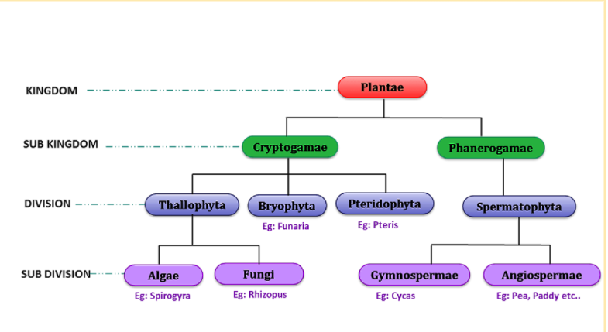

**Shema of the clasification of animal regne**