**Phylum Annelida**

**Characteristics of Annelida:**

* They are mostly aquatic; marine or freshwater some terrestrial.
* The body is elongated, **triploblastic, bilaterally symmetrical, truly coelomate** and vermiform.
* The body is metamerically **segmented**; each division is called a **segment, metamere or somite.**
* Body organization is of **organ grade system.**
* The epidermis covered by thin cuticle.
* The body wall is contractile or dermo-muscular consisting of outer muscle fiber circular and inner longitudinal.
* Appendages (**parapodia)** are jointed when present.
* Locomotory organs are segmentally repeated **chitinous bristles** called setae or chaetae, embedded in the skin. It may be bored by lateral fleshy appendages or parapodia.
* The alimentary canal is complete, extending from mouth to anus.
* **Respiration** occurs through moist skin or gills of parapodia and head.
* The blood vascular system is a closed type. Blood is red due to the presence of hemoglobin or erythromycin dissolved in plasma.
* Excretion is by **nephridia,** which communicate the coelom to the exterior.
* The nervous system consists of a pair of cerebral ganglia; **brain and double ventral nerve cord** in each segment **(hyponeurian).**
* Receptor organs include tactile organs, taste buds, statocysts, photoreceptor cells and sometimes eyes with lenses in some.
* Most of the Annelids are hermaphrodite
* Their development is direct in monoecious form but indirect in dioecious form.
* Larva, when present is a **trochophore** is characteristics in case of indirect development.
* Regeneration is common.
* Asexual reproduction occurs in some.

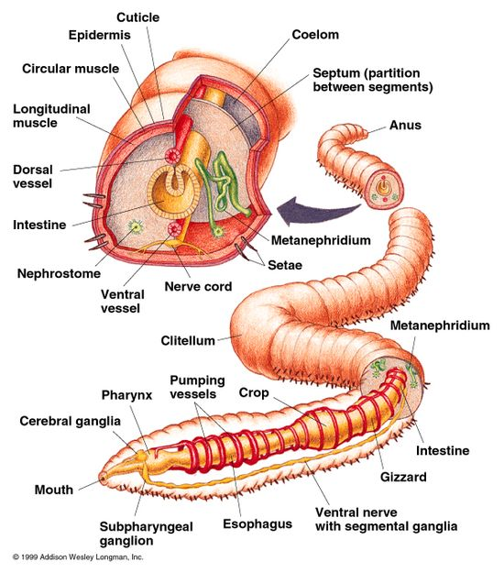

**Classification of Phylum Annelida**

Annelida are divided into four main classes, primarily on the basis of presence and absence of parapodia, setae, metameres, and other morphological features.

**Class 1- Polychaeta (**Gr.,**poly=**many**, chaeta=**bristles/hair)

* Chiefly marine, some freshwater.
* Carnivorous
* Body segmentation is internal and external.
* Head consists of prostomium and peristomium and bears eyes, tentacles cirri, and palps.
* Setae numerous on lateral **parapodia.**
* **The clitellum is absent.**
* Cirri or branchiae or both may be present for respiration.
* Sexes separate. Gonads temporary and in many segments, Fertilization external.

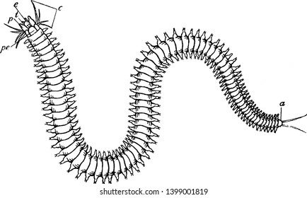

**Class 2- Oligochaeta (**Gr.,**oligos**=few**+ chaete=**hair**)**

* Mostly terrestrial or some freshwater forms.
* **Setae few,** embedded in the skin.
* **Parapodia absent.**
* Glandular **clitellum** present for cocoon formation.
* Hermaphroditic i.e. sexes united.
* Development is direct. fertilization external (in cocoon); no larval stage.

Examples: *Pheretima, Eutypheus, Megascolex, Lumbricus.*

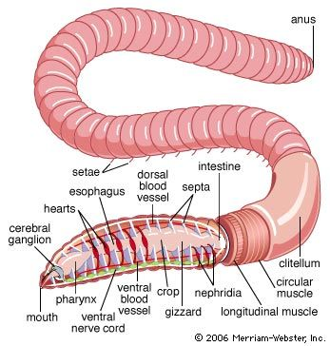

**Class 3- Hirudinea (L., hirudo=**a leech**)**

* Mostly ectoparasitic, blood-sucking or carnivorous. Few are marine, freshwater or terrestrial.
* The body consists of a fixed number of **segments (33).** Segmentation external without internal septa.
* **Parpodia and setae are absent.**
* Both anterior and posterior ends of the body with ventrally situated suckers.
* The mouth opens on the ventral surface on anterior suckers, while anus opens dorsal to the posterior suckers.
* Hermaphrodite with one male and one female gonopore.
* Fertilization internal.
* Eggs are always laid in cocoons.
* Development is direct without a free-swimming larval stage.

Examples: Hirudo, Hirudinaria,

