**Chapter II: The bacterial cell**

**Introduction**  
Bacteria are **unicellular prokaryotic microorganisms** characterized by their small size and diverse morphological forms. These organisms are ubiquitous, meaning they are found in virtually every environment on soil, water, air, and even within other living organisms. Their presence often becomes evident through observable changes in their surroundings: wounds may become infected, milk can turn sour, and meat may decompose. Despite their significant impact, bacteria are microscopic and can only be observed under a microscope. They are broadly classified into two primary groups: **eubacteria** (true bacteria) and **archaebacteria** (ancient bacteria), each with distinct characteristics and ecological roles.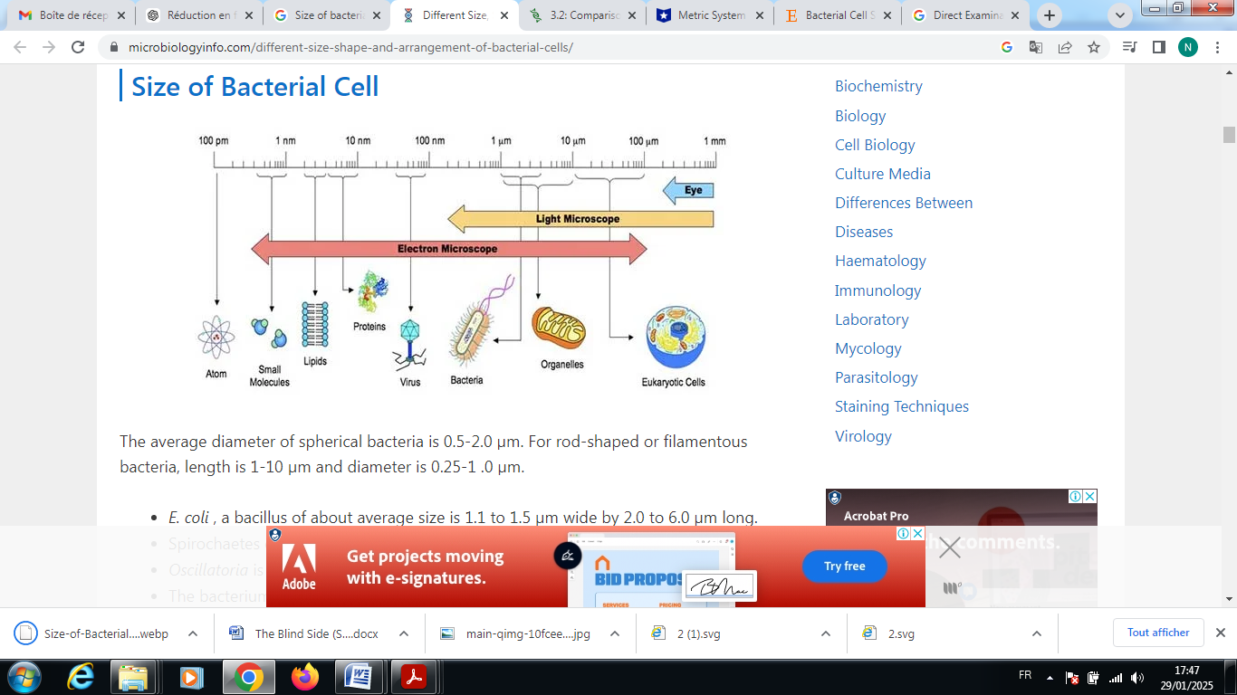

**Figure**: size of bacterial cell

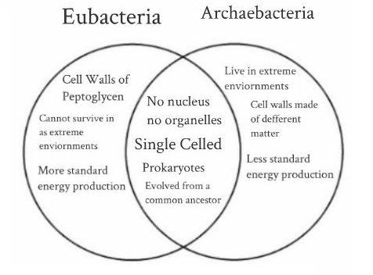

**Figure:** characteristics of Archaebacteria and Eubacteria.

**Table**: main differences between eubacteria and archaebacteria

|  |  |  |  |  |  |
| --- | --- | --- | --- | --- | --- |
| |  | | --- | | **Feature** | | |  | | --- | | **Eubacteria** | | |  | | --- | | **Archaebacteria** | |
| |  | | --- | | **Cell Wall Composition** | | |  | | --- | | Contain **peptidoglycan** | | |  | | --- | | Lack peptidoglycan; have **pseudopeptidoglycan** or **S-layer proteins** | |
| |  | | --- | | **Habitat** | | |  | | --- | | Found in **diverse environments** (soil, water, human body, etc.) | | |  | | --- | | Thrive in **extreme environments** (hot springs, salt lakes, deep-sea vents, acidic environments) | |
| |  | | --- | | **Metabolism** | | |  | | --- | | Use **standard pathways** (aerobic and anaerobic respiration) | | |  | | --- | | Use **unique metabolic pathways** (e.g., methanogenesis, sulfur reduction) | |
| |  | | --- | | **Energy Production** | | |  | | --- | | More **standard energy production** | | |  | | --- | | Less **conventional energy production**, some use alternative pathways such as methanogenesis (producing methane gas) and surviving without oxygen. | |
| |  | | --- | | **Genetic Material** | | |  | | --- | | Have **simple RNA polymerase**, ribosomal RNA differs from eukaryotes | | |  | | --- | | Have **complex RNA polymerase**, similar to eukaryotes | |
| |  | | --- | | **Examples** |  |  | | --- | |  |  |  | | --- | |  | | *Escherichia coli*, *Staphylococcus aureus*, *Bacillus subtilis*, *Pseudomonas aeruginosa* | *Methanobacterium* (methanogens), *Halobacterium* (halophiles), *Thermus aquaticus* (thermophiles), *Sulfolobus* (acidophiles) |

**1- Techniques for observing bacterial cells**  
Due to their small size (micron scale), bacteria are observed using optical microscopes, either in their fresh state (without staining) or after staining (colored state).

a) **Direct Examination in the Fresh State**  
Fresh state techniques involve observing biological material or bacterial suspensions between a slide and cover slip, with the objective set to 40 x magnification, without prior fixation using heat or alcohol. This rapid method is primarily used to observe the shape and mobility of bacteria. The fresh state is also utilized for direct observation of fungal cultures on slides, which allows for the identification of characteristic morphological features such as hyphae, mycelium, and spores.

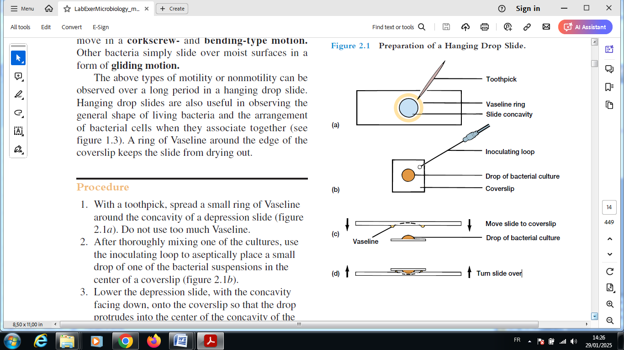

**Figure**: preparation of a hanging drop slide

b) **Smear Staining**  
Smear staining involves observing dried, fixed, and stained smears. These smears are viewed under immersion oil, which enhances clarity and provides sharper images. Various staining techniques exist to highlight different affinities for dyes. For example, methylene blue staining colors all bacteria by binding to ribosomes. The Gram staining and Ziehl-Neelsen staining techniques are commonly used to differentiate bacterial species, particularly in identifying pathogenic bacteria. Several other specialized staining techniques help detect specific bacterial structures and inclusions:

**i- Differential staining techniques**

* **Gram Staining**: Differentiates bacteria into Gram-positive and Gram-negative based on their cell wall composition.
* **Ziehl-Neelsen Staining**: Used to identify acid-fast bacteria, such as *Mycobacterium tuberculosis*.
* **Neisser Staining**: Specifically detects metachromatic granules in *Corynebacterium* species, such as *Corynebacterium diphtheriae*.

**ii- Structural staining techniques**

* **Endospore Staining (Schaeffer-Fulton Method)**: Similar to the Möller staining method, this technique uses **malachite green** and **safranin** to detect bacterial spores in *Bacillus* and *Clostridium* species. Spore staining requires special treatment to permeabilize bacterial envelopes, allowing the dye to penetrate.
* **Capsule Staining (India Ink or Maneval Stain)**: Highlights the polysaccharide capsule surrounding bacteria such as *Klebsiella pneumoniae* and *Streptococcus pneumoniae*.
* **Flagella Staining (Leifson or Gray Method)**: Thickens bacterial flagella with mordants, making them visible under a microscope.
* **Dienes Staining**: Used to differentiate colonies of *Mycoplasma* species (bacteria that lack a cell wall) particularly in cases of **contaminated cultures**. This method helps differentiate **true Mycoplasma colonies** from **contaminants** based on staining intensity and colony morphology.

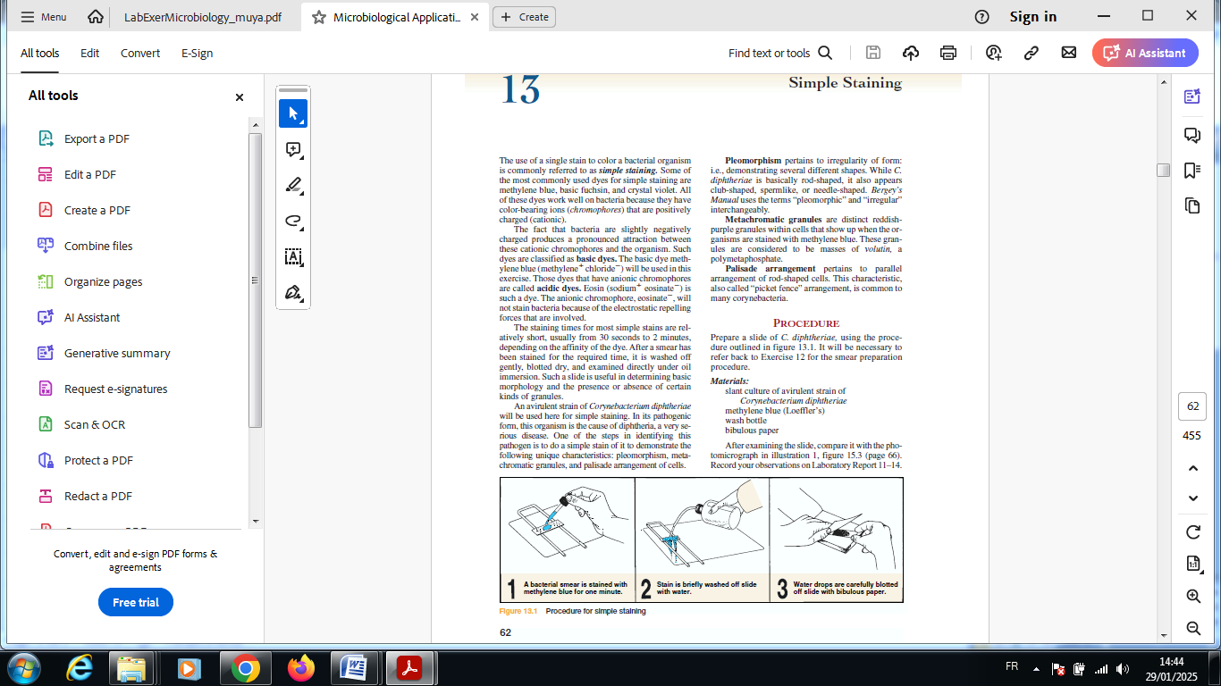

Figure: sample staining

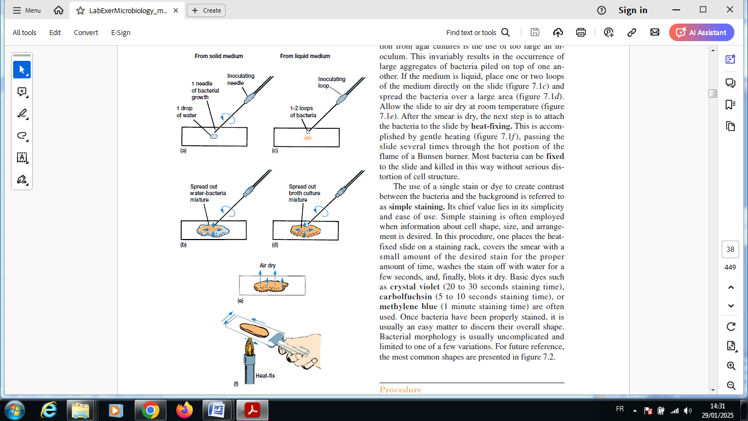

**Figure:** bacteria smear preparation

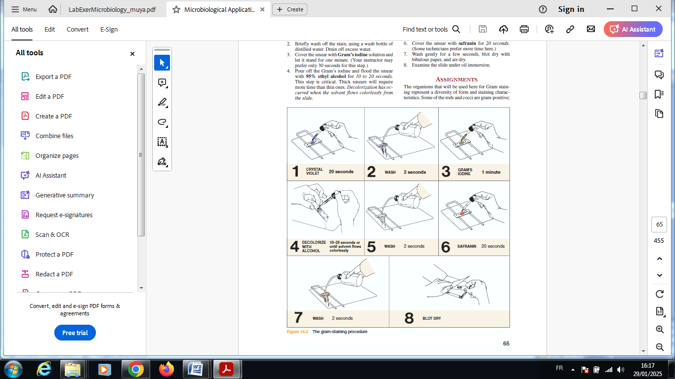

**Figure:** Gram stain procedure

**Figure:** color changes that occur at each step in the Gram staining process

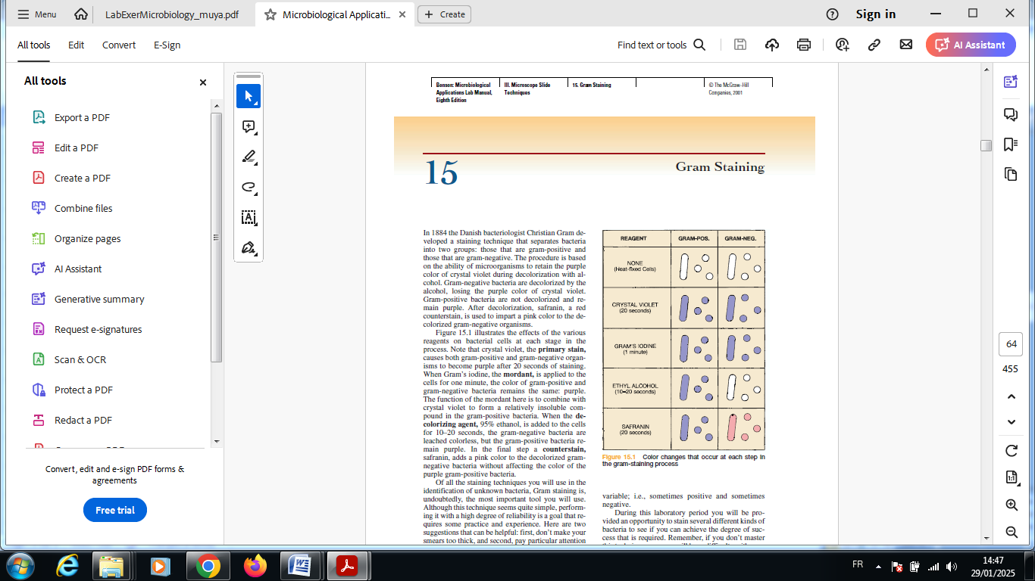

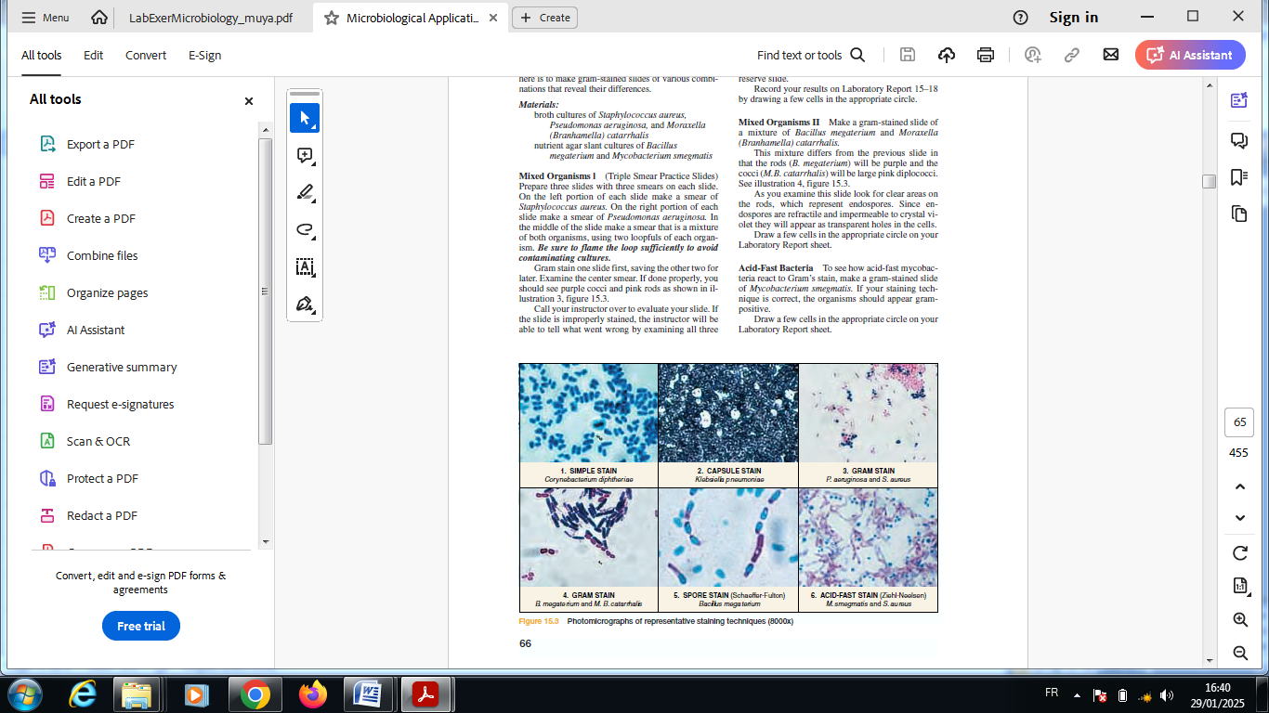

**Figure**: photomicrograph of representative techniques (8000x)

**2- Bacterial morphology and cell structure**  
Bacteria are among the smallest organized forms of life, unicellular, and prokaryotic in nature. They exhibit a wide range of shapes and structures, which can vary depending on the species.

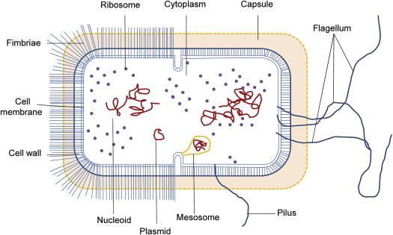

**Figure:** Bacterial morphology

**2-1- Constant and variable structural elements**  
Certain structures are present in all bacteria; these are referred to as "constant" elements. Other structures are only found in specific bacterial species and are called "variable" or "optional" elements.

|  |  |
| --- | --- |
| **Constant elements** | **Optional elements** |
| **Cell Wall** *(Gram+: PG; Gram-: outer membrane + PG)* | **Capsule** |
| **Plasma Membrane** | **Mesosome** *(uncertain role)* |
| **Cytoplasm** | **Plasmid** |
| **Periplasmic Space (Periplasm)** | **Gas Vacuole** *(aquatic bacteria)* |
| **Ribosomes** | **Storage Inclusions** |
| **Polysomes** | **Pili and Fimbriae** |
| **Nuclear Apparatus: Single Chromosome** | **Flagella** |
|  | **Chromatophore** *(photosynthetic bacteria)* |
|  | **Endospore** *(spore-forming bacteria)* |

**2-2-** **Bacterial cell shapes**  
Bacteria are unicellular organisms with diverse shapes:

* + **Cocci**: Round-shaped bacteria, which may appear singly, in chains, or clusters (variable number of cells). Examples include *Staphylococcus*, *Streptococcus*.
  + **Bacilli**: Rod-shaped bacteria that can exist as single cells, in chains, or clusters. They have variable length and diameter. Examples include *E. coli*, *Salmonella*, *Bacillus*.
  + **Spirals**: Bacteria with spiral shapes, including spirilla and spirochetes, such as *Treponema*.
  + **Filamentous bacteria**: Some bacteria resemble fungi in their filamentous shape, such as actinomycetes.

**2-3- Size and arrangements** **of bacteria**  
Bacterial size varies widely, with the smallest bacteria, such as Chlamydia, measuring around 0.2 μm, while the longest, including certain spirochetes, can reach up to 250 μm in length. On average, most bacteria range from 1 to 10 μm. Escherichia coli, a bacillus of average size, is about 1.1 to 1.5 μm wide and 2.0 to 6.0 μm long. Some bacteria, like *Thiomargarita namibiensis*, are exceptionally large, reaching up to 750 μm in diameter, while *Mycoplasma* species are among the smallest, measuring approximately 200–300 nm.

Bacteria can exist as **isolated cells** or form **characteristic groupings** depending on the species. These groupings are typically observed outside their natural habitat and include:

* **Pairs** (diplococci)
* **Clusters** (e.g., *Staphylococci*, forming "grape-like clusters" when isolated from pus)
* **Chains** (e.g., *Streptococci*, forming chains when isolated from milk)
* **Tetrads** (groups of four cells)

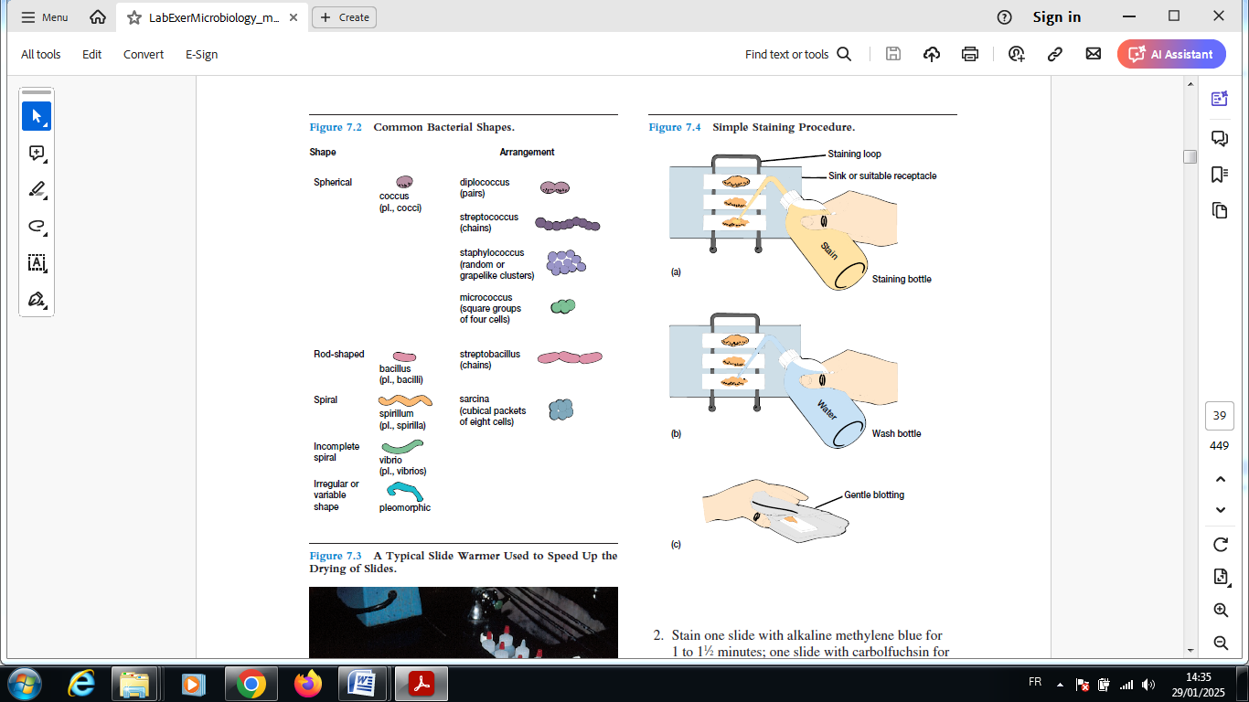

**Figure:** common bacterial shapes