Guided work: 4

Bacterial Culture Media
These are media rich in organic substances that facilitate the easy growth of numerous microorganisms. A culture medium must contain: nutrients that fulfill the elementary, energy, and specific requirements. The composition of a medium depends on the trophic type of the microorganism to be cultured.
1- Synthetic Media
Prepared exclusively with pure chemical substances and has a well-defined qualitative and quantitative composition. This type of medium allows for the precise study of the nutritional requirements of microorganisms, making it particularly useful in research.
Component | Concentration | Role in Medium
Glucose | 10 g/L | Carbon source – Provides energy for microbial growth.
Ammonium sulfate (NH₄)₂SO₄ | 3 g/L | Nitrogen source – Supplies nitrogen for protein synthesis.
KH₂PO₄ (Potassium dihydrogen phosphate) | 2 g/L | Buffer – Maintains pH during microbial growth.
Magnesium sulfate (MgSO₄·7H₂O) | 0.2 g/L | Mineral source – Provides magnesium for enzymatic reactions.
Sodium chloride (NaCl) | 5 g/L | Osmotic balance – Maintains osmotic pressure in the medium.
Distilled water | 1 L | Solvent – Dissolves all components to make the medium.

2- Complex Media
Also known as Empirical Media, these are prepared from natural products whose composition is not precisely known. Examples include: yeast extract (source of vitamin B, amino acids), malt extract (source of carbon), meat extract (source of vitamin B2 and growth factors), peptone (source of organic nitrogen), blood (nutrient element + observation of the hemolytic properties of certain bacteria).

Component | Concentration | Role in Medium
Yeast extract | 5 g/L | Source of vitamins, amino acids, and growth factors – Supports the growth of a wide range of microorganisms.
Malt extract | 10 g/L | Source of carbon – Provides fermentable sugars for microbial energy.
Peptone | 5 g/L | Source of organic nitrogen – Provides amino acids and peptides for protein synthesis.
Sodium chloride (NaCl) | 5 g/L | Osmotic balance – Maintains the osmotic pressure of the medium.
Agar | 15 g/L | Solidifying agent – Gives the medium its solid form for growing bacteria.
Distilled water | 1 L | Solvent – Dissolves the components to make the medium.

3- Selective Media
Inhibit the growth of undesirable microbes and stimulate the growth of the target microorganisms. They contain inhibitory agents (antibiotics, salts, dyes). The main factors for microbial selection, used alone or in combination, are: incubation temperature, pH of the medium, the ability to utilize a specific nutrient source (oxygen, carbon, nitrogen, etc.), and resistance to the bactericidal action of an antiseptic or antibiotic.
Ex: Mac conkey Agar
Component | Concentration | Role in Medium
Bile salts | 5 g/L | Selective agent – Inhibits the growth of Gram-positive bacteria.
Crystal violet | 0.001 g/L | Selective agent – Inhibits the growth of Gram-positive bacteria.
Lactose | 10 g/L | Differentiation – Allows differentiation between lactose fermenters and non-fermenters.
Neutral red (pH indicator) | 0.03 g/L | Differentiation – Indicates lactose fermentation (red for acid production).
Sodium chloride (NaCl) | 5 g/L | Osmotic balance – Maintains osmotic pressure in the medium.
Agar | 15 g/L | Solidifying agent – Provides solid form to the medium for bacterial growth.
Distilled water | 1 L | Solvent – Dissolves all components to make the medium.

4- Enriched Media
These are used for the cultivation of nutritionally demanding species. They are enriched by the addition of organ extracts (heart or brain), blood (horse or sheep), etc.
Example: Sheep blood agar (5%) that supports the growth of most bacteria (both Gram+ and Gram-) including those with high nutritional requirements.
Component | Concentration | Role in Medium
Sheep blood | 5% (v/v) | Enriching agent – Provides growth factors (vitamins, amino acids) and allows observation of hemolytic properties.
Peptone | 10 g/L | Nitrogen source – Supplies amino acids and peptides for protein synthesis.
Sodium chloride (NaCl) | 5 g/L | Osmotic balance – Maintains osmotic pressure of the medium.
Agar | 15 g/L | Solidifying agent – Gives the medium its solid form for bacterial growth.
Distilled water | 1 L | Solvent – Dissolves all components to make the medium.

Media | Appearance of the Medium | Inoculation Method | Selectivity/Composition | Results
Nutrient Agar | 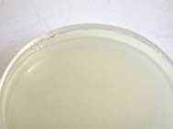  Avant  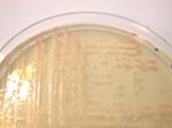  Après  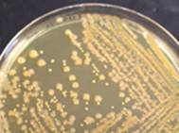  Après | All Inoculation Methods | These media allow the cultivation of less demanding bacteria. | Some colonies may have characteristic colors.
Chapman Agar | 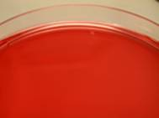  Avant  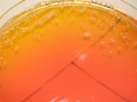  Aprés | The inoculation should be heavy, with tight streaks or by flooding. | This medium contains an inhibitor: high concentrations of sodium chloride (75 g/L), which allows for the selective isolation of Staphylococcus species that tolerate high NaCl concentrations. | The fermentation of mannitol can be studied by the yellow color change of the pH indicator, phenol red, around the colonies.
Hektoen Agar | 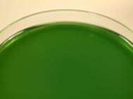  Avant  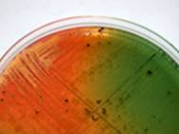  Après | The inoculation should be heavy, with tight streaks or by flooding. | Two indicators are present in the medium:  - Bromthymol blue (pH indicator)  - Acid fuchsin | Salmon-colored colonies: Escherichia, Citrobacter, Klebsiella, Enterobacter, Serratia, Yersinia  Salmon-colored colonies with a black center: Citrobacter freundii, Proteus vulgaris  Blue-green colonies with a black center: Suspected Salmonella
MacConkey Agar | 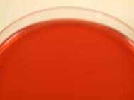  Avant  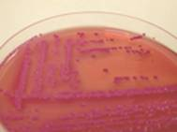  Après | Isolation by the quadrant streak method.  Incubate for 18 to 24 hours at 37°C. | This medium contains two inhibitors of Gram-positive flora:  - Bile salts  - Crystal violet | Red colonies surrounded by an opaque halo: Lactose+  Yellow or colorless colonies: Lactose-
SS Agar (Salmonella-Shigella Agar) | 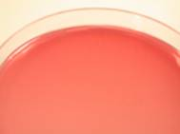  Avant  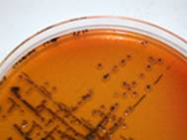  Après | Isolation by the quadrant streak method.  Incubate for 18 to 24 hours at 37°C. | The medium contains 3 inhibitors:  - Bile salts  - Brilliant green  - High concentration of sodium citrate.  These prevent the growth of all Gram-positive bacteria and make it difficult for Gram-negative bacteria other than Salmonella and Shigella to grow. | Red colonies: Lactose+  Colorless colonies: Lactose-  Colonies with a black center: H₂S+

