Exercise 1:

Marfan syndrome is an inherited disorder that affects connective tissue, resulting in unusually long bones and spinal curvature, as well as vision, heart, and breathing problems. The syndrome tends to become more severe over time. The following pedigree shows the inheritance of Marfan syndrome in a multigenerational family .

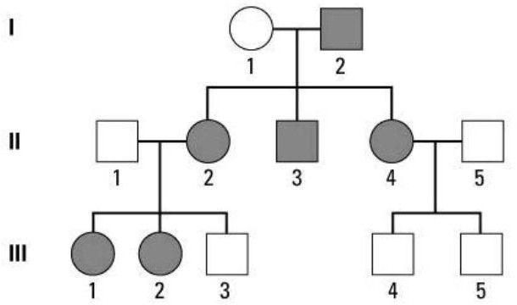

1. How is this syndrome transmitted ?
2. Can you determine the genotype of II4? Explain.
3. Individuals II1 and II2 are considering having another child. What is the probability that this child will have Marfan syndrome ? Explain using a Punnett square .
4. Give the possible genotypes of all individuals. **Exercise 2:**

As a genetic researcher, you and your colleagues have discovered a new, rare genetic disease. During your research, you analyzed a pedigree (see below) for a family in which the disease occurred.

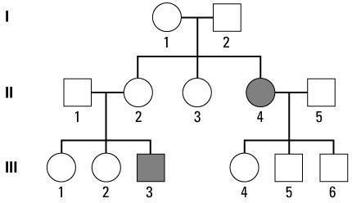

1. On which chromosome does the morbid allele appear to be located?
2. How is this syndrome transmitted ?
3. Which individuals in the pedigree can you be certain are carriers of the disease allele (asymptomatic carriers )? Explain your reasoning.
4. If individual III3 has a son with a woman who is not a carrier of the disease allele, what is the probability that the son will have the disease? Explain.
5. Give the possible genotypes of all individuals. **Exercise 3:**

Color blindness (daltonism) is inherited as a sex-linked recessive disorder that manifests as impaired vision of red and green colors. If a normal woman marries a color blinded man, what would be the expected phenotypes of their children with respect to this disorder?

You learn that this woman's father was also color blinded. What is the probability that this woman will have a normal daughter?