**Practical Work 01 :**

**Introduction to basic bicrobiology laboratory and different sterilization techniques**

**Introduction**

A microbiology laboratory is designed for working with various microorganisms. Since several culture media are prepared and organic materials are present, there is a potential for the presence of a broad spectrum of microbial communities. Additionally, when working with pure cultures, microbiological rules for asepsis must always be followed to prevent experiment failure or any hazards.

**1- Laboratory rules**  
For the safety and convenience of everyone working in the laboratory, it is essential to adhere to the following rules at all times:

1. Always wear a laboratory coat or apron before entering the lab to protect clothing from contamination or accidental staining by solutions.
2. Clean the bench tops with a disinfectant (e.g., Lysol [1:500], phenol [1:100], spirit, or 90% ethanol) at the start and end of each session.
3. Keep your laboratory bench clear of all items except laboratory equipment and your notebook.
4. Smoking, eating, or drinking is prohibited in the laboratory.
5. Do not remove media, equipment, or especially bacterial cultures from the laboratory.
6. Never place contaminated instruments (e.g., inoculating loops, needles, pipettes) on the bench tops.
7. Sterilize loops and needles by incineration.
8. Dispose of pipettes and cultures in designated receptacles.
9. Handle all microbial cultures as potential pathogens.
10. Wash your hands with liquid detergent or soap upon entering and before leaving the laboratory.
11. Tie back long hair to prevent contamination of cultures and reduce fire hazards.
12. Carry cultures in a test tube rack when moving around, and store them in a test tube stand or basket on the bench.
13. Immediately cover spilled cultures or broken culture tubes with filter paper and disinfect with an appropriate disinfectant.
14. Report any accidental cuts or burns to the instructor immediately.
15. Never pipette by mouth any broth cultures or chemical reagents. Use a mechanical pipette pump for pipetting.
16. Strictly observe aseptic techniques at all times.
17. Familiarize yourself with the exercise to be performed before starting.
18. Properly label all plates, tubes, and cultures before beginning an experiment.
19. Do not lick labels. Use self-adhesive labels for experimental purposes.

**2- Basic Requirements in a Microbiological Laboratory**

|  |  |
| --- | --- |
| **Category** | **Items** |
| **Microbiological Equipment** | Bunsen burner or spirit lamp, Laminar air flow chamber, Compound microscope, Water bath, Hot air oven, Autoclave or pressure cooker, Incubator, Refrigerator, Centrifuge, Spectrophotometer, Quebec colony counter, Balances, Homogenizer, pH meter, Hot plate, Vortex shaker, Magnetic stirrer, Membrane filter assembly, Water distillation assembly |
| **Tools** | Inoculating loops, Inoculating needles, Burette stand, Thermometer, Forceps, Scissors, Micrometer (ocular and stage) |
| **Glassware/Plasticware** | Glass Petri dishes/disposable Petri dishes, Conical flasks, Culture tubes without screw caps, Screw cap tubes, Durham fermentation tubes, Beakers, Funnels, Graduated cylinders, Bacteriological pipettes, Breed’s pipettes, Reagent bottles, Microscopic slides, Cover slips, Cavity slides, Dropper bottles for staining |
| **Miscellaneous** | Culture media, Cotton (non-absorbent/absorbent), Stains, Disinfectants, Immersion oil |

**3- Sterilization**

Sterilization is the process of rendering an article, surface, or medium free from all microorganisms. The concept was introduced by Louis Pasteur. Through sterilization, any form of microorganisms is eliminated. Sterilization is a critical step in the cultivation, isolation, and study of microorganisms in the laboratory. Other methods for microorganism destruction include disinfection and incineration.

**3-1- Physical methods of sterilization**

Several approaches are used to sterilize materials, including the following:

1. **Moist heat**: Culture media and water are sterilized using moist heat, specifically steam under pressure. This is typically achieved through autoclaving or using a pressure cooker.

**Autoclaving (Steam under Pressure) or pressure cooker**:  
Autoclaving is one of the most effective and efficient means of sterilization. All autoclaves operate based on a time/temperature relationship, where both variables are critical. Higher temperatures lead to more rapid microbial killing. The standard temperature and pressure employed are 121°C at 15 psi for 15 minutes. This combination is sufficient to exceed the thermal death time for most organisms, with the exception of some heat-resistant spore-forming bacteria. Longer times may be required for larger loads, large volumes of liquids, and denser materials. Autoclaving is ideal for sterilizing biohazardous waste, surgical dressings, glassware, microbiological media, and liquids.

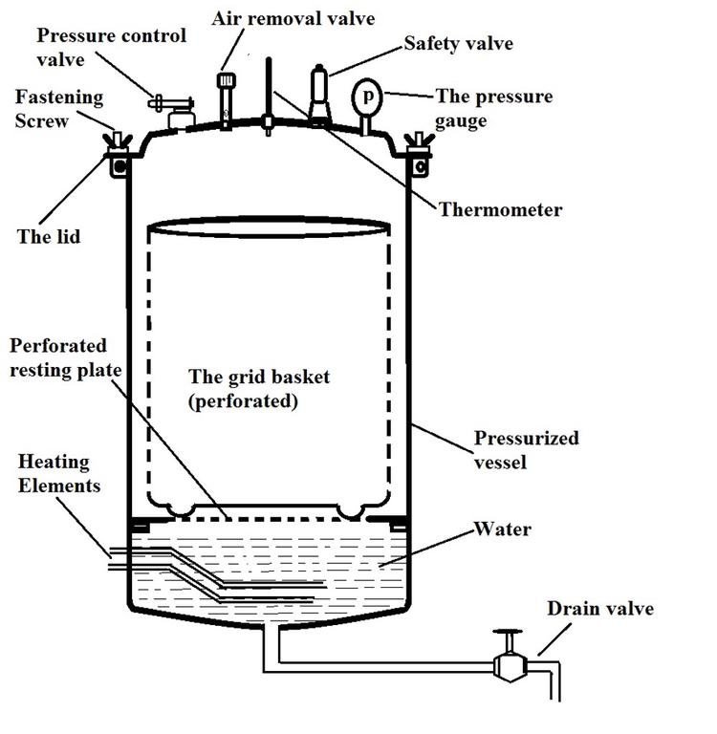

1. **Dry heat**

Dry heat is produced using a hot air oven. Glassware, glass syringes, forceps, scalpels, pipettes, flasks, Petri dishes, and other items are sterilized in the oven at 160°C for 2 hours or 170°C for 1 hour. Caution should be exercised when handling these items, as they should only be removed after cooling to avoid breakage of the glassware.

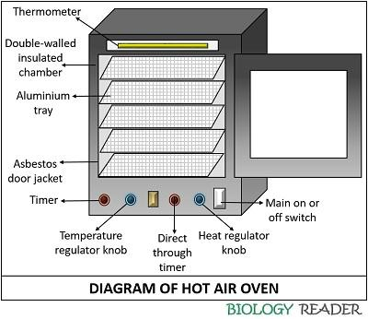

1. **Incineration**:

Incineration involves the destruction of microorganisms using flame, also known as flame sterilization. This process is carried out by inserting inoculating needles, loops, and forceps into the flame of a Bunsen burner or spirit lamp until they become red hot. The microorganisms present on the surface of the instruments are destroyed. Additionally, the mouths of culture tubes and glass slides are sterilized by flaming—bringing them near the flame for a brief second.

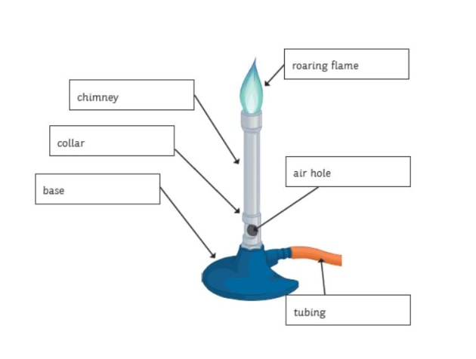

1. **Radiation**:

Ultraviolet (UV) radiation is commonly used in inoculation chambers or laminar airflow hoods. It is advisable to expose the working area to UV radiation for approximately half an hour before beginning work. UV radiation is emitted by UV lamps or UV tubes, which are typically enclosed in quartz or Vycor, as glass will not transmit UV radiation. The UV radiation damages cells by causing thymine dimer formation, leading to lethal effects. Precautions must be taken to avoid direct exposure to UV radiation with the naked eye.

1. **Sterilization by membrane filtration**:

Some substances, such as enzymes, antibiotics, amino acids, and vitamins, are heat-sensitive and cannot be sterilized by autoclaving. These substances are sterilized using filters that retain bacteria. Millipore membrane filters, commonly made from cellulose acetate or polycarbonate, have small pores (typically 0.2 μm) that trap microorganisms. The membrane filter is placed inside a filtration assembly, which is sterilized by autoclaving before use. The solution to be sterilized is passed through the membrane filter using negative pressure (via suction) or centrifugal force. The filtrate, collected in a sterile container, is free from microorganisms.

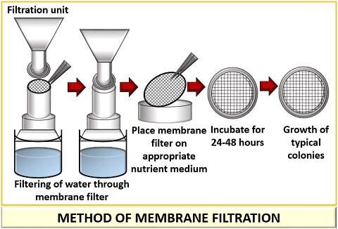

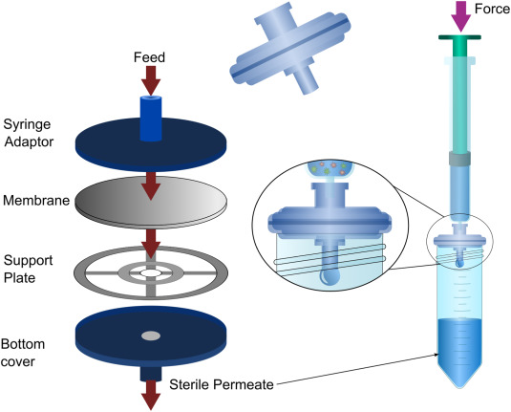

**3-2- Chemical methods of sterilization**

There are several chemicals used for sterilization of glassware, working table, hands etc. for microbial work.

**(i) Alcohol:** Ethanol or iso-propanol (70%) is used to sterilize the working tabletop, inoculation chamber, etc.

**(ii) Aldehyde:** Generally laboratory is fumigated with formaldehyde when the number of contaminants increases.

**(iii) Inorganic chemicals:** There are certain heavy metals, which are toxic to many organisms, such as salts of copper, mercury etc. HgCl2 solution (0.1%) is most commonly used as disinfectants for seeds, explants or any material. For the same purpose other chemicals used are sodium hypochlorite (10%) or calcium hypochlorite (10%). Dip the materials to be disinfected in the solution for 1 minute (for HgCl2) or for 5 to10 minutes (for Na/Ca hypochlorite). Take out the material, transfer into sterilized distilled water and wash properly. Again repeat the process of washing for 5-8 times to remove the traces of chemicals. Blot dry and inoculate the same or use as required.

**Report:**

1**-** Define the following terms: Sterilization, Asepsis, Steam Sterilization, Antiseptic, Flaming.

2- Explain the principle of autoclave sterilization.

3- Describe the use of the autoclave for sterilizing culture media.

4- Propose a sterilization method for the following materials:

|  |  |
| --- | --- |
| **Material** | **Proposed method** |
| Dry tube |  |
| Laboratory bench |  |
| Pasteur pipette |  |
| Plastic Petri dish |  |
| Culture medium in flask |  |
| Contaminated pipette |  |
| Vaccine preparation laboratory |  |
| Platinum inoculating loop |  |
| Protein solution |  |