**Chapter II: Reproduction in higher plants**

**II.1. Reproduction in Angiosperms**

**II.1.1. General characteristics of Angiosperms**

• Represented by an estimated number of species between 250 000 and 300 000,Angiosperms constitute the most diverse group of land plants **(**

• This evolutionary success is generally attributed to a major innovation: the flower, which facilitates sexual reproduction and enables efficient pollination and seed dispersal

• The flower is classically defined as a short axis ending in a more or less enlarged zone, known as the floral receptacle, which carries:

❖ **Male and female reproductive organs**: The androecium (set of stamens) forms the male reproductive structure, and the gynoecium or pistil (set of carpels) contains the ovules, which are the female reproductive organs (see **Figure 76) (Raven *et al.,* 2005).**

❖ **Sterile organs forming the perianth**: Differentiated into two distinct envelopes: the calyx (set of sepals, the outermost envelope) and the corolla (set of petals) (see **Figure 76)**

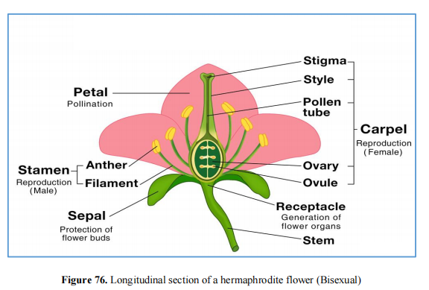

**II.1.2. Sexual reproduction of angiosperms**

**II.1.2.1. Gametogynesis**

Within the male and female organs certain cells undergo chromatic reduction and there is formation of haploid gametes.

**a) Male gametogenesis (Microsporogenesis)**

Male gametogenesis in angiosperms, also known as *microsporogenesis*, is the process by which pollen grains (male gametophytes) are formed in the anther of a flower **(Raven *et al.,* 2005).** Here's a step-bystep breakdown:

• **Location**: The process takes place in the *anther*, which is the part of the stamen (male reproductive organ) that produces pollen **(Raven *et al.,* 2005)**.

• **Archesporial cells**: In young anthers, specific cells called *archesporial cells* differentiate in the tissue of each pollen sac **(Raven *et al.,* 2005)**. These are the embryonic cells that will eventually give rise to the pollen grains (see **Figure 77)**.

• **Division of archesporial cells**:

❖ Each archesporial cell undergoes a tangential division (see **Figure 77)**, resulting in two types of cells:

▪ The *parietal cell* (external): This cell contributes to the formation of the pollen sac wall, which provides support and structure **(Raven *et al.,* 2005)**

▪ The *sporogenous cell* (internal): This cell will eventually develop into pollen mother cells, responsible for producing the male gametes **(Raven *et al.,* 2005)**

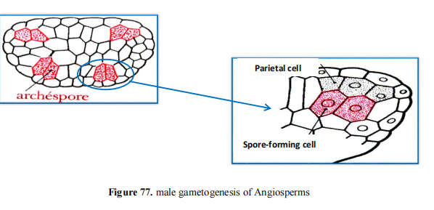

• **Microspore mother cells**:

❖ The sporogenous cells divide mitotically and differentiate into *microspore mother cells* (also called *pollen mother cells*). These cells are diploid (2n), containing two sets of chromosomes

• **Meiosis**:

❖ Each microspore mother cell undergoes *meiosis*, a process of chromosomal reduction. This division produces four haploid (n) *microspores*, each containing only one set of chromosomes. This reduction is important because gametes must be haploid so that when fertilization occurs, the diploid number can be restored in the resulting zygote (see **Figure**

**78)**

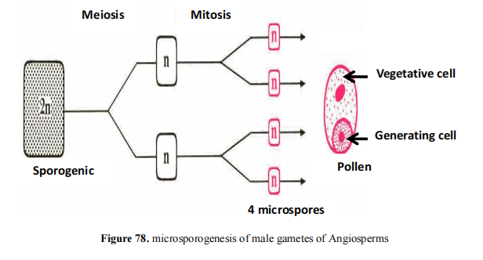

• **Tetrad formation**:

❖ The four microspores remain grouped together in a structure called a *tetrad*, which eventually breaks apart to release individual microspores **(Raven *et al.,* 2005)**.

• **Formation of pollen grains**:

❖ Each haploid microspore develops into a *pollen grain* (see **Figure 79)**. The microspore undergoes mitosis, forming two cells within the pollen grain:

▪ The *generative cell*, which will later divide again to produce two sperm cells (male gametes) **(Raven *et al.,* 2005)**.

▪ The *vegetative cell*, which will form the pollen tube that facilitates the transfer of the sperm to the female gametophyte during fertilization **(Raven *et al.,* 2005)**.

• **Maturation and release**:

❖ The mature pollen grains are released from the anther when the pollen sacs dry out and dehisce (split open). These pollen grains are then transferred to the female reproductive organ (either by wind, insects, or other pollinators) for fertilization **(Raven *et al.,* 2005)**

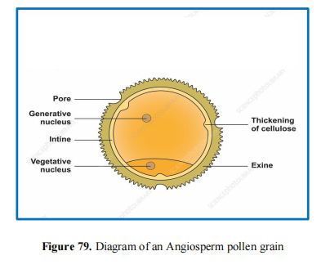

**b) Female gametogenesis ( Macrosporogenesis )**

Female gametogenesis, also known as *macrosporogenesis* (or *megasporogenesis*), occurs in the ovule of the flower and results in the formation of the female gametophyte (embryo sac). The process begins with the differentiation of an archesporial cell in the ovule and leads to the formation of the functional megaspore, which develops into the embryo sac **(Raven *et al.,* 2005)**.

• **Location**: The process of female gametogenesis takes place in the *ovule*, which is found inside the ovary of the flower. The ovule is attached to the placenta within the ovary by a structure called the *funiculus* **(Raven *et al.,* 2005)**.

• **Archesporial cell formation**: In the ovule, a *megaspore mother cell* (MMC), also called an

*archesporial cell* (see **Figure 80)**, differentiates from the nucellus tissue, which is located in the center of the ovule **(Raven *et al.,* 2005)**. This cell is diploid (2n), containing two sets of chromosomes

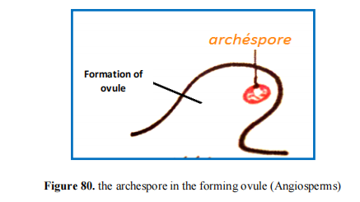

**Meiosis**: The megaspore mother cell undergoes *meiosis*, a process of reduction division. Meiosis results in the formation of four haploid megaspores (see **Figure 81)**. However, only one of these megaspores will survive, while the other three degenerate **(Raven *et al.,* 2005)**. This surviving megaspore becomes the functional megaspore (haploid), which will give rise to the female gametophyte (embryo sac)

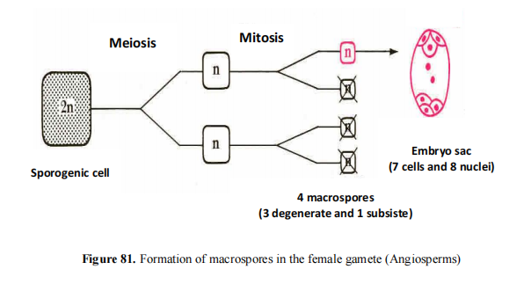

• **Formation of the embryo sac**: The functional megaspore undergoes a series of mitotic divisions to form the *embryo sac*, which is the female gametophyte. During this process, the megaspore nucleus divides mitotically three times, producing eight haploid nuclei **(Raven *et al.,* 2005)**. These eight nuclei are organized into seven cells, forming the mature embryo sac (see **Figure 82)**. These cells are:

❖ One *egg cell* (female gamete) located at the micropylar end.

❖ Two *synergid cells* flanking the egg cell, which help guide the pollen tube for fertilization

**(Raven *et al.,* 2005)**.

❖ Three *antipodal cells* located at the opposite end (chalazal end) of the embryo sac. Their role is less well defined and varies among plant species **(Raven *et al.,* 2005)**.

❖ One large *central cell* containing two polar nuclei. This cell plays a key role in double fertilization by fusing with one of the sperm cells to form the triploid endosperm, which provides nourishment to the developing embryo **(Raven *et al.,* 2005)**

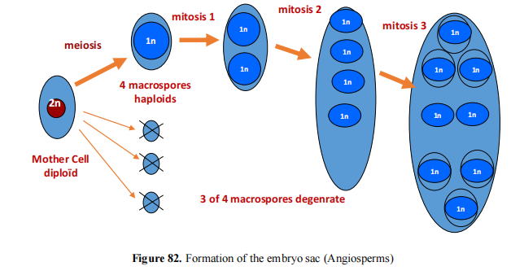

• **Fertilization Preparation**: Once the embryo sac is fully developed, the flower is ready for

fertilization. The mature ovule, containing the embryo sac, awaits the arrival of pollen, which delivers sperm cells via the pollen tube to the embryo sac. One sperm cell fertilizes the egg, forming the zygote, while the other fuses with the polar nuclei to form the endosperm, a process known as *double fertilization* **(Raven *et al.,* 2005).**

**II.1.2.2. The reproduction cycle of Angiosperms**

Angiosperms reproduce sexually through flowers, which contain the reproductive organs. Most angiosperms exhibit hermaphroditism, where both male and female reproductive structures are present in the same flower. In some species, the reproductive organs may be found on separate flowers **(Raven *et al.,* 2005).** The steps of reproduction Angiosperms are:

• **Pollination**

• **Fertilization**

• **Seed and fruit development**

• **Seed dispersal**

• **Germination and Growth**

