**Protozoa**

**Protozoa** are **unicellular** (single-celled), **heterotrophic** organisms (using organic carbon as a source of energy), belonging to the major lineages of [protists](https://www.britannica.com/science/protist) and, like most protists, typically **microscopic**. All protozoans are [**eukaryotes**](https://www.britannica.com/science/eukaryote) and therefore possess a “true,” or membrane-bound, [nucleus](https://www.britannica.com/science/nucleus-biology). They also are **non-filamentous** (in contrast to organisms such as molds, a group of [fungi](https://www.britannica.com/science/fungus), which have filaments called hyphae) and are confined to moist or aquatic habitats (**free-living**), being [ubiquitous](https://www.merriam-webster.com/dictionary/ubiquitous) in such [environments](https://www.merriam-webster.com/dictionary/environments) worldwide, from the [South Pole](https://www.britannica.com/place/South-Pole) to the [North Pole](https://www.britannica.com/place/North-Pole). Many are **symbionts** of other organisms, and some species are **parasites.** There are around 65000 species of protozoans categorized in different groups. They lack a cell wall. There are many different cell organelles, which perform various tasks performed by different organs in higher animals, e.g. mouth, anus, intestinal tract, etc.

There are many protozoa, that cause various diseases in animals and humans, e.g. **Plasmodium** (malarial parasite), **Trypanosoma** (sleeping sickness), **Trichomonas** (trichomoniasis), etc.  
The protozoa have many stages in their life cycle. Some of the stages of the life cycle are **infectious.** The cyst stage is dormant and resistant to environmental stress, the **trophozoite** stage is reproductive and causes disease.

**General Characteristics of Protozoa**

**Habitat-**Protozoa are found in the aquatic environment. They live in freshwater or oceans. Some are free-living and some are parasitic in plants and animals. Mostly they are aerobic but some are anaerobic and present in the rumen or human intestine. Some of the species are found in extreme environments like hot springs. Some of them form resting cyst to overcome dry environments.

**Size and Shape-**The size and shape of Protozoa vary greatly, from microbial (1µm) to large enough and can be seen by the naked eye. The shell of unicellular foraminifera can have a diameter of 20 cm. They lack a rigid cell wall, so they are flexible and found in various shapes. Cells are enclosed in a thin plasma membrane. Some of the species have a hard shell on the outer surface. In some of the protozoans especially in ciliates, the cell is supported by **Pellicle,**which may be flexible or rigid and give organisms the definite shape and help in locomotion.

**Cellular Structure-**They are unicellular having a eukaryotic cell. The metabolic functions are performed by some specialised internal structures.

* They mostly have one membrane-bound nucleus in the cell
* Ciliates have **micronucleus** and **macronucleus**
* The cell is enclosed in a membrane called **the plasma membrane**. Like all membranous structures in the eukaryotic cell, the plasma membrane is composed of mostly lipid and some protein molecules. The plasma membrane is a barrier between the cell cytoplasm and the outside liquid environment. Some substances, such as oxygen, readily pass through the membrane by diffusion (passive transport), while others must be transported across at the expense of energy (active transport).
* Some of the genera have a membranous envelope called pellicle, which gives a definite shape to the cell.
* The cytoplasm is differentiated into outer ectoplasm and inner endoplasm, ectoplasm is transparent and endoplasm contains cell organelles
* Some of the protozoa have cytostome for ingesting food. Food vacuoles are present, where ingested food comes. Ciliates have a gullet, a body cavity which opens outside
* In protozoans the maintenance of the osmotic gradient (osmoregulation), between the cell cytoplasm and the environment is achieved by the [**contractile vacuole**](https://www.britannica.com/science/contractile-vacuole) for that removes excess water. These membrane-bound organelles are situated close to the plasma membrane. They swell with water periodically and then suddenly contract and disappear, forcing their contents from the cell in repeated cycles.
* The central vacuole is present
* Membrane-bound cell organelles, like mitochondria, Golgi bodies, lysosomes and other specialised structures are present

**Nutrition-**Protozoa are heterotrophic and have holozoic nutrition. They ingest their food by **phagocytosis** (the food material is enclosed in food vacuoles, which are bounded by cell membrane)**.** Digestive enzymes are poured into the newly formed vacuole from the surrounding cytoplasm. Some of the protozoan groups have a specialised structure called **cytostome**for phagocytosis.

The pseudopodia of amoeboid help in catching the prey. In the ciliate Paramecium, the digestive vacuoles initially decrease in size and the enclosed particles aggregate. As digestion proceeds, the vacuole increases in size and the contents become progressively acidic, before gradually becoming alkaline near the end of the process. The products of digestion are then absorbed into the surrounding cytoplasm, and the waste material is ejected from the cell anus, or **cytoproct.** The length of the digestive cycle varies and depends on the species and the diet.

**Locomotion-**Most of the protozoa species have **flagella, cilia or pseudopodia**. Sporozoa, which don’t have any locomotory structure, have subpellicular microtubules, which help in the slow movement.

**Life Cycle-**The life cycle of most of the protozoa alternates between dormant cyst stage and proliferating vegetative stage, e.g. trophozoites.

The cyst stage can survive harsh conditions without water and nutrients. It can remain outside the host for a longer duration and get transmitted.

The trophozoite stage is infectious, and they feed and multiply during this stage.

**Reproduction-** Asexual reproduction is the most common means of replication by protozoans. They multiply by **binary fission, longitudinal fission, transverse fission, Multiple fission (schizogony) or budding**. The ability to undergo a sexual phase is confined to the ciliates, the apicomplexans, and restricted taxa among the flagellated and amoeboid organisms. The sexual reproduction is by **conjugation** (exchanging genetic material between individuals of the same species)**,** **syngamy or by gametocytes formation**. Free-living protozoans normally resort to sexual reproduction only when environmental conditions become adverse, because this mode of reproduction enhances genetic variation through mechanisms such as mutation and chromosomal crossing over. When food and other conditions are favorable, asexual reproduction occurs.

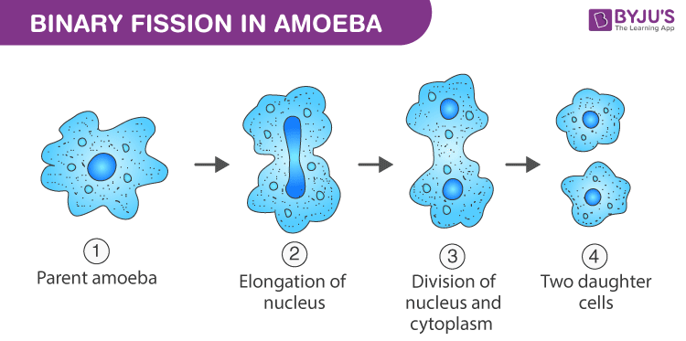

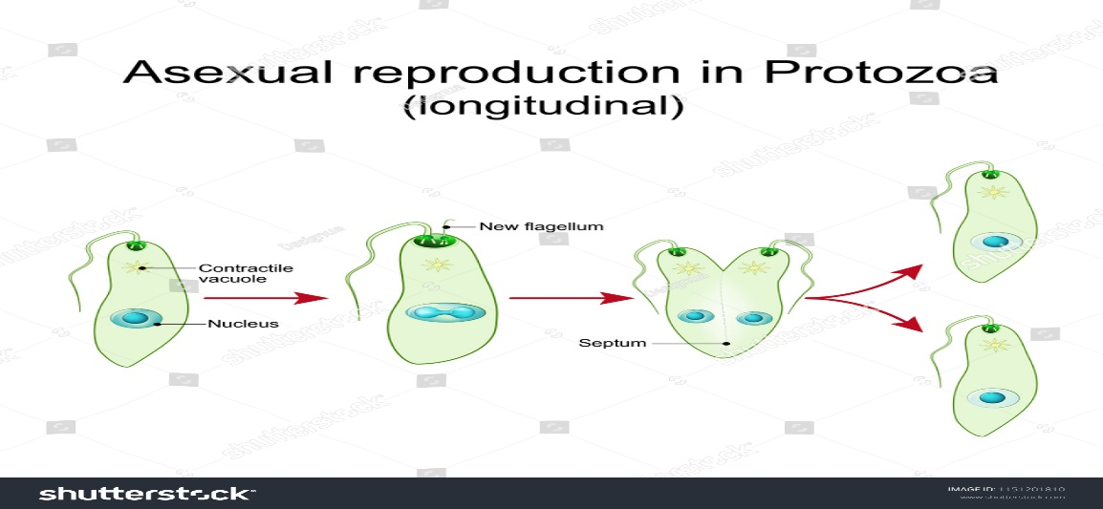

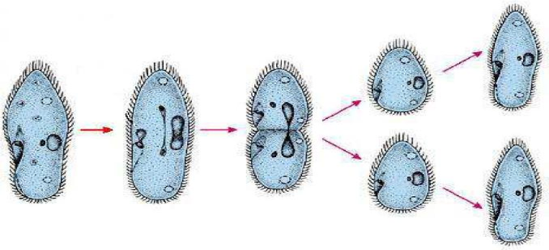

**Transverse binary division**

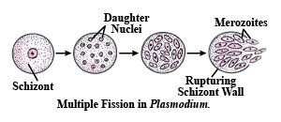

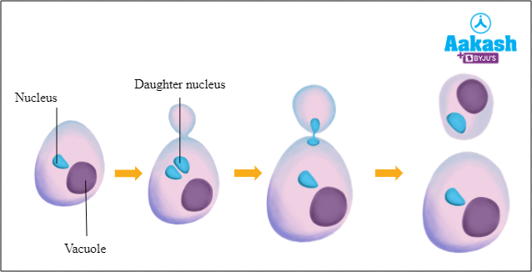

**Budding in protozoa**

**Classification of Phylum Protozoa**

It recognizes four subphyla based on organs of locomotion:

Subphylum I: Sarcomastigophora

Subphylum II: Sporozoa

Subphylum III: Cnidospora

Subphylum IV: Ciliophora

**Subphylum I: Sarcomastigophora**

* Locomotor organelles are pseudopodia or flagella.
* The nucleus is of a single type (monomorphic).
* There is no spore formation.
* Syngamy occurs in reproduction.

**Superclass A: Mastigophora or Flagellated protozoans:**

They are parasites or free-living.

* They have flagella for locomotion
* Their body is covered by a cuticle or pellicle
* They have a contractile vacuole
* Reproduction is by binary fission (longitudinal division)
* They are mostly free-living though some are parasitic.
* Nutrition is autotrophic or heterotrophic or both.

**Class 1: Phytomastigophorea**

* Chlorophyll-bearing chromatophores present.
* Nutrition mainly holophytic by phototrophy.
* They have usually only one or two flagella.
* The nucleus is vesicular.

Examples: *Euglena, Phacus, Copromonas, Peranema,* etc.

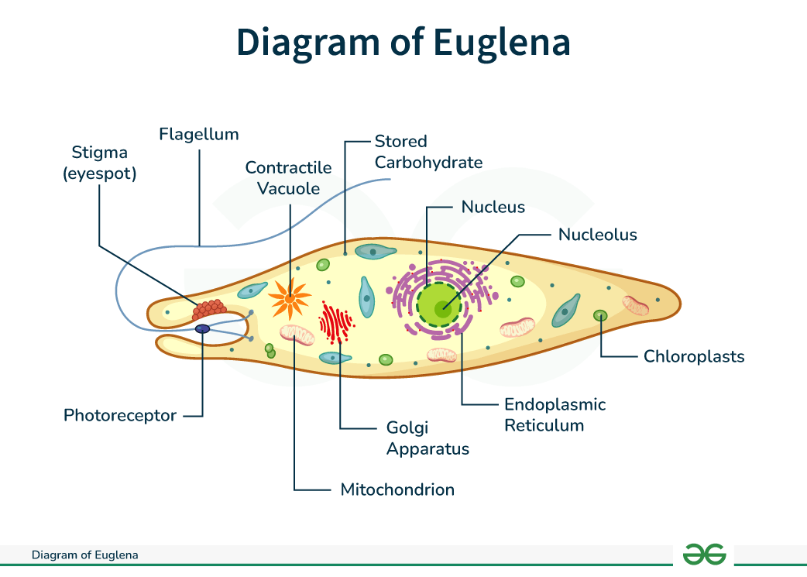

**Class 2: Zoomastigophorea**

* Chlorophyll or chromatophores absent.
* Flagella one to many.
* There is an undulating membrane.
* Organisms within this group have a spherical, elongated body with a single central nucleus.
* They are single-celled, heterotrophic eukaryotes
* Some species are parasitic, causing diseases such as the African Sleeping Sickness, caused by the zooflagellate *Trypanosoma brucei* and *Trichomonas vaginalis* caused Trichmoniasis.
* A few are mutualistic, such as those that live in the guts of termites and aid the bacteria present in breaking down wood

examples: *Trypanosoma,* Trichonympha, Lophomonas, Leptomonas, etc.

***1.Trypanosoma brucei*** “African trypanosomes” or “Old World trypanosomes” are protozoan hemoflagellates of the genus *Trypanosoma,*in the subgenus *Trypanozoon*. Two subspecies that are morphologically indistinguishable cause distinct disease patterns in humans: *T. b. gambiense*, causing chronic African trypanosomiasis (“West African sleeping sickness”) and *T. b. rhodesiense*, causing acute African trypanosomiasis (“East African sleeping sickness”). The third subspecies *T. b. brucei* is a parasite primarily of cattle and occasionally other animals, and under normal conditions does not infect humans.

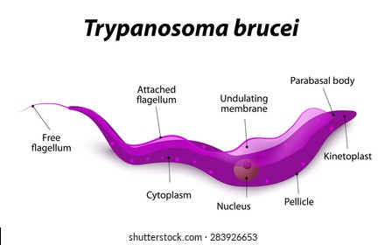

**Life cycle:**

During a blood meal on the mammalian host, an infected tsetse fly (genus *Glossina*) injects metacyclic trypomastigotes into skin tissue. The parasites enter the lymphatic system and pass into the bloodstream image . Inside the host, they transform into bloodstream trypomastigotes image , are carried to other sites throughout the body, reach other body fluids (e.g., lymph, spinal fluid), and continue the replication by binary fission image . The entire life cycle of African trypanosomes is represented by extracellular stages. The tsetse fly becomes infected with bloodstream trypomastigotes when taking a blood meal on an infected mammalian host image , image . In the fly’s midgut, the parasites transform into procyclic trypomastigotes, multiply by binary fission image , leave the midgut, and transform into epimastigotes image . The epimastigotes reach the fly’s salivary glands and continue multiplication by binary fission image . The cycle in the fly takes approximately 3 weeks. Rarely, *T. b. gambiense*may be acquired congenitally if the mother is infected during pregnancy.

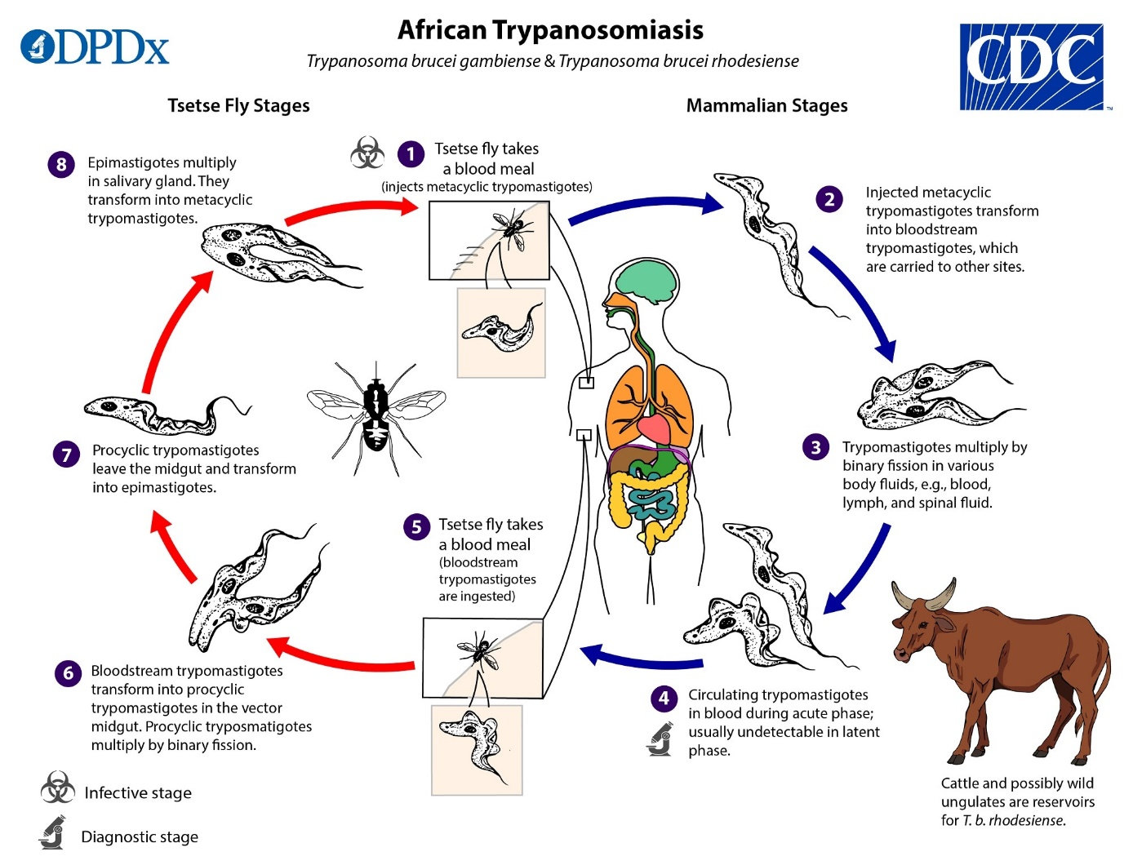

***2.Trichomonas vaginalis*** is a flagellated protozoan that resides in the lower genital tract of women, and in the urethra and prostate of men. It is a sexually transmitted disease can cause vaginitis, cervicitis and urethritis.

jkklfgqq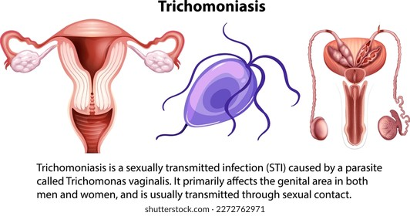

***Trichonympha***: is found exclusively in the hindgut of lower termites and wood roaches. Trichonympha’s bell shape and thousands of [flagella](https://en.wikipedia.org/wiki/Flagellum) make it an easily recognizable cell. The [symbiosis](https://en.wikipedia.org/wiki/Symbiosis) between lower termites/wood roaches and Trichonympha is highly beneficial to both parties: Trichonympha helps its host digest cellulose and in return receives a constant supply of food and shelter.

***Lophomonas blattarum*** is a [protozoan](https://en.wikipedia.org/wiki/Protozoan) [flagellate](https://en.wikipedia.org/wiki/Flagellate) that is found in the gut of [cockroaches](https://en.wikipedia.org/wiki/Cockroach). It has been found to be an [emerging pathogen](https://en.wikipedia.org/wiki/Emerging_pathogen) causing [bronchopulmonary infection](https://en.wikipedia.org/wiki/Pneumonia) and [sinusitis](https://en.wikipedia.org/wiki/Sinusitis) in immunocompromised, and immunocompetent, patients.

***Trichonympha***  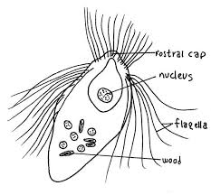

**Superclass B: Opalinata**

* Organelles of locomotion are many small sized cilia-like flagella.
* There is no cytostome.
* Two or more monomorphic nuclei are present.
* Binary fission is interkinetal.
* There is syngamy with flagellated anisogametes.
* All are parasitic, mainly in frogs and toads.
* Examples: *Opalina, Protoopalina, Zelleriella*, *Protozelleriella,* and *Cepedea*.

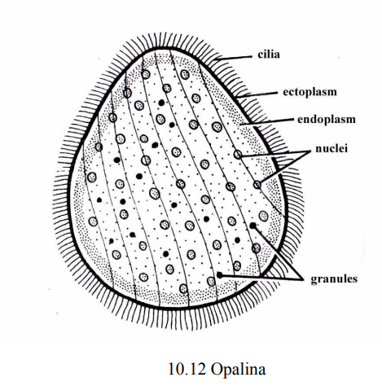

**Superclass C: Sarcodina**

They live in the freshwater, sea or moist soil.

* Locomotory organelles are pseudopodia.
* The amoeboid form is predominant.
* There is no definite shape and pellicle is absent
* Some have a hard shell.
* They generally do not form spores.
* Reproduction is by binary fission and cyst formation
* The contractile vacuole is present in the amoeboids living in freshwater
* The formation of gametes and flagellated young ones are common.
* Nutrition holozoic or saprozoic.

**Class 1: Rhizopodea**

* Locomotory organelles are pseudopodia (lobopodian or filopodia but never axopodia).
* They are generally creeping forms.
* Examples: *Amoeba, Entamoeba, Pelomyxa*, etc.

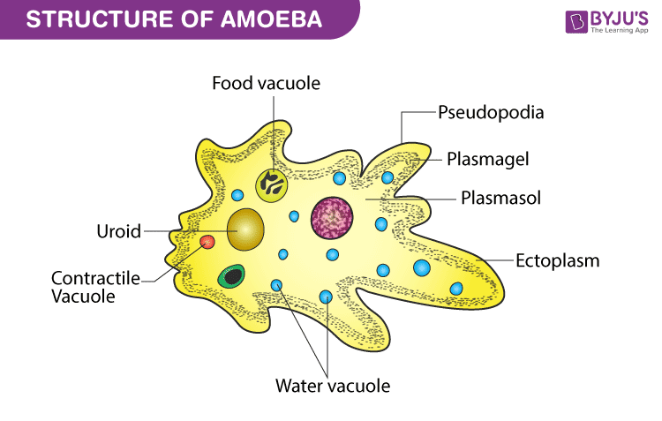

***Antamoeba histolytica***is well recognized as a pathogenic ameba, associated with intestinal and extraintestinal infections.

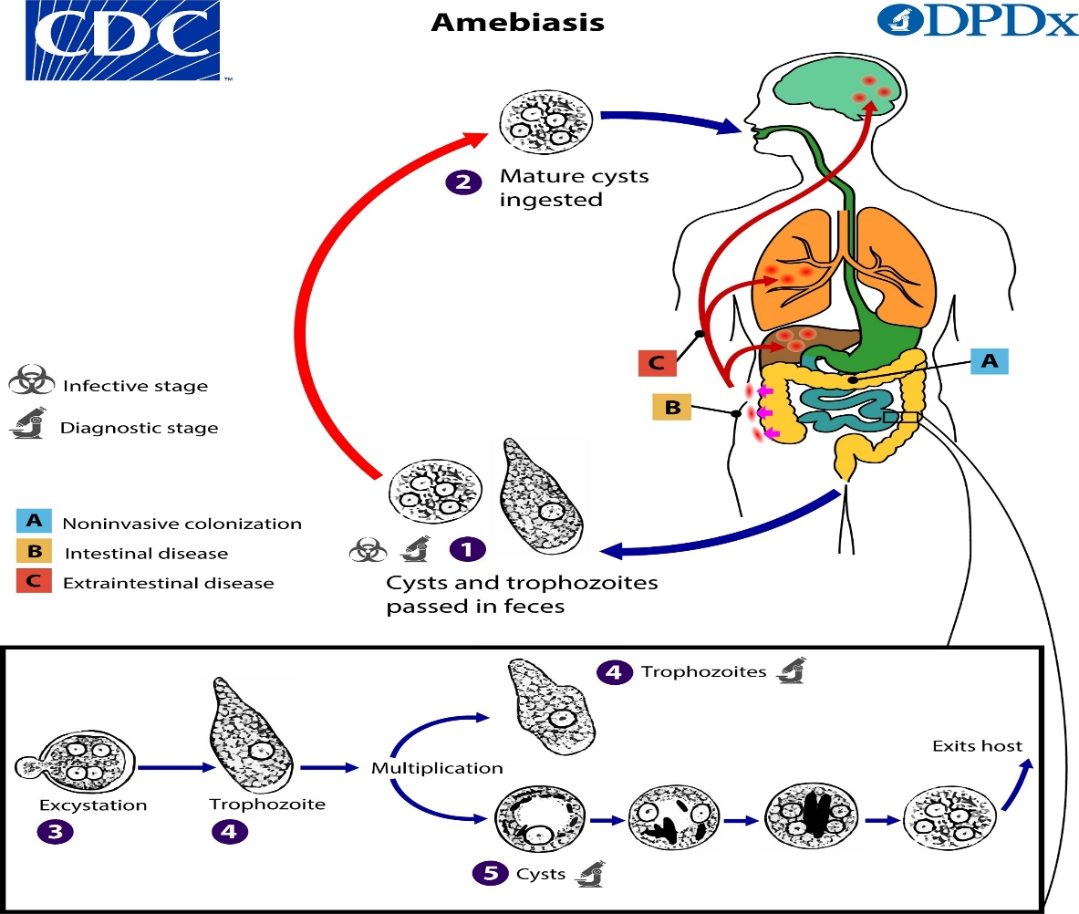

**Cycle life:**

Cysts and trophozoites are passed in feces image . Cysts are typically found in formed stool, whereas trophozoites are typically found in diarrheal stool. Infection with *Entamoeba histolytica*(and *E.dispar*) occurs via ingestion of mature cysts image from fecally contaminated food, water, or hands. Exposure to infectious cysts and trophozoites in fecal matter during sexual contact may also occur. Excystation image occurs in the small intestine and trophozoites image are released, which migrate to the large intestine. Trophozoites may remain confined to the intestinal lumen (A: noninvasive infection) with individuals continuing to pass cysts in their stool (asymptomatic carriers). Trophozoites can invade the intestinal mucosa (B: intestinal disease), or blood vessels, reaching extraintestinal sites such as the liver, brain, and lungs (C: extraintestinal disease). Trophozoites multiply by binary fission and produce cysts image , and both stages are passed in the feces image . Cysts can survive days to weeks in the external environment and remain infectious in the environment due to the protection conferred by their walls. Trophozoites passed in the stool are rapidly destroyed once outside the body, and if ingested would not survive exposure to the gastric environment.

### ****Class 2: Actinopodea****

* Pseudopodia mainly axopodia with axial filaments, radiating from a spherical body.
* They are primarily sessile or floating forms.
* Reproduction is both sexual and asexual.
* Examples: *Thalassicola, Collozoum, Lithocircus*, etc.

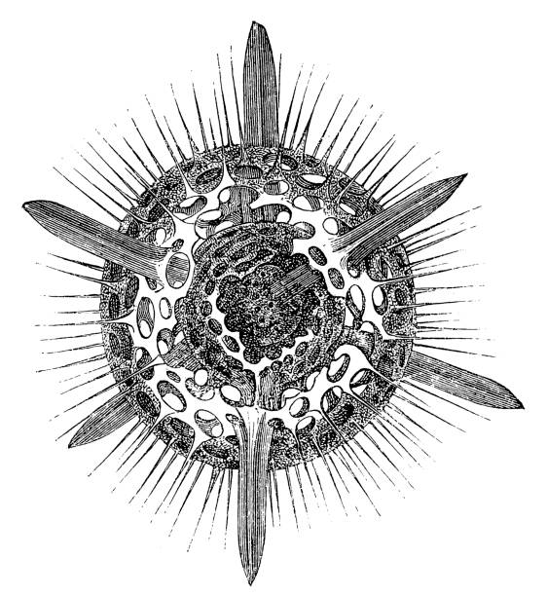

**Subphylum II: Sporozoa**

* Locomotory organelles absent.
* Spores usually present.
* Exclusively endoparasites.
* Syngamy takes place after which many spores are formed.
* The spores are simple and contain one to many sporozoites.
* Sporozoites are the infective phase.
* The nucleus is of the single type (monomorphic).

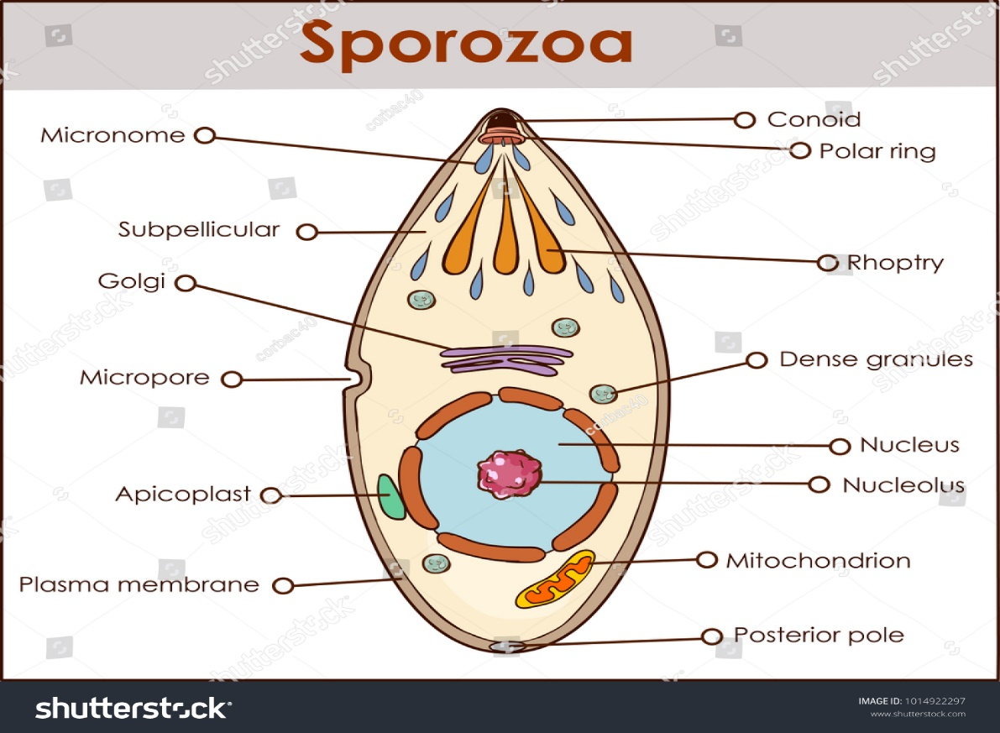

**Class 1: Telosporea**

Locomotion by gliding or body flexion.

* Spores are formed and there are flagellated microgametes in some.
* Spores are without polar capsules and filaments, naked or encysted.
* Reproduction by both sexual and asexual methods.

**Subclass a: Gregarinia**

* Mature trophozoites are large and extracellular.
* Reproduction is entirely sexual with sporogony.
* The spores contain eight sporozoites.
* They are parasites of the digestive tract and body cavity of [invertebrates](https://microbenotes.com/characteristics-of-invertebrates/).
* Examples: *Gregarina, Monocystis, Nematocystis*, etc.

**Gregarina**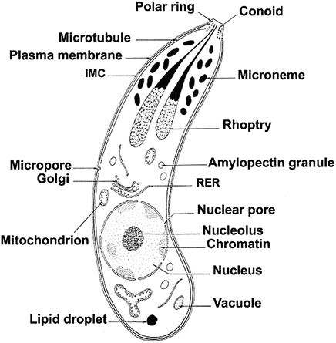

**Subclass b: Coccidia**

* Mature trophozoites are small and typically intracellular.
* Each oocyst produces many sporozoites.
* They are parasites of the digestive tract or blood of vertebrates.
* Gametocytes are dimorphic.
* Sporozoites multiply by schizogony in tissue cells.
* Examples: *Eimeria, Isospora, Plasmodium*, etc.

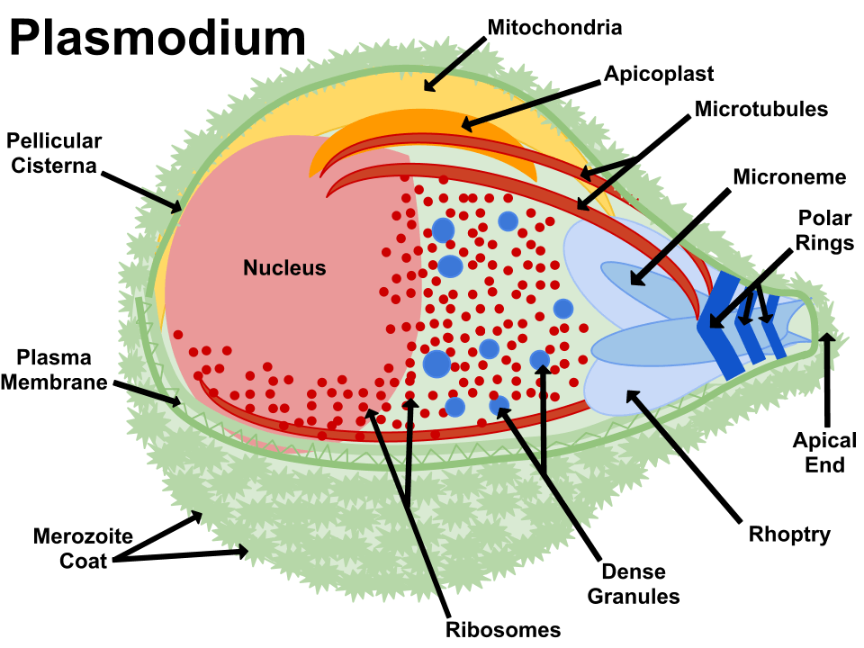

***Plasmodium falciparum*** is the etiological agent of malaria *tropica*, the leading cause of death due to a vector-borne infectious disease, claiming 0.5 million lives every year. The single-cell eukaryote undergoes a complex life cycle and is an obligate intracellular parasite of hepatocytes (clinically silent) and erythrocytes (disease causing). An infection can progress to a wide range of pathologies, including severe anemia and cerebral malaria, which can lead to death. *P. falciparum* repeatedly replicates over the course of 48h inside erythrocytes, resulting in exponential growth and rapid disease progression. As the single most important infectious disease afflicting children, no other pathogen has exerted a higher selection pressure on the human genome. Over 20 polymorphisms, including the sickle-cell trait, have been selected in human populations, despite severe fitness costs, since they offer protection against fatal *P. falciparum* infections. No effective vaccine exists, but several curative treatments are available.

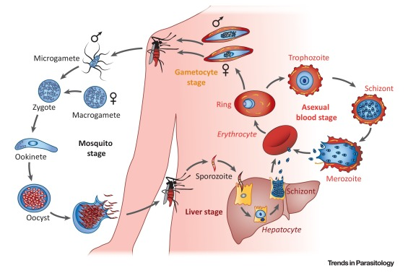

**Class 2: Toxoplasmea**

* Spores are absent.
* There are no flagella or pseudopodia at any stage.
* Reproduction by [Asexual Reproduction](https://microbenotes.com/asexual-reproduction/) ([binary fission](https://microbenotes.com/binary-fission/)).
* Cysts are formed which have many naked sporozoites.
* Examples: *Sarcocystis, Toxoplasma*, etc.

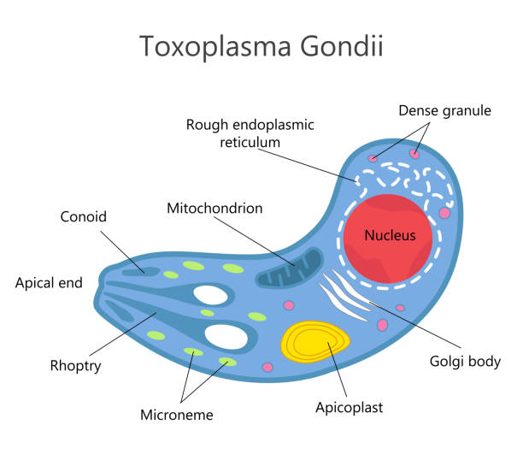

***Toxoplasma gondii*** is a protozoan parasite that infects most species of warm-blooded animals, including humans, and causes the disease toxoplasmosis.

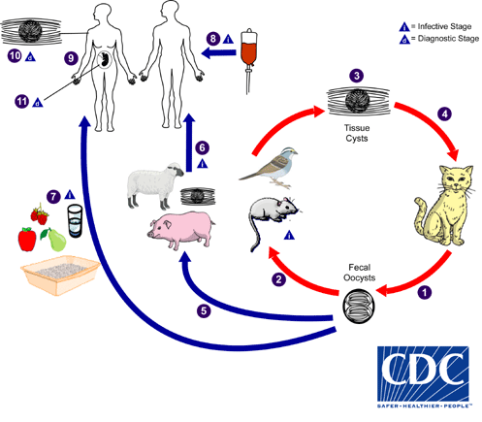

The only known definitive hosts for *Toxoplasma gondii* are members of family Felidae (domestic cats and their relatives). Unsporulated oocysts are shed in the cat’s feces https://www.cdc.gov/dpdx/images/life_cycle_numbers/new/1.jpg . Although oocysts are usually only shed for 1–3 weeks, large numbers may be shed. Oocysts take 1–5 days to sporulate in the environment and become infective. Intermediate hosts in nature (including birds and rodents) become infected after ingesting soil, water or plant material contaminated with oocysts https://www.cdc.gov/dpdx/images/life_cycle_numbers/new/2.jpg . Oocysts transform into tachyzoites shortly after ingestion. These tachyzoites localize in neural and muscle tissue and develop into tissue cyst bradyzoites https://www.cdc.gov/dpdx/images/life_cycle_numbers/new/3.jpg . Cats become infected after consuming intermediate hosts harboring tissue cysts https://www.cdc.gov/dpdx/images/life_cycle_numbers/new/4.jpg . Cats may also become infected directly by ingestion of sporulated oocysts. Animals bred for human consumption and wild game may also become infected with tissue cysts after ingestion of sporulated oocysts in the environment https://www.cdc.gov/dpdx/images/life_cycle_numbers/new/5.jpg . Humans can become infected by any of several routes:

* Eating undercooked meat of animals harboring tissue cysts https://www.cdc.gov/dpdx/images/life_cycle_numbers/new/6.jpg .
* Consuming food or water contaminated with cat feces or by contaminated environmental samples (such as fecal-contaminated soil or changing the litter box of a pet cat) https://www.cdc.gov/dpdx/images/life_cycle_numbers/new/7.jpg .
* Blood transfusion or organ transplantation https://www.cdc.gov/dpdx/images/life_cycle_numbers/new/8.jpg .
* Transplacentally from mother to fetus https://www.cdc.gov/dpdx/images/life_cycle_numbers/new/9.jpg .

In the human host, the parasites form tissue cysts, most commonly in skeletal muscle, myocardium, brain, and eyes; these cysts may remain throughout the life of the host. Diagnosis is usually achieved by serology, although tissue cysts may be observed in stained biopsy specimens https://www.cdc.gov/dpdx/images/life_cycle_numbers/new/10.jpg . Diagnosis of congenital infections can be achieved by detecting *T. gondii* DNA in amniotic fluid using molecular methods such as PCR https://www.cdc.gov/dpdx/images/life_cycle_numbers/new/11.jpg

**Class 3: Haplosporea**

* Spores are present.
* Pseudopodia may be present but flagella are absent.
* Reproduction only by an asexual method.
* Schizogony takes place.
* Examples: *Caelosporidium, Ichthyosporidium*, etc.

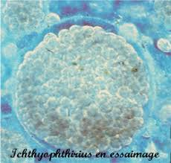 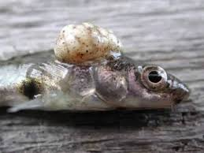

**Subphylum III: Cnidospora**

* Spores have several cells having one or more polar filaments, which are coiled threads and can be shot out, and one or more sarcoplasms or sporoplasms (analogous to sporozoites).
* All are parasitic.
* Zygote gives rise to one or more trophozoites without sporogony**.**

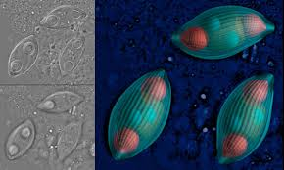

**Class 1: Myxosporidea**

* Spores are of multicellular origin and large.
* There are one or more sporoplasms with two or three valves.
* They are parasites of fish.
* Examples: *Myxobolus, Myxidium, Ceratomyxa*, etc.

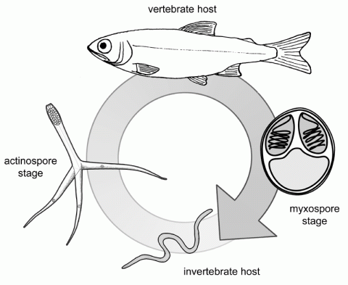

**Class 2: Microsporidea**

* Spores are of unicellular origin and small.
* There is one long tubular polar filament through which the sporoplasms emerges one valve only.
* They are cytozoic (intracellular parasites) in arthropods and vertebrates.
* Example: *Nosema*.

**Microsporidia Spore**

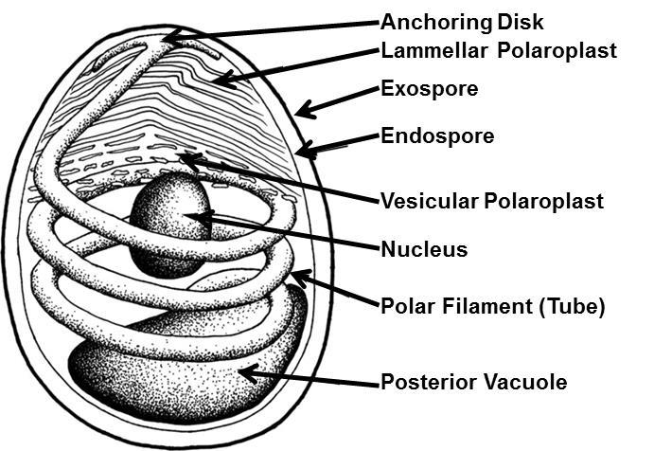

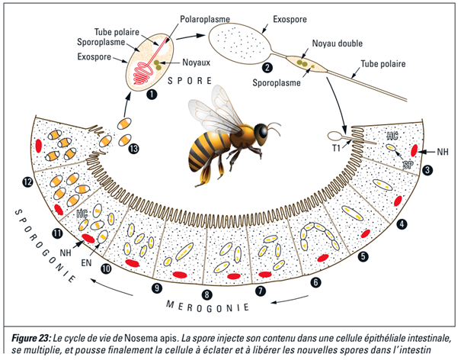

Nosemosis, or Nosema disease, is caused by two species of microsporidian parasites (a type of spore forming fungus) called *Nosema apis* and *Nosema ceranae*. *N. apis* is thought to have originated on European honey bees, while *N. ceranae* is thought to have evolved as a pest of Asian honey bees (*Apis cerana*) and has only started to affect the European honey bees relatively recently. *N. ceranae* appears to be more damaging than *N. apis*, affecting more cells in the bees mid-gut and killing infected bees faster than *N. apis*.

Infection of adult bees at a young age can cause the bee to have difficulty digesting food for the rest of its life. These bees usually do not produce brood food/royal jelly secretions from the hypopharyngeal glands and often skip the brood rearing stage of their life, becoming forager bees at a young age. The infected bee often has a shortened adult lifespan. When queen bees become infected they also have reduced lifespans and cease to lay eggs. These impacts cause reduced colony health, population and performance, which can ultimately result in the colony dying.

**Subphylum IV: Ciliophora**

* They possess simple ciliary organelles for locomotion, infraciliature is subpeculiar.
* They have two nuclei, a trophic macronucleus, and a reproductive micronucleus.
* Binary fission is perkinetal.
* Conjugation takes place with the fusion of nuclei, autogamy and cytogamy also occur.
* There are never any free gametes.
* Nutrition is mixotrophic or heterotrophic.
* They usually have a cytostome.
* Some species have an organ for defence called **trichocysts**

**Class 1: Ciliata**

* They are aquatic and they possess cilia or compound ciliary structure as locomotory or food acquiring organelles.
* There is the presence of an infraciliary system, composed of basal granules below the cell surface and interconnected by longitudinal fibrils.
* Most ciliates possess a cell mouth or cytostome.
* Anal aperture (cytopyge) permanent.
* Fission is transverse.
* Sexual reproduction never involves the formation of free gametes.
* One or more contractile vacuoles present even in marine and parasitic types.
* Two types of nuclei, one vegetative (macronucleus) and the other reproductive (micronucleus). **The**[**macronucleus**](https://www.britannica.com/science/macronucleus) is the somatic, or **nonreproductive**, nucleus. It is large and it is polyploid, meaning that it contains more than two sets of chromosomes (the condition of two sets of chromosomes is described as diploid). In contrast, **the**[**micronucleus**](https://www.britannica.com/science/micronucleus) is **germinal** (responsible for transfer of genetic information during sexual reproduction) and diploid. The macronucleus can be quite variable in shape, resembling in some species a string of beads or a horseshoe. It directs the normal functioning of the cell and usually disintegrates during [sexual reproduction](https://www.britannica.com/science/sexual-reproduction), to be re-formed from the products of micronuclear division after the sexual phase is completed.

**Subclass 1: Holotricha**

* Body cilia simple and uniform.
* Buccal cilia mostly absent.

*Exemple : Balantidium , Paramecium*, etc

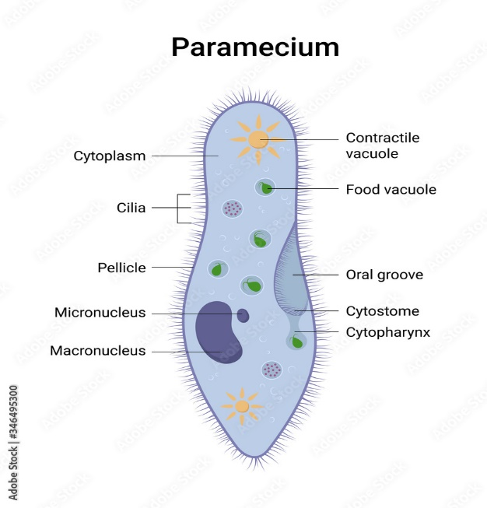

**Subclass 2: Peritricha**

* Adults without body cilia.
* Apical end with buccal cilia.

Examples: *Vorticella, Carchesium, Trichodina*, etc.

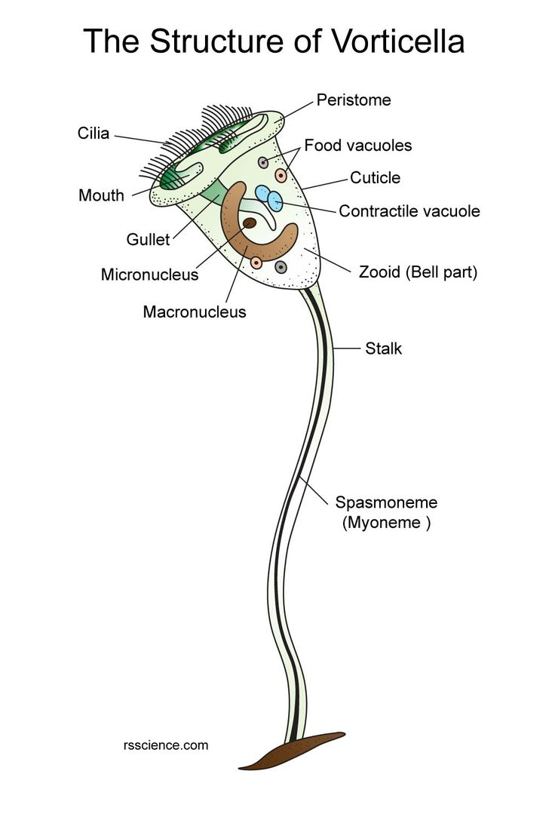

**Subclass 3: Suctoria**

* Sessile and stalked body.
* Young with cilia, and adult with suctorial tentacles.
* Examples: *Acineta, Ephelota, Podophyra*, etc.

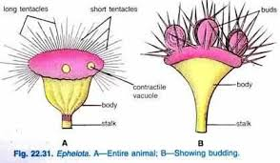 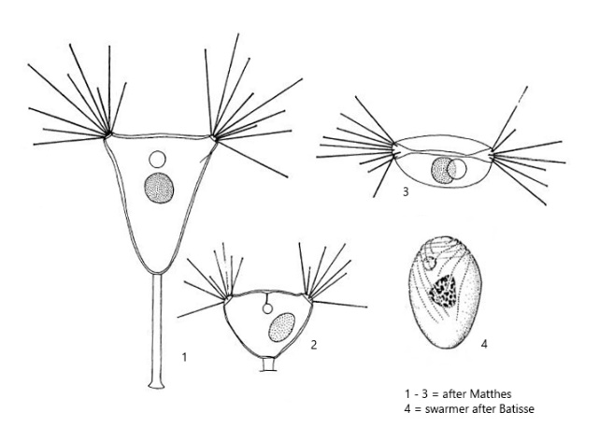

**Subclass 4: Spirotrichia**

* Reduced body cilia.
* Buccal cilia are well marked.

Examples: *Stentor, Bursaria, Spirostomum*



