# Exercise 1:

Marfan syndrome is an inherited disorder that affects connective tissue, resulting in unusually long bones and spinal curvature, as well as vision, heart, and breathing problems. The syndrome tends to become more severe over time. The following pedigree shows the inheritance of Marfan syndrome in a multigenerational family.

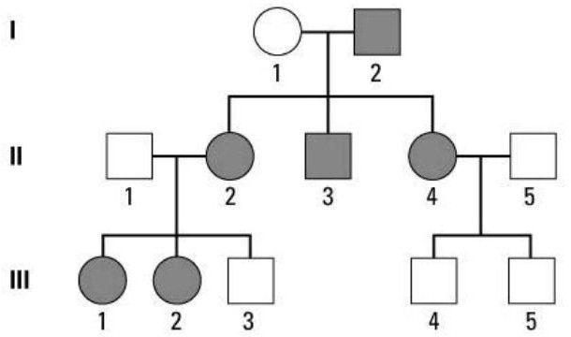

1. How is this syndrome transmitted ?

It is transmitted in an autosomal dominant manner because:

-both men and women are affected.

-there is no generation jumping.

-each sick individual has at least one of the two sick parents.

1. Can you determine the genotype of II4? Explain.

M = morbid allele

n = normal (healthy) allele

Individual II4 is sick, his genotype must be heterozygous (Mn) because he inherited the morbid allele from his father who is sick and the normal allele from his mother who is normal.

1. Individuals II1 and II2 are considering having another child. What is the probability that this child will have Marfan syndrome ? Explain using a Punnett square .

M = morbid allele

n = normal (healthy) allele

The genotype of II1 must be nn (healthy) and of II2 must be Mn (heterozygous diseased) Parents nn X Mn

Gametes n X 1/2 M, 1/2 n

## F1

|  |  |  |
| --- | --- | --- |
|  | 1/2 M | 1/2 n |
| n | 1/2 Mn (sick) | 1/2 nn (healthy) |

So the child has a 50% chance of being sick.

1. Give the possible genotypes of all individuals.

GENOTYPES ARE TO BE PUT DIRECTLY ON THE FAMILY TREE

I1 = nn , I2 = Mn or MM (very possible that he is MM because he has 3 sick children), II1 = nn , II2 = Mn , II3 = Mn , II4 = Mn , II5 = nn ,

III1 = Mn, III2 = Mn, III3 = nn , III4 = nn , III5 = nn ,

# Exercise 2:

As a genetic researcher, you and your colleagues have discovered a new, rare genetic disease. During your research, you analyzed a pedigree (see below) for a family in which the disease occurred.

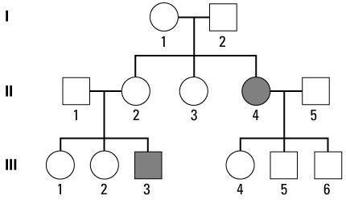

1. On which chromosome does the morbid allele appear to be located? The morbid allele would be located on an autosome.
2. How is this syndrome transmitted?

It is transmitted in an autosomal recessive manner because:

-both men and women are affected.

-there is a generation skip (generation I is not affected).

- individuals I1 and I2 as well as individuals II1 and II2 are not sick but have a sick child (individuals I1 and I2 as well as individuals II1 and II2 are asymptomatic carriers).

1. Which individuals in the pedigree can you be certain are carriers of the disease allele (asymptomatic carriers) ? Explain your reasoning.

Individuals I1, I2, II1, II2, III4, III5 III6 would certainly be heterozygous for the morbid allele. Because individuals I1 and I2 as well as individuals II1 and II2 are not sick but have a sick child. And individuals III4, III5 III6 are not sick but would have received an allele from their mother who is sick (therefore homozygous for the morbid allele) and a normal allele from their father who is phenotypically normal.

1. If individual III3 has a son with a woman who is not a carrier of the disease allele, what is the probability

that the son will have the disease? Explain. Recessive disease therefore

N = normal allele m = morbid allele

Individual III3 is sick so his genotype is mm

His wife is not a carrier of the morbid allele so her genotype must be NN SO

Parents mm X NN

Gametes m X N

## F1

100% Nm

## 100% NORMAL CHILD BUT CARRIER

So the child has 0% chance of being sick

1. Give the possible genotypes of all individuals.

I1 = Nm, I2 = Nm,

II1 = Nm, II2 = Nm, II3 = Nm or NN, II4 = mm, II5 = NN or Nm,

III1 = NN or Nm, III2 = NN or Nm, III3 = mm, III4 = Nm, III5 = Nm, III6 = Nm,

# Exercise 3:

Color blindness (daltonism) is inherited as a sex-linked recessive disorder that manifests as impaired vision of red and green colors. If a normal woman marries a color blinded man, what would be the expected phenotypes of their children with respect to this disorder?

X D = normal allele X d = Morbide allele

The woman is normal her genotype could be X D X D or X D X d

The man is color blind his genotype is X d Y SO 2 possibilities

Possibility 1

Parents X D X D X X d Y

Gametes X D X 1/2 X d , 1/2 Y

## F1

|  |  |  |
| --- | --- | --- |
|  | 1/2 X d | 1/2 Y |
| X D | 1/2 X D X d (Normal but Carrier girl) | 1/2 X D Y (healthy boys) |

So 100% of children would be healthy

Possibility 2

Parents X D X d X X d Y

Gametes 1/2 X D , 1/2 X d X 1/2 X d , 1/2 Y

## F1

|  |  |  |
| --- | --- | --- |
|  | 1/2 X d | 1/2 Y |
| 1/2 X D | 1/4 X D X d | 1/4 X D Y |
| 1/2 X d | 1/4 X d X d | ¼ X d Y |

So 50% of children would be healthy and 50% of children would be sick.

You learn that this woman's father was also color blinded. What is the probability that this woman will have a normal daughter?

This woman's father was color blind so her genotype is X d Y, so the woman's genotype must be X D X d

because she would have received the X allele from his father who was ill.

The man is color blind his genotype is X d Y

## SO

Parents X D X d X X d Y

Gametes 1/2 X D , 1/2 X d X 1/2 X d , 1/2 Y

## F1

|  |  |  |
| --- | --- | --- |
|  | 1/2 X d | 1/2 Y |
| 1/2 X D | 1/4 X D X d | 1/4 X D Y |
| 1/2 X d | 1/4 X d X d | 1/4 X d Y |

So 50% of children would be healthy and 50% of children would be sick.